Supplementary Materials

Technical description of the rapid-recovery amplifier
We aimed to develop an amplifier which can record neural activity ~1 ms after stimulation offset. To do so, the stimulus pulses should not overdrive the amplifier nor saturate the filters, particularly high-pass filters, which by design have a long recovery time constant. The amplifier schematics are shown in Figure S1. The amplifier implements a single-ended configuration with three stages; the first stage uses the OPA140DGK (Texas Instruments, Dallas, TX) operational amplifier (op-amp) and the second and third stages use OPA2277U-EP (Texas Instruments). The first (input) stage and the second stage include high-pass filters and gain compression; the third stage is a linear gain stage.
All stages are supplied with ±15 V to prevent output saturation and input current shunting. If the op-amp input were to exceed the power supply rails, the input signal would be clamped to ±15 V due to the electrostatic discharge protection of the chip, resulting in an undesirable transient drop in the input impedance. As a consequence, the input stage might shunt a part of the stimulation current, reducing the current left for stimulation if the stimulator and amplifier share the same electrode. If stimulation uses a separate electrode, the drop in impedance might inject a significant current through the recording electrode.
We used an ac-coupling input capacitance of 1 nF to balance several design objectives. A large capacitance value is advantageous as it reduces the impedance driving the input stage, extends the low-frequency corner, and reduces the residual voltage on the capacitor after a large input artifact, which could saturate the input stage. On the other hand, a small capacitance value is required to limit the charge injected into the brain in case of an op-amp failure, which may short the op-amp input to its ± 15 V supply. The ac-coupling capacitance is biased to ground with a 500 MΩ resistor, which dominates the input impedance. As the input impedance forms a voltage divider together with the electrode and the source’s equivalent impedance, the input impedance should be significantly larger than the total impedance driving the amplifier input. The high ac-coupling capacitance and high impedance leads to a long time constant of the first stage (500 ms), which is eliminated by faster (1 ms) ac-coupling dynamics in the second stage. To allow a high input impedance without a large dc voltage offset caused by the op-amp input bias current, the feedback network of the first stage is ac-coupled to ground through a 570 nF capacitor, reducing the dc gain to unity. This capacitance is larger than the ac-coupling input capacitance, but does not affect the maximum injected charge in case of a failure of an integrated circuit.
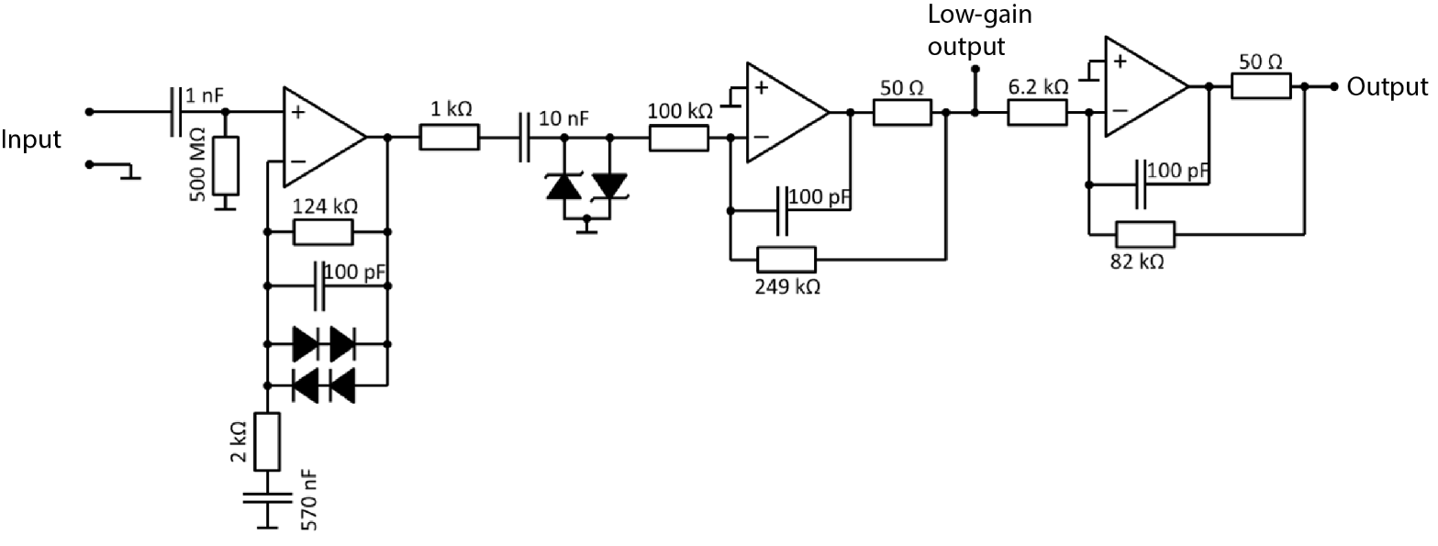
Saturation of subsequent stages during a stimulus pulse is avoided by nonlinear gain, which compresses large dynamic swings. We implemented a feedback loop in the first stage which reduces the gain to unity when the output exceeds the input by approximately 1.3 V, corresponding the total forward voltage drop of the two series diodes in parallel with the feedback resistor and capacitor. The input to the second amplification stage is ac-coupled with a fast time constant (1 ms) and is clamped by a pair of Schottky diodes limiting the gain for large signals (Mueller et al. 2014). The rest of the second stage and the third stage are linear and provide additional gain for the neural signals.
Fig. S1. Circuit diagram of the rapid-recovery amplifier. We used the output node (far-right) to record neural signal. The additional low-gain output was included for debugging. The 1 nF and the 10 nF are both 1% metalized polypropylene MKP capacitors from Vishay. The 100 pF are from Panasonic's ech-u1h series. The diodes are SD103A (Vishay) and 1N4148 (Onsemi). The 500 MOhm resistor is from the CRCW series from Vishay.
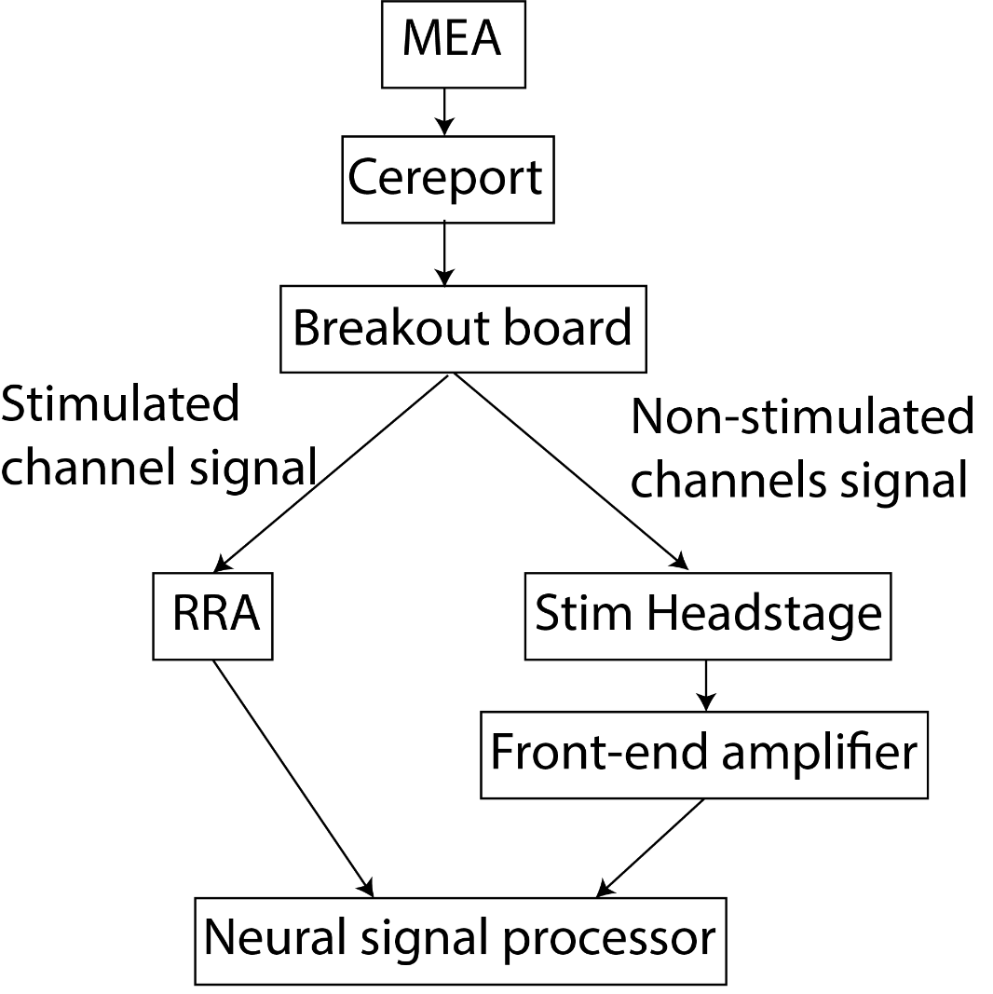
We used a custom-made breakout board to pass signals from the stimulated channel to the RRA, bypassing the Stim Headstage and Front-end amplifier (Fig. S2 and S3). Signals recorded on non-stimulated channels were passed to the Stim Headstage and Front-end amplifier.
Fig. S2. Connection diagram. Neural signal is recorded from a multi-electrode array (MEA). A custom-made breakout board passes only signal from the stimulated channel to the RRA and passes signals from all non-stimualetd channels to the Stim Headstage and Front-end amplifier. Signals from all channels are passed to the neural signal processor.

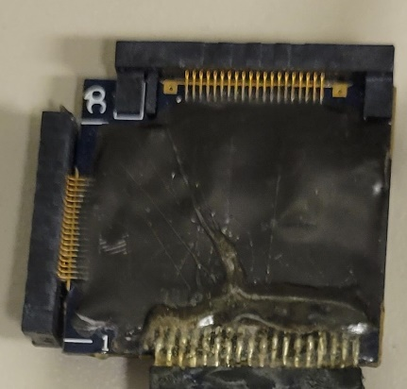
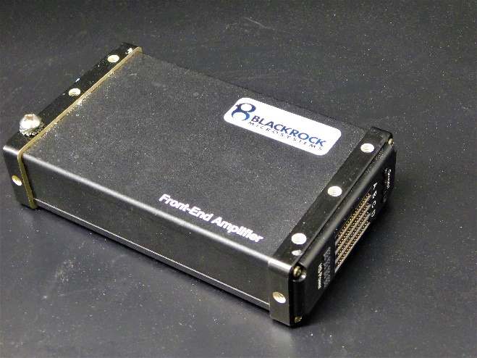
Fig. S3. Pictures of Stim Headstage (left) and Front-end amplifier (right).

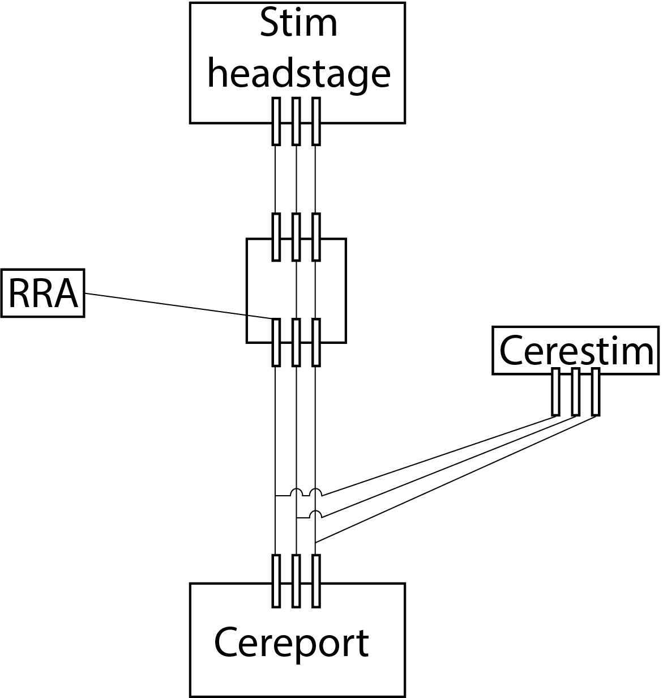
Fig. S4. Diagram of breakout board. Neural signals recorded on the stimulated channel are passed to the RRA from the Cereport while all other signals are passed to the Stim Headstage. The channel passed to the RRA was manually selected. All channels are connected to the Cerestim for stimulation (only one channel was stimulated at a time). Only three of the 96 channels are depicted for clarity.

Finding peaks in the evoked response
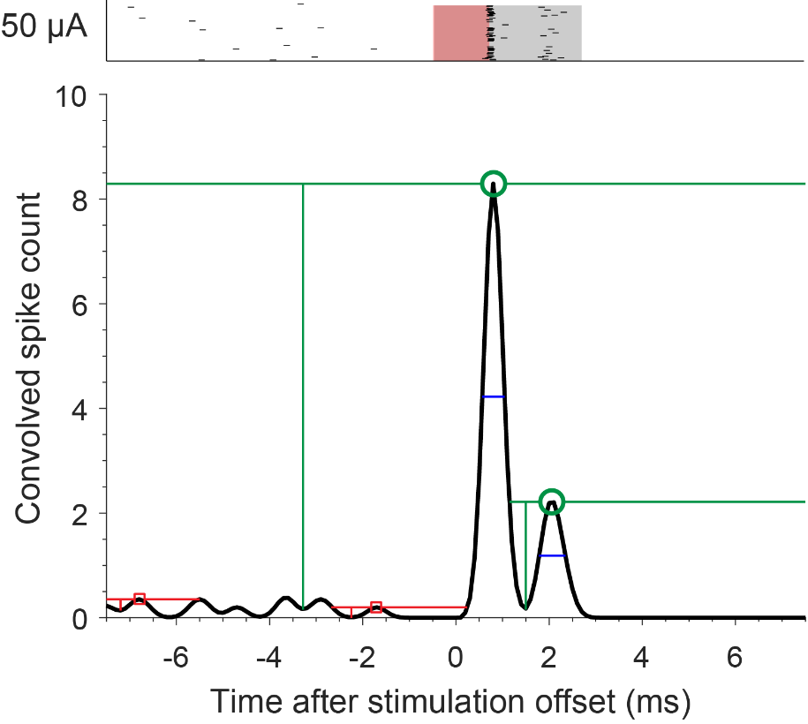
Spikes were often evoked at multiple, consistent latencies following single pulses of stimulation. Fig. S2 shows the response of an example neuron to repeated stimulation at 50 μA (top, same format as Fig. 3). We grouped spikes based on their response latency in each condition. To do so, we first convolved the spike train with a non-causal Gaussian kernel (width = 0.2 ms) (Fig. S2 bottom, black trace). We found peaks in this average with MATLAB’s findpeaks algorithm. This algorithm computes the “prominence” of every local maximum by first drawing horizontal lines before and after each maximum until the lines either cross the signal or reach the end of the signal (horizontal lines in Fig. S2). Then, the minimum of the signal is found within both intervals, one before and one after the local maximum. Prominence is the difference between the local maximum and the highest of these two minimums (vertical lines in Fig. S2). If the prominence for a local maximum is sufficiently large (above 1.0 in our case), then the maximum is labelled as a peak. Peaks that were found with this algorithm are marked with green circles and a subset of local maxima that were rejected are marked with red squares (Fig. S2). This algorithm also measures the width of the peak, defined as the time between points where the descending signal intercepts half of the peak prominence, shown as blue lines within each peak.
Fig. S5. Example prominence calculation and resulting peaks using findpeaks algorithm.

