S.1. Moran's I Index of green patent from 2006 to 2015
 | Year |  | Moran's I |  | Year |  | Moran's I
 | 2006 |  | 0.320 *** |  | 2011 |  | 0.232 **
 | 2007 |  | 0.282 ** |  | 2012 |  | 0.298 **
 | 2008 |  | 0.225 * |  | 2013 |  | 0.199 *
 | 2009 |  | 0.349 *** |  | 2014 |  | 0.196 *
 | 2010 |  | 0.266 ** |  | 2015 |  | 0.118 *
 | Note: ***, **, and * represent significance levels of 1%, 5%, and 10% respectively
S.2. Lagrange Multiplier Test (LM-test) Results
Weight |  | Test |  | Statistical value |  | P-value
$w$₁ |  | LM (lag) test |  | 3.9622** |  | 0.047
 |  | Robust LM (lag) test |  | 5.3779** |  | 0.020
 |  | LM (error) test |  | 0.2792 |  | 0.597
 |  | Robust LM (error) test |  | 1.6949 |  | 0.193
$w$₂ |  | LM (lag) test |  | 3.0483* |  | 0.081
 |  | Robust LM (lag) test |  | 19.4862*** |  | 0.000
 |  | LM (error) test |  | 0.7553 |  | 0.385
 |  | Robust LM (error) test |  | 17.1931*** |  | 0.000
$w$₃ |  | LM (lag) test |  | 13.6176*** |  | 0.000
 |  | Robust LM (lag) test |  | 11.9728*** |  | 0.001
 |  | LM (error) test |  | 4.2419** |  | 0.039
 |  | Robust LM (error) test |  | 2.5970 |  | 0.107
Note: ***, **, and * represent significance levels of 1%, 5%, and 10% respectively
S.3. LR-test and Wald-test results
Weight |  | Statistic |  | Statistical value |  | P-value
$w$₁ |  | LR spatial lag |  | 25.9092*** |  | 0.000
 |  | LR spatial error |  | 29.0208*** |  | 0.001
 |  | Wald spatial lag |  | 23.5351*** |  | 0.000
 |  | Wald spatial error |  | 25.6934*** |  | 0.000
$w$₂ |  | LR spatial lag |  | 84.4197*** |  | 0.000
 |  | LR spatial error |  | 86.2535*** |  | 0.000
 |  | Wald spatial lag |  | 87.5246*** |  | 0.000
 |  | Wald spatial error |  | 88.7692*** |  | 0.000
$w$₃ |  | LR spatial lag |  | 41.0804*** |  | 0.000
 |  | LR spatial error |  | 50.3170*** |  | 0.000
 |  | Wald spatial lag |  | 39.5888*** |  | 0.000
 |  | Wald spatial error |  | 47.0298 *** |  | 0.000
Note: ***, **, and * represent significance levels of 1%, 5%, and 10% respectively

S.4. Descriptive statistics of main variables
Variable name |  | Unit | Observed value | Average value | Standard deviation | Minimum value | Maximum value
Explained  variable | Number of green patents (patent) | piece | 290 | 944.624 | 1561.062 | 7.000 | 10 506.000
Explanatory  variable | Number of environmental protection penalties (supervision) | piece | 290 | 98.772 | 151.190 | 0.000 | 1 177.000
Control  variable | Economic development level (GDP_per) | 10 thousand RMB | 290 | 37 124.860 | 21 658.520 | 6 225.659 | 106 908.400
Control  variable | Industry structure (indu_stru) | % | 290 | 0.020 | 0.015 | 0.006 | 0.104
Control  variable | Education level (educ) | % | 290 | 0.099 | 0.060 | 0.025 | 0.395
Control  variable | Resident consumption expenditure (expend) | RMB per person | 290 | 5 624.695 | 4778.203 | 230.690 | 28 438.600
Control  variable | Population density (densi_pop) | 10 thousand | 290 | 447.812 | 644.970 | 7.587 | 3 850.286

S.5. Estimated results of fixed effect models in different regions
Effect Region | Variable name | Eastern  Region | Central  Region | Western  Region
Direct  Effect | supervision | 0.028*** | -0.008 | 0.060***
Direct  Effect | gdp_per | 0.002 | -0.004* | -0.001
Direct  Effect | indu_stru | 9112.102*** | 3027.82*** | 416.578
Direct  Effect | educ | -884.100*** | 473.16 | 59.915
Direct  Effect | expend | 0.007 | 0.017*** | 0.035***
Direct  Effect | densi_pop | -0.093 | 1.763 | 1.983***
Indirect  Effect | supervision | -0.010 | 0.022 | -0.083**
Indirect  Effect | gdp_per | 0.013*** | 0.005 | 0.006***
Indirect  Effect | indu_stru | 8816.121** | 215.903 | 1862.932*
Indirect  Effect | educ | 28.770 | -951.747 | -396.918**
Indirect  Effect | expend | -0.009 | 0.018 | -0.021**
Indirect  Effect | densi_pop | 1.127*** | 3.618 | 3.528**
Total effect | supervision | 0.018 | 0.014 | -0.023
Total effect | gdp_per | 0.016*** | 0.001 | 0.005***
Total effect | indu_stru | 17928.220*** | 3243.724* | 2279.511**
Total effect | educ | -855.330*** | -478.589** | -337.003**
Total effect | expend | -0.002 | 0.035*** | 0.014**
Total effect | densi_pop | 1.034*** | 5.381 | 5.511***
Note: All estimates include double fixed effects; ***, **, and * represent significance levels of 1%, 5%, and 10% respectively
Eastern Region: Beijing, Tianjin, Hebei, Liaoning, Shanghai, Jiangsu, Zhejiang, Fujian, Shandong, and Guangdong
Central region: Shanxi, Jilin, Heilongjiang, Anhui, Henan, Hubei, Hunan, and Jiangxi
Western region: Inner Mongolia, Guangxi, Chongqing, Sichuan, Guizhou, Yunnan, Shaanxi, Gansu, Qinghai, Ningxia, and Xinjiang

S.6. Regression Estimation Results of Spatial Durbin Model
with Difference Transformation
Variable name | w₁ | w₂ | w₃
Supervision | 0.0132*** | 0.0139*** | 0.0167***
 | (4.0900) | (4.3100) | (4.7200)
GDP_per | 0.0009** | 0.0002 | -0.0002
 | (2.1800) | (0.2900) | (-0.2900)
Indu_stru | 506.5811 | 648.6364 | 1012.8960
 | (1.2100) | (0.8900) | (1.5000)
educ | -148.7235 | -380.8452*** | -317.3453***
 | (-1.3500) | (-3.3600) | (-2.7900)
expend | 0.0028** | 0.0052*** | 0.0063***
 | (2.2400) | (2.7700) | (3.3800)
densi_pop | -0.0118 | -0.0344 | -0.0596
 | (-1.2400) | (-1.0200) | (-1.5100)
w×Supervision | -0.0145** | -0.0176*** | -0.0053
 | (-2.0300) | (-2.9400) | (-0.6500)
w×GDP_per | 0.0012** | 0.0042*** | -0.0031
 | (2.2200) | (4.7200) | (-1.4400)
w×Indu_stru | 1301.349* | 1022.3740 | 325.4971
 | (1.9100) | (1.0700) | (0.3400)
w×Colle_pop | -154.8158 | 133.7071 | -599.6932
 | (-1.1700) | (0.9300) | (-1.6400)
w×Expend | 0.0085*** | 0.0010 | 0.0053
 | (2.9800) | (0.3100) | (0.9600)
w×densi_pop | -0.0613*** | 0.0601 | 0.8230***
 | (-3.3200) | (1.3700) | (3.6600)
w×dep.var | -0.1615* | -0.1309** | -0.0550
 | (-1.5100) | (-2.1980) | (-0.5700)
R² | 0.4429 | 0.3031 | 0.1463
log-likelihood | -1343.5429 | -1276.2132 | -1292.1592
Sigma^2 | 1529.2650 | 1026.4410 | 1168.0140
Note: All estimates include double fixed effects; ***, **, and * represent significance levels of 1%, 5%, and 10% respectively

S.7. Contiguity weight matrix (0-1 contiguity weight matrix) $w_{1}$

S.8. Inverse distance weight matrix $w_{2}$

S.9. Economic distance weight matrix $w_{3}$

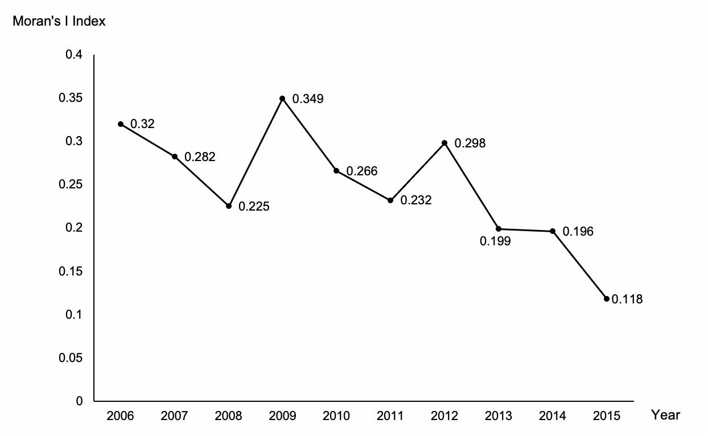
S.10. Evolution of the Morans’I index.

