Valuation of pollination services of habitat created at solar energy facilities in the United States

Supplementary Materials

Figs. S1 to S2
Fig. S1. Pollination DR on insects
Fig. S2. Price paid for pollination services per acre of crops across the United States

Tables S1 to S4
Table S1. Pollinator use in the United States, pollinated area, number of colonies used, price of pollination, and total cost of pollination in the United States
Table S2. Pollinators supply demand discrepancy area in the United States
Table S3. Total capacity of solar facilities in the United States and their spatial footprints
Table S4. Potential value (US $) of pollination provided by developing pollinator habitats at 217 USSE facilities in the United States

Supplementary Text
Analysis of Demand for Pollinators

Fig. S1 Pollination DR on insects (data were collected from a review of literature [Klein et al. 2007; Gallai et al. 2009;, and Kremen et al 2007]).

Table S1. Pollinator use in the United States, pollinated area under various crops, number of colonies used, price of pollination, and total cost of pollination in the United States in 2016 (2016 U.S. dollars)
Crop | Paid Pollinated Area (hectare) | Total Colonies Used | Price of Pollination ($/ha)e) | Total Cost of Pollination ($)$)
Alfalfa | 17,280 | 92,000 | 55.44 | $5,851,000
Almond | 393,120 | 1,680,000 | 116.96 | $280,560,000
Apple | 93,323 | 183,400 | 17.81 | $10,167,000
Avocado | 5,180 | 69,000 | 89.03 | $2,815,000
Blueberry | 29,866 | 147,000 | 55.85 | $10,166,000
Cantaloupe | 17,301 | 46,600 | 21.85 | $2,316,000
Cherry | 40,227 | 134,100 | 31.57 | $7,711,000
Clover | 3,359 | 10,500 | 17.40 | $353,000
Cranberry | 15,904 | 88,000 | 69.61 | $6,740,000
Cucumber | 19,365 | 42,500 | 17.81 | $2,112,000
Honey dew | 3,764 | 10,000 | 22.26 | $513,000
Kiwi | 1,133 | 4,800 | 142.05 | $984,000
Orange | 3,804 | 49,000 | 75.68 | $1,756,000
Peach | 2,044 | 4,700 | 19.83 | $249,000
Pear | 9,834 | 30,000 | 26.71 | $1,593,000
Plum | 12,019 | 46,000 | 40.47 | $2,962,000
Pumpkin | 9,106 | 20,500 | 27.11 | $1,514,000
Raspberry | 4,654 | 22,000 | 56.66 | $1,612,000
Squash | 8,701 | 27,000 | 24.69 | $1,309,000
Sunflower | 9,227 | 30,000 | 15.38 | $864,000
Watermelon | 26,244 | 76,900 | 27.11 | $4,327,000
Others# | 29,401 | 163,800 |  | $7,743,000
Total | 754,856 | 2,977,800 |  | $359,483,000

# Includes all other crops, miscellaneous crops, other tree fruits, and other vegetable crops
(based on USDA 2016 report on pollination).

Table S2. Pollinators supply demand discrepancy area in the United States.

No. | State | Area (ha)
1 | Alabama | 139,722
2 | Arizona | 229,137
3 | Arkansas | 146,252
4 | California | 1,484,127
5 | Colorado | 383,954
6 | Connecticut | 9,871
7 | Delaware | 4,709
8 | Georgia | 669,264
9 | Idaho | 714,040
10 | Illinois | 51,931
11 | Indiana | 62,846
12 | Iowa | 216,209
13 | Kansas | 240,536
14 | Maryland | 8,898
15 | Minnesota | 781,567
16 | Mississippi | 179,124
17 | Montana | 1,076,769
18 | Nevada | 63,982
19 | New Jersey | 17,729
20 | New Mexico | 101,506
21 | North Dakota | 1,314,098
22 | Oklahoma | 195,892
23 | Pennsylvania | 98,284
24 | South Carolina | 79,674
25 | South Dakota | 570,799
26 | Utah | 207,906
27 | Vermont | 1,417
28 | West Virginia | 2,904
29 | Wyoming | 190,830
30 | Florida | 422,673
31 | Kentucky | 12,442
32 | Louisiana | 60,162
33 | Maine | 10,617
34 | Massachusetts | 7,919
35 | Michigan | 606,816
36 | Missouri | 113,286
37 | Nebraska | 389,873
38 | New Hampshire | 825
39 | New York | 261,150
40 | North Carolina | 140,543
41 | Ohio | 105,781
42 | Oregon | 216,521
43 | Rhode Island | 130
44 | Tennessee | 89,857
45 | Texas | 2,475,768
46 | Virginia | 34,109
47 | Washington | 369,636
48 | Wisconsin | 791,905
 | Total | 15,353,990

Table S3. Total capacity (megawatts) of solar facilities in the United States and their spatial footprints (hectares).

State | Existing USSE |  | Planned USSE |  | Total
State | Capacity | Land Area | Capacity | Land Area | Capacity | Land area
CA | 9501 | 30761 | 4706 | 11427 | 14207 | 42188
NC | 2426 | 7856 | 1600 | 3885 | 4027 | 11741
AZ | 1884 | 6098 | 639 | 1550 | 2522 | 7648
NV | 1598 | 5174 | 860 | 2088 | 2458 | 7263
TX | 580 | 1877 | 2121 | 5150 | 2701 | 7027
UT | 856 | 2771 | 306 | 742 | 1162 | 3513
GA | 978 | 3167 | 52 | 125 | 1030 | 3292
FL | 331 | 1070 | 774 | 1878 | 1104 | 2949
NJ | 612 | 1982 | 52 | 127 | 664 | 2108
NM | 477 | 1545 | 161 | 391 | 638 | 1936
MA | 474 | 1536 | 95 | 230 | 569 | 1766
CO | 420 | 1358 | 15 | 36 | 434 | 1394
MN | 255 | 826 | 234 | 567 | 489 | 1394
MD | 143 | 464 | 216 | 525 | 360 | 989
ID | 120 | 389 | 220 | 534 | 340 | 923
VA | 139 | 450 | 140 | 339 | 279 | 789
IN | 161 | 520 | 41 | 100 | 202 | 620
OR | 100 | 323 | 104 | 253 | 204 | 576
SC | 19 | 62 | 186 | 451 | 205 | 514
NY | 110 | 357 | 56 | 136 | 166 | 493
AL | 75 | 243 | 97 | 236 | 172 | 479
TN | 73 | 235 | 71 | 172 | 143 | 407
MS | 3 | 10 | 158 | 382 | 161 | 393
VT | 66 | 214 | 14 | 33 | 80 | 246
AR | 13 | 42 | 81 | 197 | 94 | 239
OH | 49 | 158 | 20 | 49 | 69 | 206
MI | 13 | 40 | 61 | 147 | 73 | 187
PA | 54 | 176 | 0 | 0 | 54 | 176
CT | 22 | 72 | 30 | 73 | 52 | 145
MO | 26 | 83 | 18 | 45 | 44 | 128
IL | 33 | 107 | 2 | 5 | 35 | 112
DE | 31 | 100 | 2 | 4 | 32 | 103
KY | 10 | 32 | 15 | 37 | 25 | 69
WI | 3 | 10 | 17 | 42 | 20 | 52

Data on solar facilities were obtained from USEIA. The land area covered is estimated based on 8 acres (3.24 hectares) of land requirement per megawatt facility calculated by Ong et al. 2013.

Table S4. Potential value (US $) of pollination provided by developing pollinator habitats at 217 USSE facilities in the United States

Commodity | Lowe Bound Value | Average Value | Upper bound Value
almonds | 101,045,910 | 161,427,003 | 221,808,096
apples | 26,801 | 42,817 | 58,832
blueberries | 99,534 | 159,012 | 218,490
cotton | 863,145 | 2,000,926 | 3,138,708
cucumbers | 52,391 | 83,698 | 115,004
grapefruit | 335,321 | 1,844,267 | 3,353,212
melons | 6,829,655 | 7,129,860 | 7,430,065
nectarines | 153,588 | 245,366 | 337,144
peaches | 165,765 | 264,820 | 363,874
peanuts | 8,268 | 45,474 | 82,679
pears | 1,339,320 | 2,139,645 | 2,939,970
plums | 143,165 | 228,715 | 314,265
pumpkins | 66,045 | 68,948 | 71,851
soybeans | 609,469 | 1,412,860 | 2,216,251
squash | 237,670 | 248,117 | 258,564
sunflower | 422,964 | 2,326,300 | 4,229,637
walnuts | 7,770,601 | 12,414,008 | 17,057,416
Grand Total | 120,169,612 | 192,081,836 | 263,994,059

Supplementary Text

Analysis of Demand for Pollinators
Three million colonies of honeybees were used to pollinate cropland across a variety of pollination-dependent crops in 2016 (USDA 2016) (Table S4). The population of native pollinators is the minimum in U.S. croplands (Koh 2016). Commercial honeybee keepers transport bee colonies to California in February, to the northern plains in the summer for sunflower and alfalfa, and to the Dakotas to provide pollination services (USDA 2017).

The demand for honeybee pollination is high for crops such as cranberry, blueberry, raspberry, and kiwi. To pollinate these crops, farmers pay more than $200/acre (USDA 2016). Honeybee pollination demand is also high for crops such as avocado, almond, cherry, alfalfa, and orange, although these pollination costs are lower. The price paid for pollination depends upon the number of bee colonies needed, which varies by crop—from one colony per acre for apple, pear, peach, cherry, cucumber, and sunflower to five colonies per acre for orange and avocado. Almond, berry, kiwi, and alfalfa crops need two colonies per acre for effective pollination. The honeybee pollination price per acre paid in 2016 is represented in Fig. S3.

The native pollinators’ abundance is observed the highest in areas with higher proportions of grassland, fruits, and forests. Only some of the field crops such as sunflower provide high-quality foraging, and the rest of them have low or very low suitability. The demand for solar pollinator habitat creation would be higher in the areas with lower forage suitability index (Fig. S3).

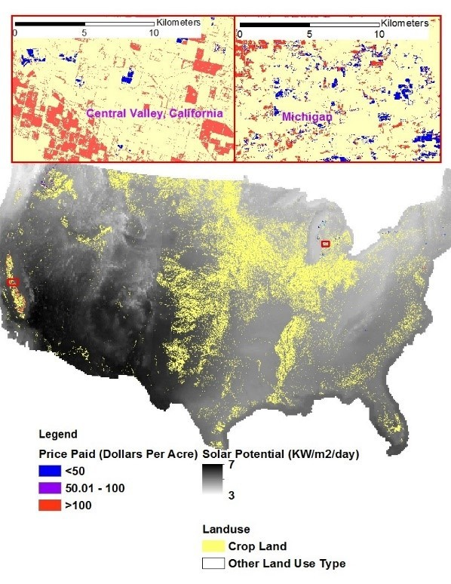

Fig. S3 Price paid for pollination services per acre of crop across the United States.

References

Gallai N, Salles JM, Settele J, Vaissière BE. Economic valuation of the vulnerability of world agriculture confronted with pollinator decline. Ecol Econ. 2009.
Klein AM, et al. Importance of pollinators in changing landscapes for world crops. Proc. R. Soc. B Biol. Sci. 2007. Available from: https//: doi:10.1098/rspb.2006.3721.
Kremen C, Williams NM, Aizen MA, Gemmill-Herren B, LeBuhn G, Minckley R, et al. Pollination and other ecosystem services produced by mobile organisms: A conceptual framework for the effects of land-use change. Ecology Letters. 2007.
Ong S, Campbell C, Denholm P, Margolis R, Heath G., Land-Use Requirements for Solar Power Plants in the United States, Office of Scientific and Technical Information, Golden, CO 2013. Available from: https//:doi:10.2172/1086349.
USDA (U.S. Department of Agriculture), Cost of Pollination, 2016.
USDA, Land Use, Land Cover, and Pollinator Health: A Review and Trend Analysis, 2017.
U.S. Energy Information Administration (EIA), Form EIA-860 Detailed Data, Early Release 2016 Data, 2016. Available from: https://www.eia.gov/electricity/data/eia860/.

