Supplementary File

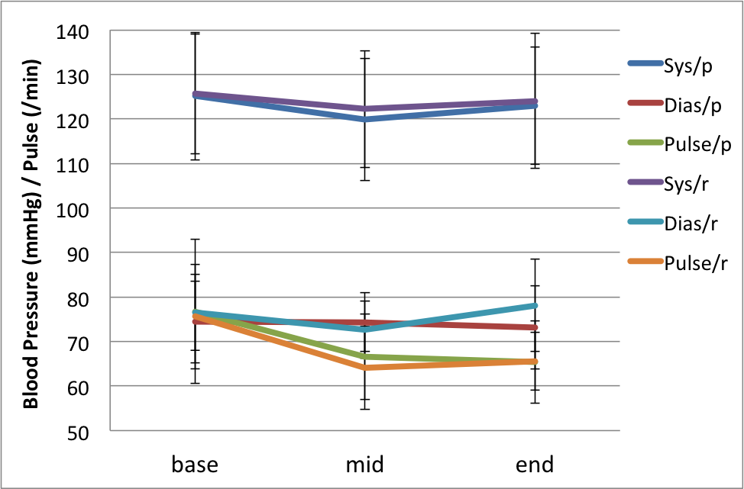

**Figure 1. Cardiovascular parameters in participants during the study. Top: Pulse; Bottom: blood pressure. There were no significant treatment group by time interactions (all p>0.10). Error bars represent SEs.** Abbreviations. Sys-p: systolic blood pressure with placebo, Dias-p: diastolic blood pressure with placebo, Pulse-p: pulse rate with placebo, Sys-r: systolic blood pressure with real drug, Dias-p: diastolic blood pressure with real drug, Pulse-p: pulse rate with real drug. SE: standard error of the mean.

Supplementary table (Figure 1)

|  |  |  |  |  |  |  |
| --- | --- | --- | --- | --- | --- | --- |
|  | Istradefylline (SD) | | | Placebo (SD) | | |
|  | Base | Mid | End | Base | Mid | End |
| Systolic Blood Pressure  (mmHg) | 125.7 (13.5) | 122.2 (13.1) | 124.0 (15.2) | 125.1 (14.3) | 119.9 (13.8) | 123.0 (13.1) |
| Diastolic Blood Pressure  (mmHg) | 76.6 (8.5) | 72.7 (6.5) | 78.2 (10.4) | 74.4 (9.2) | 74.4 (6.6) | 73.2 (9.3) |
| Pulse (times/min) | 75.6 (11.7) | 64.1 (9.3) | 65.6 (6.5) | 76.8 (16.1) | 66.6 (9.6) | 65.4 (9.2) |

|  |  |  |  |
| --- | --- | --- | --- |
|  | Base (SD) | Mid (SD) | End (SD) |
| *Istradefylline* |  |  |  |
| Systolic Blood Pressure (mmHg) | 125.7 (13.5) | 122.2 (13.1) | 124.0 (15.2) |
| Diastolic Blood Pressure (mmHg) | 76.6 (8.5) | 72.7 (6.5) | 78.2 (10.4) |
| Pulse (times/min) | 75.6 (11.7) | 64.1 (9.3) | 65.6 (6.5) |
|  |  |  |  |
| *Placebo* |  |  |  |
| Systolic Blood Pressure (mmHg) | 125.1 (14.3) | 119.9 (13.8) | 123.0 (13.1) |
| Diastolic Blood Pressure (mmHg) | 74.4 (9.2) | 74.4 (6.6) | 73.2 (9.3) |
| Pulse (times/min) | 76.8 (16.1) | 66.6 (9.6) | 65.4 (9.2) |

Caffeine History Questionnaire (CHQ)

[Developed by Ioannidis, Hook and Chamberlain for the purposes of this study. Copyright the authors 2022. The questionnaire may be used for free for non-commercial academic research, provided the instrument is not re-printed or modified in any way, and that credit is given by citing this paper. For permission to use this instrument for commercial use (e.g. by companies), individuals are asked to contact Dr Chamberlain in advance].

Candidate ID: _______________ Date:_________________

Please take a couple of minutes to reply to the questions below:

**Have you consumed any of the following products in the last week? Please circle the average e.g. two cups per day; OR if you drink them less often, circle e.g. “2 cups in a week”. Circle NONE if you haven’t consumed that product.**

|  |  |  |  |  |  |  |  |  |  |  |  |  |  |  |  |  |  |  |  |  |
| --- | --- | --- | --- | --- | --- | --- | --- | --- | --- | --- | --- | --- | --- | --- | --- | --- | --- | --- | --- | --- |
| Percolated/brewed coffee | How many cups? | |  |  |  |  |  |  |  |  |  | | --- | --- | --- | --- | --- | --- | --- | --- | --- | | 1 | 2 | 3 | 4 | 5 | 6 | 7 | more | Day | | 1 | 2 | 3 | 4 | 5 | 6 |  |  | Week |   NONE |
| Espresso coffee | How many cups? | |  |  |  |  |  |  |  |  |  | | --- | --- | --- | --- | --- | --- | --- | --- | --- | | 1 | 2 | 3 | 4 | 5 | 6 | 7 | more | Day | | 1 | 2 | 3 | 4 | 5 | 6 |  |  | Week |   NONE |
| Decaffeinated coffee | How many cups? | |  |  |  |  |  |  |  |  |  | | --- | --- | --- | --- | --- | --- | --- | --- | --- | | 1 | 2 | 3 | 4 | 5 | 6 | 7 | more | Day | | 1 | 2 | 3 | 4 | 5 | 6 |  |  | Week |   NONE |
| Other caffeinated preparations *(see below)* | How many cups? | |  |  |  |  |  |  |  |  |  | | --- | --- | --- | --- | --- | --- | --- | --- | --- | | 1 | 2 | 3 | 4 | 5 | 6 | 7 | more | Day | | 1 | 2 | 3 | 4 | 5 | 6 |  |  | Week |   NONE |
| Please circle: Cappuccino | Mocha | Latte | Iced coffee | Macchiato | other | | |
| Black Tea (with or without milk) or Earl Grey | How many cups? | |  |  |  |  |  |  |  |  |  | | --- | --- | --- | --- | --- | --- | --- | --- | --- | | 1 | 2 | 3 | 4 | 5 | 6 | 7 | more | Day | | 1 | 2 | 3 | 4 | 5 | 6 |  |  | Week |   NONE |
| Green Tea | How many cups? | |  |  |  |  |  |  |  |  |  | | --- | --- | --- | --- | --- | --- | --- | --- | --- | | 1 | 2 | 3 | 4 | 5 | 6 | 7 | more | Day | | 1 | 2 | 3 | 4 | 5 | 6 |  |  | Week |   NONE |
| Herbal, peppermint, chamomile tea | How many cups? | |  |  |  |  |  |  |  |  |  | | --- | --- | --- | --- | --- | --- | --- | --- | --- | | 1 | 2 | 3 | 4 | 5 | 6 | 7 | more | Day | | 1 | 2 | 3 | 4 | 5 | 6 |  |  | Week |   NONE |
| Other Tea *(see below)* | How many cups? | |  |  |  |  |  |  |  |  |  | | --- | --- | --- | --- | --- | --- | --- | --- | --- | | 1 | 2 | 3 | 4 | 5 | 6 | 7 | more | Day | | 1 | 2 | 3 | 4 | 5 | 6 |  |  | Week |   NONE |
| Please circle: Nestea | Iced tea | Sweet tea | Chai Latte | other | | |
| Cola *(see below)* | How many? | |  |  |  |  |  |  |  |  |  | | --- | --- | --- | --- | --- | --- | --- | --- | --- | | 1 | 2 | 3 | 4 | 5 | 6 | 7 | more | Day | | 1 | 2 | 3 | 4 | 5 | 6 |  |  | Week |   NONE |
| Please circle: Coke | Diet coke or Zero | Pepsi or Diet Pepsi | Pepsi max | Dr Pepper | Jolt cola | or other | | |
| Energy drinks and shots *(see below)* | How many? | |  |  |  |  |  |  |  |  |  | | --- | --- | --- | --- | --- | --- | --- | --- | --- | | 1 | 2 | 3 | 4 | 5 | 6 | 7 | more | Day | | 1 | 2 | 3 | 4 | 5 | 6 |  |  | Week |   NONE |
| Please circle: Red Bull | Monster Energy | Rockstar | NOS | 5-hour Energy | Relentless | Mountain Dew | other | | |
| Coffee flavoured ice-creams or cakes | How many? | |  |  |  |  |  |  |  |  |  | | --- | --- | --- | --- | --- | --- | --- | --- | --- | | 1 | 2 | 3 | 4 | 5 | 6 | 7 | more | Day | | 1 | 2 | 3 | 4 | 5 | 6 |  |  | Week |   NONE |
| Dark chocolate bars, sweets, biscuits, cakes | How many? | |  |  |  |  |  |  |  |  |  | | --- | --- | --- | --- | --- | --- | --- | --- | --- | | 1 | 2 | 3 | 4 | 5 | 6 | 7 | more | Day | | 1 | 2 | 3 | 4 | 5 | 6 |  |  | Week |   NONE |
| Hot chocolate or cocoa | How many cups? | |  |  |  |  |  |  |  |  |  | | --- | --- | --- | --- | --- | --- | --- | --- | --- | | 1 | 2 | 3 | 4 | 5 | 6 | 7 | more | Day | | 1 | 2 | 3 | 4 | 5 | 6 |  |  | Week |   NONE |
| Other chocolate *(see below)* | How many? | |  |  |  |  |  |  |  |  |  | | --- | --- | --- | --- | --- | --- | --- | --- | --- | | 1 | 2 | 3 | 4 | 5 | 6 | 7 | more | Day | | 1 | 2 | 3 | 4 | 5 | 6 |  |  | Week |   NONE |
| Please circle: milk chocolate bars | sweets | biscuits | cakes | | |
| Caffeine tablets | How many? | |  |  |  |  |  |  |  |  |  | | --- | --- | --- | --- | --- | --- | --- | --- | --- | | 1 | 2 | 3 | 4 | 5 | 6 | 7 | more | Day | | 1 | 2 | 3 | 4 | 5 | 6 |  |  | Week |   NONE |
| Over the counter medications containing caffeine *(see below)* | How many tablets? | |  |  |  |  |  |  |  |  |  | | --- | --- | --- | --- | --- | --- | --- | --- | --- | | 1 | 2 | 3 | 4 | 5 | 6 | 7 | more | Day | | 1 | 2 | 3 | 4 | 5 | 6 |  |  | Week |   NONE |
| e.g. pain relief medications containing caffeine | migraine medication | medication for cold or cough | | |
| Caffeinated Gum *(see below)* | How many? | |  |  |  |  |  |  |  |  |  | | --- | --- | --- | --- | --- | --- | --- | --- | --- | | 1 | 2 | 3 | 4 | 5 | 6 | 7 | more | Day | | 1 | 2 | 3 | 4 | 5 | 6 |  |  | Week |   NONE |
| Please circle: Think Gum | Military energy | other | | |

**Guide appendix for the calculation of a gross estimate of caffeine consumption; caffeine content is provided as a mean content of a usual dosing regime for one serving e.g. one cup of coffee**

|  |  |  |  |  |  |
| --- | --- | --- | --- | --- | --- |
| Percolated/brewed coffee | 107mg | Pepsi | 38mg | Relentless | 160mg |
| Espresso coffee | 100mg | Diet Pepsi | 38mg | AMP | 142mg |
| Decaffeinated coffee | 10mg | Pepsi Max | 69mg | Other Energy | 160mg |
| Cappuccino | 100mg | Dr Pepper | 41mg | Coffee flavoured ice-creams or cakes | 6mg |
| Other caffeinated preparations | 80mg | Jolt cola | 280mg | Dark chocolate | 43mg |
| Black Tea | 42mg | Other cola | 35mg | Hot chocolate or Cocoa | 5mg |
| Green Tea | 25mg | Red Bull | 80mg | Milk chocolate | 20mg |
| Herbal, peppermint, chamomile tea | 0mg | Monster Energy | 160mg | Caffeine tablets | 200mg |
| Other Tea | 45mg | Rockstar | 160mg | Medication containing caffeine | 65mg |
| Coke | 34mg | NOS | 160mg | Think Gum | 10mg |
| Diet coke or Zero | 45mg | 5-hour Energy | 207mg | Military Gum | 100mg |