Reproduced with permission from Chicago Face Database, available at https://www.chicagofaces.org/download/.

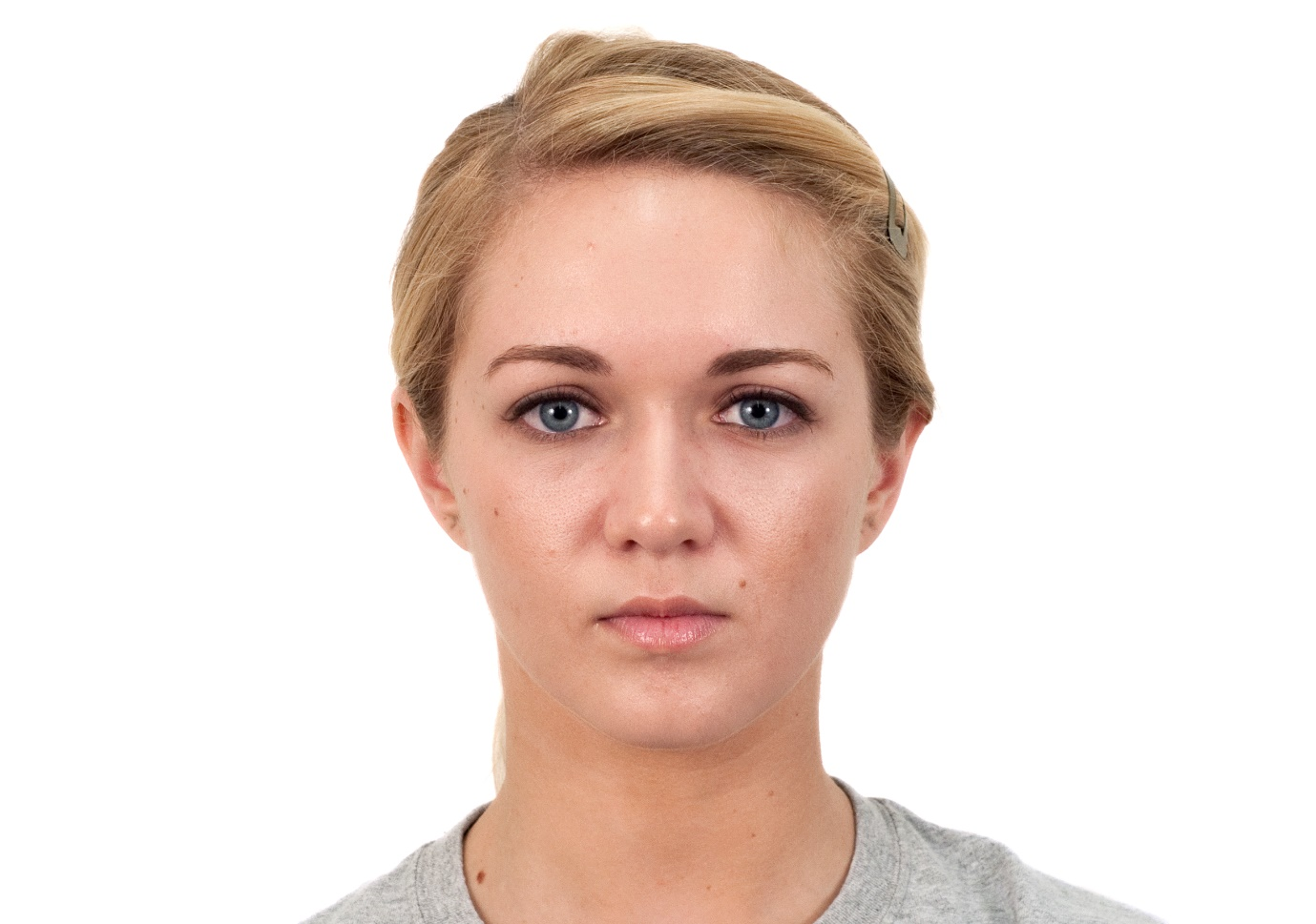
Figure S1: CFD-WF-233-112-N.jpg; image from the Chicago Face Database used in the Female Talker Prompt Condition
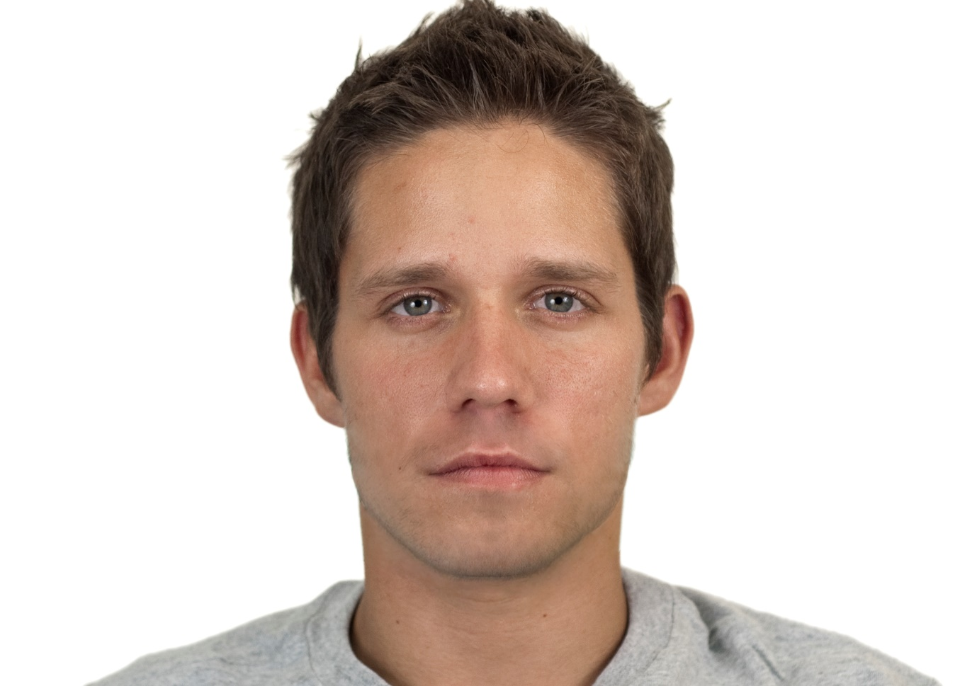
Figure S2: CFD-WM-004-010-N.jpg; image from the Chicago Face Database used in the Female Talker Prompt Condition

