Supplementary Information for
Action experience in infancy predicts visual-motor functional connectivity during action anticipation

This PDF file includes:
- Channels used for analyses
  - Table S1
  - Table S2

- EEG processing steps

- Results: Action Observation Window
  - Figure S1
  - Figure S2

- Results: Grasp Latency & ISPC across time (Theta, Alpha, and Beta)
  - Figure S3
  - Figure S4

- Results: alpha power
  - Figure S5
  - Figure S6

- Additional Figures
  - Figure S7

- Number of trials & ISPC
  - Figure S8

- References
- Channels used for analyses
Table S1. Electrodes included in Occipital, Central, Parietal and Frontal ROIs
 | Left Hemisphere | Right Hemisphere
Occipital | 'E66', 'E69', 'E70', 'E71', 'E74' | 'E76', 'E82', 'E83', 'E84', 'E89'
Central | 'E29', 'E30', 'E35', 'E36', 'E37', 'E41', 'E42' | 'E87', 'E93', 'E103', 'E104', 'E105', 'E110', 'E111'
Parietal | 'E47', 'E51', 'E52', 'E53', 'E59', 'E60' | 'E85', 'E86', 'E91', 'E92', 'E97', 'E98'
Frontal | 'E19', 'E20', 'E23', 'E24', 'E27', 'E28' | 'E3', 'E4', 'E117', 'E118', 'E123', 'E124'

Table S2. Electrodes in each of the ROIs used to calculate whole-brain connectivity
ROI | Electrodes
Frontal Pole | 'E1', 'E8', 'E9', 'E14', 'E15', 'E21', 'E22', 'E25', 'E32'
Central Frontal | 'E4', 'E5', 'E10','E11', 'E12','E16', 'E18','E19
Left Frontal | 'E20','E23','E24', 'E26','E27', 'E28', 'E33', 'E34'
Right Frontal | 'E2', 'E3', 'E116','E117', 'E118','E122', 'E123', 'E124'
Left Temporal | 'E39', 'E40', 'E45', 'E46', 'E47', 'E50', 'E51', 'E57', 'E58'
Right Temporal | 'E96', 'E97', 'E98', 'E100', 'E101', 'E102', 'E108', 'E109', 'E115'
Central Z | 'E6', 'E7', 'E13', 'E31', 'E80', 'E106', 'E112'
Left Central | 'E29', 'E30', 'E35', 'E36', 'E37', 'E41', 'E42'
Right Central | 'E87','E93', 'E103', 'E104', 'E105', 'E110', 'E111'
Central Parietal | 'E54', 'E55', 'E61', 'E62', 'E78', 'E79'
Left Parietal | 'E52', 'E53', 'E59', 'E60', 'E65'
Right Parietal | 'E85','E86', 'E90', 'E91', 'E92'
Central Occipital | 'E67','E72','E75','E77'
Left Occipital | 'E66', 'E69', 'E70', 'E71', 'E74'
Right Occipital | 'E76', 'E82', 'E83', 'E84', 'E89'

- EEG processing steps
The procedure to process EEG data followed the Maryland Analysis of Developmental EEG (MADE) pipeline developed by researchers at University of Maryland (Debnath et al., 2020). Video-coded markers were imported onto the EEG dataset and data were downsampled to 500Hz. Electrodes in the outer ring were removed due to potential poor connections in pediatric data (see Debnath et al., 2020), with 104 channels remaining. The continuous data was filtered (0.3Hz to 50Hz) using FIR filter provided within the FIRfilt plugin of EEGLab (Widmann et al., 2015). Next, bad channels were detected and removed using FASTER (Nolan et al., 2010). As suggested by Debnath et al. (2020), we applied a hybrid ICA approach to filter out non-neural artifacts including blinks, saccades or EMG. In a copied version of the EEG dataset a 1Hz high-pass filter was applied, data was segmented into 1 second epochs, excessive EMG segments were removed, and then independent component analysis (ICA) was performed on the copied dataset. After ICA decomposition, artifactual independent components (ICs) were automatically identified using ADJUST EEGLAB plugin (Mognon et al., 2011) and then manually reviewed. Then, ICs were transferred from the copied dataset to the original dataset and artifactual ICs were removed from the original dataset. In addition, time-windows contaminated by behavioral artifacts (grasp, parental interference, etc) were excluded from the analysis. The remaining data during the action observation block was segmented into epochs from 2000ms before to 2000ms after the 0ms time-locked mark, corresponding to E1’s movement onset. A voltage threshold rejection (±150 μV) was applied on six frontal channels (E1, E8, E14, E21, E25, E34) to identify and remove additional eye artifacts. For all other channels, we interpolated data for noisy channels in each epoch. Epochs with more than 10% of interpolated channels were rejected. To be included in further analysis, participants had to provide a minimum of 3 epochs per condition.

- Results: Action Observation Window

We investigated the relation between motor skills and visual-motor connectivity during the action observation window (0 to 500ms). To address this, a mixed-effect model (LMM) was constructed using the lme4 package. The LMM included condition, age, grasp latency and all the possible interactions as fixed effects, with subject-specific intercepts as random effects. A similar LMM was also constructed with cane latency rather than grasp latency to investigate whether competence performing novel rather than familiar actions related to connectivity patterns. Resulting p-values for fixed effects and their interactions were obtained using Likelihood Ratio tests with the ANOVA function from R, and significant interactions were followed up on by planned pairwise comparisons. For any significant effects or interactions in the visual-motor network, a LMM model was constructed including connectivity in each control network as a dependent variable, and the effects of interest as predictors.
  - Grasp Latency
The model revealed no significant effects or interactions (all p > .1) of grasp latency in the visual-motor network (See Figure S1).

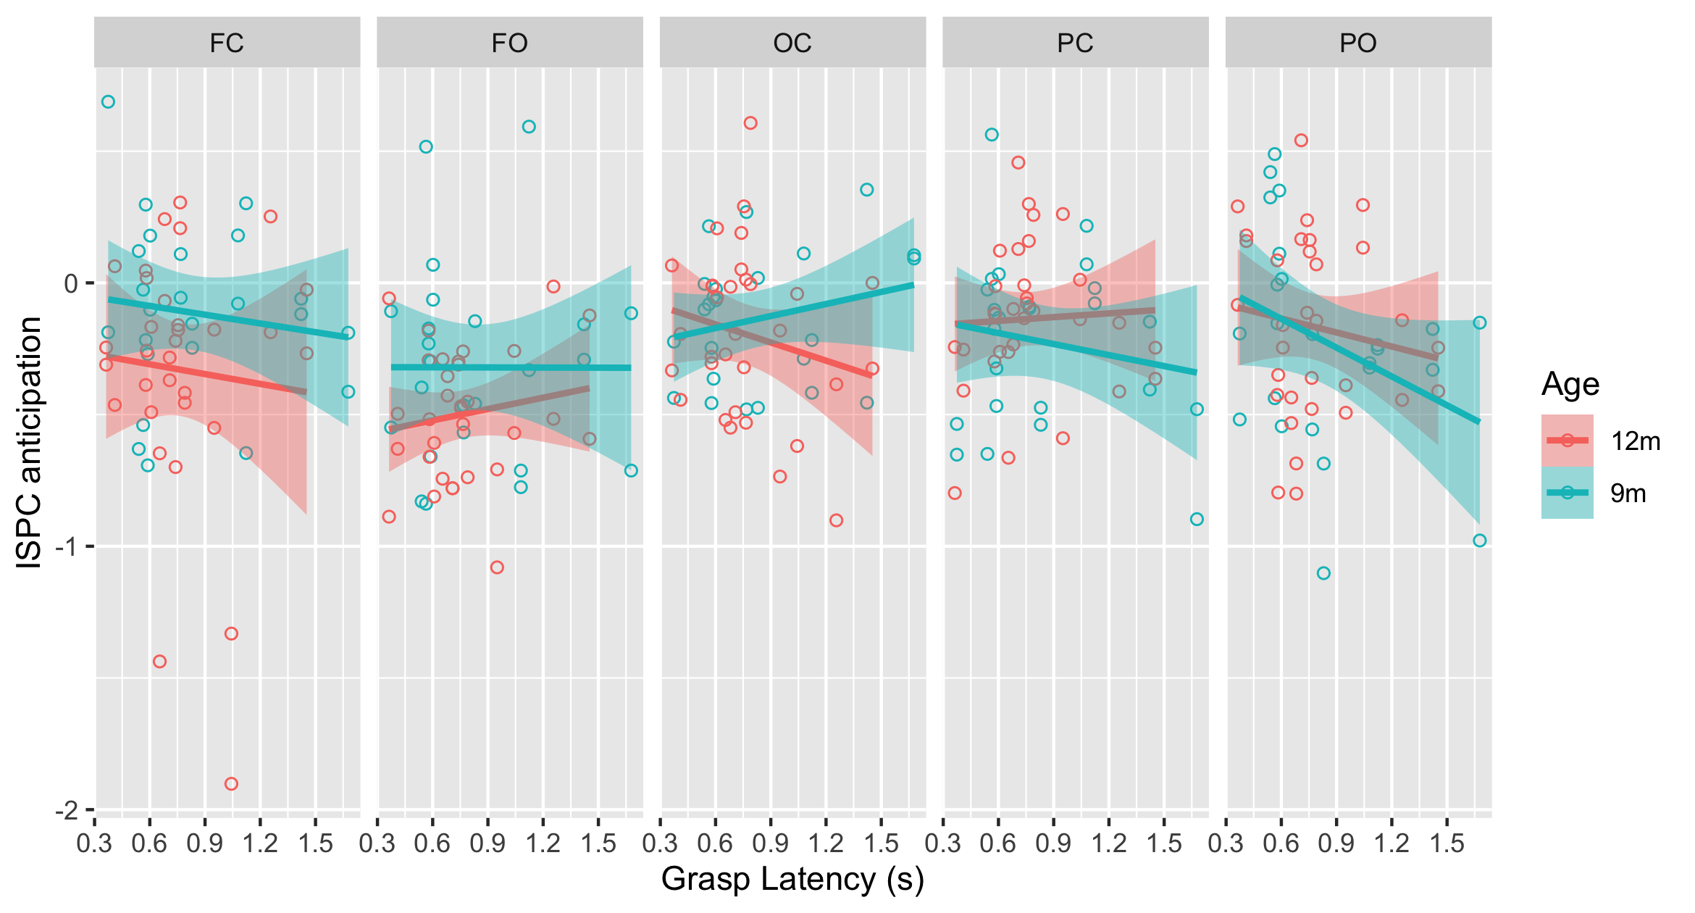

Figure S1. Relation between grasp latency (in seconds) and averaged ISPC during the observation window (0 to 0.5 s after the action onset) for each network (FC; FO; OC; PC; PO) and as a function of age.
  - Cane Latency
The model revealed no significant effects or interactions (all p > .1) of cane latency in the visual-motor circuit (See Figure S2).
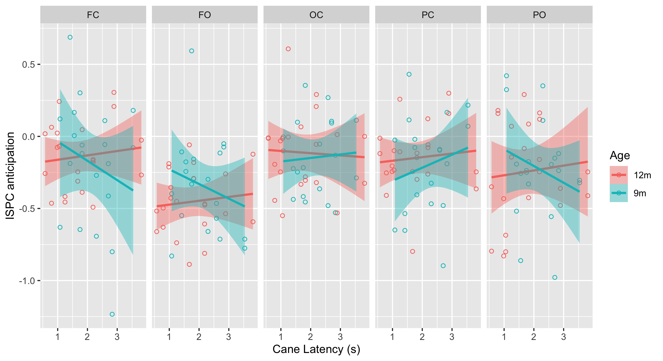
Figure S2. Relation between cane latency (in seconds) and averaged ISPC during the observation window (0 to 0.5 s after the action onset) for each network (FC; FO; OC; PC; PO) and as a function of age.
- Results: Grasp Latency & ISPC across time (Theta, Alpha, and Beta)
The links between action experience and alpha ISPC were tested without averaging ISPC in windows of 500 ms to maximize the temporal resolution of the data. In addition, exploratory analyses on the theta (4-6Hz) and beta (15-19Hz) bands were also included to investigate whether the relations between experience and connectivity are specific to alpha, and to explore what other networks may be involved in processing familiar and unfamiliar actions in infancy.
Hypothesis. We hypothesized that phase connectivity between central and occipital areas and its relation to action experience may be specific to alpha. Alpha power decrease over central and occipital sites is commonly observed during action prediction and observation, and is well-established as an index of motor dynamics and visual attention respectively (Debnath et al., 2019). However, theta is more commonly measured over frontal and temporal areas as an index of attention, memory, and learning (Begus & Bonawitz, 2020; Meyer et al., 2022). It is possible that functional networks on the theta band may also play a role on attending and learning from others’ actions, but we would expect frontal rather than central, parietal or occipital regions to be more involved. Finally, the findings on beta are somewhat mixed in infancy (Cuevas et al., 2014; Meyer et al., 2016), and the role of beta in cognition is on debate (Spitzer & Haegens, 2017). Beta power decrease has been found as a sensitive measure to distinguish perception of crawling versus walking in infancy (van Elk et al., 2008), and to detect social interaction and top-down effects in early childhood (Meyer et al., 2011, 2020), but several studies have found that beta is not suppressed as infants observe grasping actions (Meyer et al., 2016; Nyström & Nyströ, 2008; Virji-Babul et al., 2012). While inconclusive, we tested the relations between connectivity at the beta range and motor development to shed light on the function of beta networks in action processing.
Method. The relation between motor development and connectivity at different frequency bands and networks over time were investigated using a descriptive approach. For each frequency and network, a linear model relating action experience and connectivity was constructed sample by sample over time (10 ms steps). Following the main findings of the manuscript, in the first set of analyses the linear model was constructed with ISPC as a dependent variable and grasp latency as a predictor. In the second set of analyses, the linear model also included age, and condition to provide a more complete picture of the relation between action experience and connectivity. In each case, the resulting R-squared estimate was plotted over time, and descriptive observations were reported. Higher R-squared scores were interpreted as higher modulations of functional networks as a function of action experience.
Results
Model 1 (ISPC ~ Grasp Latency). Descriptively, the strongest link between grasp latency and ISPC is observed in the alpha band and the visual-motor circuit around 800 ms before the onset of the action (See Figure S3). These findings confirm that the links between motor development and the visual-motor circuit are mainly found during action anticipation, particularly around 800 ms before the action begins. In addition, the findings suggest that alpha better captures the relations between motor competence and connectivity patterns than theta and beta.
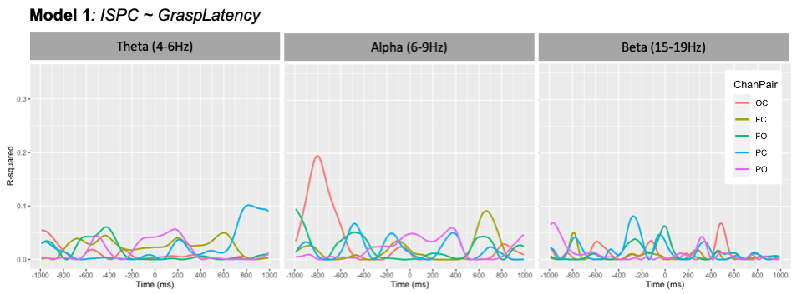
Figure S3. Plot describing the R-squared of a regression model (ISPC ~ Grasp Latency) calculated over time in steps of 10 ms and for each network of interest (Visual-motor (OC), control networks (FC, FO, PC, PO)) and frequency band (theta, alpha, and beta).

Model 2 (ISPC ~ Grasp Latency + Age + Condition). In line with the findings of the main manuscript, as well as the findings of Figure S3, action experience measured in terms of age, condition, and grasp latency correlated with ISPC more strongly in the alpha visual-motor network around 800 ms before the action onset, suggesting a unique role of this network in action anticipation. However, we found other patterns that may be interesting to discuss. Note that, due to the exploratory and descriptive approach used here, any conclusion should be interpreted with caution.
Theta band. The strongest relation between experience and connectivity was found in the F-C network during the anticipatory period, between 600 and 200 ms before the action onset (See Figure S4). The results suggest that networks involving frontal areas, in coordination with central areas, may be modulated by action experience when anticipating others’ actions. If modulated, a possible role of this network would be the allocation of attention and investment of cognitive effort to process an upcoming action depending on infants’ experience with the action (Begus & Bonawitz, 2020; Berger et al., 2006; Bosseler et al., 2013). In line with this idea, previous oscillatory models of cognitive control and sustained attention have proposed that frontomedial theta oscillations are involved in the modulation of oscillatory activity over task-relevant sensory areas, including sensorimotor regions (Cavanagh & Frank, 2014; Clayton et al., 2015).
Alpha band. In addition to a strong peak in the visual-motor network (O-C) around 800 ms before the action onset, the following period with the greater peaks was around 1000 ms after the action onset, at the completion of the action goal. In this period, networks involving occipital areas (F-O, P-O and O-C) were most relevant, with the highest peak in the F-O network (See Figure S4). These findings could suggest that both top-down (frontal) and bottom-up (occipital) attentional processes are particularly relevant when evaluating the effects of an action in infancy.
Beta band. As compared to the other frequency bands, R-squared peaks in the beta band were mostly found in periods close to the movement onset, from 250 before to 500 ms after the onset. Most of the networks showed a moderate peak at some time point, although the strongest peak was in the F-O network around 250 ms before the action onset (See Figure S4). Although the role of beta in cognition is on debate, several cognitive functions have been attributed to beta in the adult brain (Spitzer & Haegens, 2017). One of the functions is the preservation of the current sensorimotor or cognitive state (Engel & Fries, 2010). In addition, modulations of beta in non-somatomotor areas (e.g., frontal, visual) have been associated with visual motion detection (Donner et al., 2007). A possible interpretation of the F-O peak is that differences in F-O functional relations before an action onset indicate differences in the capacity to expect visual attentional changes. However, this remains speculative.
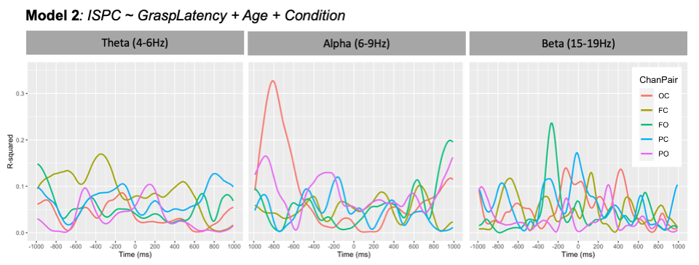
Figure S4. Plot describing the R-squared of a regression model (ISPC ~ GraspLatency + Age + Condition) calculated over time in steps of 10 ms and for each network of interest (Visual-motor (OC), control networks (FC, FO, PC, PO)) and frequency band (theta, alpha, and beta).

- Results: alpha power

To help dissociate the results on functional connectivity from volume conduction, the same statistical models of the main manuscript were constructed with power rather than connectivity as a dependent variable. Note that, unlike in Chung et al., (2022), here we analyzed absolute power in the alpha band rather than baseline-corrected power to be able to directly compare the results of power and connectivity. First, we investigated whether the power of alpha oscillations in each cluster of interest (Central and Occipital) changed across time as a function of age and condition. We selected the central and occipital clusters to compare them to the patterns of central-occipital connectivity found in the main manuscript. In addition, we investigated whether central alpha power or occipital alpha power during the anticipation window (-1000 to -500ms) correlated with infants’ motor skills.

Changes across time based on age and condition. We constructed an ANOVA with condition (novel vs familiar) and time window (-1000:-500 vs -500:0 vs 0:500 vs 500:1000) as within-subject factors, age (9m vs 12m) as between-subject factor, and alpha power in each cluster (Central and Occipital) as a dependent variable.

Central alpha power. The model only found a significant effect of time window (F(3,102) = 21.98, p < .01). Bonferroni-corrected post-hoc t-test found greater power in the last window (500 to 1000ms) as compared to the rest of windows (all p < .05), but no significant differences between the other window pairs.

Occipital alpha power. The model found a main effect of time window (F(3, 102) = 18.9, p < .01) that was qualified by an interaction between time window and condition (F(3, 102) = 8.59; p < .01) and time window and age (F(3, 102) = 2.95; p = .036). Post-hoc analysis calculated the main effect and interaction of condition and age for each time window. The models only found a main effect of condition in the windows corresponding to action observation (0-500ms: F(1, 34) = 10.53; p < .01); 500-1000ms: F(1, 34) = 5.33; p = .027).

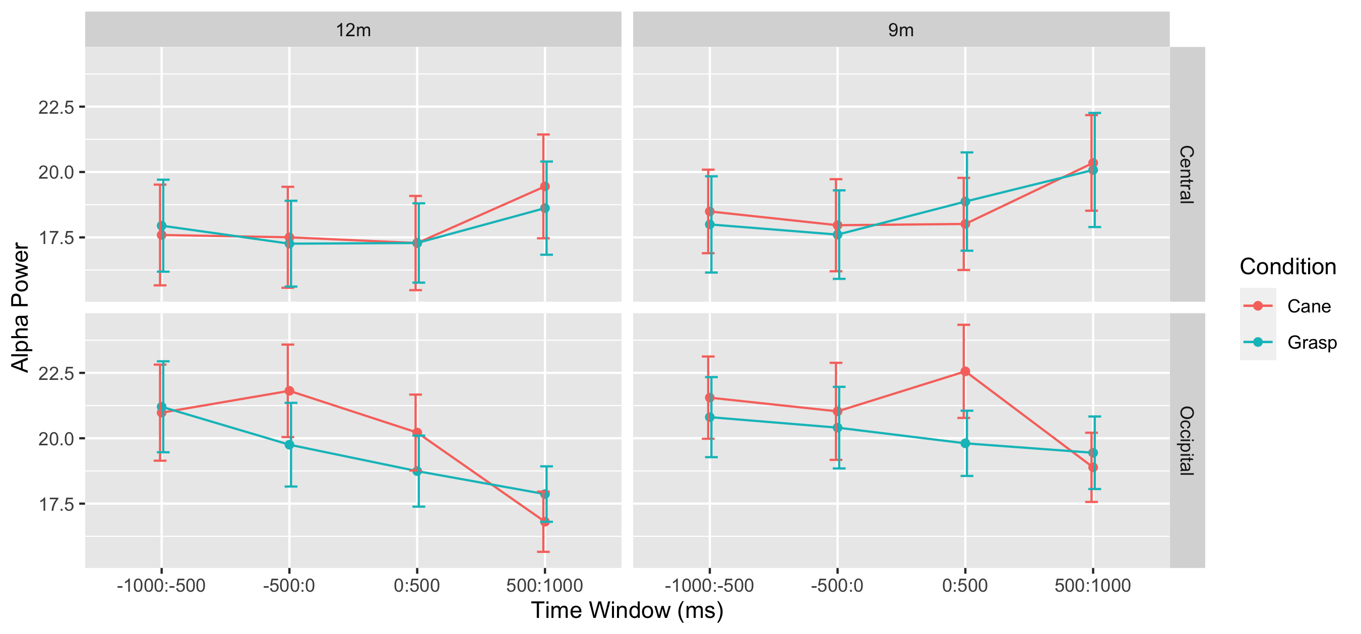

Figure S5. Mean alpha power across time for the central and occipital clusters separated by age and condition.

Correlation with infants’ motor skills. We investigated the relation between motor skills and central and occipital alpha power during the action anticipation window (-1000 to -500ms). To address this, a mixed-effect model (LMM) was constructed including condition, age, grasp latency and all the possible interactions as fixed effects, with subject-specific intercepts as random effects. The dependent variable was alpha power (occipital or central) during the anticipation window (-1000 to -500ms). Resulting p-values for fixed effects and their interactions were obtained using Likelihood Ratio tests.

Central alpha power and grasp latency. The model found no significant main effect or interactions based on grasp latency.

Occipital alpha power and grasp latency. The model found no significant main effect or interactions based on grasp latency.

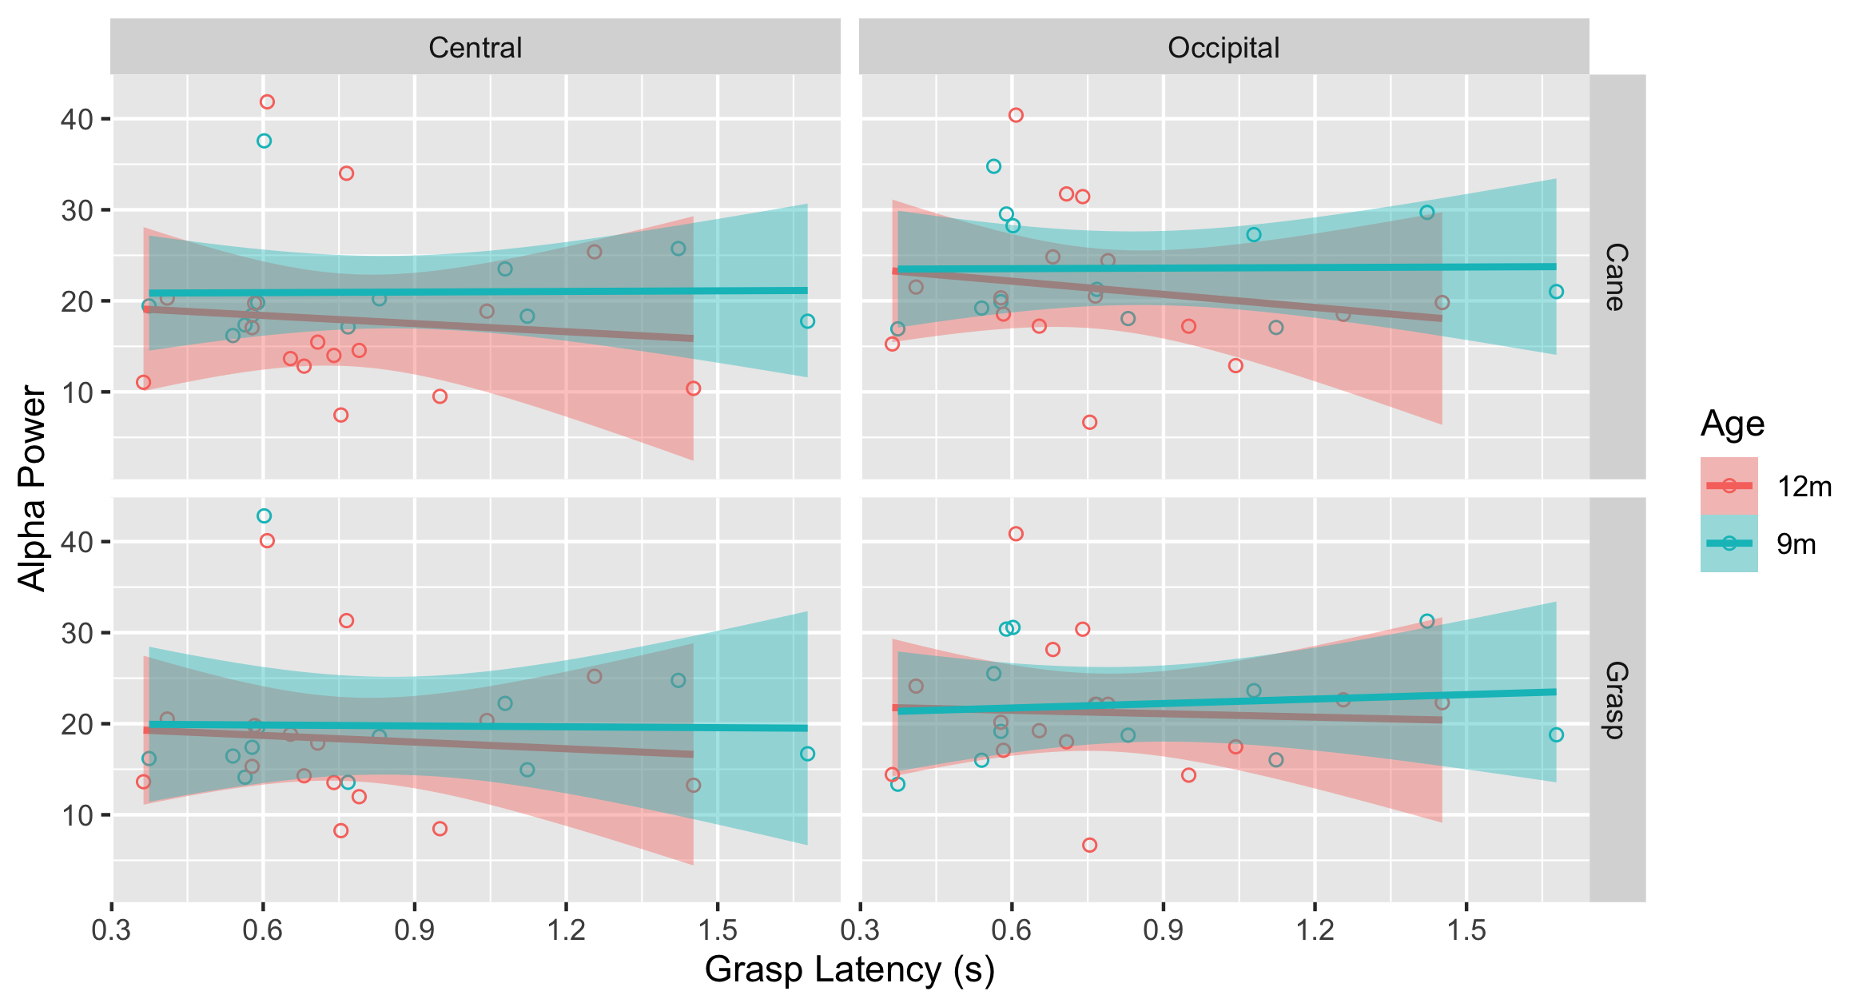
Figure S6. Relation between grasp latency (in seconds) and alpha power during anticipation. Each dot represents data of a participant. The line represents a linear model of the relation between grasp latency and alpha power for each cluster (central and occipital). The shaded area around the lines represents the 95% confidence level interval for predictions from a linear model (“lm”).

Summary of the results. Alpha power changed across time on the central cluster, and it changed across time depending on condition on the occipital cluster. Thus, the pattern of results differed from the pattern found on connectivity analysis. Connectivity estimates were influenced by condition, age and motor skills (grasp latency) and effects for age and motor skills were specific to the anticipation window from -1000 to -500ms. However, age and motor skills did not significantly influence alpha power in any time window, and condition did only influence occipital power during the observation windows (0 to 500ms and 500 to 1000ms). The difference between power and connectivity patterns suggests that it is unlikely that the results on functional connectivity are due to volume-conducted activity.

- Additional plots
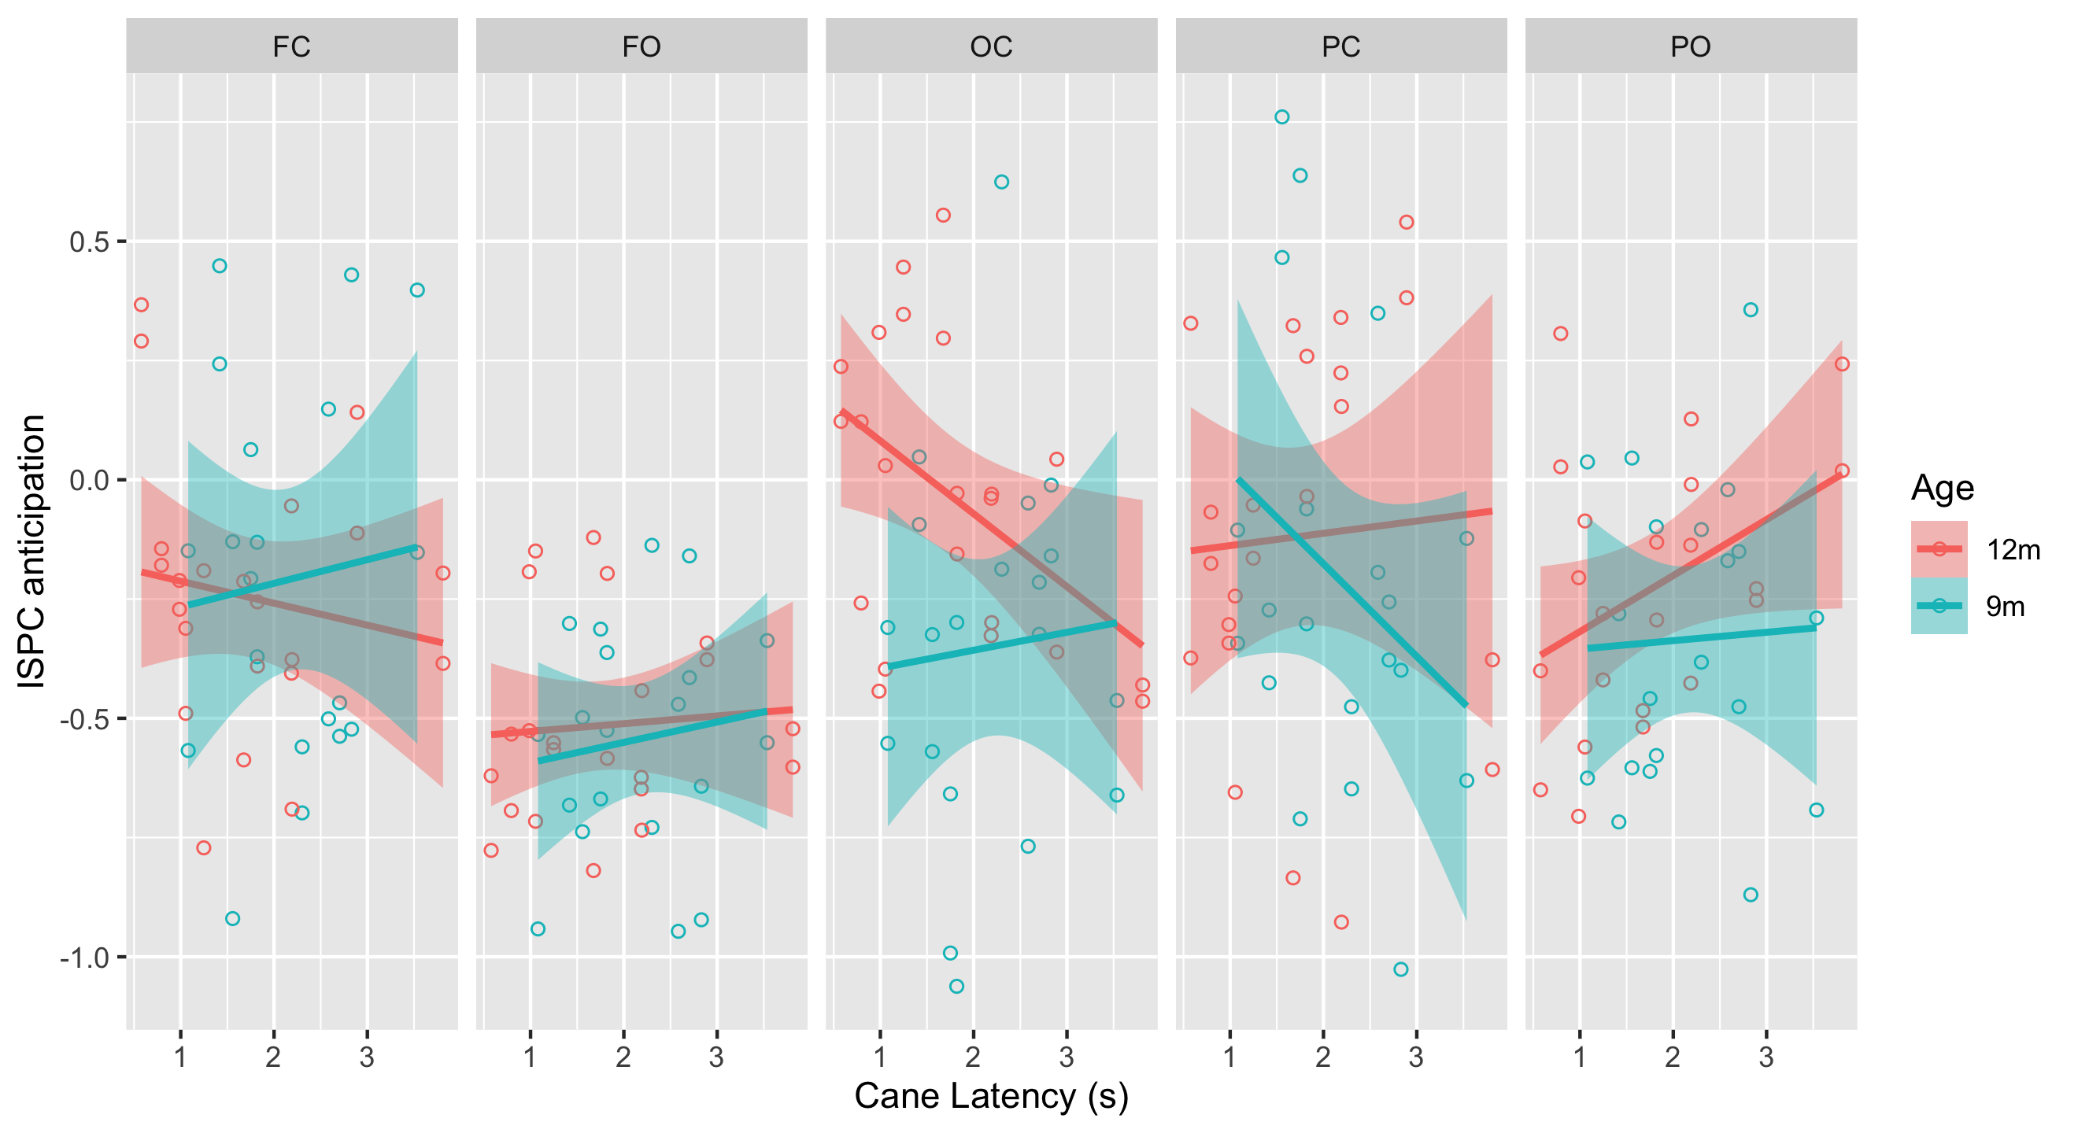
Figure S7. Relation between cane latency (in seconds) and averaged ISPC normalized by whole-brain during action anticipation (-1 to -0.5 s before action onset) for each network (FC: frontal-central; FO: frontal-occipital; OC: Occipital-Central; PC: Parietal-Central; PO: Parietal-Occipital) and as a function of age. The line represents a linear model of the relation between cane latency and ISPC. The shaded area around the lines represents the 95% confidence level interval for predictions from a linear model (“lm”).

- Number of trials & ISPC

Statistical tests were performed to investigate whether the number of trials included in the analysis related to levels of functional connectivity. A linear model was constructed with ISPC_{OC} as a dependent variable and the number of trials as a predictor, controlling for time window (-1000:-500, -500:0, 0:500, 500:1000), age (9mo, 12mo), and condition (familiar, novel). The same model was then constructed with ISPC_{WB} as the dependent variable. No significant effects of the number of trials were found (all p > 0.1; See Figure S8).
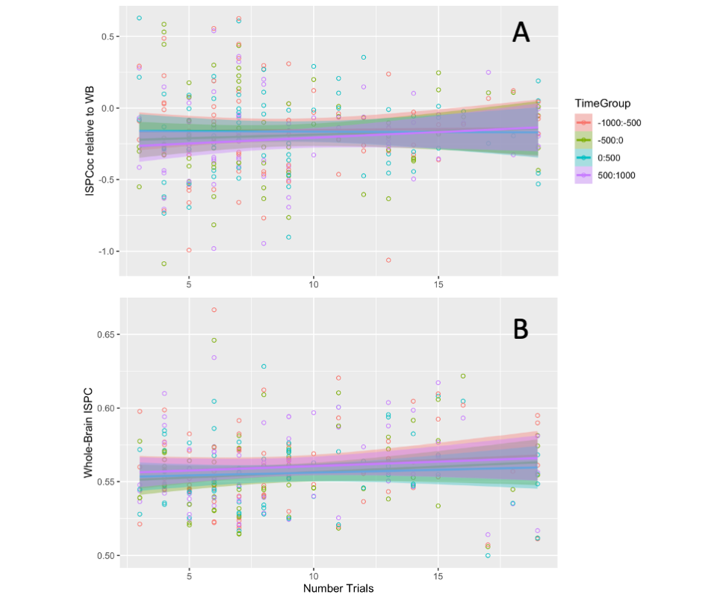
Figure S8. Relation between number of trials included in the analysis and functional connectivity patterns, separated by windows of interest across time. The line represents a linear model of the relation between number of trials and ISPC in each case. The shaded area around the lines represents the 95% confidence level interval for predictions from a linear model (“lm”). (A) Functional connectivity in the visual-motor network (relative to whole-brain). (B) Functional connectivity in the whole-brain network.

- References

Begus, K., & Bonawitz, E. (2020). The rhythm of learning: Theta oscillations as an index of active learning in infancy. In Developmental Cognitive Neuroscience (Vol. 45). Elsevier Ltd. https://doi.org/10.1016/j.dcn.2020.100810
Berger, A., Tzur, G., & Posner, M. I. (2006). Infant brains detect arithmetic errors. Proceedings of the National Academy of Sciences of the United States of America, 103(33), 12649–12653. https://doi.org/10.1073/PNAS.0605350103/SUPPL_FILE/05350MOVIE1.MP4
Bosseler, A. N., Taulu, S., Pihko, E., Mäkelä, J. P., Imada, T., Ahonen, A., & Kuhl, P. K. (2013). Theta brain rhythms index perceptual narrowing in infant speech perception. Frontiers in Psychology, 0, 690. https://doi.org/10.3389/FPSYG.2013.00690
Cavanagh, J. F., & Frank, M. J. (2014). Frontal theta as a mechanism for cognitive control. Trends in Cognitive Sciences, 18(8), 414–421. https://doi.org/10.1016/J.TICS.2014.04.012
Chung, H., Meyer, M., Debnath, R., Fox, N., & Woodward, A. (2022). Neural Correlates of Familiar and Unfamiliar Action in Infancy. PsyArXiv. https://doi.org/10.31234/OSF.IO/QCTJ7
Clayton, M. S., Yeung, N., & Cohen Kadosh, R. (2015). The roles of cortical oscillations in sustained attention. Trends in Cognitive Sciences, 19(4), 188–195. https://doi.org/10.1016/J.TICS.2015.02.004
Cuevas, K., Cannon, E. N., Yoo, K., & Fox, N. A. (2014). The Infant EEG Mu Rhythm: Methodological Considerations and Best Practices. Developmental Review : DR, 34(1), 26–43. https://doi.org/10.1016/j.dr.2013.12.001
Debnath, R., Buzzell, G. A., Morales, S., Bowers, M. E., Leach, S. C., & Fox, N. A. (2020). The Maryland analysis of developmental EEG (MADE) pipeline. Psychophysiology, 57(6), e13580. https://doi.org/10.1111/PSYP.13580
Debnath, R., Salo, V. C., Buzzell, G. A., Yoo, K. H., & Fox, N. A. (2019). Mu rhythm desynchronization is specific to action execution and observation: Evidence from time-frequency and connectivity analysis. NeuroImage, 184, 496–507. https://doi.org/10.1016/J.NEUROIMAGE.2018.09.053
Donner, T. H., Siegel, M., Oostenveld, R., Fries, P., Bauer, M., & Engel, A. K. (2007). Population activity in the human dorsal pathway predicts the accuracy of visual motion detection. Journal of Neurophysiology, 98(1), 345–359. https://doi.org/10.1152/JN.01141.2006/ASSET/IMAGES/LARGE/Z9K0070782970009.JPEG
Engel, A. K., & Fries, P. (2010). Beta-band oscillations — signalling the status quo? Current Opinion in Neurobiology, 20(2), 156–165. https://doi.org/10.1016/J.CONB.2010.02.015
Meyer, M., Braukmann, R., Stapel, J. C., Bekkering, H., & Hunnius, S. (2016). Monitoring others’ errors: The role of the motor system in early childhood and adulthood. British Journal of Developmental Psychology, 34(1), 66–85. https://doi.org/10.1111/BJDP.12101
Meyer, M., Endedijk, H. M., & Hunnius, S. (2020). Intention to imitate: Top-down effects on 4-year-olds’ neural processing of others’ actions. Developmental Cognitive Neuroscience, 45, 100851. https://doi.org/10.1016/J.DCN.2020.100851
Meyer, M., Hunnius, S., van Elk, M., van Ede, F., & Bekkering, H. (2011). Joint action modulates motor system involvement during action observation in 3-year-olds. Experimental Brain Research, 211(3), 581. https://doi.org/10.1007/S00221-011-2658-3
Meyer, M., van Schaik, J. E., Poli, F., & Hunnius, S. (2022). How infant-directed actions enhance infants’ attention, learning, and exploration: Evidence from EEG and computational modeling. Developmental Science, e13259. https://doi.org/10.1111/DESC.13259
Mognon, A., Jovicich, J., Bruzzone, L., & Buiatti, M. (2011). ADJUST: An automatic EEG artifact detector based on the joint use of spatial and temporal features. Psychophysiology, 48(2), 229–240. https://doi.org/10.1111/J.1469-8986.2010.01061.X
Nolan, H., Whelan, R., & Reilly, R. B. (2010). FASTER: Fully Automated Statistical Thresholding for EEG artifact Rejection. Journal of Neuroscience Methods, 192(1), 152–162. https://doi.org/10.1016/J.JNEUMETH.2010.07.015
Nyström, P., & Nyströ, P. P. (2008). The infant mirror neuron system studied with high density EEG. Https://Doi.Org/10.1080/17470910701563665, 3(3–4), 334–347. https://doi.org/10.1080/17470910701563665
Spitzer, B., & Haegens, S. (2017). Beyond the Status Quo: A Role for Beta Oscillations in Endogenous Content (Re)Activation. ENeuro, 4(4). https://doi.org/10.1523/ENEURO.0170-17.2017
van Elk, M., van Schie, H. T., Hunnius, S., Vesper, C., & Bekkering, H. (2008). You’ll never crawl alone: Neurophysiological evidence for experience-dependent motor resonance in infancy. NeuroImage, 43(4), 808–814. https://doi.org/10.1016/j.neuroimage.2008.07.057
Virji-Babul, N., Rose, A., Moiseeva, N., & Makan, N. (2012). Neural correlates of action understanding in infants: influence of motor experience. Brain and Behavior, 2(3), 237–242. https://doi.org/10.1002/BRB3.50
Widmann, A., Schröger, E., & Maess, B. (2015). Digital filter design for electrophysiological data – a practical approach. Journal of Neuroscience Methods, 250, 34–46. https://doi.org/10.1016/J.JNEUMETH.2014.08.002

