THE UNIVERSITY OF CHICAGO

The effect of linguistic diversity on 6-year-old children’s social preference for and epistemic perception of unfamiliar language speakers

By
Diqi Zeng
July 2021

A Thesis submitted in partial fulfillment of the requirements for the
Master of Arts degree in the
Master of Arts program in the Social Science

Faculty Advisor: Hyesung Grace Hwang
Preceptor: Samantha Peishan Fan

Acknowledgements
I would first like to express my deepest appreciation to my supervisor Dr. Hyesung Grace Hwang for providing me with an invaluable opportunity to contribute to the Language Project and for her guidance through each stage of process. Grace is and will always be my role model for a great developmental scientist, the most considerate mentor, and an awesome teacher. I would also like to extend my sincere thanks to Dr. Amanda Woodward for allowing me to be a part of Infant Learning and Development Laboratory. I would like to thank Dr. Nicole Burke for consulting on collection and analysis on the social network data, to my preceptor Dr. Samantha Fan for her insightful comments and suggestions on my thesis. I would also like to thank my EDSO preceptor Dr. Lisa Rosen for her support and valuable advice. I gratefully acknowledge the effort of our research assistant Abigaël Thinakaran who helped with recruiting the participants and running the interviews with children and parents. Many thanks to all the members in the Woodward Lab. The enthusiasm you’ve all shown in child research is contagious and very encouraging. Although met in a time when our world was struck by a global health crisis, I was so fortunate to have learned from the most talented mentors and peers at University of Chicago. Finally, I must express my very profound gratitude to my family and my friends for providing me with unfailing support and continuous encouragement every step of the way in this challenging year, and to my lovely cat Kiki for having the softest belly in the world and never grumbling at me whenever I stroked her belly to relieve my stress. This accomplishment would not have been possible without them. Thank you.

Table of Contents
Title Page 1
Acknowledgements 2
Table of Contents 3
Abstract 4
Introduction 5
Method 11
Participants 11
Materials 12
Design and Procedure 13
Exposure Measures. 16
Results 18
Discussion 23
References 32
Appendix A 38
Appendix B 42
Appendix C 44
Appendix D 45

Abstract
Language is an important social category that is used to divide the social world. Starting early in life, children can distinguish familiar and unfamiliar languages and start to choose friends and informants based on language. However, little is known about how children’s exposure to different language speakers from their social environment influences their social preferences and learning decisions. The current study examined how linguistic diversity within children’s social networks and neighborhoods relate to children’s perception of familiar and unfamiliar language speakers. Eighty-seven 6-year-old U.S. children’s neighborhood and social network were assessed as they made judgments about how much they liked unfamiliar language speakers (i.e., Korean speakers) and familiar language speakers (i.e., English speakers) and how knowledgeable they found these speakers. Overall, children were found to selectively favor speaks of a familiar language: They liked familiar language speakers more and considered familiar language speakers as more knowledgeable than unfamiliar language speakers. However, monolingual children exposed to greater linguistic diversity from their neighborhood were more likely to think unfamiliar speakers as knowledgeable. This finding suggests that for monolingual children, linguistic diversity in their neighborhood may play a crucial role in shaping how they think about the knowledge state of unfamiliar language speakers. This study shed lights on how children’s language-based social and learning preferences are shaped by their linguistic environment.

Keywords: language, social preference, epistemic judgement, linguistic diversity

Introduction
The language a person speaks is an important social marker. Early in development, infants from monolingual families show robust ability to distinguish native versus foreign languages (Liberman, Woodward & Kinzler, 2017; Kinzler, Dupoux, & Spelke, 2007; Kinzler, Shutts, & Spelke, 2012) and as early as 5 months, infants demonstrate a preference to look longer at individuals who speak their native language over a foreign language (Kinzler et al., 2007; Bosch & Sebastián-Gallés, 1997; Nazzi, Juscayk, & Johnson, 2000). This ability to differentiate between languages and show preferences based on languages plays a continuous role in children’s social cognition development. For instance, children use the language spoken by the person to make affective decisions, such as social preferences and friendship choices. By 10 months of age, infants choose to play with toys presented by a speaker of their native language over a foreign language (Kinzler et al., 2007) and by 5 years of age, children prefer to befriend native language speakers over unfamiliar language speakers (Kinzler et al., 2009; Souza, Byers-Heinlein & Poulin-Dubois, 2013). These robust preferences on native language speakers are robustly found in children living in both linguistically homogeneous and heterogeneous environment. For instance, children selectively chose to be friends with familiar language speakers over unfamiliar language speakers even if they grew up in South Africa where at least three languages were spoken in a community (Kinzler et al., 2012). Collectively, prior findings suggest that children have robust preferences for people who speak a familiar language over an unfamiliar language and raised a question on the nurture effect of language environment on children’s language-based social preferences.
At the same time, children also demonstrate selectivity for familiar language speakers over unfamiliar language speakers when choosing whom to learn from. By 14 months of age, infants imitate native language speakers more than foreign language speakers when learning novel actions (Buttelmann, Zmyj, Daum, & Carpenter, 2013). Three-year-old children show similar selective imitation of native language speakers over unfamiliar language speakers (Howard et al., 2015). By 4 to 5 years of age, children are more likely to endorse information presented by native accented speakers over foreign accented speakers (Corriveau, Kinzler & Harris, 2013; Kinzler, Corriveau & Harris, 2011).
Two possible factors may lead to children’s avoidance of speakers of nonnative language and accent (as shown in Kinzler et al., 2011). The first reason may be that children, like adults, perceive nonnative accented speakers as more likely to be foreigners than native accented speakers (Cargile, Maeda, Rodriquez, & Rich, 2010 on adults; Kinzler & DeJesus, 2013a and Weatherhead, White, & Friedman, 2016 on children). Essentially, this selective trust in familiar accent and language speakers over foreign accent and language speakers may stem from prejudice against foreign speakers – such as thinking foreign speakers are less intelligent than native speakers. American children have been found to develop adult-like prejudice based on accents (Gluszek & Dovidio, 2013; Kinzler & DeJesus, 2013b). For instance, children were more likely to rate northern-accented American speakers as “smarter” regardless of whether they lived in northern or southern regions of the U.S. (Kinzler & DeJesus, 2013b). However, it is less investigated whether children show the same prejudice against foreign language speakers. With accents, children – as adults do – may make assumptions that a person with a nonnative accent has low proficiency in the English language and is less intelligible; with foreign language, similar assumptions may be made but there may also be more ambiguity. Adults do not tend to make as much robust negative judgements about a person who speaks a foreign language compared to a foreign accent (Gluszek & Dovidio, 2013): It is an open question whether children also show such tendency.
Alternatively, children may choose to learn from native language speakers more because they think native language speakers have more shared knowledge with them (Soley & Aldan, 2020). By 5 to 6 years of age, children understand that they will continue to speak the same language they are speaking when they grow up (Kinzler & DeJesus, 2012). Further, children of this age attribute shared cultural knowledge primarily to speakers of the same language (Soley & Aldan, 2020). Given this assumption by children that people who speak the same language will share cultural knowledge, Soley and Spelke (2016) argued that shared knowledge drives children’s selective learning in native language speakers over foreign language speakers. Overall, it requires further effort on investigating how children think about different language speakers to test the reliability of these two possible theories of children’s selective learning behaviors.
Taken together, these studies revealed that children demonstrate a reliable preference toward those who speak their native language in both affective and cognitive domains. However, this past research has almost exclusively been conducted with monolingual children. Now, regular exposure to diverse language speakers has become the global norm, rather than an exception. Back in the United States, recent census data has shown increasing linguistic diversity in the United States over the past two decades. According to the U.S. Census Bureau’s American Community Survey (2019), more than 20% of U.S. residents speak a language other than English at home and this number has almost doubled since 1980. Thus, the linguistic experiences among U.S. children may vary greatly according to where they live. For instance, children who live in Cook County in Illinois, where 34.2% of households speak a language other than English at home, will have different experiences compared to children who live in Menard County in Illinois where only 1.2 % households speak a language other than English at home. Hence, more attention needs to be paid to how children’s exposure to diverse language speakers from their social environment influences their social preferences and learning decisions.
Recent studies have started to examine the role of language environment in shaping children’s language-based preferences and reasoning. Children growing up in a more linguistically diverse home or community show higher accuracy in language discrimination tests (e.g., Atagi & Sanhofer, 2020; Bosch & Sebastian-Galles, 2001). Further, compared to a strong preference for their native language over other languages in infants from a monolingual environment, infants growing up in a bilingual environment did not show clear preference between two familiar languages (Bosch & Sebastián-Gallés, 1997). By preschool age, monolingual children prefer to befriend native language speakers over other language speakers, but bilingual children show equal preference between English speakers and speakers of the other language they are proficient in (Byers-Heinlein et al., 2017; DeJesus et al., 2017). Similarly, children who have more exposure to diverse languages tend to be more open to making friends with people who speak with a foreign accent. 3- to 5-years-old children showed a higher acceptance of foreign-accented speakers in friendship decisions if they had spent more time with other language speakers on a weekly basis (Pierre & Johnson, 2020).
Close contact and forming interpersonal relationships with different linguistic groups may be crucial for changing school-aged children’s attitude toward linguistic outgroup members. For example, anglophone British eighth-graders who had intense contact with Quebec residents during their two-week excursion to Canadian showed the most positive attitude towards French-speaking Canadian compared with students who did not join the excursion or had low amount of contact with French speakers during the excursion (Clement, Gardner, & Smythe, 1977). Children who received a second-language education or awareness rising interventions about multilingualism in schools are more likely to befriend children who speak a different language (Pirchio, Passiatore, Carrus & Taeschner, 2017; Wright & Tropp, 2005). Notably, this research on intergroup contact has been conducted with mostly older children.
Distal contact (versus direct contact), such as seeing and hearing people using other languages in the neighborhood playground or on the bus, could also shape children’s emerging perceptions about different language speakers (e.g., Atagi & Sanhofer, 2020; Howard, Carrazza, and Woodward, 2015). Atagi and Sanhofer (2020) found that neighborhood and home environment is related to how well children can differentiate and label different languages. Crucially, Howard, Carrazza, and Woodward (2015) found that 19-month-old monolingual infants that lived in more linguistically diverse neighborhoods imitated the actions of foreign language speakers more than infants who live in less linguistically diverse neighborhoods. These findings suggest that even distal exposure to linguistic diversity could shape children’s emerging understanding and possibly even embrace of foreign language speakers.
Of note, some research showed contradictory results, suggesting that children’s robust social preferences for familiarity may not be influenced or overridden by exposure to linguistic diversity. For example, a recent study found that greater number of hours exposed to nonlocal Canadian accents and living in a linguistically diverse city (e.g., Toronto) did not lead to a greater acceptance of speakers of unfamiliar accent in accent-based friendship decisions (Paquette-Smith, Buckler, White, & Choi, 2019). The authors suggested that even if children lived in a community with greater linguistic diversity, children still showed a preference for native accent speakers. Similarly, children raised in a diverse linguistic environment such as South Africa, preferred affiliating with speakers of their native language or the second language they learned at school over speakers of an unfamiliar language (Kinzler et al., 2012). Further, Byer-Heinlein et al. (2017) found that even with some familiarity with non-native language, monolingual children raised in a bilingual community still showed a strong preference for native language speakers over speakers of a non-native language that is commonly spoken in their community. The debating outcomes in the prior research require more empirical evidence to investigate whether children prioritize similarity with in-group members or prior exposure to out-group members in their language-based social preferences. Moreover, methodologically, most studies measured exposure by either comparing children in different sites or collecting a weekly approximate contact time children spent with speakers of other languages. This lack of details in the exposure measurement may lead to the contradictory in these prior findings. Therefore, we sought to fill the gap and directly investigate how exposure to diverse languages shapes children’s language-based social preferences by quantifying the exposure measurement in a more sophisticated way.
In particular, the current study examined how the linguistic diversity within children’s social networks and neighborhoods are related to children’s perceptions of familiar and unfamiliar language speakers. Unlike previous studies that use forced-choice methods, the current study used a rating scale to look at how children make their judgments about speakers individually, not in comparison to others. Further, this study explores whether exposure to diverse language speakers at an interpersonal level as measured through social networks versus as measured through neighborhood demographics will have differential impact on children’s perception of unfamiliar language speakers. We predicted that social network linguistic diversity might relate to children’s social preferences, such as greater liking of unfamiliar language speakers, whereas neighborhood linguistic diversity might predict children’s cognitive decisions, such as how knowledgeable they find unfamiliar language speakers. Specifically, we predicted that children overall would prefer familiar language speakers over unfamiliar language speakers, and that children who have more exposure to various language speakers from their social networks will prefer unfamiliar language speakers more than children who have less exposure to diverse language speakers. We also predicted that children would view familiar language speakers as more knowledgeable than unfamiliar language speakers and predicted that children from linguistically diverse neighborhoods would rate unfamiliar language speakers as being more informative than children who with less exposure to different language speakers.

Method

Participants
Ninety-nine 6-year-olds (M_{age} = 77.57 months, SD = 3.48, 43% females) were recruited from a participant database based in the Midwest region of the U.S. and from online social media ads from across the U.S. Seventeen additional children were excluded from the final sample due to not being able to distinguish the two languages used in the study (n = 15) or not completing the experiment (n = 2). For the social network analysis, two children were excluded due to substantial missing data. Hence, the final sample consisted of eighty-two 6-year-old children (M_{age} = 77.96 months, SD = 3.32, 52% females). The demographic breakdown of the final sample is as follows: 48.78% White, 7.32% Black or African American, 6.10% Hispanic or Latino, 20.73% Asian or Asian American, 2.44% bi/multiracial. All children were fluent English speakers and had no prior exposure to Korean, the unfamiliar language used in this study. Each participant received 5 U.S. dollars for participation and an extra 5 U.S. dollars for completing the additional social network interview questionnaire.
The power analysis was performed to estimate the study sample size using the effect sizes seen in previous studies (Liking task: cohen’s d = 1.32 in Kinzler, Shutts, DeJesus, & Spelke, 2009; Knowledge task: averaged cohen’s d = 0.89 in Kinzler, Corriveau, & Harris, 2011; Exposure effect: averaged r² = 0.09 in Howard, Carrazza, & Woodward, 2015). All calculations were conducted through the pwr package and superpower package in R. The power calculation for the knowledge task indicated that to achieve 80% chance to detect a medium to large effect at an alpha level of 0.05 we would need a sample size of 21 participants. The power calculation for the liking task indicated that to achieve 80% chance to detect a medium to large effect at an alpha level of 0.05 we would need a sample size of 10 participants. The power calculation for the neighborhood and social network effect indicated that to achieve 80% chance to detect a medium to large effect at an alpha level of 0.05 we would need a sample size of 80 participants. Given the neighborhood and social network effects required the largest number of participants, we collected 82 valid participant data for the final sample size.

Materials
Four native female Korean speakers and four native female English speakers recorded the sentences used in the study (see Appendix I). Face stimuli included 16 head shots of White females taken from the Chicago Face Database (Ma, Correll, & Wittenbrink, 2015) that were rated to be close in age, attractiveness, and facial expression. Knowledge task stimuli were four novel objects that children were unfamiliar with in appearances and function taken from the novel noun database (Horst & Hout, 2016) and four familiar objects that children this age know very well: ball, book, spoon, and cup. Eight faces were presented against a black background and eight faces were presented against a white background. Pairing of the faces to languages and objects was counterbalanced.

Design and Procedure
Setup. Parents and children participated online over Zoom. Children were asked to be seated in front of the computer with their head in the center of the screen. Parents were asked not to interact with the child or interfere during the experiment. The experimenter shared the screen with the online survey questions with the children. The study session was recorded if parents gave permission. Children proceed to complete three tasks: Liking task, Knowledge task, and Language Discrimination task. The order of the liking task and knowledge task was counterbalanced, and Language Discrimination task was completed always last to ensure children were not cued to think about the language of the people they see.
Liking task. Children were presented with a three-point Likert scale with three faces (red sad face: “don’t like very much”; yellow neutral face: “maybe like”; green happy face: “like very much”; see Figure 3 in Appendix A for visualization). The experimenter first familiarized the children to the scale and presented two warm-up questions to ensure children correctly understood the scale. In the warm-up questions, children were asked to rate their liking of two cartoon characters: Mickey mouse, a friendly character, and Pete, a villain character. For each test trial, children were presented with a picture of an individual and the experimenter introduced children to each person by saying “This person sounds like this,” then playing an English or Korean voice clip. After listening to the sentence, the experimenter asked, “How much do you like this person?” Children either reported the color of the scale (red, yellow, or green) or shared how much they liked the person verbally to indicate their selection. Children completed a total of eight trials and the order in which each person was presented was randomized.
Knowledge task. Children were presented with a three-point scale with three signs (red X: “this person doesn’t know things”; black question mark: “this person maybe know things.”; green check mark: “this person does know things.”; see Figure 5 in Appendix A for visualization). Similar to the Liking task, the experimenter familiarized children to the scale and presented two warm-up questions to ensure children correctly understood the scale. In these warm-up questions, children were asked to rate whether they think a teacher knows what a computer is for, and whether a baby knows what a computer is for. In each trial, children were presented with a picture of one individual and a picture of either a novel or familiar object. The experimenter first said, “This person sounds like this,” and played an English or Korean voice clip and then the experimenter circled the picture of either a familiar object or a novel object with the cursor and said, “Look at this. Do you think THIS PERSON knows what THIS is for?” While the experimenter was saying “THIS PERSON”, she circled the picture of the individual in the video with a cursor. Likewise, when the experimenter was saying “THIS”, she circled the object. Children either responded using the signs or color of signs to indicate their selections. There were in total 16 trials (8 novel objects and 8 familiar objects) and the order in which each person was presented was randomized. Forty children received the liking task first and knowledge task second, whereas the other 42 children received the opposite order.
Language Discrimination Test. In this test, we examined whether children could differentiate between the two languages: English versus Korean. The experimenter introduced the task by saying, “Here are two people and we are going to hear what they sound like,” then introduced each person by saying, “This person sounds like this,” and played a corresponding voice clip. The experimenter then asked “Is this person speaking English? Yes or No?” to determine if children can distinguish whether the person was speaking in English or not. All of the children included in the final sample correctly identified which person spoke English; children who could not identify the English speaker were excluded from analyses.
Social Network Interview. At the end of the session, the experimenter conducted a short interview with the parent about the people that their child sees on a weekly and daily basis (developed by Burke, Brezack, & Woodward, in press). Parents were asked whether their child speaks another language besides English and whether their child hears or sees anyone who speaks another language than English on a regular basis. Parents were also asked to complete a survey about the demographic information of the people in their child’s social networks (e.g., race, gender, emotional closeness; see Burke, Brezack, & Woodward, in press).
Demographic information. Parents filled out a demographic survey through an online platform Qualtrics. The survey asked information about children’s and parent(s)’ race, gender, language use, language environment, educational level, neighborhood trust through the social cohesion scale (Shampson, Raudenbush, & Earis, 1997), and children’s current residential zip code. Parent were asked to report whether they thought their children was a monolingual, exposure, or bi/multi-lingual. A monolingual child would hear English almost all the time (e.g., over 95% of the time). All the child's primary caregivers speak to her in English. Parents would imagine that if the child’s current language environment continues, when the child grows up, they will be a native English speaker, and not be fluent in any other language. An “exposure” child would hear primarily English but is exposed to a second language on a regular basis, but not nearly as much as English (e.g., 80-90% English; 10-20% Spanish). Parents would imagine that if the child’s current language environment continues, when the child grows up, they will be a native speaker of English, and will have some proficiency in a second language, yet will not be fluent in that language. A bi/multilingual child would hear both English and other language(s) on a highly regular basis (e.g., 50% English/50% Spanish; or 70% English/30% Spanish; or 40% English/30% Spanish/30% French). Parents might imagine that if the child’s current language environment continues, when the child grows up, they will be a native speaker of both English and at least one other language.

Exposure Measures.
Social Network Size. Network size is the total number of people (also called “node”) that the participant child saw and interacted with on a regular basis. The number is determined from the social network interview. Each node count in child’s social network usually indicates one individual, but it can also indicate a group of people (Burke, Brezack, & Woodward, in press). For example, if the child went to school where they saw a fixed group of classmates on a regular basis, then all the kids in class were counted as one node in the child’s social network. Notably, if any of the kids in the class was considered as a friend to the child, then that friend(s) was also counted individually as a separate node.
Social Network Linguistic E-I index. External-Internal (E-I) index is a measure of heterophily to assess the number of in-group and out-group members (Krackhardt & Stern, 1988; Perry, Pescosolido, & Borgatti, 2018). In the current study, it was calculated using the R package “egor” (Krenz et al., 2018) based on the number of in-group and out-group members in the child’s network. The linguistic groups were categorized by language use: In-group nodes were people who spoke the same language as the child and out-group nodes were people who spoke a different language from the child.
Neighborhood Trust Index. Neighborhood trust index is a parent-reported measure of how much people trust their neighbors. The value was calculated by averaging the responses from the “social cohesion scale” from Shampson, Raudenbush, & Earis (1997).
Neighborhood Linguistic Diversity Measure. We assessed the neighborhood linguistic diversity by using the neighborhood linguistic isolation index. It was calculated based on the native language(s) of the child. For example, for a monolingual English-speaking child, it was the percentage of non-English speaking households in the child’s zip code. Hence, a higher value of linguistic isolation index indicates a higher possibility of having contact with diverse language speakers in the community. The language spoken by different neighborhood households in the children’s zip code (42 categories, e.g., Chinese, Russian, Italian, Hindi, etc. see https://www.census.gov/topics/population/language-use/about.html for a complete list of categories) was extracted from the 2015 American Community Survey (U.S. Census Bureau, 2015), which is the most recent census data to date that includes the 42 language categories. Neighborhood linguistic entropy, another measure of linguistic diversity, was also calculated.
Neighborhood Demographics. Neighborhood Median Income and Population Density were included as control variables in the neighborhood analyses. Median income was extracted from the 2019 American Community Survey (U.S. Census Bureau, 2019) based on the child’s residential zip code. Population density were calculated by dividing total population by the total land area in the child’s zip code. Total population was extracted from the 2019 American Community Survey (U.S. Census Bureau, 2019), whereas total area land was extracted from the 2019 TIGER/Line Shapefiles (U.S. Census Bureau, 2019).

Results
Liking task
A 2 (language type of speaker: English vs. Korean) x 3 (child language background: monolingual, exposure, and bi-/multilingual) repeated-measures analysis of variance (ANOVA) revealed a significant main effect of language type of speaker, F(1, 79) = 59.37, p = 0.001, η²_{p} = 0.43, indicating that children rated liking English speakers (M = 2.52, SD = 0.45) more than Korean speakers (M = 2.00, SD = 0.58). There was no main effect of child language background, F(2, 79) = 0.30, p = 0.74, η²_{p} = 0.01, or a significant interaction between language background and language type of speakers, F(2, 79) = 1.21, p = 0.305, η²_{p} = 0.0, indicating no evidence of a relation between linguistic backgrounds and children’s liking ratings. No interaction between child language background and language type of speakers was found, F(2, 79) = 1.21, p = 0.305, η²_{p} = 0.03. Together, the results suggest that children liked familiar English speakers more than unfamiliar Korean speakers (see Figure 1A), regardless of whether they had or had not been exposed to languages other than English.
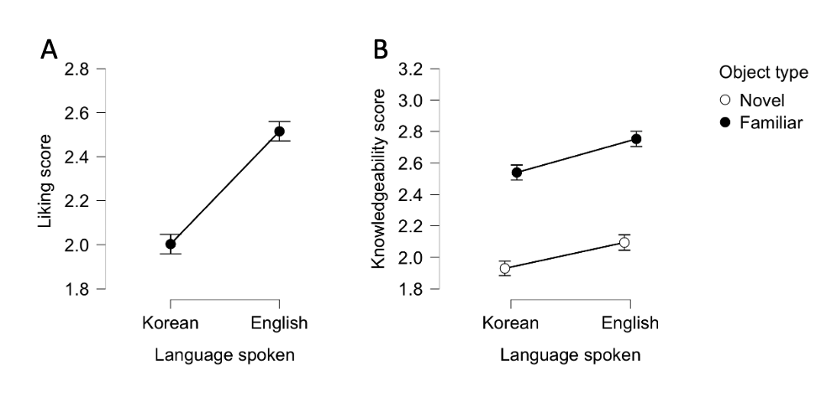
Figure 1. Children's averaged responses (liking and judgement on knowledgeability) on familiar English speakers and unfamiliar Korean speakers.
Follow-up two-tailed one-sample t-tests were conducted to investigate whether children’s averaged preference for either English speakers or Korean speakers were different from the ambivalent choice in the Likert scale (2 - “Maybe like”). Children showed a significant preference above the ambivalent choice for English speakers, M = 2.52, SD = 0.45, t(81) = 10.40, p = 0.001, d = 5.61. However, children’s preference for Korean speakers did not significantly differ from the ambivalent choice, M = 2.00, SD = 0.58, t(81) = 0.05, p = 0.965, d = 3.43. The results indicate that children demonstrated a reliable preference for familiar English speakers but do not show a significant liking above “maybe liking” for the unfamiliar Korean speaker.
To investigate the effect of exposure to linguistic diversity, we used logistic mixed-effects regression models with random intercepts for participants. We observed no effects of the linguistic diversity exposure measures (including neighborhood linguistic isolation, neighborhood trust, social network linguistic entropy, social network E-I index, and social network size) on 6-year-old children’s liking ratings of speakers (see Table 2 in Appendix C).
To determine whether the impact of exposure to linguistic diversity might differ according to whether children are monolinguals or have some exposure to other languages, we then divided children into two groups: monolinguals (N = 40) and exposed (combination of exposure, N = 26, and bi/multilinguals, N = 16 for a total N = 42) children. A set of exploratory logistic mixed-effects regression models with random intercepts for participants were conducted for monolingual children and exposed children, respectively. Once again, neither main effects nor interaction effects of the different linguistic exposure measures was found among monolingual or exposed children.
Knowledge task
A second 2 (language type of speaker: English vs. Korean) x 2 (object type: familiar vs. novel) x 3 (child language background: monolingual, exposure, and bi-/multilingual) ANOVA was conducted to determine whether children’s knowledgeability ratings differed according to the languages spoken by the speakers and the object type. Similar to the results of the liking task, this second ANOVA revealed a significant main effect of language type of speaker, F(1, 79) = 14.63, p = 0.001, η²_{p} = 0.16, indicating that children judged English speakers (M = 2.42, SD = 0.47) as more knowledgeable than Korean speakers (M = 2.00, SD = 0.58). Additionally, there was a significant main effect of object type, F(1, 79) = 128.26, p = 0.001, η²_{p} = 0.63, demonstrating that children thought speakers were more likely to know the functions of familiar objects (M = 2.65, SD = 0.43) than novel objects (M = 2.01, SD = 0.56). There was no main effect of child language background, F(2, 79) = 0.30, p = 0.74, η²_{p} = 0.01, suggesting that different linguistic backgrounds may not relate to children’s knowledge ratings. No reliable interaction effects were found among language, object type and child language background (language*background: F(2, 79) = 1.32, p = 0.27, η²_{p} = 0.03; object*background: F(2, 79) = 0.73, p = 0.49, η²_{p} = 0.02; language*object: F(1, 79) = 0.43, p = 0.52, η²_{p} = 0.01; language*object*background: F(2, 79) = 0.22, p = 0.81, η²_{p} = 0.01). These results suggest that children viewed familiar English speakers as knowing more than unfamiliar Korean speakers, regardless of whether the object was familiar or novel and whether children themselves were exposed to languages other than English (see Figure 1B).
Follow-up two-tailed one-sample t-tests were conducted to investigate whether children’s knowledgeability ratings of either English speakers or Korean speakers differed from the ambivalent choice (2 - “Maybe know”) and according to object type (familiar vs. novel). Overall, we found that children judged the English speakers, M = 2.42, SD = 0.47, t(81) = 8.24, p = 0.001, d = 5.21, and Korean speakers, M = 2.24, SD = 0.53, t(81) = 4.02, p = 0.001, d = 4.22, as both knowledgeable (more than “maybe knows”) across object type. Children thought that both speakers clearly knew the functions of familiar objects (M = 2.65, SD = 0.43, t(81) =13.62 , p = 0.001, d = 6.16) but not the functions of novel objects (M = 2.01, SD = 0.56, t(81) = 0.20 , p = 0.844, d = 3.596). According to object type, we also found that children thought Korean speakers knew the function of familiar objects (M = 2.54, SD = 0.55, t(81) = 8.88 , p = 0.001, d = 4.61) as well as English speakers (M = 2.75, SD = 0.49, t(81) = 14.06 , p = 0.001, d = 5.68). On the other hand, children thought both Korean speakers (M = 1.93, SD = 0.64, t(81) = -0.99 , p = 0.33, d = 3.00) and English speakers (M = 2.10, SD = 0.61, t(81) = 1.40 , p = 0.166, d = 3.42) did not know the functions of novel objects.
Next, a set of logistic mixed-effects regression models with random intercepts for participants were used to examine the effect of exposure to linguistic diversity on children’s knowledgeability assessments. We observed no effects of linguistic diversity exposure measures (including neighborhood linguistic isolation, neighborhood trust, social network linguistic entropy, social network E-I index, and social network size) (see Table 3 in Appendix C).
To examine whether monolingual infants in a more linguistically diverse neighborhood were more likely to imitate foreign language speakers (as seen in Howard et al., 2014), we extracted monolingual children’s responses (N = 40) to Korean speakers and conducted a set of exploratory linear regression models on the effects of neighborhood linguistic diversity on children’s judgements of knowledgeability. Additionally, neighborhood trust was included in models to explore the interaction effects between trust and linguistic diversity measures in the neighborhood. We hypothesized that children living in a more trustworthy neighborhood may have higher possibility of running into or interacting with neighbors who speak different languages and as such, their judgements of unfamiliar language speakers may more likely be affected by neighborhood linguistic diversity. We observed a significant association between neighborhood linguistic isolation and children’s judgement of Korean speakers’ knowledgeability, b = 17.38, SE = 5.62, t(35)= 3.09 , p = 0.004, suggesting that children from more linguistically diverse neighborhoods were more likely to think Korean speakers were knowledgeable. There was also a significant interaction between neighborhood linguistic isolation and trust, b = -5.29, SE = 1.65, t(35) = -3.22, p = 0.003, suggesting that children living in a low trust community were more likely to consider Korean speakers knowledgeable when there were higher proportion of linguistic outgroup member in the neighborhood. In contrast, children living in a high trust community considered unfamiliar Korean speakers as less knowledgeable with greater linguistic outgroup population (see Figure 2). The significant effect of linguistic isolation was observed for both familiar objects (isolation: b = 18.59, SE = 4.88, t(35) = 3.81, p = 0.001; isolation*trust: b = -5.66, SE = 1.43, t(35) = -3.96, p = 0.001) and novel objects (isolation: b = 16.17, SE = 7.45, t(35) = -0.95, p = 0.04; isolation*trust: b = -4.93, SE = 2.18, t(35) = -2.26, p = 0.03), suggesting that the effect of neighborhood linguistic diversity on children’s epistemic judgement on unfamiliar language speakers was present regardless of whether the objects were familiar or novel. Moreover, neighborhood isolation index still predicted monolingual children’s judgement of Korean speakers in knowledge task even after we controlled other demographic variables, such as median income and population density (isolation: b = 16.67, SE = 5.91, t(33) = 2.82, p = 0.008; isolation*trust: b = -5.11, SE = 1.72, t(33) = -2.97, p = 0.005).
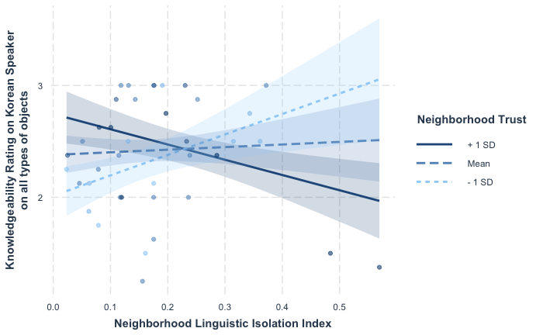
Figure 2. Monolingual children's judgements on Korean speakers' knowledgeability
Association between liking and knowledge tasks
Pearson correlation indicated that there was a significant association between children’s liking and knowledgeability ratings of Korean speakers, r = 0.35, p = 0.001. No significant association was found between children’s liking and knowledgeability ratings of English speakers, r = -0.03, p = 0.77.

Discussion
The current study examined the effects of exposure to linguistic diversity on children’s language-based social preferences and judgements about the knowledgeability of familiar and unfamiliar language speakers. Our results showed that 6-year-old children liked speakers of a familiar language more and judged speakers of a familiar language as more knowledgeable over speakers of an unfamiliar language. In particular, we found that monolingual children living in a more linguistically diverse neighborhood rated unfamiliar language speakers as more knowledgeable than those living in less linguistically diverse neighborhoods. The current study was among the first to comprehensively quantify and examine the impact of linguistic exposure (includes social network and neighborhood) on children’s language-based preferences and judgements. Further, the use of Likert scales (versus forced choice) showed that children displayed distinct liking and disliking separately for each speaker type than as a relative comparison. This Likert scale approach allowed us to replicate and provide additional evidence supporting past findings on children’s linguistic in-group preferences.
The first goal of our study was to compare children’s liking of familiar and unfamiliar language speaker and to examine whether more exposure to diverse language speakers would make children like unfamiliar speakers more. As predicted, our results showed that 6-year-old children preferred familiar language speakers, and their liking ratings of the familiar language speakers were higher than their ratings of unfamiliar language speakers. Moreover, children did not like the unfamiliar language speakers above “maybe liking,” indicating that children do not necessarily dislike the unfamiliar language speakers. An alternative possibility is that children are unsure on reporting their affinity for speakers of an unfamiliar language perhaps due to their lack of knowledge and experience with unfamiliar language speakers.
Interestingly, we did not find any significant effects of exposure to linguistic diversity on children’s perceptions of speakers in the liking task, regardless of how exposure was measured – whether through parental report, social network, or neighborhood. Children’s experience with more than one language did not increase their liking of unfamiliar language speakers. Our results may also suggest that children prioritize similarity over their experiences with speakers of diverse languages in affective ratings. Research has found that similarity was predictive to children’s preference. For example, Fawcett and Markson (2010)’s study showed that, starting at 3, children displayed preferences on puppets whose food preferences or physical appearances matched their own. In relation to the current finding, children may show linguistic in-group favoritism because they recognized the linguistic similarity between themselves and familiar language speakers. This finding is also consistent with findings in prior studies (Byer-Heinlein et al., 2017; Kinzler, Shutts, & Spelke, 2012; Paquette-Smith et al., 2019), supporting the notion that children hold a strong preference towards speakers of their native language, and that such preference can be powerful and not swayed by exposure to other languages.
Apart from familiarity, an alternative explanation may be that the robust social preference for familiar language speakers is tied with higher status of speakers in the United States. Kinzler and colleagues’(2012) study reported that children raised in multilingual community preferred native speakers and speakers of a language with higher standing in the society despite having daily interactions with different language speakers. This study suggested that children may consider status more important in their friendship decisions. Corresponding with Kinzler et al. (2012)’s finding, the mechanism underlying our results may be that U.S. children preferred English speakers not only because English sounded more familiar, but also because English has a higher linguistic status in the U.S. society.
Our second goal was to examine whether children’s epistemic judgements about familiar and unfamiliar language speakers differed and whether prior exposure to diverse languages would influence such judgments. Just like the liking task, children judged familiar language speaker as significantly more knowledgeable than unfamiliar language speakers in the knowledge task. The present findings both corroborate and extend studies on selective learning from native speakers (Buttelmann et al., 2012; Howard et al., 2015; Kinzler, Corriveau & Harris, 2011) and studies on stereotypes about intelligence associated with speakers of foreign accents (Gluszek & Dovidio, 2010; Kinzler & DeJesus, 2013b). Our findings shed light on potential mechanisms behind children’s selective learning from native language speakers. It may be because children consider native language speakers as more knowledgeable than foreign language speakers. Additionally, children were more confident in judging the knowledgeability of speakers when they knew the function of the objects but were more unsure when the objects were novel. Interestingly, children’s knowledgeability ratings did not significantly differ between familiar versus unfamiliar language speakers according to object type. Instead, children consistently rated the familiar language speakers as more knowledgeable than unfamiliar language speakers even for familiar objects. The findings suggest that children use language as an important marker to determine the epistemic status of people. These findings might have implications for scientists who are interested in the nature of children’s selective trust in testimony provided by ingroup members (e.g., Harris & Corriveau, 2011; Koenig & Harris, 2007). Our findings may also lay a foundation for future studies to investigate the connection between children’s epistemic judgements and the potential factors of children’s selective trust. For example, researchers could examine if children had higher epistemic evaluation on familiar language speakers because they think linguistic in-group members are smarter (i.e., Kinzler & DeJesus, 2013b) or have more shared knowledge (i.e., Soley & Aldan, 2020).
When we analyzed children from various linguistic background as a whole group, we did not find evidence that children’s assessment of epistemic status of unfamiliar speakers is altered by their exposure to other languages from either their neighborhood or social network. However, as a separate group, monolingual children showed malleability in their judgements: Monolingual children living in a community with greater proportion of linguistic outgroup population rated unfamiliar language speakers as more knowledgeable, indicating that the input children received from their neighborhood may moderate their judgements about the knowledgeability of unfamiliar language speakers. One possible explanation for this finding is that after observing interactions among people from diverse linguistic backgrounds in their neighborhood, children may realize that people could share similar knowledge even if they speak another language besides English. No impact of linguistic exposure was found among children who had daily experiences with languages other than English, suggesting that the impact of neighborhood linguistic diversity may only be tenable among children with limited exposure to other languages other than English. Moreover, we found that linguistic isolation index (i.e., the proportion of linguistic outgroup members) explained more variance in children’s epistemic judgements than linguistic entropy in the neighborhood (see comparison in Table 4 in Appendix D), suggesting that 6-year-old children’s different predictions on the knowledgeability of unfamiliar language speakers are better predicted by the proportion of the outgroup population rather than the variety of linguistic groups within the neighborhood.
Interestingly, we also found that different levels of cohesiveness in neighborhoods can impact monolingual children’s knowledgeability judgement of unfamiliar language speakers. We found that monolingual children currently living in a more cohesive and more linguistically diverse neighborhood rated unfamiliar speakers as less knowledgeable. On the other hand, with greater linguistic diversity, monolingual children living in a less cohesive neighborhood rated unfamiliar speakers as more knowledgeable. These findings suggest a more dynamic connection between neighborhood characteristics and children’s potential exposure to linguistic diversity. Future research should extend this line of research by untangling how much trust in foreign neighbors may influences children’s judgements on more general foreign population.
Although we failed to find evidence that linguistic diversity in children's social network relate to children’s perceptions of unfamiliar language speakers, our analysis may be limited by how the social network information was collected. The inconsistency between our current finding and prior findings may also be a result of the substantial change in children’s social network brought by the ongoing COVID-19 pandemic. In our social network interview, we asked parents about children’s regular contact in a “typical week” within the past 2 weeks, which allowed us to capture only children’s regular contact in a short time window rather than their close contact with other language speakers since birth. It is especially noteworthy that our data was collected from March 2021 to June 2021 when schools were going through different reopening phrases from remote setting during the pandemic. Thus, “a typical week” in the pandemic may have resulted in a fair bit of variation. Moreover, due to the nature of remote learning and the quarantine policy, the quantity and quality of social interaction within children’s social network may have been substantially impaired. The quarantine policy could also limit the chance of incidental exposure to linguistic diversity from children’s neighborhood.
Our nonsignificant results about the effect of social network linguistic diversity on children’s preference and judgments could also be due to the lack of analysis on the closeness of the relationships children have with people in their social network. For example, learning a second language one hour every week from a Spanish teacher at school might be less influential than having a Spanish-speaking grandmother who visits the family every week. Therefore, it is worth differentiating and weighing the influence of people in child’s network based on relational closeness. On the other hand, the null findings do raise doubts about the effect of exposure to linguistic diversity through social networks. The interaction between children and individuals in their network are a two-way process, meaning that it is shaped by the language ability of both children and their nodes. Even if nodes can speak more than one language, the child may not be aware of this because nodes may not use the other language with the child who does not know how to speak it.
Taken together, our results from the liking and knowledge tasks demonstrate that children make robust assumptions about individuals based on the language spoken. Children consider familiar language speakers more likeable and more knowledgeable than unfamiliar language speakers. This finding echo other findings that children attune to language not only as signals of social group memberships, but also as information about group categorizations, such as ethnicity (Hirschfeld & Gelman, 1997), national and geographical locations (Kinzler et al., 2012), as well as social relationships (Johnson & White, 2019; Liberman et al., 2017). Furthermore, our findings shed light on the association between children’s friendship preference and selective trust according to language. Prior research has already suggested the connection between favorable traits and epistemic status: Around 6 years of age, children are more likely to think smart people are more likely to be generous (Roussos & Dunhan, 2016) and also demonstrate adult-like stereotypes of trusting knowledge from people who have positive traits (e.g., nice) more than negative traits (e.g., mean) (Lane, Wellman, & Gelman, 2013). This tendency seems to emerge early as by 11 months of age, infants selectively pay more attention to native speakers potentially because they have greater expectation of gaining information from native language speakers (Begus, Gliga, & Southgate, 2016). In the current study, we found that children’s perceptions of familiar language speakers in the affective and the cognitive domains were independent. Children who liked native language speakers more did not necessarily also think native language speakers were more knowledgeable. In contrast, when faced with people speaking an unfamiliar language, children who were more favorable to foreign language speakers also perceived these speakers as being more knowledgeable. More studies are required to assess these associations. For example, future study might investigate whether children’s perceptions of speakers of a “somewhat” familiar language (e.g., Spanish) to see if children make the connection between affective and cognitive perceptions based on familiarity.
Lastly, we also found that most children can differentiate between their native tongue and a language they did not have any exposure to (Bosch & Sebastián-Gallés, 1997; Liberman, Woodward & Kinzler, 2017; Nazzi, Juscayk, & Johnson, 2000). In the current study, although the majority of the recruited 6-year-old children in the study could distinguish between English and Korean (83%), the number of children who could not distinguish between English and Korean was larger than our expectation (n = 15). Thus, our study also raises an important question about what causes children’s confusion on identifying these two languages. If children who could not distinguish English from Korean have an above averaged amount of exposure, it may suggest that exposure could hinder children’s language recognition development, thus, challenging their language-based social learning.
Despite our initial evidence of the impact of linguistic diversity exposure on children’s language-based preferences and judgements on epistemic status, there are other aspects of linguistic exposure left for future research. For example, schools are also unignorable resources of linguistic exposure, besides neighborhood and social network. Handful evidence has shown that more intensive bilingual education at school can increase cross-group friendship and reduce the children from a dominant social group’s bias against minority children (Wright & Bougie, 2007; Wright & Tropp, 2005; Pirchio et al., 2017). Hence, future research might include school as a third input of linguistic exposure to generate a more comprehensive understanding on the impact of linguistic exposure.
In conclusion, the current study is among the first to assess language-based social preference and knowledgeability judgement using a Likert scale method and is also one of the first to investigate the effect of exposure to linguistic diversity by quantifying the amount of exposure from neighborhood and social network. We found that 6-year-old children liked the speakers of a familiar language more and judged speakers of a familiar language as more knowledgeable than speakers of an unfamiliar language regardless of their exposure to different languages. Further, monolingual children’s judgement on the knowledgeability of unfamiliar language speakers were related to the linguistic diversity in their community. Our finding demonstrated that children’s emerging understanding of foreign language speakers may be closely interlinked and shaped by their neighborhood.

References
Allport, G. W., Clark, K., & Pettigrew, T. (1954). The nature of prejudice.
Atagi, N., & Sandhofer, C. M. (2020). Early language environments predict aspects of explicit language awareness development. Language Learning, 70(2), 464-505.
Begus, K., Gliga, T., & Southgate, V. (2016). Infants’ preferences for native speakers are associated with an expectation of information. Proceedings of the National Academy of Sciences, 113(44), 12397-12402.
Burke, N., Brezack, N., & Woodward, A. (2021). The Social Network Questionnaire. Unpublished manuscript, Department of Psychology, University of Chicago, Chicago, United States.
Buttelmann, D., Zmyj, N., Daum, M., & Carpenter, M. (2013). Selective imitation of in‐group over out‐group members in 14‐month‐old infants. Child development, 84(2), 422-428.
Bosch, L., & Sebastián-Gallés, N. (1997). Native-language recognition abilities in 4-month-old infants from monolingual and bilingual environments. Cognition, 65(1), 33-69.
Bosch, L., & Sebastián-Gallés, N. (2001). Evidence of early language discrimination abilities in infants from bilingual environments. Infancy, 2(1), 29-49.
Byers‐Heinlein, K., Behrend, D. A., Said, L. M., Girgis, H., & Poulin‐Dubois, D. (2017). Monolingual and bilingual children's social preferences for monolingual and bilingual speakers. Developmental science, 20(4), e12392.
Cargile, A. C., Maeda, E., Rodriguez, J., & Rich, M. (2010). " Oh, You Speak English So Well!": US American Listeners' Perceptions of" Foreignness" among Nonnative Speakers. Journal of Asian American Studies, 13(1), 59-79.
Clément, R., Gardner, R. C., & Smythe, P. C. (1977). Inter-ethnic contact: Attitudinal consequences. Canadian Journal of Behavioural Science/Revue canadienne des sciences du comportement, 9(3), 205.
Corriveau, K. H., Kinzler, K. D., & Harris, P. L. (2013). Accuracy trumps accent in children's endorsement of object labels. Developmental Psychology, 49(3), 470–479. doi:10.1037/a0030604
Davidson, J. W., Howe, M. J., Moore, D. G., & Sloboda, J. A. (1996). The role of parental influences in the development of musical performance. British Journal of Developmental Psychology, 14(4), 399-412.
DeJesus, J. M., Hwang, H. G., Dautel, J. B., & Kinzler, K. D. (2017). Bilingual children’s social preferences hinge on accent. Journal of Experimental Child Psychology, 164, 178-191.
Fawcett, C. A., & Markson, L. (2010). Similarity predicts liking in 3-year-old children. Journal of experimental child psychology, 105(4), 345-358.
Fuertes, J. N., Gottdiener, W. H., Martin, H., Gilbert, T. C., & Giles, H. (2012). A meta‐analysis of the effects of speakers' accents on interpersonal evaluations. European Journal of Social Psychology, 42(1), 120-133.
Gluszek, A., & Dovidio, J. F. (2010). The way they speak: A social psychological perspective on the stigma of nonnative accents in communication. Personality and social psychology review, 14(2), 214-237.
Harris, P. L., & Corriveau, K. H. (2011). Young children’s selective trust in informants. Philosophical Transactions of the Royal Society B: Biological Sciences, 366(1567), 1179–1187. doi:10.1098/rstb.2010.0321
Hirschfeld, L. A., & Gelman, S. A. (1997). What young children think about the relationship between language variation and social difference. Cognitive Development, 12(2), 213-238.
Hoff, E. (2003). The specificity of environmental influence: Socioeconomic status affects early vocabulary development via maternal speech. Child development, 74(5), 1368-1378.
Horst, J. S., & Hout, M. C. (2016). The Novel Object and Unusual Name (NOUN) Database: A collection of novel images for use in experimental research. Behavior research methods, 48(4), 1393-1409.
Howard, L. H., Henderson, A. M., Carrazza, C., & Woodward, A. L. (2015). Infants’ and young children's imitation of linguistic in‐group and out‐group informants. Child development, 86(1), 259-275.
Hwang, H. G., & Markson, L. (2018). Locals don't have accents: Children weigh phonological proficiency over syntactic or semantic proficiency when categorizing individuals. Journal of Child Language, 45(4), 1018-1034.
Johnson, E. K., & White, K. S. (2020). Developmental sociolinguistics: Children's acquisition of language variation. Wiley Interdisciplinary Reviews: Cognitive Science, 11(1), e1515.
Kinzler, K. D., Corriveau, K. H., & Harris, P. L. (2011). Children’s selective trust in native‐accented speakers. Developmental science, 14(1), 106-111.
Kinzler, K. D., & Dautel, J. B. (2012). Children’s essentialist reasoning about language and race. Developmental Science, 15(1), 131-138.
Kinzler, K. D., Dupoux, E., & Spelke, E. S. (2007). The native language of social cognition. Proceedings of the National Academy of Sciences, 104(30), 12577-12580.
Kinzler, K. D., Shutts, K., DeJesus, J., & Spelke, E. S. (2009). Accent trumps race in guiding children's social preferences. Social cognition, 27(4), 623-634.
Kinzler, K. D., Shutts, K., & Spelke, E. S. (2012). Language-based social preferences among children in South Africa. Language learning and development, 8(3), 215-232.
Kinzler, K. D., & DeJesus, J. M. (2013)a. Children's sociolinguistic evaluations of nice foreigners and mean Americans. Developmental Psychology, 49(4), 655–664. doi: 10.1037/a0028740
Kinzler, K. D., & DeJesus, J. M. (2013)b. Northern= smart and Southern= nice: The development of accent attitudes in the United States. Quarterly Journal of Experimental Psychology, 66(6), 1146-1158.
Koenig, M. A., & Harris, P. L. (2007). The basis of epistemic trust: Reliable testimony or reliable sources? Episteme, 4(3), 264-284.
Lane, J. D., Wellman, H. M., & Gelman, S. A. (2013). Informants' traits weigh heavily in young children's trust in testimony and in their epistemic inferences. Child development, 84(4), 1253-1268.
Liberman, Z., Gerdin, E., Kinzler, K. D., & Shaw, A. (2020). (Un) common knowledge: Children use social relationships to determine who knows what. Developmental science, 23(6), e12962.
Liberman, Z., Woodward, A. L., & Kinzler, K. D. (2017). Preverbal infants infer third‐party social relationships based on language. Cognitive science, 41, 622-634.
Nazzi, T., Jusczyk, P. W., & Johnson, E. K. (2000). Language discrimination by English-learning 5-month-olds: Effects of rhythm and familiarity. Journal of Memory and Language, 43(1), 1-19.
Paquette-Smith, M., Buckler, H., White, K. S., Choi, J., & Johnson, E. K. (2019). The effect of accent exposure on children’s sociolinguistic evaluation of peers. Developmental psychology, 55(4), 809.
Pierre, T. S., & Johnson, E. (2020). The development of accent-based friendship preferences: Age and language exposure matter. In CogSci.
Pirchio, S., Passiatore, Y., Carrus, G., & Taeschner, T. (2019). Children’s interethnic relationships in multiethnic primary school: Results of an inclusive language learning intervention on children with native and immigrant background in Italy. European Journal of Psychology of Education, 34(1), 225-238.
Roussos, G., & Dunham, Y. (2016). The development of stereotype content: The use of warmth and competence in assessing social groups. Journal of Experimental Child Psychology, 141, 133-144.
Sampson, R. J., Raudenbush, S. W., & Earls, F. (1997). Neighborhoods and violent crime: A multilevel study of collective efficacy. science, 277(5328), 918-924.
Soley, G., & Aldan, P. (2020). Children and adults selectively attribute shared cultural knowledge to speakers of the same language. Child development, 91(1), e218-e230.
Soley, G., & Spelke, E. S. (2016). Shared cultural knowledge: Effects of music on young children’s social preferences. Cognition, 148, 106-116.
Souza, A. L., Byers-Heinlein, K., & Poulin-Dubois, D. (2013). Bilingual and monolingual children prefer native-accented speakers. Frontiers in psychology, 4, 953.
Weatherhead, D., White, K. S., & Friedman, O. (2016). Where are you from? Preschoolers infer background from accent. Journal of Experimental Child Psychology, 143, 171-178.
Wright, S. C., & Tropp, L. R. (2005). Language and intergroup contact: Investigating the impact of bilingual instruction on children’s intergroup attitudes. Group Processes & Intergroup Relations, 8(3), 309-328.
2019 TIGER/Line Shapefiles (machine readable data files) / prepared by the U.S. Census Bureau, 2019

Appendix A
Procedure Visualization

Table 1. Four sentences of the video clips in English and Korean
 | English | Korean
1 | “During spring, flowers bloom.” | “봄이 되면 꽃이 피어나.”
2 | “In general, dogs are bigger than cats.” | “대부분의 강아지들은 고양이보다 커.”
3 | “There are three meals, lunch, breakfast, and dinner.” | “하루에는 세번의 식사를 해: 아침, 점심, 저녁.”
4 | “Hide and seek is a very popular game.” | “숨바꼭질은 아주 재미있는 놀이야.”

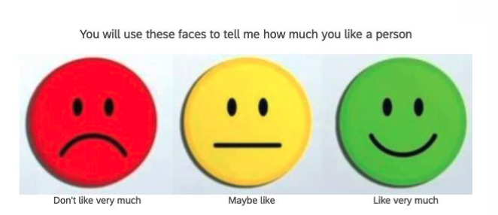
Figure 3. Three-point scale used in the liking task. Experimenter introduced the meaning of the three faces to children and asked the which face meant "Don't like/Maybe like/Like very much" to ensure children's correct understandings
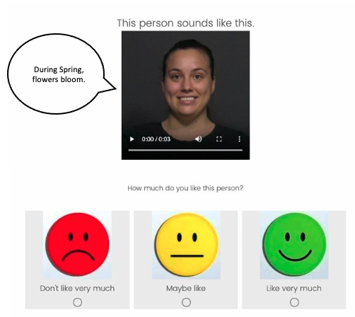
Figure 4. Children were presented with a video clip and the scale on the screen for a total of eight trials in the liking task. The speech bobbles were included for better illustration and were not presented in the actual experiment trials.

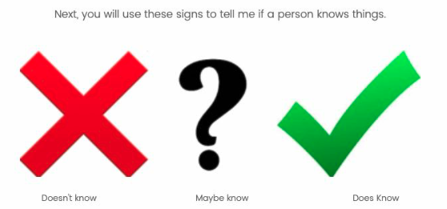
Figure 5. Three-point scale used in the knowledge task. Experimenter introduced the meaning of the three signs to children and asked the which sign meant "Doesn’t know/Maybe know/Does know” to ensure children’s correct understandings

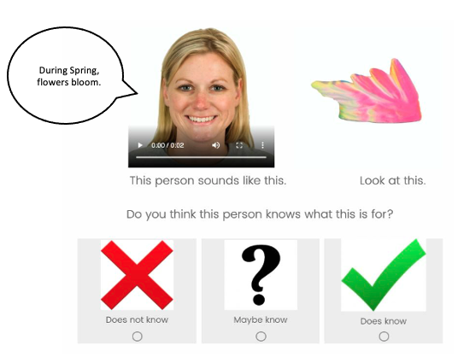
Figure 6. Children were presented with a video clip on the top left of the screen, the objects on the top right of the screen and the scale on the bottom of the screen for a total of sixteen trials in the liking task. The speech bobbles were included for better illustration and were not presented in the actual experiment trials.

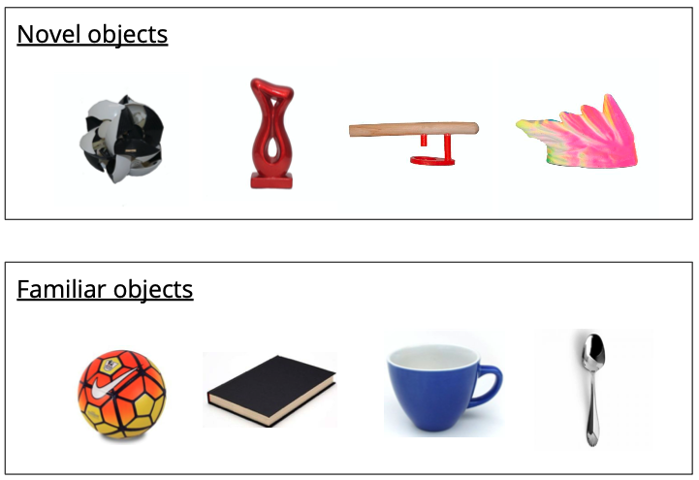
Figure 7. Two types of objects showed to children in the knowledge task.
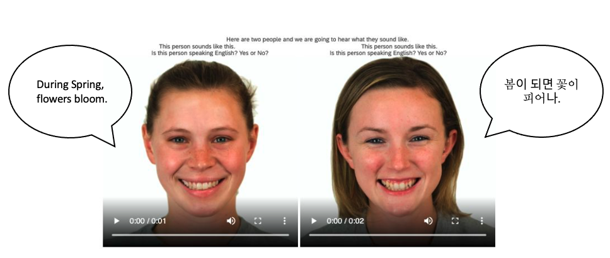
Figure 8. Language discrimination test. Children were presented with two video clips side by side on the screen. Experimenter played the video clips on the left side first and asked “Is this person speaking English? Yes or No?”, then repeated the same procedure for the video clip on the right side. The speech bobbles were included for better illustration and were not presented in the actual experiment trials.

Appendix B
Linguistic Entropy Measure and Results
Entropy is a measure initially developed to assess the similarity (Shannon, 1948) and later used to analyze representation of different categories as a quantification of diversity. In the current study, linguistic entropy was generated in both neighborhood and social network measures. For neighborhood, it was calculated using the R package “entropy” (Hausser & Strimme, 2009) and based on the percentages of neighborhood households in the children’s zip code that reported speaking languages in five categories, including English (only), Spanish, Indo-European languages, Asian and Pacific languages, and other languages. The original data was extracted from the 2019 American Community Survey (U.S. Census Bureau, 2019). Social network determination is calculated from the representation of language abilities of individuals in children’s network, reported in network demographic survey. Higher values of linguistic entropy in both measures indicates higher linguistic diversity. In the social network calculation, languages abilities of nodes were categorized into four categories, including speaking only English, speaking only one language (not English), speaking more than one language, and preverbal. The language ability of children was converted from the demographic survey. We converted monolingual children’s language ability category into “speaking only English”, whereas exposure and bi/multilingual children’s language ability category into “speaking more than one language” (see Byers-Heinlein et al., 2017 for the authors’ finding being exposed to second languages per se, irrespective of the amount, moderated bilingual children’s preference for the monolingual speakers and the fact that children who have basic understanding of other languages may consider themselves as a ingroup member of more than one linguistic groups).
Our results showed that there were a significant association between neighborhood linguistic entropy and children’s judgement on Korean speakers’ knowledgeability, b = 4.92, SE = 3.45, t (35) = 2.29, p = 0.03, and a significant interaction effect between neighborhood linguistic entropy and neighborhood trust, b = -1.52, SE = 0.66, t (35)= -2.31, p = 0.03, suggesting that children living in a low trust level community considered Korean speakers more knowledgeable as linguistic diversity increases in the community (see Figure 2.A). In particular, the significant effects seemed to be attributed to children’s responses on the familiar objects (entropy: b = 5.63, SE = 1.78, t (35) = -1.28, p = 0.005; entropy*trust: b = -1.74, SE = 0.58, t (35)= -2.98, p = 0.005), whereas children’s responses on novel objects were not significant (entropy: b = 4.21, SE = 2.78, t (35 )= 1.52, p = 0.14; entropy*trust: b = -1.31, SE = 0.85, t(35) = -1.53, p = 0.13), suggesting that when facing objects with unknown functions, neighborhood linguistic diversity may not significantly alter children’s judgement on the knowledgeability of unfamiliar speakers.

Appendix C
Table 2. Results of logistic mixed-effects regression models for liking task
 |  | b | Std. error |  | t |  |  | p
Main effect of exposure measures
Neighborhood linguistic entropy |  | 0.22 |  | 0.25 |  |  | 0.87 |  | 0.39
Neighborhood linguistic isolation |  | 0.49 |  | 0.75 |  |  | 0.66 |  | 0.51
Neighborhood trust |  | 0.02 |  | 0.33 |  |  | 0.07 |  | 0.94
Social network linguistic entropy |  | 0.09 |  | 0.24 |  |  | 0.37 |  | 0.71
Social network linguistic E-I index |  | 0.10 |  | 0.18 |  |  | 0.58 |  | 0.57
Social network size |  | 0.01 |  | 0.01 |  |  | 1.03 |  | 0.31
Interaction effect between exposure measures and language type
Neighborhood linguistic entropy |  | -0.10 |  | 0.15 |  |  | -0.60 |  | 0.15
Neighborhood linguistic isolation |  | -0.22 |  | 0.44 |  |  | 0.49 |  | 0.63
Neighborhood trust |  | 0.10 |  | 0.20 |  |  | 0.50 |  | 0.62
Social network linguistic entropy |  | -0.04 |  | 0.14 |  |  | 0.28 |  | 0.78
Social network linguistic E-I index |  | -0.07 |  | 0.18 |  |  | 0.58 |  | 0.57
Social network size |  | -0.01 |  | 0.01 |  |  | -1.20 |  | 0.23

Table 3. Results of logistic mixed-effects regression models for knowledge task
 |  | b | Std. error |  | t |  |  | p
Main effect of exposure measures
Neighborhood linguistic entropy |  | -0.11 |  | 0.23 |  |  | -0.49 |  | 0.62
Neighborhood linguistic isolation |  | 0.24 |  | 0.66 |  |  | 0.36 |  | 0.72
Neighborhood trust |  | 0.15 |  | 0.30 |  |  | 0.51 |  | 0.61
Social network linguistic entropy |  | -0.08 |  | 0.21 |  |  | -0.39 |  | 0.70
Social network linguistic E-I index |  | -0.09 |  | 0.16 |  |  | -0.58 |  | 0.56
Social network size |  | 0.00 |  | 0.01 |  |  | 0.35 |  | 0.73
Interaction effect between exposure measures and language type
Neighborhood linguistic entropy |  | -0.01 |  | 0.13 |  |  | -0.10 |  | 0.92
Neighborhood linguistic isolation |  | -0.27 |  | 0.37 |  |  | -0.73 |  | 0.46
Neighborhood trust |  | 0.05 |  | 0.17 |  |  | 0.31 |  | 0.76
Social network linguistic entropy |  | -0.01 |  | 0.12 |  |  | -0.06 |  | 0.95
Social network linguistic E-I index |  | -0.04 |  | 0.09 |  |  | -0.44 |  | 0.66
Social network size |  | -0.00 |  | 0.01 |  |  | -0.39 |  | 0.70

Appendix D
Table 4. Comparison on the results of different knowledgeability models that includes linguistic entropy or linguistic isolation
Knowledgeability Model | Adjusted R²
 | Linguistic  Entropy Index | Linguistic  Isolation Index
All objects (novel & familiar)
Rating ~ diversity*trust | 0.06 | 0.18
Rating ~ diversity * trust + median income + population density | 0.01 | 0.14
Familiar objects
Rating ~ diversity*trust | 0.13 | 0.27
Rating ~ diversity * trust + median income + population density | 0.08 | 0.22
Novel objects
Rating ~ diversity*trust | 0.00 | 0.06
Rating ~ diversity * trust + median income + population density | 0.00 | 0.03
Note. Only monolingual children’s responses on Korean speakers were used in the analysis

Neighborhood linguistic entropy did not explain much variance as neighborhood linguistic isolation index did (see statistics in Appendix B). Hence, we only reported the analysis on linguistic isolation index in the main manuscript.

