The university of Chicago

GOTV Effect and Election Laws: How Are Election Laws and GOTV Effects Related in the United States

By
Jenna Ashley Salzman
August 2021

A paper submitted in partial fulfillment of the requirements for the
Master of Arts degree in the
Master of Arts Program in the Social Science

Faculty Advisor: Anthony Fowler
Preceptor: Yan Xu
Introduction
Compared to other WEIRD (Western, Educated, Industrial, Rich, and Democratic) nations, the United States lags in turnout, consistently turning out 45% of eligible voters nationwide. Countless studies and experiments have been dedicated to research exploring this topic. Some political and grassroot campaigns have sought to increase turnout by utilizing Get Out the Vote (GOTV) strategies. These organizations use GOTV to create and plan their efforts to increase the turnout of eligible voters in their election. In the mid-1900s, the first batch of GOTV research emerged and most of which was not revisited until the beginning of the 21st century. Twenty years later, a plethora of research explores the impact and consequences of varied GOTV tactics. These tactics can include contact type, such as mail, door hangers, phone banking and canvassing, but it can also include the additional of a partisan advocacy or psychological theory called social pressure. Partisan advocacy—advocating for a specific party or candidate—typically increases the GOTV effect (Green, McGrath, and Aronow 2013) as does social pressure.
Another aspect of voter turnout is understanding what Anthony Downs calls the “Cost of Voting” (Downs, 1957). In Downs’ theory, the cost of voting is almost exclusively time related. When determining who to vote for and where to vote, potential voters extend their energies to research and learn about the candidates as well as determine where and how to vote. This time and effort are considered the cost of voting. There are ways to make it easier and more difficult. Ricker and Ordershook (Riker and Ordeshook 1968) continued Downs’ work and added to it this equation: $R = BP – C$, wherein R is the reward of voting, B is the differential benefit that a voter receives when their preferred candidates win, P is the probability that their vote is the deciding vote in an election, finally, C is the cost of voting that the voter must pay. An individual will only vote when R is positive—when the costs do not outweigh the benefits.
Consideration of costs is another focus unto itself. However, for the sake of this study, I will focus on a specific subset of voting cost: election laws. Regardless of the intention and necessity, election laws place a burden on the voter. Registering to vote requires effort, finding a polling location requires effort and even knowing when the polling location is open requires effort. All these efforts are due to election laws. Exploring how election laws impact the cost of voting and therefore, voter turnout, has been extensive and has recently become a pronounced subset of the discipline due to the new elections law being passed after the 2020 election. The goal of this study is to begin to understand how GOTV effects are related to each state’s election laws.
What this study does not do, is measure how restrictive different election laws are; however, to further the understanding of this relationship it might be important to frame in terms of complementary or substitutive goods. Can less restrictive laws be a substitute for GOTV campaigns. Conversely, are they complimentary good; do campaigns need to utilize GOTV to increase turnout, along with furthering less restrictive election laws? There has been little research into the large-scale combination of these separate election features (WORD CHOICE). While this is not the first study to investigate the combination of election laws and GOTV efforts, it does begin to fill a large gap in the literature about the wide-scale association between the two THINGS (WC).
This study evaluates election laws from 1996 through 2014 across a multitude of states. To measure the effect of GOTV campaigns, I utilize data from Green, McGrath, and Arrnow (2013) which was a metadata analysis of GOTV campaigns. The metanalysis calculated the effect of each study by evaluating the ITT/ATT, which are the percentage of increased turnout due to the study’s experiment. To measure how restrictive or lenient a state’s election are, I utilize the Cost of Voting Index measure from (Li and others) originally published in 2018 but updated in 2020. Further explanation of these variables is done in the methodology section of this paper.
This study seeks to understand how election laws and GOTV effects are associated. To accomplish this, I utilize a multi-linear regression model which considers cofounders such as social pressure and partisan advocacy.
Literature Review
Mail
Sending out mailers is a common method of GOTV. It can be cheap and easy for volunteers to assist with. However, unlike other form of GOTV, it is not typically associated with a personal connection to a volunteer. Because of this, mailers and door hangers are typically less effective methods of GOTV contact, compared to that of face-to-face contact and phone calls (Gerber and Green 2000; Bentele and O’Brien 2013; Justwan 2015; White 2019), This isn’t to say that this method is ineffective. Typically mailers and door hangers are effective up to 2%, though most studies average closer to 1% (Arceneaux, Kousser, and Mullin 2012; Nickerson 2005; Nickerson, Friedrichs, and King 2006). When GOTV mailers are effective, it is typically only effective in older voters and wealthier voters (Hill and Kousser 2016; Miller, Reynolds, and Singer 2017). When non-partisan, informational mailers are sent out the results are the same: the effect is highest with older and wealthier voter who are already pre-disposed to vote (Davenport et al. 2010; Hill and Kousser 2016). However, there is some evidence to suggest that mailers that target Asian American, and come in various languages are statistically effective, but the effect itself is small and on par with previous research (Wong 2005). Additions like social pressure, can make mailers more effective, but they still remain less effective than phone calls and canvassing (Green, McGrath, and Aronow 2013; Murray and Matland 2014). Ultimately, while mail can be a cost-effective method of reaching out to potential voters, it has weak effects and is typically only successful with those already more likely to vote.
Phone
In some of the early literature, experiments found phone contact to be lacking in similar ways to mail; high monetary costs, but low effect overall (Gerber and Green 2000; Wong 2005). However, as more research was completed, different findings were discovered. There is a difference between pre-recorded call, professional phone bankers, and volunteer phone bankers. Pre-recorded calls typically do not increase turnout compared to the effect found in professional and volunteer phone calls (Green, McGrath, and Aronow 2013). There is some disagreement within the literature about which is more effective: professional phone bankers or volunteers. Some research has suggested that professional phone bankers receive more training which can increase the effect of phone contact. (Green, McGrath, and Aronow 2013; Nickerson 2007). However other research suggests that it is the personal aspect of phone calls, the lack of recognizable script, that increases turnout; this is in line with Social Occasions Theory (Mann and Klofstad 2015; Ramírez 2005). Typically, GOTV phone contact increases turnout by 3% (Dale and Strauss 2009; Nickerson 2005; Nickerson, Friedrichs, and King 2006); even text messages are effective in the same way that phone calls are. While they appear to have more in common with mailers or door hangers, text reminders are just as effective as phone calls in their turnout effect (Dale and Strauss 2009). Phone calls are also effective tool for different minority groups such as Asian Americans and black Americans (Ramírez 2005; Wong 2005). However, this is only the case when these groups are specifically targeted; the bulk of the phone banking turnout is seen in high propensity voters (Green, McGrath, and Aronow 2013; Ramírez 2005; Wong 2005).
Canvassing
Canvassing is by far the most effective method of GOTV contact according to most research done in this area (Gerber and Green 2000; Green, McGrath, and Aronow 2013; Michelson 2020; Nickerson, Friedrichs, and King 2006; Wong 2005). Face-to-face contact establishes a personal connection and allows the quality of contact to be higher (Matland and Murray 2012). In fact, face-to-face is the best method to use when reaching out to minority voters across the US (Matland and Murray 2012; Michelson 2020; Michelson and Bedolla 2014; Ramírez 2005; Wong 2005). Face-to-face is also effective at turning out voters that are not typically targeting by political campaigns, like college student. College students are registered on their campus, face-to-face are significantly more likely to show up at the polls compared to their non-face-to-face counterparts (Ulbig and Waggener 2011). Face-to-face contact is by far the most effective at turning out voters; however, it too also tends to mobilize people already more likely to vote (Enos, Fowler, and Vavreck 2014).
Race & GOTV
As stated previously, those who are mobilized by GOTV are typically more likely to vote regardless, this includes people who are wealthier, white, and highly educated. At times GOTV contact can widen the voter gap (Berinsky 2005; Enos, Fowler, and Vavreck 2014). White voters are more likely to be contacted by actual partisan and political campaigns compared to their minority counterparts (Stevens and Bishin 2011). This is important because partisan contact can increase turnout compared to non-partisan contact (Doherty and Adler 2014; Hassell 2017; Nickerson 2005).
Social Pressure
Social pressure has been found to be the most effective addition to GOTV contact in the literature thus far (Gerber, Green, and Larimer 2008; Davenport et al. 2010; Green and Gerber 2010; Green, McGrath, and Aronow 2013). It has been shown to have long-term effects; lasting far beyond the original election the treatment took place in (Davenport et al. 2010). Furthermore, social pressure can impact turnout by up to 2-4% depending on the experiment in question (Green and Gerber 2010; Panagopoulos 2013; Panagopoulos, Larimer, and Condon 2014). Including previous voting activity or lack thereof, appears to be one of the best way to implement social pressure in contact (Green and Gerber 2010; Panagopoulos, Larimer, and Condon 2014); however, just reminding voters that voting is normative is not enough to turnout a significant result (Green and Gerber 2010). Lastly, not all forms of social pressure are effective, a few experiments found that social pressure had no effect on the overall rate of turnout (Matland and Murray 2016; Murray and Matland 2014).
Election Laws
Convenience
Convenience laws are laws that make voting more or less convenient. For example, requiring paid time off jobs, like in Texas, voting centers, and polling hours all fall under convince laws. When laws are crafted to make voting easier and more convenient, there is a small increase in turnout, but only when voters know they exist (Herrnson, Hanmer, and Koh 2019). Early voting is a complicated factor regarding how it impacts convivence, one study suggested that early voting makes voting seem less valuable which can decreases voting; however, other studies have found that early voting reduces long lines on election day positively impacting turnout (Biggers and Hanmer 2015; Urbatsch 2017; Karp and Banducci 2020). Traveling, however can have an impact on turnout and what voters associate the cost of voting to be (Cortina and Rottinghaus 2019; Dyck and Gimpel 2005). There is some evidence that suggest in local elections additions of voting centers or voting only by mail (VOBM) would be effective (Cortina and Rottinghaus 2019; Dyck and Gimpel 2005; Gerber, Huber, and Hill 2013; Karp and Banducci 2020). However, distance is a non-linear predicter of voting. If a voter is far away from a traditional polling location they are more likely to vote by mail; however if they decide at the last minute to vote, they are more likely to choose a proximate location due to that time crunch (Dyck and Gimpel 2005). There is a decreasing number of polling locations in urban (mainly minority) areas, and this can increase the perceived cost of voting for minority and low-income voters. Furthermore these polling locations are frequently opened during awkward hours for those working to be able to utilize (Klain et al. n.d.; Urbatsch 2017). Opening polling locations earlier increases older turnout, while keeping polling locations open later increases younger turnout (Urbatsch 2017). Moreover, when removing the consideration of polling locations and moving strictly to VOBM, turnout only increases marginally by 2-4% (Gerber, Huber, and Hill 2013).
Administration
Election administration directly relates to trust of the election process. Since the U.S. election system is very disparate, it is important to evaluate how local administration impact laws, regulations and processes (Baringer, Herron, and Smith 2020; Biggers and Hanmer 2015). Young people and minorities suffer the most under election administration. They are most likely to have their mail-in ballots rejected and are less likely to receive communication from their election administrators (Baringer, Herron, and Smith 2020; A. R. White, Nathan, and Faller 2015). While election administration decisions do not fit into ideological roles, they still can impact massive aspect of the election process (Biggers and Hanmer 2015; Burden et al. 2017). However, over time election administers have become more reliable at counting votes and ensuring more and more votes are counted each election; this pattern is due to the increase technology that is used for election, specifically optical scanning (Alvarez, Beckett, and Stewart 2013).
Registration
Registration is a major burden to surpass for the population (Mann and Klofstad 2015, 202; Nickerson 2015). Face-to-face encouragement to vote can increase registration by 4%, including in populations less likely to vote such as young college students (Nickerson 2015; Ulbig and Waggener 2011). Pre-registration of youth is also useful at increasing youth turnout (Holbein 2021). Shorter registration deadlines can also increase turnout, because it reduces the cost of voting; however typically those who turnout are voters that were previously registered since there appears to be an encouragement effect (Vonnahme 2012). Election Day Registration, however, would make significant difference amongst turnouts. EDR had the potential to increase turnout by 3-4 million voters in the 2012 presidential election, this equated to roughly a 3% increase. Most interest in registration in focused on the two days prior to election day (Street et al. 2015). While EDR typically increases turnout of democrats, early voting typically increases turnout for republicans (Burden et al. 2017).
Election Reforms
No excuse absentee mail in voting has a greater impact of decreasing barriers compared to that of VOBM (Larocca and Klemanski 2011). VOBM only marginally increased turnout (Richey n.d.). Most common forms of election reform can have the opposite of intended effects. For instance early voting can make voting seem less important and ultimately disincentivize voting (Burden et al. 2017). Furthermore, most of the common types of election reforms also increase the voter gap because typically, the kinds of people who take advantage of these avenues are those already predisposed to vote (Berinsky 2005).
Minority Voters
Election trust keeps people from the polls; this is exacerbated by over partisan and ideological election reforms (Ravel 2019). Most election laws impact minority voters (Liberman 2012; Bentele and O’Brien 2013; Herron and Smith 2013; Justwan 2015; A. White 2019). Redistricting can negate the power of votes and typically will target minority communities to pack their districts or split them to favor the political party in power (Liberman 2012). Furthermore, negative effects of election laws against minority voters is seen by the 2012 passage of Florida HB 1355—this bill was struck down by the Supreme Court—the bill was associated with a decrease of registration and increase in rejection of mail in ballots (Herron and Smith 2013).
Partisanship
Election laws that are passed on party lines tend to lead to decreased trust in the election process overall, regardless the party. The more partisan election reforms are, the less trust voters have in the overall system (Bowler and Donovan 2016). Most restrictive policies are passed on party margins and typically impact minority voters (Bentele and O’Brien 2013).
Voter ID Laws
Voter ID laws are a hot topic issue in the realm of election laws; however, there is little evidence to support the assertion that Voter ID laws overwhelmingly disenfranchise voters. Most of the laws are passed by states that have high GOP representation and black legislators are not likely to vote for these regulations (Biggers and Hanmer 2017). A 2017 paper claims to have found support that Voter ID laws decrease participation and disenfranchise minorities (Hajnal, Lajevardi, and Nielson 2017); however, these findings were not replicated and the methodology was criticized due to a misinterpretation of the statistical findings (Grimmer et al. 2018). Most papers do not find much support for disenfranchisement overall (Bright and Lynch 2017; Mycoff, Wagner, and Wilson 2009). However, there is evidence that it can hinder Native American participation as their reservations do not have strict mailing addresses which can prohibit them from getting government photo IDs (Harrison 2021). However, both political parties use these laws to mobilize their bases, which have small effects (Valentino and Neuner 2017).
Taking the literature into consideration, the following are the hypothesis that I am seeking to evaluate for this study.
H₁: There will be a negative relationship between the Cost of Voting Index score (COVI) and overall GOTV effect.
When evaluating the regression model for this study, I believe there a negative relationship between my measure for how effective GOTV campaigns are and the measure for the difficulty of voting (COVI).
H₂: There will be a negative relationship between the Cost of Voting Index score (COVI) and individual GOTV treatment effects (e.g., mail contact, phone contact, and canvassing contact).
The statistical model breaks down each type of GOTV contact; therefore, based on the preceding literature, I believe there will be a negative relationship for each individual type of contact effect and the difficulty measure (COVI).
H₃: Phone contact GOTV effect will have a smaller negative relationship with COVI compared to mail contact GOTV effect.
Despite these negative relationships, the literature indicates that phone contact is more effective, and mobilization compared to mail contact. Because of this, I believe that the coefficient will be smaller for phone contact compared to mail contact—meaning that there is a smaller negative relationship between these two measures.
H₄: Canvass contact GOTV effect will have a smaller negative relationship with COVI compared to mail and phone contact GOTV effect.
As with phone contact, canvassing or face-to-face contact is the most effective method to mobilize potential voter to turnout; therefore, I believe that this coefficient will be the smallest negative relationship of the three individual contact methods.
Methodology
Data Collection and Cleaning
The Get out the Vote data comes from a meta-analysis that was completed by Green, McGrath, and Aronow (2013). The data from their study is available on Yale ISPS. Once the data was collected, I went about doing two main things: (1) determining which state each study was completed in and once that was completed (2) I added each state’s COVI code, as reported in (Li, Pomante, and Schraufnagel 2018). In the original dataset there were multiple studies that did not have states associated with them. For most of the studies, I was able to track down the published article and determine the location. However, there were seven observations I deleted. Two took place in England and there were five papers I could not verify the location of the experiment. Once this was completed, I also went through each study and determined which type of election the GOTV study took place in; I also determined which election year the studies took place in. Once the basic set-up and cleaning had been completed, I added a few recently published GOTV studies and filled in the same information into the data sheet. These papers were selected by checking journal publications for APSA and Electoral Studies, then I downloaded each GOTV experiment that had been published between 2010 and 2014. This brought the total of observations up to 255.
Variables
Important variables that need explanation are Election Type, Treatment. Election type was split into three groups: Presidential Elections (including presidential primaries), (2) Midterm/Gubernatorial Elections (3) Municipal/Special elections. This is also a dummy variable with presidential elections being comparative variable, which means one should expect midterm/gubernatorial and Municipal/Special regression coefficients to be negative since they will likely have a lower turnout to the high turnout of a presidential election.
While in recent years there has been a growing body of literature looking at microtargeting online as a form of GOTV, this study focuses on the three original forms of GOTV contact: mail, phone, and canvass. Microtargeting experiments were not included because there were a limited number of experiments accessible which would not have been robust enough to add into this regression. Mail GOTV turnout increase is calculated differently compared to phone and canvassing turnout increases. Mail is calculated by utilizing intent-to-treat as it is impossible to know which of the treatment group got the actual treatment. Whereas phone and canvassing treatments allow the study coordinator to know which of the experiment group got the treatment. For this reason, I thought it would be important to do a regression with all the data, as well as split up by treatment type, allowing calculations of the ITT and ATT scores to be separate as well as combined.
Cost of Voting Index
The Cost of Voting Index (COVI) is a dynamic scale meant to measure the cost of voting during specific presidential election years throughout the United States. Despite some federal legislation regarding elections and registration, overwhelmingly, there is significant diversity across the United States when it comes to election laws. These laws impact how easy or difficult it is for citizens to register to vote and cast a ballot. The COVI is a 33-point scale with seven sections of interest that quantify how difficult it is to cast a ballot in each state. The scale covers every presidential year from 1996 to 2020, with a scale adjustment to the 2020 calculations.
The scale was created by researchers ﻿Quan Li, Michael J. Pomante II, and Scot Schraufnagel from Wuhan University, Jacksonville University, and Northern Illinois University respectively. The scale considers the changing laws throughout the 25-year timeframe with a new quantitative score for each state during each presidential election year. The calculations are updated to remain dynamic with the ever-changing election laws throughout the country. In their 2018 paper, the researchers found a correlation between COVI scores and self-reported turnout from the ANES survey (Li, Pomante, and Schraufnagel 2018). Because of the dynamic adjustments and association with turnout, I argue this is a useful scale and variable to use in this model.
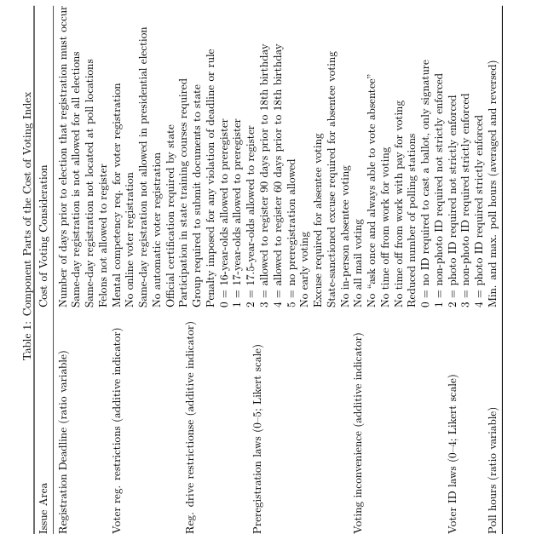
(Li, Pomante, and Schraufnagel 2018)
When computing the scale, there are seven points of interest. These seven points of interest are: (1) registration deadline, (2) voter registration restrictions, (3) Registration drive restrictions, (4) Pre-registration laws, (5) Voting inconvenience, (6) Voter ID laws, (7) Poll hours. Within these seven areas of interest are individual considerations which together create the entire scale. The table for the individual areas of interest and their scale type are below. This scale is then weighted. The researchers decided to weight the scale by “the ‘‘proportion of variance explained,’’ by each included principal component as our weighting strategy, a linear aggregation, and the Likert and additive scales” (Quan et.al, p. 238). Because of the dynamic nature of the scale, some components are used during a specific year and others are not. This dynamic aspect allows the scale to adapt to the changing laws and considerations through adjustment each calculated year.
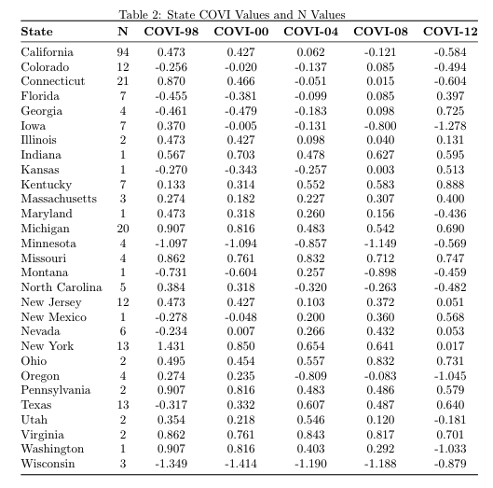
For my use of this scale, I took each state COVI score from the years 1998-2016 and associated the correct score with each experiment based on the state it took place in and the election year it occurred during. For elections that were not within presidential years, I used the last presidential election’s score. It should be noted that there is a newly updated measure for 2020 and that deals with an additional component within the scale; however, my sample of experiments do not go past 2013 which means that is not a consideration for this study.
Regression
The goal of this study is to discover the relationship between the cost of voting in each state and the overall effectiveness of GOTV campaigns. The cost of voting is measured by utilizing the COVI variable while the effectiveness of GOTV campaigns comes from a grouping of GOTV experiments. To test the relationship between these variables, a series of regression models estimated their association. Each regression was a multiple linear regression with confounder variables. The first regression model had a dependent variable of the GOTV effectiveness scores—intent to treat (ITT) for mail experiments and average treatment effect on treated (ATT) for phone and canvassing experiments— with an independent variable of the corresponding state’s COVI score which ranged from 0-1. The first regression also includes binary control variables for social pressure in the GOTV intervention and election type.
$$All Treatment GOTV Effect = B_{0}+ B_{(Cost of Voting)}+B_{(Election Type)}+ B_{(Social Pressure)}$$
The second, third and fourth regressions were similar, but each were split by contact type. Therefore, the first regression had a dependent variable of Mail experiment’s ITT scores as a measure for GOTV effectiveness, the second regression had a dependent variable of phone contacts experiment’s ATT scores as a measure for GOTV effectiveness, and lastly the third regression had a dependent variable of canvass contact experiment’s ATT scores as a measure for GOTV effectiveness. All three regressions had an independent variable of the COVI score, with confounding dummy variables for election type and social pressure. These two confounders were included because election type and social pressure have significant impacts on the effectiveness of GOTV effects.
Descriptive Statistics
Election Year & Election Type Breakdown
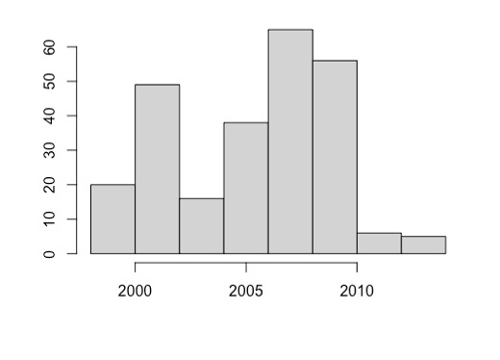
In order to get a basic understanding of the data at hand. I generated descriptive statistics tables to demonstrate the look of the data. Firstly, I generate histograms of the two main numeric variables. Most observations are between 2008-2010, with a notable increase around 2000. The average overall, was 2006 as we can see from Figure 1. Furthermore, latest election year was 2013, so this study does not include data from the 2016 or 2020 elections which saw an increased turnout amongst most population groups. Most of the observations focus on presidential election years; a little less than one-third of my data points are from presidential elections, with 80 of 255 observations. Regarding gubernatorial and midterm election, 99 out of 255 observations fall into this category, which roughly equals a little more than one-third or 38% of the sample; these were categorized as “mid-turnout” since they fall in the middle of high and low turnout elections. Finally, 29% of my data can be categorized as special, primary or municipal elections. Broadly speaking, these two aspects of the data demonstrate a large margin of coverage for my data, which allows it to be more externally valid.
Election Year
Frequency
Figure 1
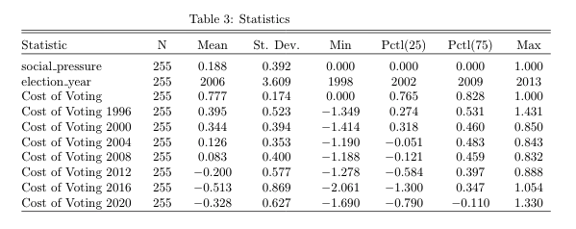
Cost of Voting Index (COVI)
The Cost of Voting (COVI) is a broad tool that spans every presidential year from 1996 to the present. While it is only calculated during presidential years, it is the best measure I found available to represent the wide swath of varied voting laws across the country. This measure was associated with each experimental observation by state and previous presidential years. For instance, if an experiment took place during the 2006 midterm elections, the COVI score associated would be from the 2004 calculation. Furthermore, only the variable that was used to in the regression was rescaled from 0 to 1; this was completed by using the rescaling command in R, the others years from 1996-2020 were not. Despite this, the lack of rescaling does provide an interesting look at how the cost of voting has changed overall. In Table 3, the COVI—or cost of voting—variables are summarized. The first Cost of Voting variable is the rescaled COVI measure that corresponds with the GOTV data observations. The next 7 cost of voting variables are the original calculations from the original article’s calculations (Li, Pomante, and Schraufnagel 2018). From 1996 to 2020 the cost of voting has decreased overall. This can be seen by looking at the “mean” column in Table one. In 1996 the mean score was a positive 0.395; positive scores are an indication of strict and more arduous election laws. However, over the next twenty years, the scores begin to decrease which indicates that many states were making it easier to vote. This decreased the systemic barriers against voters. These scores do not include the rush of new laws passed by state legislatures in 2021, wherein legislation passed which might have changed these laws.
In order to visualize how election laws have changed over the past 20 years, Figures 2 – 4 demonstrate the COVI scores for 1996, 2012 and the rate of change respectively.

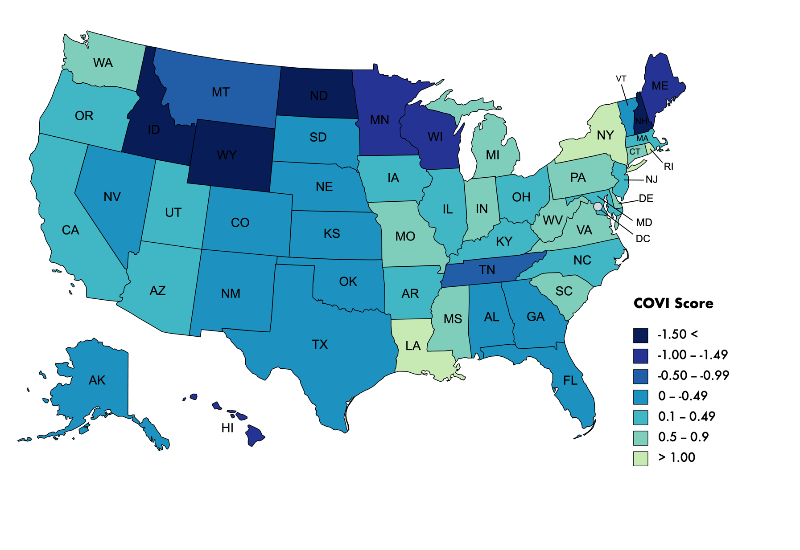
Figure 2. U.S. COVI Scores - 1996

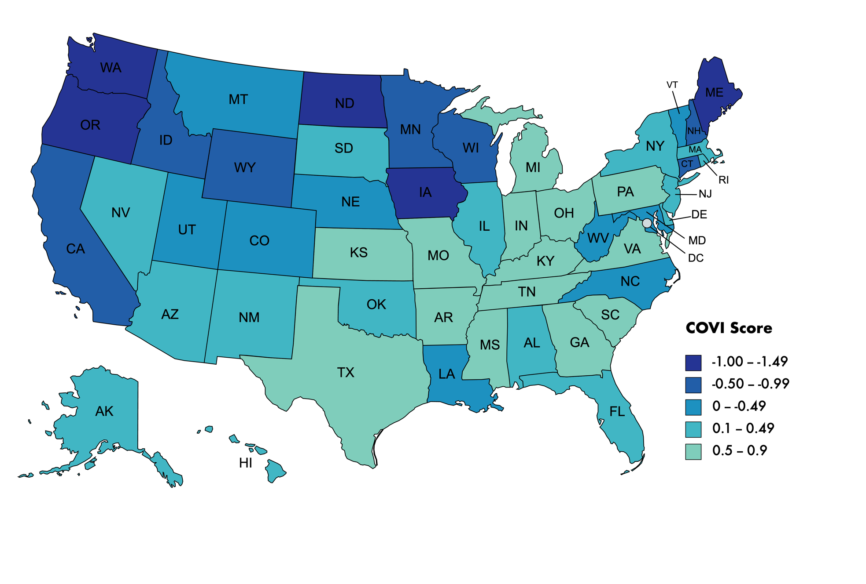
Figure 3. U.S. COVI Scores - 2012
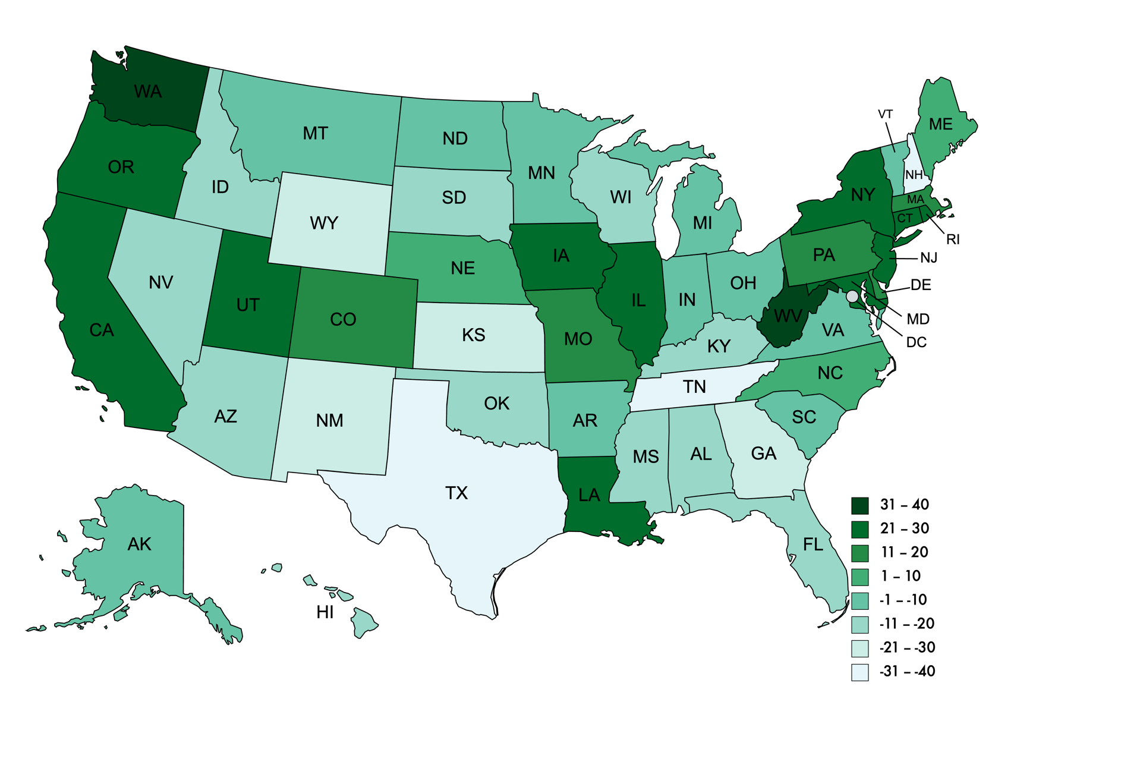
Figure 4. U.S. COVI Scores - Change
Regression Results
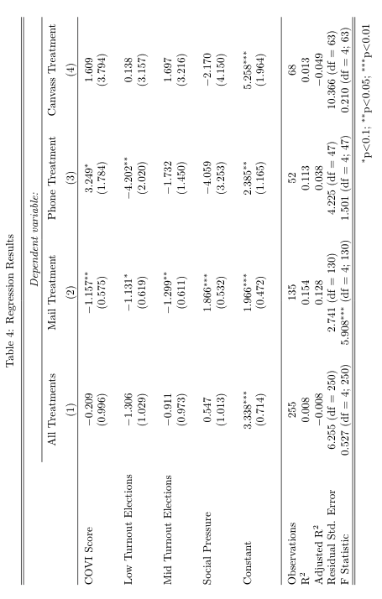
Table 4 lays out the results from each of the four regressions ran on the data. Each of these models represent multiple linear regressions and sought to understand how Get Out the Vote (GOTV) campaigns increased turnout. For each experiment’s data points, the corresponding COVI score was introduced into the model to understand how each state’s election laws (Cost of Voting Index) were associated with the GOTV campaigns. The first model combined the increased turnout percentages between the three different types of GOTV contact—that is mail contact, phone contact, and canvassing contact—and sought to understand how a state’s strict or lenient election laws were related. The GOTV data was presented in increased turnout percentages, which is kept in mind when interpreting the data. Each model controlled for additional confounders, or other independent variables, such as social pressure and election type; election type is a dummy variable with low turnout, mid turnout, and high turnout elections, high turnout elections was the comparison point within the model and is represented by the constant value.
The constant value in the first regression model suggests that when a GOTV campaign is held during a presidential election (high turnout) in the state with the lowest COVI score and does not include social pressure, on average, the campaign will increase turnout by roughly 3%. Keep in mind that the state with the lowest COVI score changes from year to year due to changing state legislation. The variables were rescaled in order to give the constant coefficient an interpretable value. The rest of the model is a comparative average to this value.
In this first model in Table 4, the coefficient associated with the cost-of-voting index is -0.209, which suggests that when it becomes more difficult to vote due to stricter election laws—the associated turnout increase from GOTV campaigns decreases by 0.2%. This suggests the direction of the association is negative, some literature suggests that this would be the case; however, there is not a broad consensus across the literature that this would be the case (Herron and Smith 2013; Nickerson 2015). It is important to note that this value is not statistically significant, which could be due to a small data frame; nevertheless, it does reflect on the validity of the association. Similarly, the standard error is large, which also indicates the association is between the COVI score and GOTV treatment turnout increase is weak. This regression controls for some confounders, but not all. Unfortunately, I was limited by the amount of data that was available to me. With this set of data—provided by Green, McGrath, and Aronow (2013)—information regarding race, gender, socioeconomic standing, and education were not included. Because of this It was not possible to control for these factors beyond what the original experiments did in their own calculations.
The election type confounders are high turnout, low turnout, and mid-turnout. These correspond with specific types of election based on average turnout. High turnout elections are presidential elections which are captured in the constant value. Low and mid-turnout elections are special and municipal election, as well as midterm and gubernatorial elections respectively. Both of these values suggest that when GOTV campaigns are held during non-presidential elections the increased turn out is less than that of the GOTV campaigns during the presidential elections; this finding is also in line with previous literature and is not a surprise. Lastly, social pressure, which has been found to be an exceptionally effective method of GOTV, increases on average when associated with GOTV campaigns. Plainly, this means that as social pressure is added to a campaign there is an associated increase in turnout during an election regardless of what type of election is being held.
The next three regression that were computed separated the data by the treatment type: mail contact, phone contact, and canvassing contact. By doing this, I hoped to further understand how each treatment type was associated with election laws, represented by the Cost of Voting (COVI) variable in within the regression. As with the first regression model, these models controlled for two main factors: election type and social pressure.
The mail contact regression found similar associations to the first all-treatment regression: a negative association between the COVI and GOTV. In plain terms, when the COVI score increases, or it becomes more difficult to vote due to more stringent election laws, GOTV’s increased turnout will decrease, compared to the constant, or expected average of 1.96%. According to this model, stricter election laws are associated with a 1.15% decrease in GOTV increased turnout. This suggests that in states with stricter election laws, GOTV contact by mail will be 1.15% less effective compared to a state with more lenient laws, on average. As with previous findings, low turnout and mid-turnout elections are also expected to see a decrease in GOTV turnout, which is in line with previous experiments and literature. Unsurprisingly, when social pressure is involved, regardless of election laws, it is associated with a significant increase in turnout, staying in line with the literature that suggests that social pressure is a successful GOTV tactic.
What is different about this regression model compared to the first, is the significance of the COVI coefficient. Perhaps one reasons is that compared to the phone and canvass groups, there are more observations within this group. However, there is another possibility, which is mail contact is more sensitive to election laws. This might suggest that mail contact is less mobilizing against systemic forces preventing people from voting; however, further experiments would be needed to reach this conclusion with any surety.
The third regression looked at the association between phone contact and the COVI measure. It found the opposite of the previous two regression models; there was a positive association found in this model. This finding suggests that when election laws are stricter, it is associated with increased GOTV turnout. The low turnout and mid-turnout factors are negative, as with the preceding models. Finally, the social pressure variable has a positive association, also in line with previous models and findings. Interestingly, this model had a significant positive finding for the COVI variable association. This association found that when the COVI score increase, the score was associated with an increase GOTV turnout of 3.2%, which is a significantly large number.
There are some potential explanations for this disparate model outcome. The first is model misspecification. However, when the residuals were plotted as a diagnostic against the fitted values, the residuals appear normally distributed. The outcome could also be due to a small number of observations comparatively. There are two other options to regarding the results. One of which is the model could be suggesting that phone GOTV contact is exceptionally effective when attempting to surpass the systemic barriers of strict voter laws. Another potential option is found within the Enos, Fowler, and Vavreck paper (2014), which suggests that GOTV efforts mobilize those already more primed to vote. While there has been experiments and literature that finds phone contact more effective than mail contact during GOTV campaigns, there has not been much regarding how it interacts with election laws. To confirm this finding, and determine it is not a Type I error, further tests and experiments need to be completed.
The fourth and last regression model run on this data was a comparison of GOTV canvass contact and COVI scale that controlled for confounding variables such as election type and social pressure. Regarding social pressure, this model presented a different pattern to the first two regression and more similar to the third regression model that captured phone GOTV effect. Social pressure had a negative association with GOTV turnout in the Canvassing data. This is not in line with previous literature and findings, which might suggest a Type I error or a lack of observations to accurately explain the data. The same can also be said for low turnout and mid-turnout elections; these data points suggest that compared to the constant which represents the average canvassing GOTV turnout during a presidential election with a state that has the a zero for a COVI score (which would indicate it is the state with the least amount of restrictive laws), election such as municipal and midterm elections will see higher turnout; this is not something frequently seen in real U.S. elections.
Finally, regarding the COVI score, it too has a positive association with GOTV turnout. This association suggests that when COVI increase in scale GOTV turnout will increase by 1.6%. As with the phone regression, there is the potential that canvassing can help voter surpass the systemic barriers of election laws; however, I am less inclined to believe that with this data. The other findings are the exact opposite to what one expects to see based on previous research and literature. Furthermore, the p-value for the COVI coefficient is not significant, suggesting that the model may not accurately describe the data. Looking at the regression graph, there is only a few data points within range of the regression line. Ultimately, I posit that the fourth regression model does not have enough data points to be an explanation of the data in the population at large.
Discussion
This study sought to understand how election laws interact with the effect of GOTV campaigns. I had four main hypotheses; for most of the hypothesis I failed to reject the null hypothesis and found only one statically significant relationship between the data, which was the positive relationship between Phone contact GOTV campaigns and the cost of voting in each state. Overall, there was little indication of a significant association between the data.
Nevertheless, this preliminary study highlights unique potential for relationships such as the positive relationship between phone and canvassing GOTV effect and the cost of voting in each state. This data, which can be found in Table 2, demonstrates a positive association between the two sets of data, indicating a significant relationship. However, the non-separated data did not show this pattern, rather it indicated a negative relationship between the cost of voting and the effect of GOTV contact. When separated mail continued this negative relational pattern, but both canvassing and phone contact GOTV suggested a positive relationship. Once again, phone contact was the only regression which had any significant p-value.
This study begins to shed light on how election laws impact GOTV effects. There are mixed findings regarding how strict election laws impact voter turnout. Some laws, like Voter ID do not seem to have a significant impact, but other studies have found that more convenient laws would increase turnout. These regression models within this study follow the same pattern as the literature. There is no resolute finding within the data that indicates strict election laws are strongly correlated with GOTV effects, either positively or negatively.
While the Mail Regression model found a negative relationship between GOTV effect and the COVI score, the opposite was true for the phone regression. This model suggests that as the cost of voting increases, so does the effect of GOTV. This is a unique result and could be the result of a model misspecification, but this is unlikely due to the significant p-value and the f-statistic. A potential explanation for the model’s finding could be that GOTV helps voters overcome certain systemic barriers that are inherent in the election process. Suggesting that there is something that occurs during contact that helps potential voters decrease the cost of voting as seen in the equation by Riker and Odershook (1968): $R = BP – C$ .
Frequently when contacted by phone, phone bankers are trained to instruct the potential voter on how to register, where to go vote, and how to make sure they meet the requirement of the state and county. This significantly decreases the work and effort that potential voters must invest in the process of voting. Regarding the fourth regression model exploring canvassing GOTV effects and the cost of voting, it found a similar pattern to the data as the phone model; however, these findings were not as large, nor did they have a significant p-value associated with the model. Nevertheless, it echoes the finding from the fourth canvass model regression. According to these estimated models, the phone contact has the largest potential compensating effect for strict election laws. It is not clear why phone is more effective than face-to-face contact regarding system election barriers—election laws. There could be potential within the model, perhaps there were more presidential election GOTV campaigns compared to the canvassing model. Or perhaps phone experiments took place in states with smaller COVI scores. Further research is needed to support he findings from his experiment.
There are a few weaknesses that this experiment falls victim to. Firstly, here are a limited number of observations that the models are describing. This low N value of observations can impact the ability of the model to properly explain the sample population and extrapolate the model to the population at large. Partially, this is due o the sample being limited o published GOTV experiments as data observational points. While this process allows for the ability o discerns methodology of GOTV campaigns that is more effective compared to other methods; the process limits how the model estimates the impact of demographic information and does not consider non-published data which might have an impact on the observations. Lastly, the data is also limited by date. Mos of the observations are prior to 2016, so the model does not help estimate how GOTV is impacted by the changing political field.
Despite these limits, the models have shown a lot of interesting perspective in the realm of GOTV and election laws. While their relationship appears to be slightly negative, when potential voters are contacting by phone or through face-to-face encounters, the relationship is positive. Potentially this could be due to these two contact methods being more equipped to assist potential voters to overcome the barrier of strict voter laws. By have a dialogue the potential voter could ask questions about laws and registration that the phone banker or canvasser is trained to answer. This decreases he effort the potential voter must put into the voting process, making I feel more achievable.
Moving forward, further experiments and data must be able to support or disagree with this finding. Further elaboration on the relationship between election laws and GOTV could be found by utilizing he data from that ANES or could be in partnership with on the ground GOTV campaigns from parties, campaigns, and grassroots organizations to get a less macro view of how election laws impact individual campaigns.
Conclusion
This paper sought to understand how state election laws are associated with GOTV effects. Overall, there is a non-significant negative relationship between the “Cost of Voting” in each state and the GOTV effects from individual experiments. However, when broken down by contact type, phone and canvassing treatments had a positive relationship, the positive phone relationship being significant. There are two possible explanations for this finding. The first is that phone and to a lesser extent, canvass help voters overcome restrictive election laws. However, the second, a perhaps, more likely explanation is found by referring by to Enos, Fowler, and Vavreck’s paper that highlighted how GOTV typically turnout people more likely to vote anyways. Most election laws are impacting minorities and low-income individuals (Liberman 2012; Bentele and O’Brien 2013; Herron and Smith 2013; Justwan 2015; A. White 2019). This study is one of the first which seeks to understand how Get Out the Vote effects and election laws are associated with one another. Overall impacts from the study impact the general literature on election laws and GOTV; however, it also has practical impacts regarding current GOTV campaigns as the 2022 elections draw near. In order to further understand and illuminate the concepts brought up in this paper, future studies should attempt to get “raw” data from current campaigns and political parties, this would allow further understanding of demographic issues to be included.
Ultimately this study sought to understand how GOTV effects and election laws were related, whether they were complementary or substitutive good. This study finds more evidence for the former, suggesting that GOTV and elections impact people differently depending on type of contact, type of election, and year the GOTV contact occurred. More research must be done before any concrete conclusions can be established in this research field.

Works Cited
Alvarez, R. Michael, Dustin Beckett, and Charles Stewart. 2013. “Voting Technology, Vote-by-Mail, and Residual Votes in California, 1990–2010.” Political Research Quarterly 66(3): 658–70.
Arceneaux, Kevin, Thad Kousser, and Megan Mullin. 2012. “Get Out the Vote-by-Mail? A Randomized Field Experiment Testing the Effect of Mobilization in Traditional and Vote-by-Mail Precincts.” Political Research Quarterly 65(4): 882–94.
Baringer, Anna, Michael C. Herron, and Daniel A. Smith. 2020. “Voting by Mail and Ballot Rejection: Lessons from Florida for Elections in the Age of the Coronavirus.” Election Law Journal: Rules, Politics, and Policy 19(3): 289–320.
Bentele, Keith G., and Erin E. O’Brien. 2013. “Jim Crow 2.0? Why States Consider and Adopt Restrictive Voter Access Policies.” Perspectives on Politics 11(4): 1088–1116.
Berinsky, Adam J. 2005. “The Perverse Consequences of Electoral Reform in the United States.” American Politics Research 33(4): 471–91.
Biggers, Daniel R., and Michael J. Hanmer. 2015. “Who Makes Voting Convenient? Explaining the Adoption of Early and No-Excuse Absentee Voting in the American States.” State Politics & Policy Quarterly 15(2): 192–210.
———. 2017. “Understanding the Adoption of Voter Identification Laws in the American States.” American Politics Research 45(4): 560–88.
Bowler, Shaun, and Todd Donovan. 2016. “A Partisan Model of Electoral Reform: Voter Identification Laws and Confidence in State Elections.” State Politics & Policy Quarterly 16(3): 340–61.
Bright, Chelsie L. M., and Michael S. Lynch. 2017. “Kansas Voter ID Laws: Advertising and Its Effects on Turnout.” Political Research Quarterly 70(2): 340–47.
Burden, Barry C., David T. Canon, Kenneth R. Mayer, and Donald P. Moynihan. 2017. “The Complicated Partisan Effects of State Election Laws.” Political Research Quarterly 70(3): 564–76.
Cortina, Jeronimo, and Brandon Rottinghaus. 2019. “Vote Centers and Turnout by Election Type in Texas.” Research & Politics 6(3): 205316801986422.
Dale, Allison, and Aaron Strauss. 2009. “Don’t Forget to Vote: Text Message Reminders as a Mobilization Tool.” American Journal of Political Science 53(4): 787–804.
Davenport, Tiffany C. et al. 2010. “The Enduring Effects of Social Pressure: Tracking Campaign Experiments Over a Series of Elections.” Political Behavior 32(3): 423–30.
Doherty, David, and E. Scott Adler. 2014. “The Persuasive Effects of Partisan Campaign Mailers.” Political Research Quarterly 67(3): 562–73.
Dyck, Joshua J., and James G. Gimpel. 2005. “Distance, Turnout, and the Convenience of Voting*.” Social Science Quarterly 86(3): 531–48.
Enos, Ryan D., Anthony Fowler, and Lynn Vavreck. 2014. “Increasing Inequality: The Effect of GOTV Mobilization on the Composition of the Electorate.” The Journal of Politics 76(1): 273–88.
Gerber, Alan S., and Donald P. Green. 2000. “The Effects of Canvassing, Telephone Calls, and Direct Mail on Voter Turnout: A Field Experiment.” American Political Science Review 94(3): 653–63.
Gerber, Alan S., Gregory A. Huber, and Seth J. Hill. 2013. “Identifying the Effect of All-Mail Elections on Turnout: Staggered Reform in the Evergreen State.” Political Science Research and Methods 1(1): 91–116.
Green, Donald P., and Alan S. Gerber. 2010. “Introduction to Social Pressure and Voting: New Experimental Evidence.” Political Behavior 32(3): 331–36.
Green, Donald P., Mary C. McGrath, and Peter M. Aronow. 2013. “Field Experiments and the Study of Voter Turnout.” Journal of Elections, Public Opinion and Parties 23(1): 27–48.
Grimmer, Justin et al. 2018. “Obstacles to Estimating Voter ID Laws’ Effect on Turnout.” The Journal of Politics 80(3): 1045–51.
Hajnal, Zoltan, Nazita Lajevardi, and Lindsay Nielson. 2017. “Voter Identification Laws and the Suppression of Minority Votes.” The Journal of Politics 79(2): 363–79.
Harrison, Sally. 2021. “MAY I SEE YOUR ID? HOW VOTER IDENTIFICATION LAWS DISENFRANCHISE NATIVE AMERICANS’ FUNDAMENTAL RIGHT TO VOTE.” : 33.
Hassell, Hans J.G. 2017. “Teaching Voters New Tricks: The Effect of Partisan Absentee Vote-by-Mail Get-out-the-Vote Efforts.” Research & Politics 4(1): 205316801769480.
Herrnson, Paul S., Michael J. Hanmer, and Ho Youn Koh. 2019. “Mobilization Around New Convenience Voting Methods: A Field Experiment to Encourage Voting by Mail with a Downloadable Ballot and Early Voting.” Political Behavior 41(4): 871–95.
Herron, Michael C., and Daniel A. Smith. 2013. “The Effects of House Bill 1355 on Voter Registration in Florida.” State Politics & Policy Quarterly 13(3): 279–305.
Hill, Seth J., and Thad Kousser. 2016. “Turning Out Unlikely Voters? A Field Experiment in the Top-Two Primary.” Political Behavior 38(2): 413–32.
Holbein, John B. 2021. “Making Young Voters: The Impact of Preregistration on Youth Turnout.” : 20.
Justwan, Florian. 2015. “Disenfranchised Minorities: Trust, Definitions of Citizenship, and Noncitizen Voting Rights in Developed Democracies.” International Political Science Review 36(4): 373–92.
Karp, Jeffrey A, and Susan A Banducci. 2020. “Going Postal: How All-Mail Elections Influence Turnout.” : 18.
Klain, Hannah, Kevin Morris, Max Feldman, and Rebecca Ayala. “Racial Disparities in Election Day Experiences.” : 36.
Larocca, Roger, and John S. Klemanski. 2011. “U.S. State Election Reform and Turnout in Presidential Elections.” State Politics & Policy Quarterly 11(1): 76–101.
Li, Quan, Michael J. Pomante, and Scot Schraufnagel. 2018. “Cost of Voting in the American States.” Election Law Journal: Rules, Politics, and Policy 17(3): 234–47.
Mann, Christopher B., and Casey A. Klofstad. 2015. “The Role of Call Quality in Voter Mobilization: Implications for Electoral Outcomes and Experimental Design.” Political Behavior 37(1): 135–54.
Matland, Richard E., and Gregg R. Murray. 2012. “An Experimental Test of Mobilization Effects in a Latino Community.” Political Research Quarterly 65(1): 192–205.
———. 2016. “I Only Have Eyes for You: Does Implicit Social Pressure Increase Voter Turnout?: I Only Have Eyes for You.” Political Psychology 37(4): 533–50.
Michelson, Melissa R. 2020. “Getting out the Latino Vote: How Door-to-Door Canvassing Influences Voter Turnout in Rural Central California.” Political Behavior 25(3): 18.
Michelson, Melissa R., and Lisa García Bedolla. 2014. “Mobilization by Different Means: Nativity and GOTV in the United States <sup/>.” International Migration Review 48(3): 710–27.
Miller, Peter, Rebecca Reynolds, and Matthew Singer. 2017. “Mobilizing the Young Vote: Direct Mail Voter Guides in the 2015 Chicago Mayoral Election *.” Research & Politics 4(4): 205316801773841.
Murray, Gregg R., and Richard E. Matland. 2014. “Mobilization Effects Using Mail: Social Pressure, Descriptive Norms, and Timing.” Political Research Quarterly 67(2): 304–19.
Mycoff, Jason D., Michael W. Wagner, and David C. Wilson. 2009. “The Empirical Effects of Voter-ID Laws: Present or Absent?” PS: Political Science & Politics 42(01): 121–26.
Nickerson, David W. 2005. “Partisan Mobilization Using Volunteer Phone Banks and Door Hangers.” The ANNALS of the American Academy of Political and Social Science 601(1): 10–27.
———. 2007. “Quality Is Job One: Professional and Volunteer Voter Mobilization Calls.” American Journal of Political Science 51(2): 269–82.
———. 2015. “Do Voter Registration Drives Increase Participation? For Whom and When?” The Journal of Politics 77(1): 88–101.
Nickerson, David W., Ryan D. Friedrichs, and David C. King. 2006. “Partisan Mobilization Campaigns in the Field: Results from a Statewide Turnout Experiment in Michigan.” Political Research Quarterly 59(1): 85–97.
Panagopoulos, Costas. 2013. “Positive Social Pressure and Prosocial Motivation: Evidence from a Large-Scale Field Experiment on Voter Mobilization: Positive Social Pressure and Prosocial Motivation.” Political Psychology 34(2): 265–75.
Panagopoulos, Costas, Christopher W. Larimer, and Meghan Condon. 2014. “Social Pressure, Descriptive Norms, and Voter Mobilization.” Political Behavior 36(2): 451–69.
Ramírez, Ricardo. 2005. “Giving Voice to Latino Voters: A Field Experiment on the Effectiveness of a National Nonpartisan Mobilization Effort.” The ANNALS of the American Academy of Political and Social Science 601(1): 66–84.
Richey, Sean. “Voting by Mail: Turnout and Institutional Reform in Oregon n.” Social Science Quarterly: 15.
Stevens, Daniel, and Benjamin G. Bishin. 2011. “Getting Out the Vote: Minority Mobilization in a Presidential Election.” Political Behavior 33(1): 113–38.
Street, Alex, Thomas A. Murray, John Blitzer, and Rajan S. Patel. 2015. “Estimating Voter Registration Deadline Effects with Web Search Data.” Political Analysis 23(2): 225–41.
Ulbig, Stacy G., and Tamara Waggener. 2011. “Getting Registered and Getting to the Polls: The Impact of Voter Registration Strategy and Information Provision on Turnout of College Students.” PS: Political Science & Politics 44(03): 544–51.
Urbatsch, R. 2017. “Youthful Hours: Shifting Poll-Opening Times Manipulates Voter Demographics.” Research & Politics 4(3): 205316801772059.
Valentino, Nicholas A., and Fabian G. Neuner. 2017. “Why the Sky Didn’t Fall: Mobilizing Anger in Reaction to Voter ID Laws: Mobilizing Anger in Reaction to Voter ID Laws.” Political Psychology 38(2): 331–50.
Vonnahme, Greg. 2012. “Registration Deadlines and Turnout in Context.” Political Behavior 34(4): 765–79.
White, Ariel. 2019. “Misdemeanor Disenfranchisement? The Demobilizing Effects of Brief Jail Spells on Potential Voters.” American Political Science Review 113(2): 311–24.
White, Ariel R., Noah L. Nathan, and Julie K. Faller. 2015. “What Do I Need to Vote? Bureaucratic Discretion and Discrimination by Local Election Officials.” American Political Science Review 109(1): 129–42.
Wong, Janelle S. 2005. “Mobilizing Asian American Voters: A Field Experiment.” The ANNALS of the American Academy of Political and Social Science 601(1): 102–14.

