The University of Chicago

The Role of Wisdom and Social Support on Resilience

By
Megan Loh
July 2021

A paper submitted in partial fulfillment of the requirements for the
Master of Arts degree
in the Master of Arts Program in the Social Sciences

Faculty Advisors: Howard Nusbaum, Ph.D.
Preceptor: Resney Gugwor
Acknowledgements
I would like to express my utmost gratitude and appreciation to my supervisor, Professor Howard Nusbaum for his words of wisdom and guidance throughout my thesis, of which owes its completion to his invaluable insight. Your advice and feedback challenged me to approach my research question differently and elevated my understanding on the topic as a whole.
I would also like to extend my sincere thanks to my preceptor Resney Gugwor for his patience and support over the program. Your consistent guidance over both my research and professional development is greatly appreciated.
Finally, I could not have completed this thesis without my fellow MAPSS students, Seline Messmer and Devin Kaiser. Your friendship and company throughout this pandemic are irreplaceable.
This research was supported in part by Increasing public engagement by strengthening civic virtues, a grant from the Institute for the Study of Human Flourishing at the University of Oklahoma to the University of Chicago.

Abstract
The SARS-CoV-2 virus that has produced the COVID-19 disease outbreak has disrupted life throughout the globe. To control this spread, shutdowns of cities and quarantine orders have been put in place by respective governments, but at the consequence of increasing rates of social isolation and frustration amongst citizens. Recent studies on resilience have reported benefits in confronting adverse life events and as a protective factor against psychopathology, with these results differing across social groups. A variety of psychological factors have also been shown to drive individual differences in resilience, with wisdom, epistemic humility and perception of social support playing an important role in mediating this difference. As such, this present study focuses on the role these factors play in predicting resilience in the context of the different types of challenges faced during the Covid-19 pandemic across three different groups: an undergraduate sample, a general US sample and a Malaysian sample. Results show that wisdom, epistemic humility and social support are positively correlated with resilience, while only wisdom and epistemic humility were found to mediate the impact of the pandemic. Future studies in understanding the full psychological impacts of the pandemic are still required to better understand the psychological reasonings behind these results.

Keywords: Covid-19, Wisdom, Epistemic Humility, Social Support, Resilience
Introductory Background
The SARS-CoV-2 virus that has produced the COVID-19 disease outbreak has become one of the largest public health crises of our generation. In the rapidly changing landscape of the outbreak, daily life has been disrupted across various countries, with millions of deaths reported throughout the globe, creating sudden and profound impacts on both psychological and physiological well-being through various communities (World Health Organization, 2020). In an effort to control the spread of the virus, abrupt shutdowns of cities and quarantine orders have been put in place by respective governments. In addition to economic distress and increasing unemployment rates, the consequences of these actions also result in increasing rates of social isolation, loneliness and psychological distress amongst citizens (Long & Van Dam, 2020; McGinty et al., 2020; Park & Park, 2020). Despite the development of vaccines, there remains no end date to the pandemic which continues to exacerbate stress levels, separating it from previous traumatic natural events, resulting in an elevation of mental health problems (Ghebreyesus, 2020). This combination of stressors, lack of control and heterogeneity in responses presents the need for more research to understand the psychological consequences of the pandemic which remain largely unknown, and the maintenance of resilience during such times.
The concept of stress is not one that is unfamiliar to many and serves as an integral part of our lives. While stress is traditionally defined as the disruption of homeostasis in the presence of a threat, it can also be viewed as a person-environment relationship (Ulrich-Lai & Herman, 2009; Lazarus & Folkman, 1984). Interestingly, the psychological reappraisal of stress plays a larger role than that of the stressor itself, signifying the presence of individual differences that can impact the way each individual reacts with similar stressors (Lazarus & Folkman, 1984). These differences can result in a variation of emotional reactions that further impact the perception and reaction to stress, and as such create differences in stress coping mechanisms (Lazarus & Folkman, 1984). In this regard, the sense of perceived control over a situation can serve as a deciding factor over the type of appraisal and coping mechanism used, with a higher degree of control eliciting appraisals of challenge and task-focused coping, while uncontrollable situations result in threat appraisals and emotion focused coping instead, ultimately dictating one’s response to the stressor (Endler et al., 2000). Most interestingly, a large degree of stress observed in our lives have social origins, ranging from death of loved ones and social isolation from communities, to cases of bullying and workplace harassment (Björkqvist, 2001). In light of this, the increasing social isolation encountered through the pandemic raises the importance in understanding the role of individual differences in psychological processes and prosocial behavior in ameliorating the adverse consequences of social isolation and the threats inherent in the pandemic.
A variety of psychological processes, both internal and external in nature, have shown to successfully facilitate one’s resilience to these stressors. These factors range from individual differences in personality to the interpersonal relationships maintained throughout our lives and play a role in mediating our resilience to hardships through various abilities that range from the regulation of emotions to the reappraisal of stressors (Weber, 2003; Carlson et al., 2012). It is through this combination of personality traits, experience and social bonds that determines one’s ability to overcome these challenges and thrive in spite of them. Despite this however, how these processes function during a global crisis remains much to be desired. While research has been conducted to understand the impact of these psychological processes separately, no research has investigated the impact of these processes as a whole. As such, this current research is to understand both the interaction between these psychological processes and resilience during a pandemic as well as how these psychological processes interact with one another to promote resilience. It is paramount that a better understanding of the both the short- and long-term effects of this pandemic on one’s psychological health be pursued, especially in light of the decrease in overall well-being over the span of the pandemic, with countries like the United States having reported a 12-year low in well-being (WHO, 2020c; Witters & Harter, 2020). To fully prevent any further deterioration, studies to better understand the psychological impacts of this pandemic must be conducted. The following section is a literature review on the psychological processes that would be the focus of this current research.
Literature Review
Wisdom
Wisdom has long been considered the pinnacle of human development; and has long been admired as a virtue, a noble facet of personality and an exemplary character trait (Ardelt, 2003; Peterson & Seligman, 2004; Brugman, 2006) that has been identified as important to human flourishing. This apex of psychosocial maturity is achieved through the evaluation of life experiences and full development of one’s potentials, with wise individuals being viewed as competent and having their insights high valued by their peers (Taylor, Bates & Webster, 2011). In this sense, wise individuals are not necessarily intelligent, but possess a sense of maturity, self-awareness as well as the transcendence of self-focus (Ardelt & Oh, 2016). This sense of maturity and self-awareness together with a broader view of connections to and importance of others makes it possible to take different perspectives on threats and loss in ways that can increase resilience.
Historically, there have been difficulties setting clear definitions for wisdom due to its complexity despite its significance in understanding human development (Sternberg & Jordan, 1990). A widely accepted belief across cultures and time periods has been that age is a major factor for the development of wisdom through the maturation process, with a possible explanation is that greater age is associated with more experience, with Aristotle himself suggesting that wisdom is learned rather than taught (Schwartz & Sharpe, 2006; (Staudinger & Leipold, 2011). Despite this, most research share the consensus that age is not a sufficient condition for the progression of wisdom as one may not necessarily reflect on their experiences; previous studies have reported a lack of positive correlation between age and wisdom in adult populations; with some studies even finding a negative correlation between the cognitive dimension of wisdom and age in older populations (Ardelt, 2011b). Age, is however, linked to wisdom in children and young adults, suggesting a normally distributed relationship between age and wisdom. This change in wisdom can be derived from individual differences in motivation, social conditions, education levels and even developmental maturation (Ardelt & Oh, 2016). It is still unclear however if there are other factors influencing the growth of wisdom, and this suggests that it is not exactly clear that biological age alone is responsible for this development (Staudinger, 1999).
The present study defines wisdom as a combination of cognitive, reflective and affective abilities, and includes traits such as compassion, understanding, open mindedness, altruism and an optimistic outlook on life (Clayton & Birren, 1980; Holliday & Chandler, 1986; Sternberg, 1986; Takahashi, 2000). This general 3-dimensional definition of wisdom is compatible with most implicit and explicit theories of wisdom (Sternberg & Jordan, 2005; Takahashi & Bordia, 2000). These traits have shown to be accurate in measuring wisdom in past studies and serve to distinguish wisdom from other traits such as altruism and intelligence (Clayton & Birren, 1980; Ardelt, 2004). The cognitive dimension of wisdom involves an understanding of life and a desire to comprehend the deeper meaning of its truths as how they relate to intrapersonal and interpersonal matters (Ardelt, 2003). This includes the acceptance of the positive and negative aspects of human nature and an acceptance over the unpredictability of life. The reflective dimension of wisdom is the reflection of events from different perspectives and requires self-examination and self-awareness in order to diminish one’s self-focus and facilitate a deeper understanding of life (Ardelt, 2003). Lastly, Ardelt (2003) states that the affective dimension of wisdom involves the sympathetic and compassionate behaviors towards others, and the absence of negative feelings or behaviors. Through the integration of these three dimensions, wisdom is conceptualized as a developmental personality quality rather than a state (Ardelt, 2003).
Research has demonstrated that wisdom is associated with having important implications across an individual and societal level, suggesting it to be a highly desirable indicator of development and is associated as a protective factor against various psychological risk disorders (Masten & Coatsworth, 1995). Wisdom is positively correlated to better overall physical and mental health, life satisfaction, happiness and resilience, and has been associated with an increased purpose in life, self-acceptance, emotional competence as well as greater self-efficacy (Ardelt, 2000; Ardelt, 2003; Webster, Westerhof, & Bohlmeijer, 2014; Bergsma & Ardelt, 2012; Jeste et al., 2013; Ryff, 1989). In past studies, wisdom has been linked to meaningful aging for adults with dementia and resilience (Harris & Keady, 2008; Hayat, Khan & Sadia, 2016). It has also been reported that individuals possessing higher degrees of wisdom have increased levels of reflectivity, which reduces self-centeredness and heightens compassion as well as empathy towards one’s self and others, as such promoting the incentive to foster well-being (Kramer, 1990; Levitt 1999). Additionally, this ability to reflect on one’s actions encourages self-examination, which allows individuals to healthily process and regulate negative emotions that arise from difficult circumstances and transcending these hardships without causing adverse impacts on oneself (Webster, 2003). This capability to regulate and maintain healthy emotions despite the adversities experienced is said to benefit humankind at societal, relational, and individual levels, and reiterates the high desirability of wisdom.
Epistemic Humility
In this regard, wisdom and epistemic humility are intrinsically linked. Seeing as a component of wisdom is the reflective ability of one’s own intellectual limitations, epistemic humility’s own definition of the awareness of one’s cognitive limitations and ability to take responsibility for them aligns with this notion (Ardelt, 2003; Whitcomb et al., 2015). In this regard, epistemic humility enables the facilitation of wisdom through enabling unbiased and reflective thought (Brienza et al., 2017; Grossmann, 2017). Going beyond this, epistemic humility also involves the openness to new forms of information that may not necessarily align with pre-existing notions of knowledge and enables reflection on alternate viewpoints without being defensive (McElroy et al., 2014). It is this sense of openness to ambiguity that ultimately facilitates one’s reaction when exposed to the unknown and their reaction to uncertainty, while simultaneously using one’s experience and taking the current situation into consideration to decide the next best course of action. As such, epistemic humility, as an element of wisdom, may be foundational in resilience in the face of hardship.
With research into the field of positive psychology have expanded over the years, studies into virtues such as gratitude and self-transcendence have enjoyed a similar expansion as well; the same, however, cannot be applied to humility (Gottlieb & Froh, 2019; Wegemer, 2020). This lack of development cannot be mitigated to the lack of public and research interest, as humility has always been viewed as an important virtue and is associated with personal, relational, and spiritual benefits, with individuals possessing higher levels of humility being viewed more favorably than less humble counterparts (LaBouff et al., 2012; Exline & Hill, 2012). This slow development can be linked to difficulties in quantifying and measuring humility, suggesting that what remains to be desired is a better conceptualization of humility itself, with several definitions of humility having emerged from recent literature over the years. It is important, however, to bring to light that humility does not equate to low self-esteem, nor is it the underestimate of one’s accomplishments or worth (Tangney, 2002). As Emmons (1998) states, “…to be humble is not to have a lowly opinion of oneself, it is to have an accurate opinion of oneself” (p. 33). Templeton (1997) presents a similar argument, claiming that in this sense, humility represents wisdom, and suggest that humility encompasses the acceptance of one’s limits and faults while being receptive to improvements of the self. Humility also involves a separation from self-focus, with an individual recognizing their place in the state of the world and their role as a part of the community, ultimately allowing one to be aware of the value and potential of others around them (Tangney, 2002). As Means et al (1990) state, “… humility is an increase in the valuation of others, and not a decrease in the valuation of oneself” (p. 214). This present study focuses on epistemic humility, which is a type of humility, and as stated earlier, involves the understanding and awareness of the fallibility of one’s own knowledge, and the vastness of universe that is greater than oneself. It involves an accurate assessment of one’s knowledge, an openness to the idea of one’s own intellectual fallacy, and the acceptance of criticism (Meagher et al., 2015). While epistemic humility does share notable similarities with general humility, the emphasis on intellectual growth ultimately distinguishes it from general humility. In light of this, epistemic humility as a concept is increasingly important in light of the uncertainty faced during the pandemic.
Several studies in current research have produced promising results on the possible benefits of humility. A study by Krause (2010) highlighted that physical health is related to humility, with participants with higher levels of humility reporting better self-rated personal healthy scores. In addition to higher academic and job performance, humility has also been associated with a higher quality of interpersonal relationships and is an important component in determining social bonds, with studies suggesting that humility is essential in the formation, maintenance, and strengthening of relationships (Peters, Rowatt & Johnson, 2011; Davis et al., 2011; Worthington et al., 2010). A study by Hilbig, Moshagen and Zettler (2015) found that participants who reported higher levels of humility reported lower rates of infidelity, with participants with lower levels of humility being more likely to commit moral transgressions. Participants with higher levels of humility were also more likely to be cooperative and responsive to incentives for cooperation, made more fair allocations in standard economic trade games and refrained from exploiting others even when opportunities were presented (Ashton & Lee, 2008; Zettler, Hilbig & Heydasch, 2013). Other studies have reported similar results, with humility being positively correlated with forgiveness and empathy while being negatively correlated to vengeful behaviors (Davis et al., 2011). This suggest that humility is an essential component in self-improvement, with individuals being required to acknowledge their own shortcomings and accept help from others to enable personal transformation (Breggin, 2011). In this context, it is possible that through its ability to regulate ego, humility is a master virtue (Seligman, 2002).
Social Support
When taking all these characteristics of epistemic humility in consideration, it can be theorized that epistemic humility is capable of facilitating social bonds and is as such a highly social desirable trait. Often times, one’s humility is taken into consideration when predicting the behavior of others, and this can impact how one is perceived, and by extension, subsequent interactions (Davis et al., 2013). This awareness of their own intellectual shortcomings and openness to new opinions reduces both egoistic motives and self-focus actions that serve to facilitate altruistic behavior (Davis et al., 2011). By adopting this sense of openness, individuals would be more accepting of cultures different from their own, allowing them to broaden their social circle and gain further insight into the experiences of others, and in turn enable them to better understand others, thus building a stronger social support system. It is also this awareness that gives individuals a more accurate view of themselves, which can enhance relationship satisfaction and result in more positive relationship outcomes (Lewandowski, Nardone, & Raines, 2010). Moreover, other research has indicated that humility can facilitate the reparation of social bonds through mediating the act of forgiveness, with individuals who are viewed as humbler being more likely to receive forgiveness post-transgression and were more likely to receive empathy (Davis et al., 2011, 2013). By overcoming this sense of self-interest, epistemically humble individuals would be more focused on nurturing the well-being of others rather than just themselves, suggesting that epistemic humility is associated with an orientation towards others and necessary for the facilitation of one’s social support.
Social support has been shown to be an essential component in mediating between stress and well-being, both from a psychological and physiological perspective. Cohen (2004) defines social support as “… a social network’s provision of psychological and material resources intended to benefit an individual’s capacity to cope with stress” (p.676). Components of social support can include forms such as structural support, emotional support, and cognitive support, each of which serve to fulfill distinct emotional and cognitive needs that promote feelings of being loved and assist one in overcoming and adjusting to crisis (Sippel et al., 2015). In this sense, social support can be viewed as the exchange between providers and recipients.
By taking these factors into consideration, it is well-known that the presence of a healthy support network would serve to negate the negative impacts of stress and can even serve as a protective factor against stressors, that in turn can be translated into health benefits. The act of receiving acts of compassion from others has shown to be beneficial towards overall well-being, with the degree of received social support being linked to our protection against high mortality rates, with individuals who suffer from cardiovascular diseases or cancer and maintain strong support networks experiencing decrease risk for both morbidity and mortality in comparison to their low social support counterparts (Brummett et al., 2001; Hawkley et al., 2006). Multiple studies have demonstrated that the capacity to mobilize and utilize this social support mechanism have better outcomes, with individuals who receive high degrees of social support reporting less severe symptoms of mental illnesses and were being less likely to develop other associated mental disorders overall, suggesting that buffering effects social support have against stress (Maulik, Eaton & Bradshaw, 2010; Wang et al., 2018). Specifically, prior studies have demonstrated that individuals with high degrees of social support, with sample sizes including depressed patients, normal working adults and HIV positive patients, reported a negative correlation between social support, anxiety and depression (Thakur, Hays, Krishnan & Ranga, 1999; Bettoli, Brown, Brown, & Baldwin, 1998). These results were also cross-cultural, as reported by studies conducted on indigenous people on islands of the Southern Pacific Ocean (Ginter, Glauser, & Richmond, 1994). Additionally, epidemiological studies have also suggested that social support is inverse proportional to mortality rates, with studies reporting individuals with strong social support networks having lower risk factors towards cardiovascular diseases, cancer and infectious disease (Brummett et al., 2001; Rutledge et al., 2004; Hibbard & Pope, 1993).
Interestingly enough, it is not just the act of receiving social support that results in these benefits, but by demonstrating care towards others through acts of altruism replicate these results as well, suggesting that the need to feel connected is what enables these benefits (Baumesiter & Leary, 1995; Weinstein & Ryan, 2010). This is consistent with previous research that has demonstrated how individuals who produced altruistic acts reported greater life satisfaction, happiness and self-esteem as a result from their actions, as seen how elderly individuals reported higher levels of happiness when reciprocating acts of support (Williams et al., 1998; Antonucci et al., 1990). In this sense, this highlights the implications of reciprocation in the facilitation of social bonds and its possible necessity in experiencing the benefits of social support.
Resilience
Previous discussions into the positive effects of wisdom, epistemic humility and social support have suggested that each of these factors are capable of influencing one’s resilience in the face of hardships (Khan & Sadia, 2016; Peters, Rowatt & Johnson, 2011; Maulik, Eaton & Bradshaw, 2010). However, as stated previously, there has been limited research on understanding how these components interact to facilitate resilience. It is a possibility that the combination of these factors would be essential in the development of resilience by supplementing support in areas where each of these processes are weak. The reflective component of wisdom enables one to consider the impacts of their actions as it relates to interpersonal matters and reduces self-focus, an act that is not possible through relying on epistemic humility alone, as such enabling an individual to realize the significance of others and ameliorates altruistic behavior that serve to foster social support. In contrast, epistemic humility can promote one’s acceptance of the fallibility in their knowledge, even after thorough reflection, and enable them to be open to new perspectives and information that is vital in adapting to difficult situations. Even with these traits however, the development of resilience requires social support due to the social nature of humanity itself (Adolphs, 1999). As important as both wisdom and epistemic humility are, the social support from others gives one much needed additional perspective and buffering properties against stress (Wang et al., 2018). It is implausible, as such, to achieve one’s potential just by solely rely on one’s abilities, and the fact of the matter is that humans need the support of others to thrive under difficult circumstances. As a result, it is this combination of these psychological processes that are essential to facilitate the growth of resilience.
The past decade of research has placed increasing focus on resilience in both the fields of behavioral and medical sciences (Charney, 2004). Resilience research have extended beyond its original focus on resilience as a protective factor that served to assist children “bouncing back” from adversities to optimal functioning in adult populations (Haggerty et al., 1996; Schetter & Dolbier, 2011). Despite the amount of research on this topic, resilience itself remains to be defined in a variety of ways, ranging from the ability to bounce back or recover from stress, to the adaptation to stressful life events, and to continue functioning despite life adversities (Carver, 1998; Tusaie & Dyer, 2004). Noticeably, measures of resilience have emphasized on factors and resources that enable resilience rather than the qualities of resilience itself (Ahern et al., 2006). There are 2 main ways in which resilience has been conceptualized in current literature; either as recovery post-exposure to trauma, or as a personal qualities and social resources that enable one to overcome hardships (Bonanno, 2004; Norris et al., 2009; Connor & Davidson, 2003; Friborg et al., 2009). In this study, the resilience referred to here follows the first definition, and resilience is viewed as the general capacity to bounce back from stress. Individuals under this definition are said to exhibit resilience if they demonstrate the ability to return psychological functioning to preexposure levels post-traumatic event (Bonanno, 2004). While personal traits and social resources play a role in the expression of resilience, Smith et al (2008) suggest these resources are more akin to “resilience resources” and are unidentical to actual resilient outcomes. “Resilience resources” are conceptually differet from resuluence, as resilience is oriented specifically towards stress while “resilience resources” include factors such as optimism and self-esteem that have broader effects not limited to just negative events (Emith et al., 2010, Smith & Zautra, 2008).
Studies on resilience have shown how it serves to address psychological well-being in the face of adverse life events. As such, individuals possessing higher levels of resilience exhibit a reduced vulnerability towards a myriad of mental and physical illnesses (Schneiderman et al., 2005). Recent studies on resilience have reported its positive correlation to overall well-being, and as a protective factor against psychopathology, with these results translating across different groups ranging from healthcare professionals, kidney donors and college students, suggesting the role resilience can have in mitigating life stressors (Rudow et al., 2014; Arrogante et al., 2017; Hartley, 2013). This ability to successfully cope with adversities are both non-specific and specific-to-adversities and serves to explain the high protective factors resilience provides against situations that possess a high risk of developing mental disorders while still maintaining a positive outlook on life (Davydov et al., 2010). Through engaging in aspects of mental health resilience such as optimism, positive affect and finding meaning in hardships, resilience would serve to promote an individual’s well-being against adversities by enabling access to psychological resources to buffer the stressors encountered (Ickovics et al., 2006).
Current Study
The goal of this current research is to take a first step toward examining the role of wisdom, epistemic humility and social support, both perceived and reciprocated, in predicting resilience to the various types of hardships face in light of the Covid-19 pandemic. As such, this present study would be composed of 2 hypotheses. I hypothesized that wisdom, epistemic humility and perceived social support are positively correlated to higher levels of resilience, and that all 3 factors would serve as mediators in light of the pandemic. Both of these hypotheses would be tested across 3 different population groups; undergraduate students at the University of Chicago, the general US population, and the general Malaysian population. The Malaysian sample was selected in the context of the experiment by and large for 2 main reasons, Firstly, Malaysia is largely heterogenous and is ethnically diverse, mirroring the ethnic composition of the US sample. These different ethnic groups also live under similar economic and social systems while experiencing minimal acculturation, allowing for a more accurate comparison to the US sample in comparison with other traditionally collectivistic countries which are largely ethnically homogenous. As a former British colony, Malaysia is also fairly proficient in English, and as such the study measures did not need to be translated. Furthermore, despite recent exposure to individualistic values observed in western societies, collectivistic values are still very prevalent in Malaysia and makes it an ideal setting for a non-western context. These changes ultimately enable the understanding of how wisdom, epistemic humility and social support facilitate resilience from a collectivistic context. It is also important to note that the undergraduate students in the context of this study are not a typical representation of the US population due to its highly selective nature. The selection of these population groups provides broader applicability of the measures tested across different age groups and nationalities and may inform potential mediating affects age and culture may have in development of resilience in light of the pandemic.
The primary focus of this current study is to investigate the role of wisdom, epistemic humility and social support in the development of resilience against hardships faced during the Covid-19 pandemic and the possible mediating effects. It is reasoned that individuals who demonstrate higher levels of wisdom would display higher levels of resilience as hardships increased, regardless of age and cultural background, with similar reasonings made for epistemic humility and level of social support.
Methodology
Participants
Undergraduate Sample A total of 106 individuals participated in this experiment and were asked to complete an online survey in exchange for credit in an introductory to psychology course at the University of Chicago. Of these students, 19 individuals were excluded due to task non-compliance (i.e., failing to pass attention checks, failure to complete sections of the experiment as indicated by the instructions). The sample for the undergraduate population thus consisted of 87 participants (Mean age = 20.057, SD = 1.57 years; 42.5% male, 20.68% preferred not to answer; 23% White, 32% Native American/Alaskan Native, 14.9% Multiracial; 59% spoke English as a first language). Participants were recruited from the online system SONA, in which eligible participants read a short description of the experiment on the studies page before signing up. The experiment was advertise as investigating the influences on decision-making tasks using problem-solving as well as reading and responding to hypothetical situations (i.e., there was no explicit mention of wisdom); all participants were debriefed and informed of the research objective at the end of the study.
US Population Sample The US Population sample consisted of 73 participants (Mean age= 32.15 years, SD = 7.745 years; 65.75% male; 72.16% White, 15.06% Black, 4.1% Asian, 4.1% Multiethnic; 93.15% spoke English as a first language) who were recruited via Prolific. The experiment itself was also advertised similarly to the undergraduate sample, and participants were also screened and excluded if they exhibited non-task compliance. The participants were compensated 5 USD for contributing their time and effort to the study.
Malaysian Population Sample 208 individuals from Malaysia participated in the study. After cleaning the data and removing participants for similar non-compliance reasons previously listed, the final participant count for this sample consisted of 166 participants, although only 98 of these participants completed the demographic form located at the end of the survey (Mean age= 35.262 years, SD = years; 44.89% male; 22.44% Malay-Bumiputera; 3.06% Non-Malay Bumiputera, 4.08% Chinese, 67.34% Other; 42.85% spoke English as a first language, 68.38% used English most frequently in daily use). The participants were recruited via social media sites Facebook and Reddit, and the experiment itself was advertised similarly to the undergraduate sample. Participants in this sample did not receive any monetary compensation in the study, which is the norm for psychology experiments conducted in Malaysia.
Measures
Participants were asked to complete 7 sections in the online survey; Impact of Events Scale – Revised (IES_R) to measure the perceived consequences of the pandemic, Covid Challenges Scale (CCS) the measure Covid-specific effects on one's life, Strength of Ties (STQ) to measure both social connection strength and network composition, Multidimensional Scale of Perceived Social Support (Zimet, Dahlem, Zimet & Farley, 1988), The Three-Dimensional Wisdom Scale (3D-WS-Ardelt), Epistemic Humility Scale and The Brief Resilience Scale (BRS) which measures self-assessment of general resilience.
Impact of Events Scale – Revised (IES_R)
The Impact of Events Scale-Revised (IES_R) is a widely used measure developed to assess event-specific distress from traumatic life events. Rather than assessing the severity of stress-related thoughts and behavior, it instead assesses the frequency of which respondents experience these acts, and is used to measure the presence of alternating cycles of intrusive thoughts and images associated with a traumatic event as well as effort to avoid thinking about said event. This study uses a modified version of the scale to address the impacts of the pandemic, is composed of 21 items and has two subscales that assess the frequency of intrusive and avoidant cognitions associated with a specific stressor. Subjects respond using a 5-point scale, ranging from ‘not at all’ to ‘extremely’, regarding how often they experienced specific symptoms during the past week. This scale also includes a subscale assessing autonomic arousal that mirror the three symptom clusters of post-traumatic stress disorder: intrusions, avoidance, and hyperarousal (American Psychiatric Association, 2001). It also measures the severity of distress related to specific symptoms (‘How much were you distressed or bothered by these difficulties?’) instead of the frequency of specific symptoms, a potentially important distinction that could improve measurement of this construct.
Covid Challenges Scale (CCS)
While there have been previous studies on the impacts of the pandemic on different population groups, there has not, to my knowledge, been any studies on the difference in resilience between individuals who were differently impacted by the pandemic (i.e., online schooling due to the pandemic, lost a family member due to Covid-19, losing a job due to Covid-19 etc.) and measured through 3 categories: Loss (i.e., loss a family member due to Covid-19, loss of job), Covid Contraction (i.e., contracted Covid-19 and was hospitalized), and Inconvenience (i.e., work from home, moved back in with family). The hardships encountered by the participants in this study will be termed “challenges” and will be grouped as well as scored according to the severity of their impact, with challenge levels listed as low, moderate and high. Additionally, these challenges were also categorized under different types of categories of hardship: inconvenience, loss, and contracted virus for further analyzation. Measurements for this scoring system are included in Table 1a, while categories for which these challenges were classified under are listed in Table 1b.
Covid-19 Challenges Measurement
Challenge Level | Score | Types of Challenges
Low | +1 | Online classes, Working from home, Moving back in with family, Was in contact with someone who had contracted Covid-19 but did not contact the virus
Moderate | +2 | Contracted Covid-19 and had mild symptoms (eg: fever, dry cough, shortness of breath, fatigue), Minor health problems post-Covid infection (eg: loss of sense of taste and/or smell, slight lethargy), Lost an acquaintance and/or distant family member from Covid-19, Caring for sick family members, Lost job because of Covid-19, Evicted because of Covid-19
High | +3 | Contracted Covid-19 and had serious symptoms (eg: severe shortness of breath,  low blood pressure, high fever, profound weakness), Was hospitalized because of Covid-19, Serious health problems post-Covid infection (eg: difficulty breathing, highly lethargic), Lost a close family member/friend from Covid-19
Table 1a. Types of challenges faced during Covid-19 and their grouping based on the severity of impact. Each challenge would correspond to a question in the Covid Challenges Scale and will be scored according to the score system listed in Table 1a.
Covid-19 Challenges Categories
Types of Categories | Types of Challenges
Inconvenience | Online classes, Working from home, Moving back in with family, Was in contact with someone who had contracted Covid-19 but did not contact the virus, Caring for sick family members, Evicted because of Covid-19,
Loss | Contracted Covid-19 and had mild symptoms (eg: fever, dry cough, shortness of breath, fatigue), Minor health problems post-Covid infection (eg: loss of sense of taste and/or smell, slight lethargy), Lost an acquaintance and/or distant family member from Covid-19, Lost job because of Covid-19, Lost a close family member/friend from Covid-19
Contracted Virus | Contracted Covid-19 and had mild symptoms (eg: fever, dry cough, shortness of breath, fatigue), Minor health problems post-Covid infection (eg: loss of sense of taste and/or smell, slight lethargy), Contracted Covid-19 and had serious symptoms (eg: severe shortness of breath, low blood pressure, high fever, profound weakness), Was hospitalized because of Covid-19, Serious health problems post-Covid infection (eg: difficulty breathing, highly lethargic)
Table 1b. Types of Challenges faced during the pandemic and the categories they were classified under. These categories were scored as listed in Table 1a.
Network Composition
The questions for this measure are similar to the ones proposed by Huang et al (2019), where participants were asked to discuss their core discussion networks, a type of strong-ties network (McPherson et al., 2006). The questions were as follows: ‘From time to time, most people discuss important matters with other people. Looking back over the last six months, have you discussed matters important to you with other people?’ If so, ‘with how many people have you discussed matters important to you?’ Respondents were required to report their relationship with the named discussant (i.e. family or relative, including spouse/partner, friend and other), how well they knew the named discussants and the mutual familiarity between the named discussants (i.e. on a five-point scale, from ‘Don’t know each other at all’ to ‘Extremely familiar with each other’). Based on the information we construct 3 variables to indicate respondents’ network composition, namely, the size of whole discussion network, the number of kin in the core discussion network and the number of non-kin in the core discussion network.
Strength of Ties (STQ)
As with Network Composition, the variables used here would be similar to the one proposed by Huang et al (2019). In that paper, the authors cite Granovetter (1973, 1995) in proposing that there are 4 dimensions in measuring strength of ties across different role relationships. These dimensions include: frequency of contact, emotional intensity, intimacy, and reciprocal services, and can be applied to relationships ranging from family members to acquaintances (Granovetter, 1973, 1995; Bian, 1997). The questionnaire focused on 2 variables for members of the core discussion network: reciprocity of providing advice or help (strong=1) and frequency of contact (high=5), which are based on the following 2 questions: ‘Did this person ask you for any advice or help in the last six months?’ and ‘Generally, how often do you contact each other?’ Strong reciprocity of helping means that at least 50 per cent of the named discussants asked the respondent for advice or help. High frequency of contact indicates that the ‘mean frequency of contact’ among these discussion network members was at least a 4.
Multidimensional Scale of Perceived Social Support (MSPSS)
The Multidimensional Scale of Perceived Social Support (MSPSS) is a theoretically driven instrument widely used in research to measure levels of perceived and subjective social support from 3 sources: family, friends and significant others. The measure itself is brief and has easy-to-follow self-report measures and reports the aforementioned 3 sources of social support as distinct subscales (Bruwer et al., 2008, Zimet et al., 1988). The MSPSS has also been used on several populations, ranging from students, psychiatric patients, and older adults, as well as across various countries (Ginter, Glauser, & Richmond, 1994). This version of the measure has 12 items, with 4 items per subscale (family, friends, significant other), and was originally tested by Zimet et al (1988), using both positive and negative phrasing to limit response set bias of agreement. The instrument uses a Likert scale which ranges from 1 (very strongly disagree) to 7 (very strongly agree), of which the final score is a sum of the scores from the 12 items; with a higher score indicating more perceived social support (Zimet et al., 1990).
Three-Dimensional Wisdom Scale (3D-WS-Ardelt)
The Three-Dimensional Wisdom Scale (3D-WS) is a self-administered measure of wisdom originally developed as an instrument for standardized testing in older adults. Compared to previous tests which emphasized on one’s cognitive ability in decision making in response to hypothetical dilemmas, the measure instead focuses on the personality qualities of a wise individual, and as such assesses wisdom indirectly through observed indicators of the latent construct (Ardelt, 2003). Ardelt conceptualizes wisdom as compromising of 3 dimensions: cognitive, reflective, and affective, and designs the measurement around these dimensions. The current measure includes 12 items, with 4 items for each dimension that are self-rated on a Likert scale which ranges from 1 (strongly disagree) to 5 (strongly agree). 1 item from the Reflective dimension and 2 items from the Affective dimension are reverse-scored and indicated as such.
Epistemic Humility Scale
The Epistemic Humility Scale consists of 16 items that address the 6 dimensions of epistemic humility: (1) how easily one acknowledges that others have more knowledge and skills than them; (2) how readily one admits when they do not know how to do something; (3) how much one has made peace with the fact that they are human; (4) how much one usually admits when they are wrong; (5) how much one is very willing to learn from others; and (6) how readily one is to hand over responsibility to those who are more competent than them. The measure consists of a 8-point Likert-type scale, ranging from 1 (Strongly disagree) to 8 (Strongly agree), with all answers closer to 8 implying greater explicit epistemic humility.
The Brief Resilience Scale (BRS)
The Brief Resilience Scale (BRS) consists of 6 items and was developed by Smith et al (2008) to measure an individual’s ability to bounce back from stressful situations. This ability to recover from stressful situations is particularly important for individuals experiencing stressful life events, and the instrument has shown adequate reliability across various population groups in different countries (Leontjevas et al., 2014; Amat et al., 2014). The construct identified by the BRS is different from other established scales such as the Connor-Davidson Resilience Scale (CD-RISC) or the Ego Resilience Scale, which are only moderately correlated to one’s ability to bounce back from hardship (Smith et al., 2008). The BRS consists of 6 items and a self-report scale with a 5-point response scale ranging from 1 (strongly disagree) to 5 (strongly agree), with a higher score indicating a higher degree of resilience. Items 1, 3 and 5 are positively worded, while items 2, 4, and 6 are negatively worded. The BRS is scored by reverse coding items 2, 4, and 6 and finding the mean of the 6 items.
Procedure
Undergraduate participants and US general population participants for the study were recruited via online recruiting systems SONA and Prolific respectively, while the Malaysian participants were recruited via social media sites such as Reddit. Participants from all groups were excluded from the study if they were below the age of 18.
The study itself took place over the span of 30 minutes. After consenting to the study, participants were asked to complete the aforementioned measures and various attention checks throughout the survey. At the end of the study, participants were asked to complete a brief sociodemographic survey as well. Participants who failed these attention checks were informed that they would not be allowed to proceed with the study and did not receive compensation for their participation, while participants who completed the survey and passed the attention checks were awarded either credit or monetary compensation for their participation. The Malaysian sample did not receive any compensations and were aware of this prior to beginning the study.
Statistical Analysis
Linear regressions were applied with a stepwise method using wisdom, epistemic humility, and social support as predictor variables and resilience as the predicted variable. Alpha level of .05 was used to determine statistical significance in all analyses.
Mediation analyses were also performed to test whether wisdom, epistemic humility and social support impacted the relationship between IES and CCS respectively. All measures were tested resulting in 6 separate mediation models for each sample group. A bootstrapping procedure (1,000 bootstrap samples) was employed to compute the indirect effect and corresponding 95% confidence interval.
Results
Distribution of Scores across samples
Descriptive analysis for the 6 measures demonstrated that undergraduate students reported lower IES scores (M= 1.89, sd=0.77) and CCS scores (M= 2.86, sd=2.51) compared to the general US sample as a whole, which reported a mean of for both IES (M= 2.31, sd=0.89) and CCS scores (M=3.91, sd=3.50). In comparison, participants in the Malaysian sample reported a lower CCS score compared to the general US sample (M= 2.84, sd= 2.20), but had a similar IES score (M= 2.271582, sd=0.797513). Both undergraduates and the general US sample reported higher MPSS scores (M-undergraduate sample=65.55, sd= 15.47; M-US general sample=65.96, sd=12.02) compared to the Malaysian sample (M= 62.37, sd= 15.44). These same results were also observed for Network size (M-undergraduate sample= 2.43, sd=1.33; M-US general sample= 2.08, sd=1.11, M-Malaysian sample= 1.94, sd=1.11), and contact frequency (M-undergraduate sample= 4.24, sd=1.31; M-US general sample=4.31, sd=0.56, M-Malaysian sample= 4.24, sd=1.70) with the Malaysian sample reporting lower scores compared to the US general sample and undergraduate sample. The general US sample also reported higher reciprocity rates compared to the Malaysian sample (M-US general sample= 0.84, sd=0.30; M-Malaysian sample= 0.82, sd=0.42). Table 2a contains a complete descriptive analysis of all the measures.
Correlation between Wisdom, BRS, IES and CCS
Wisdom is positively correlated to resilience across all three sample groups, such that increases in wisdom are related to increased self-perception of resilience as measured by the BRS. Both the undergraduate and Malaysian samples showed significant correlation between wisdom and BRS scores (r-undergraduate sample = 0.19, p < .01; r-Malaysian sample = 0.27, p< .01), while the general US sample did not replicate similar findings (r= 0.05242, p= 0.0246). There was a significant positive correlation between wisdom and CCS for the undergraduates (r = 0.07, p < .01), neither the US general sample nor Malaysian sample showed any significant correlation (r-US general sample = 0.020, p = 0.11; r-Malaysian sample = -0.0049, p= 0.65; p >.05), with both the US general sample and Malaysian sample showing a negative correlation between the wisdom and CCS. While the US general population did not report any significant correlation between wisdom and IES score (r = 0.037, p = 0.051), it did show a negative correlation between the measures. Both the undergraduate and Malaysian sample reported a similar negative correlation, with the results for both groups being significant (r-undergraduate sample = 0.18, p<.01; r-Malaysian sample = 0.11, p< .01), indicating that individuals with higher wisdom scores suffered less adverse effects of the pandemic. Further analysis was conducted by dividing the CCS scale into the different categories the challenges were classified under. Only the undergraduate sample reported a significant correlation to the loss category (r= 0.11, p<.01). No other categories of challenges were significantly correlated (p>0.05) with any of the other samples.
Given the similarities between the groups and their relationships to the measures, subsequent analyses would have all 3 groups combined.
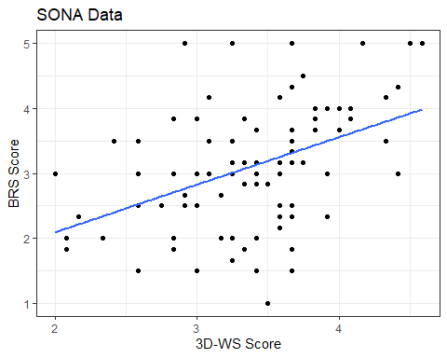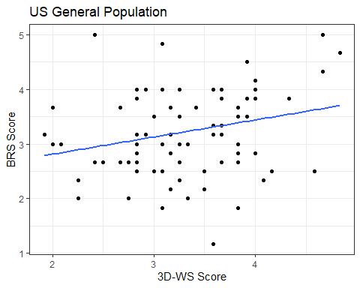
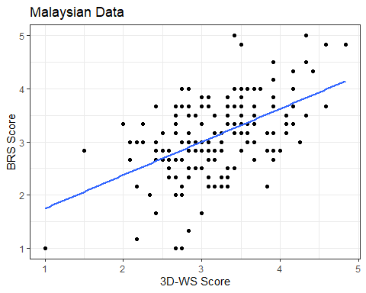
Figure 1a. Relationship between Wisdom and Resilience across the 3 samples.
Correlation between Epistemic Humility, BRS, IES and CCS
The analysis of the results indicate that epistemic humility is positively related to BRS score at a significant level (r= 0.38, p<0.001). These results were also observed in relation to IES score as well (r= 0.010, p<0.05), although they were not replicated for CCS score, which found no significant correlation with epistemic humility.
Further analysis was conducted by dividing the CCS scale into the different categories the challenges were classified under. No categories of challenges were significantly correlated (p>0.05) with the combined population samples.
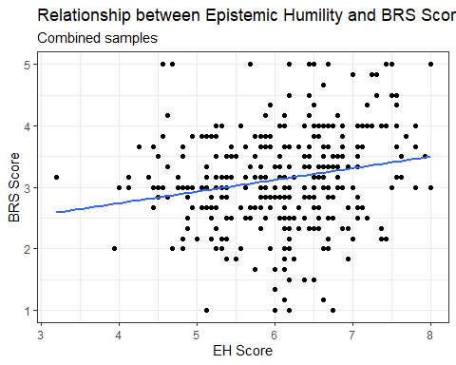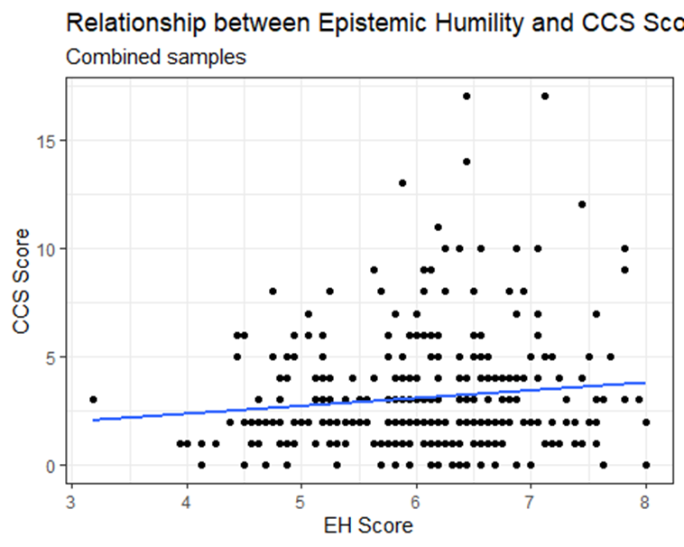
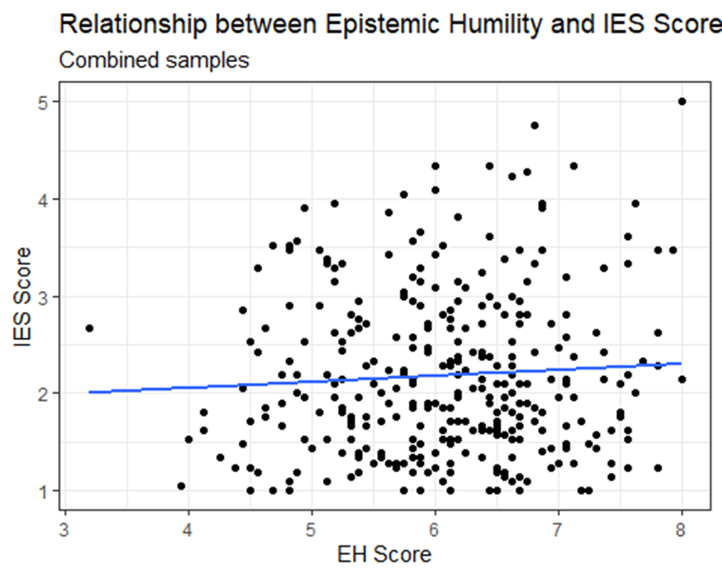
Figure 1b. Relationship between Epistemic Humility and BRS
Correlation between Perceived Social Support, BRS, IES and CCS
Social support is positively correlated to the BRS score in the combined sample at a significant level (r= 0.072, p<0.001). These results were not replicated with either CCS score (r=0.0048, p= 0.11) or IES score (r= -0.0027, p= 0.75), with neither measure reporting any significant correlation with social support. Further analysis was conducted by dividing the CCS scale into the different categories the challenges were classified under. No categories of challenges were significantly correlated (p>0.05) with the combined sample.
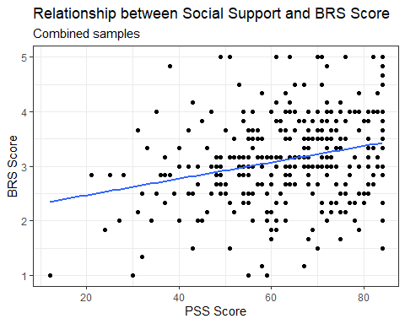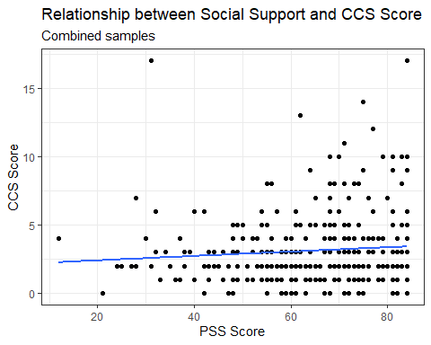
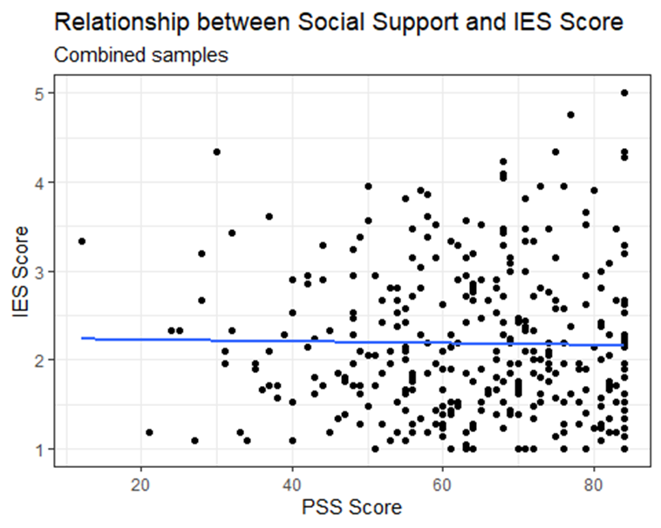
Figure 1c. Relationship between Perceived Social Support and Resilience
Mediating Effects of Wisdom, Epistemic Humility and Social Support on IES Score
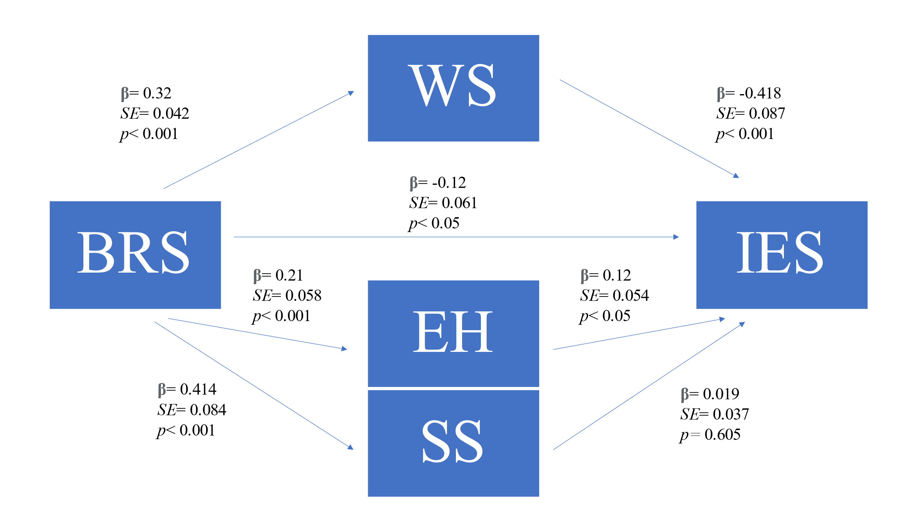
Figure 1d. Results from Model 1: Model of the mediational role of wisdom, epistemic humility and social support in the relationship between resilience and IES score in the combined sample

In Model 1, the direct pathway between BRS score and IES score was significant before the addition of mediators to the model (β = -0.21, p<0.001). However, upon the addition of the mediators, the direct pathway only became partially significant (β = -0.12, p< 0.05), suggesting partial mediation effect. As Figure 1d illustrates, wisdom is a significant mediator, with the 1,000-sample bootstrap test estimated that the unstandardized indirect effect being -.13, p< 0.001, CI 95% = (-0.20, -0.069). In contrast, epistemic humility is only a partial direct mediator, with the 1,000-sample bootstrap test estimated that the unstandardized indirect effect being .27, p= 0.071, CI 95% = (0.0045038, 0.0658932). The results found social support was not a mediator between BRS and IES score, with the regression coefficient between measures not being statistically significant (p>0.05).
Mediating Effects of Wisdom, Epistemic Humility and Social Support on IES Score
In Model 2, the direct pathway between BRS score and IES score was not significant before the addition of mediators to the model (p>0.05), with the significance remaining unchanged even after the addition of the mediators (p>0.05). Neither wisdom, epistemic humility or social support were reported to function as a mediator between BRS and IES score, with the regression coefficient between the measures not being statistically significant (p>0.05).
Correlation between Wisdom, Social Support, Network Size, Contact Frequency and Reciprocity
The analyses indicate a positive correlation between wisdom and social support at a significant level (r= 0.029, p< 0.01). These results were also observed with network size (r= 0.013, p< 0.05), contact frequency (r= 0.030, p< 0.01) and reciprocity (r= 0.0026, p< 0.01), suggesting that wisdom facilitates both the degree of perceived social support as well as its different components.
Correlation between Epistemic Humility, Social Support, Network Size, Contact Frequency and Reciprocity
The results show that epistemic humility and social support are significantly correlated and are positive related (r= 0.099, p< 0.001). While epistemic humility and contact frequency reported similar results (r= 0.014, p< 0.05), neither network size nor reciprocity replicated these results (p>0.05).
Correlation between Social Support, Network Size, Contact Frequency and Reciprocity
Perceived social support is positively correlated to network size, contact frequency and reciprocity in the combined sample data, suggesting that participants who have more perceived social support had larger network groups, frequently contacted people within their network, and reciprocated their help more often. The results also reported significant correlation between social support and network size (r= 0.073, p< 0.001), contact frequency (r= 0.12, p< 0.001) and reciprocity (r= 0.058, p< 0.001).
Correlation between Network Size, BRS, IES and CCS
The results found a significant correlation between network size and CCS scores (r= 0.013, p< 0.05), although no other significant correlations (p> 0.05) were found between network size, BRS and IES scores across the combined sample group. However, separate analyses on each of the different sample populations reported contrasting results, with the analyses finding a significant correlation (p<0.05) between Network Size and CCS Score (r= 0.04342, p= 0.0403) in the general US sample, although neither the undergraduate sample nor Malaysian sample reported any significant correlations. No significant correlations were also reported for resilience or IES scores across all 3 sample groups.
Correlation between Contact Frequency, BRS, IES and CCS
The analyses did not find any significant correlation between contact frequency, BRS, IES and CCS scores in the combined sample data (p>0.05). Conversely, separate analyses of the different sample groups reported contrasting results to the combined data. Contact Frequency was found to be significantly correlated to resilience (p< 0.05) in the general US sample (r= 0.04193, p< 0.05), although these results were not observed for both the undergraduate sample and the Malaysian sample. A significant correlation (p< 0.05) was also found between contact frequency and CCS scores for the undergraduate sample (r= 0.04726, p< 0.05), which was not found in either the general US sample or the Malaysian sample. No significant correlations were observed between contact frequency and IES scores across all 3 samples.
Correlation between Reciprocity, BRS, IES and CCS
The results found a positive significant correlation between reciprocity rate and BRS score in the combined sample, suggesting that individuals who perceive themselves as more resilient reciprocated the help received from individuals in their network at a higher rate (r= 0.016, p<0.05). Conversely, these results were not replicated for either IES score or CCS score, with no significant correlations being reported for those measures (p>0.05).
Relation among Covid Challenges Scale and BRS
The analysis found no significant correlation between resilience and CCS score across the combined sample group, nor did it find any significant correlation between the 3 categories of CCS.
Relation among Impact of Events Scale and BRS
The analysis found that BRS score and IES score was significantly correlated in the combined sample group (r= 0.043, p<0.001) and indicate a negative relationship between the 2 measures.
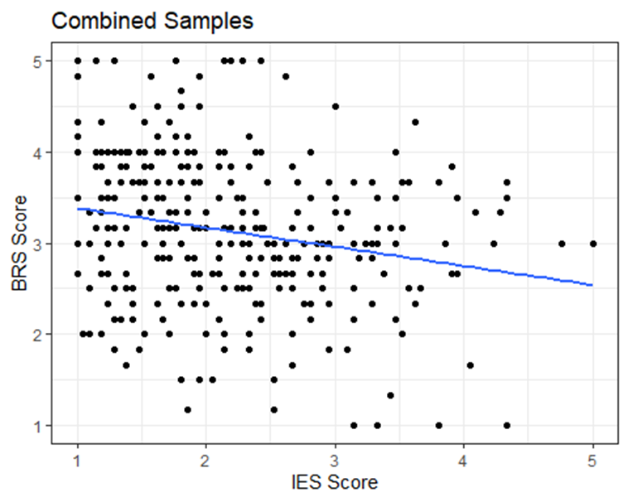
Figure 1e: Relationship between IES score and BRS score
Relation among Covid Challenges Scale and Impact of Events Scale
The results found a significant positive correlation between IES scores and CCS scores in the combined sample group (r= 0.053, p< 0.001). These results were also replicated across the different components of CCS, with analyses reported significant positive correlations between IES score and Contracted score (r=0.018, p<0.01), IES score and Loss score (r=0.015, p<0.05), as well as IES score and Inconvenience score (r=0.038, p<0.001).
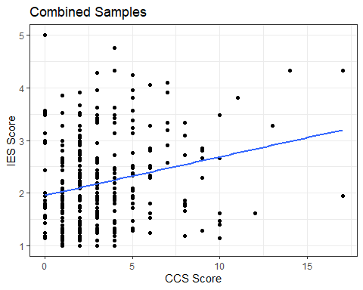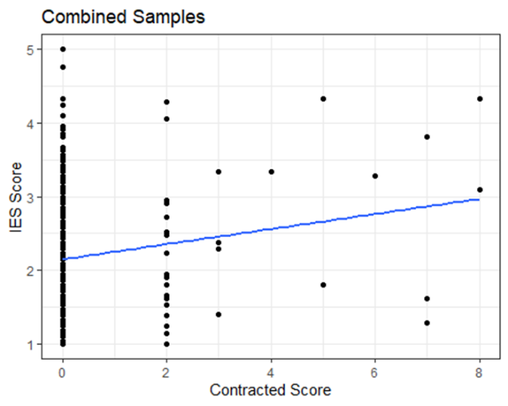
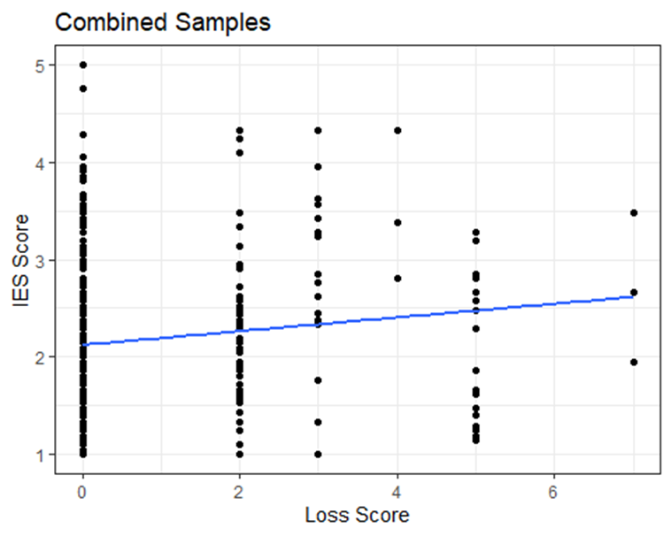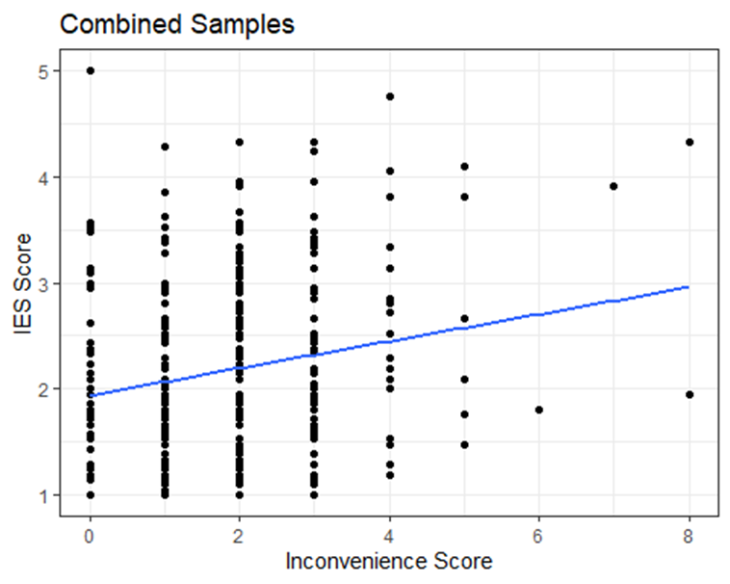
Figure 1f: Relationship between IES score, CCS score, and the different categories of CCS across the combined sample

Discussion
This present study is conducted with 2 aims in mind. The first purpose being to investigate the relationship of wisdom, epistemic humility, and social support to measured resilience in relation to the various types of challenges faced during Covid-19. The second purpose being to understand the possible mediating effects wisdom, epistemic humility and social support on measured resilience to the difficulties encountered during the pandemic. The results of the study support the first hypothesis: that wisdom, epistemic humility and perceived social support are all positively related to higher levels of resilience across age groups and cultures. This suggests that all 3 factors facilitate the development of resilience, and that individually, these factors serve to foster more resilient individuals. The study also found that both wisdom and epistemic humility buffered the impact of the pandemic, with both psychological processes moderating the negative consequences experienced, thus suggesting that the negative consequences of the pandemic appear to be greater among participants who have lower levels of either wisdom or epistemic humility. These results could not be applied for social support however, which was found to only be related to resilience.
Conversely, the results from the study only partially support the second hypothesis; wisdom is found to have negative direct and fully mediating effects effects on the relationship between resilience and IES score, while epistemic humility only reported a partial mediation. These findings suggest that individuals who reported to be wiser were less affected by the adverse circumstances of the pandemic. The negative direct relationship between wisdom and IES score is similar the study conducted by Ardelt (2005), who found that individuals who scored higher on the 3D-WS could cope better with distressing events, were able to successfully distance themselves from said events and were less likely to ruminate on these negative occurrences as well. On the other hand, social support did not mediate the relationship between resilience and IES score in this study. The lack of mediating effect by social support in inconsistent with previous studies on the matter. Previous research has suggested its mediating effects in managing distressing circumstances, with these circumstances ranging from breast cancer to mental health illnesses (Manning-Walsh, 2005; Sherry et al., 2008). Sherry et al (2008) previously indicated that the social support received from family and friends increases the capacity for intimacy while simultaneous reducing the sense of isolation experienced during depressive periods. A separate study by Sachs-Ericsson et al (2021) also found social support to be positively correlated to cognitive reappraisal skills post-emotionally arousing circumstances, which is line with the positive correlation observed between wisdom and social support in this study, suggesting that the lack of mediating effect could be possibly due to entirely external factors. By taking this into consideration, the lack of mediating effect by social support reported in this study could be due to the nature of pandemic itself. Due to the virus’s methods of transmission, it is possible that previous forms of in-person social have changed from being a source of comfort to a stressor. The lack of knowledge on how exactly transmission of the virus occurred between individuals would have caused the act of physically socializing to be considered stressful due to the uncertainty involved and over fear of getting infected. Once previously considered a protective factor against stressors, it is possible that under the circumstances of this pandemic, social interactions, particularly during the early stages, could have developed into a stressor instead, losing its protective abilities. In line with this, it is also possible that the circumstances of lockdown caused individuals to be made all too aware of the severity of the situation, with social interactions with others revolving around the topic of the pandemic, ensured that one was constantly reminded of this stress of the pandemic, which could also have indirectly caused socializing to be seen as a form of stress by this association. Conversely, it is also possible that switching to mostly online forms of communication caused individuals to be all the more aware of their own isolation and communicating with others increased the impact of the pandemic at large.
In this current study, wisdom is found to be positive related to resilience and acts as a mediator between resilience and IES score, with individuals who self-reported to be wiser being more resilient and experiencing less severe effects from the pandemic. These results could be possible due to the reflective component of wisdom, as epistemic humility was only found to be a partial mediator and reported a positive relationship between IES score. It is possible that being aware of one’s own intellectual shortcomings in insufficient to mediate the impacts of the pandemic and requires further introspection. The reflection of events would allow an individual to process what has occurred and accept the current situation at hand. This reflection could also facilitate a deeper understanding of the hardships encountered during the pandemic, and result in the reappraisal of the situation. By reappraising what has occurred, individuals can learn to go beyond the negativity of the situation and find meaning in their struggle. This aligns with previous research that failure to understand and accept one’s struggle can foster feelings of helplessness and anger (Tausch, 2004). The acceptance of negative outcomes in this regard could also have a hand in preventing further rumination, further facilitating one’s ability to move past the event. In light of this, Ardelt (2005) claims that the acceptance of what has come to past is an excellent coping strategy as it goes hand in hand with the idea of self-responsibility by holding ourselves responsible for our own well-being, further proving the importance of wisdom in our lives. This significance of wisdom in our daily lives is also observed with its positive relation to social support and its various components, suggesting that wise people not only receive more social support, but also reciprocate this support as well. While this study did not find social support to be a mediating factor, it does still report that social support is positively related to resilience, and as other studies have suggested, have an overarching protective effect over our physical and psychological health.
A limitation that should be taken into consideration in this study would be the time frame at which the data was collected. While data was collected at the same time, the challenges experienced by the different populations would have been different, and as such could have affected the final results. Samples from the US for this present study were collected as both case and mortality rates across the country were decreasing, while vaccination rates increased, with the country opening up pandemic-related restrictions. In contrast, the Malaysian sample was collected right as cases were rising and right as the third national lockdown began to curb the spread of the virus. This could have impacted the severity of the pandemic and how citizens in both countries perceived it. This difference in perceived stress can also be observed in the difference with how both countries handled the pandemic through its entirety; with the higher infection rates earlier on in the US in comparison to the later spike observed in Malaysia during the third wave, of which the difference in time could impact how one appraises and responds to their respective stressors.
In conclusion, this study finds that while wisdom, epistemic humility and social support facilitate resilience, only wisdom and epistemic humility were found to have an mediating effects on the impacts of the pandemic. The inevitability of hardships is a fact of life, and resilience in overcoming these difficulties are a necessity. The combination of new variants as well as lagging vaccination rates throughout the country suggest that the pandemic is still far from over and that continued perseverance is needed in light of these recent developments. Future investigations into the psychological impacts of the Covid-19 pandemic should consider continuing the work to better understand these impacts on our overall well-being, specifically in individuals who have experienced more challenges during this difficult period in time, as well as the necessary measures that must be taken to ensure the continued preservation of our physical and psychological well-being.
References
Adolphs, R. (1999). Social cognition and the human brain. Trends in cognitive sciences, 3(12), 469-479.
Ahern, N. R., Kiehl, E. M., Lou Sole, M., & Byers, J. (2006). A review of instruments measuring resilience. Issues in comprehensive Pediatric nursing, 29(2), 103-125.
Amat, S., Subhan, M., Jaafar, W. M. W., Mahmud, Z., & Johari, K. S. K. (2014). Evaluation and Psychometric Status of the Brief Resilience Scale in a Sample of Malaysian International Students. Asian Social Science, 10(18), 240- 245. doi:10.5539/ass.v10n18p240
American Psychiatric Association. (2000). Diagnostic and statistical manual of mental disorders (4th ed.).
Antonucci, T. C., Fuhrer, R., & Jackson, J. S. (1990). Social support and reciprocity: A cross- ethnic and cross-national perspective. Journal of social and personal relationships, 7(4), 519-530.
Ardelt, M. (2003). Empirical assessment of a three-dimensional wisdom scale. Research on aging, 25(3), 275-324.
Ardelt, M. (2003). Effects of religion and purpose in life on elders' subjective well-being and attitudes toward death. Journal of religious gerontology, 14(4), 55-77.
Ardelt, M. (2004). Wisdom as expert knowledge system: A critical review of a contemporary operationalization of an ancient concept. Human development, 47(5), 257-285.
Ardelt, M. (2005). How wise people cope with crises and obstacles in life. ReVision, 28(1), 7-20.
Ardelt, M. (2011). Wisdom, age, and well-being. In Handbook of the psychology of aging (pp. 279-291). Academic Press.
Ardelt, M., & Oh, H. (2016). Correlates of wisdom. The encyclopedia of adulthood and aging, 262-264.
Baumeister, R. F., & Leary, M. R. (1995). The need to belong: desire for interpersonal attachments as a fundamental human motivation. Psychological bulletin, 117(3), 497.
Bergsma, A., & Ardelt, M. (2012). Self-reported wisdom and happiness: An empirical investigation. Journal of Happiness Studies, 13, 481-499.
Bettoli, V.E., Brown, R.T., Brown, J.V., & Baldwin, K. (1998). Psychological adjustment and adaptation of siblings and mothers of children with HIV/AIDS. Families Systems and Health, 16, 249–266.
Bian, Y., & Huang, X. (2015). Beyond the strength of social ties: Job search networks and entry- level wage in urban China. American Behavioral Scientist, 59(8), 961-976.
Björkqvist, K. (2001). Social defeat as a stressor in humans. Physiology & behavior, 73(3), 435- 442.
Bonanno, G. A. (2004). Loss, trauma, and human resilience: Have we underestimated the human capacity to thrive after extremely aversive events? American Psychologist, 59, 20-28.
Breggin, P. R. (2011). Humility, augmented by the deep breath technique. Favorite counseling and therapy techniques,, 77-80.
Brienza, J. P., & Kung, F. Y. H., Santos, HC, Bobocel, DR, & Grossmann, I.(2017). Wisdom, bias, and balance: Toward a process-sensitive measurement of wisdom-related cognition. Journal of Personality and Social Psychology.
Brugman, G. (2006). Wisdom and aging. In J. E. Birren & K. W. Schaie (Eds.), Handbook of the psychology of aging (6th ed., pp. 445–476). Amsterdam, The Netherlands: Academic Press
Brummett, B. H., Barefoot, J. C., Siegler, I. C., Clapp-Channing, N. E., Lytle, B. L., Bosworth, H. B., Williams, R. B. Jr., and Mark, D. B. (2001). Characteristics of socially isolated patients with coronary artery disease who are at elevated risk for mortality. Psychosom. Med. 63: 267–272
Bruwer, B., Emsley, R., Kidd, M., Lochner, C., & Seedat, S. (2008). Psychometric properties of the Multidimensional Scale of Perceived Social Support in youth. Comprehensive psychiatry, 49(2), 195-201.
Carlson, J. M., Dikecligil, G. N., Greenberg, T., & Mujica-Parodi, L. R. (2012). Trait reappraisal is associated with resilience to acute psychological stress. Journal of research in personality, 46(5), 609-613.
Carver, C. S. (1997). You want to measure coping but your protocol’too long: Consider the brief cope. International journal of behavioral medicine, 4(1), 92-100.
Charney, D. S. (2004). Psychobiological mechanisms of resilience and vulnerability: Implications for successful adaptation to extreme stress. American Journal of Psychiatry, 161, 195–216.
Chou, K. L. (2000). Assessing Chinese adolescents’ social support: the multidimensional scale of perceived social support. Personality and individual differences, 28(2), 299-307.
Cohen, A. N., Hammen, C., Henry, R. M., & Daley, S. E. (2004). Effects of stress and social support on recurrence in bipolar disorder. Journal of affective disorders, 82(1), 143-147.
Connor, K. M., & Davidson, J. R. T. (2003). Development of a new resilience scale: The Connor–Davidson Resilience Scale (CD-RISC). Depression and Anxiety, 18, 76-82.
Davis, D. E., Hook, J. N., Worthington Jr, E. L., Van Tongeren, D. R., Gartner, A. L., Jennings, D. J., & Emmons, R. A. (2011). Relational humility: Conceptualizing and measuring humility as a personality judgment. Journal of Personality Assessment, 93(3), 225-234.
Davis, D. E., Worthington Jr, E. L., Hook, J. N., Emmons, R. A., Hill, P. C., Bollinger, R. A., & Van Tongeren, D. R. (2013). Humility and the development and repair of social bonds: Two longitudinal studies. Self and Identity, 12(1), 58-77.
Emmons, R. A. (1998). The psychology of ultimate concern: Personality, spirituality, and intelligence. Unpublished manuscript, University of California at Davis.
Endler, N. S., Speer, R. L., Johnson, J. M., & Flett, G. L. (2000). Controllability, coping, efficacy, and distress. European Journal of Personality, 14, 245–264. 30.
Exline, J. J., & Hill, P. C. (2012). Humility: A consistent and robust predictor of generosity. The Journal of Positive Psychology, 7(3), 208-218.
Friborg, O., Hjemdal, O., Martinussen, M., & Rosenvinge, J. H. (2009). Empirical support of resilience as more than the counterpart and absence of vulnerability and symptoms of mental disorder. Journal of Individual Differences, 30, 138-151.
Friedlander, L. J., Reid, G. J., Shupak, N., & Cribbie, R. (2007). Social support, self-esteem, and stress as predictors of adjustment to university among first-year undergraduates. Journal of college student development, 48(3), 259-274.
Ginter, E.J., Glauser, A., & Richmond, B.O. (1994). Loneliness, social support, and anxiety among two South Pacific cultures. Psychological Reports, 74((3, Pt 1)), 875–879
Gottlieb, R., & Froh, J. (2019). Gratitude and happiness in adolescents: A qualitative analysis. In Scientific concepts behind happiness, kindness, and empathy in contemporary society (pp. 1-19). IGI Global.
Granovetter M (1973) The strength of weak ties. American Journal of Sociology 78: 1360–1380. Granovetter M (1995) Afterword 1994: Reconsiderations and a new agenda. In: Getting a Job. Chicago, IL: University of Chicago Press, 139–182
Grossmann, I. (2017). Wisdom in context. Perspectives on Psychological Science, 12(2), 233- 257.
Hawkley, L. C., Masi, C. M., Berry, J. D., & Cacioppo, J. T. (2006). Loneliness is a unique predictor of age-related differences in systolic blood pressure. Psychology and aging, 21(1), 152.
Hibbard, J. H., and Pope, C. R. (1993). The quality of social roles as predictors of morbidity and mortality. Soc. Sci. Med. 36: 217–225.
Jenkins, S. R., Belanger, A., Connally, M. L., Boals, A., & Durón, K. M. (2013). First‐generation undergraduate students' social support, depression, and life satisfaction. Journal of College Counseling, 16(2), 129-142.
Jeste, D. V., Savla, G. N., Thompson, W. K., Vahia, I. V., Glorioso, D. K., Martin, A. V. S., ... & Depp, C. A. (2013). Association between older age and more successful aging: critical role of resilience and depression. American Journal of Psychiatry, 170(2), 188-196.
Jou, Y. H., & Fukada, H. (2002). Stress, health, and reciprocity and sufficiency of social support: The case of university students in Japan. The Journal of Social Psychology, 142(3), 353- 370.
Kong, F., Ding, K., & Zhao, J. (2015). The relationships among gratitude, self-esteem, social support and life satisfaction among undergraduate students. Journal of Happiness Studies, 16(2), 477-489.
Krause, N. (2010). Religious involvement, humility, and self-rated health. Social indicators research, 98(1), 23-39.
LaBouff, J. P., Rowatt, W. C., Johnson, M. K., Tsang, J. A., & Willerton, G. M. (2012). Humble persons are more helpful than less humble persons: Evidence from three studies. The Journal of Positive Psychology, 7(1), 16-29.
Lazarus, R. S., & Folkman, S. (1984). Stress, appraisal, and coping. Springer publishing company.
Leontjevas, R., de Beek, W. O., Lataster, J., & Jacobs, N. (2014). Resilience to affective disorders: A comparative validation of two resilience scales. Journal of Affective Disorders, 168, 262-268. doi:10.1016/j.jad.2014.07.010
Lewandowski Jr, G. W., Nardone, N., & Raines, A. J. (2010). The role of self-concept clarity in relationship quality. Self and Identity, 9(4), 416-433.
Manning‐Walsh, J. (2005). Social support as a mediator between symptom distress and quality of life in women with breast cancer. Journal of Obstetric, Gynecologic, & Neonatal Nursing, 34(4), 482-493.
Maulik, P. K., Eaton, W. W., & Bradshaw, C. P. (2010). The effect of social networks and social support on common mental disorders following specific life events. Acta Psychiatrica Scandinavica, 122(2), 118-128.
McElroy, S. E., Rice, K. G., Davis, D. E., Hook, J. N., Hill, P. C., Worthington Jr, E. L., & Van Tongeren, D. R. (2014). Intellectual humility: Scale development and theoretical elaborations in the context of religious leadership. Journal of Psychology and Theology, 42(1), 19-30.
McGinty, E. E., Presskreischer, R., Han, H., & Barry, C. L. (2020). Psychological distress and loneliness reported by US adults in 2018 and April 2020. Jama, 324(1), 93-94.
McPherson M, Smith-Lovin L and Brashears ME (2006) Social isolation in America: Changes in core discussion networks over two decades. American Sociological Review 71: 353–375.
Means, J. R., Wilson, G. L., Sturm, C., Biron, J. E., & Bach, P. J. (1990). Humility as a psychotherapeutic formulation. Counselling Psychology Quarterly, 3(2), 211-215.
Peters, A. S., Rowat, W. C., & Johnson, M. K. (2011). Associations between dispositional humility and social relationship quality. Psychology, 2(03), 155.
Peterson, C., & Seligman, M. E. P. (2004). Character strengths and virtues: A handbook and classification. Oxford: Oxford University Press.
Sachs-Ericsson, N., Carr, D., Sheffler, J., Preston, T. J., Kiosses, D., & Hajcak, G. (2021). Cognitive reappraisal and the association between depressive symptoms and perceived social support among older adults. Aging & mental health, 25(3), 453-461.
Schwartz, B., & Sharpe, K. E. (2006). Practical wisdom: Aristotle meets positive psychology. Journal of Happiness Studies, 7(3), 377–395. doi:10.1007/s10902-005-3651-y
Seligman, M. E. P. (2002). Authentic happiness. New York, NY: Free Press.
Sherry, S. B., Law, A., Hewitt, P. L., Flett, G. L., & Besser, A. (2008). Social support as a mediator of the relationship between perfectionism and depression: A preliminary test of the social disconnection model. Personality and Individual Differences, 45(5), 339-344.
Sippel, L. M., Pietrzak, R. H., Charney, D. S., Mayes, L. C., & Southwick, S. M. (2015). How does social support enhance resilience in the trauma-exposed individual?. Ecology and Society, 20(4).
Smith, B. W., Dalen, J., Wiggins, K., Tooley, E. M, Christopher, P. J., & Bernard, J. (2008). The brief resilience scale: Assessing the ability to bounce back. International Journal of Behavioral Medicine, 15(3), 194-200. doi:10.1080/10705500802222972
Smith, B. W., Tooley, E. M., Christopher, P. J., & Kay, V. S. (2010). Resilience as the ability to bounce back from stress: A neglected personal resource? The Journal of Positive Psychology, 5(3), 166–176. doi:10.1080/17439760.2010.482186
Staudinger, U. M. (1999). Older and wiser? Integrating results on the relationship between age and wisdom-related performance. International Journal of Behavioral Development, 23, 641–664. doi:10.1080/016502599383739
Staudinger, U. M., & Leipold, B. (2011). The Assessment of Wisdom-Related Performance, 139–156.
Sternberg, R. J., & Jordan, J. (Eds.). (2005). A handbook of wisdom. Psychological perspectives. New York: Cambridge University Press.
Takahashi, M., & Bordia, P. (2000). The concept of wisdom: A cross-cultural comparison. International Journal of Psychology, 35, 1–9.
Thakur, M., Hays, J., Krishnan, K., & Ranga, R. (1999). Clinical, demographic and social characteristics of psychotic depression. Psychiatry Research, 86, 99–106.
Tangney, J. P. (2002). Humility. Handbook of positive psychology, 411-419.
Taylor, M., Bates, G., & Webster, J. D. (2011). Comparing the psychometric properties of two measures of wisdom: Predicting forgiveness and psychological well-being with the Self- Assessed Wisdom Scale (SAWS) and the Three-Dimensional Wisdom Scale (3D- WS). Experimental Aging Research, 37(2), 129-141.
Templeton, J. M. (2011). Worldwide laws of life: 200 eternal spiritual principles. Templeton Foundation Press.
Tusaie, K., & Dyer, J. (2004). Resilience: A historical review of the construct. Holistic Nursing Practice, 18, 3–8.
Ulrich-Lai, Y. M., & Herman, J. P. (2009). Neural regulation of endocrine and autonomic stress responses. Nature reviews neuroscience, 10(6), 397-409.
Rutledge, T., Reis, S. E., Olson, M., Owens, J., Kelsey, S. F., Pepine, C. J., Mankad, S., Rogers, W. J., Merz, C. N. B., Sopko, G., Cornell, C. E., Sharaf, B., and Matthews, K. A. (2004). Social networks are associated with lower mortality rates among women with suspected coronary disease: The National Heart, Lung, and Blood Institute-sponsored Women’s Ischemia Syndrome Evaluation study. Psychosom. Med. 66: 882–888.
Wang, J., Mann, F., Lloyd-Evans, B., Ma, R., & Johnson, S. (2018). Associations between loneliness and perceived social support and outcomes of mental health problems: a systematic review. BMC psychiatry, 18(1), 1-16.
Webster, J. D., Westerhof, G. J., & Bohlmeijer, E. T. (2014). Wisdom and mental health across the lifespan. Journals of Gerontology Series B: Psychological Sciences and Social Sciences, 69(2), 209-218.
Wegemer, C. M. (2020). Selflessness, Depression, and Neuroticism: An Interactionist Perspective on the Effects of Self-Transcendence, Perspective-Taking, and Materialism. Frontiers in psychology, 11, 2556.
Weinstein, N., & Ryan, R. M. (2010). When helping helps: autonomous motivation for prosocial behavior and its influence on well-being for the helper and recipient. Journal of personality and social psychology, 98(2), 222.
Whitcomb, D., Battaly, H., Baehr, J., & Howard-Snyder, D. (2017). Intellectual humility: Owning our limitations. Philosophy and Phenomenological Research, 94(3).
Williams, A. L., Haber, D., Weaver, G. D., & Freeman, J. L. (1997). Altruistic activity: Does it make a difference in the senior center?. Activities, Adaptation & Aging, 22(4), 31-39.
Witters, D., & Harter, J. (2020). In US, life ratings plummet to 12-year low. Avaialble online at: Gallup website: https://news. gallup. com/poll/308276/liferatings-plummet-year-low. aspx (accessed June 3, 2020).
World Health Organization . (2020c). Novel coronavirus(2019-nCoV), situation report – 12. Retrieved April 22, 2020, from https://www.who.int/docs/default- source/coronaviruse/situation-reports/20200201-sitrep-12-ncov.pdf?sfvrsn=273c5d35_2
Worthington Jr, E. L. (2013). A just forgiveness: Responsible healing without excusing injustice. InterVarsity Press.
Zimet, G. D., Dahlem, N. W., Zimet, S. G., & Farley, G. K. (1988). The Multidimensional Scale of Perceived Social Support. Journal of Personality Assessment, 52, 30–41.
Zimet, G. D., Powell, S. S., Farley, G. K., Werkman, S., & Berkoff, K. A. (1990). Psychometric characteristics of the Multidimensional Scale of Perceived Social Support. Journal of Personality Assessment, 55(3–4), 610–617. http://dx.doi.org/10.1080/00223891.1990.9674095

