The University of Chicago

Ex-Post-Facto War Crimes:
The Forgotten War Crimes of the Forgotten War
by Samuel Jake Zucker
August 2021

A paper submitted in partial fulfillment of the requirements for the Masters of Arts degree in the Masters of Arts Program in the Committee on International Relations

Faculty Advisor: Bruce Cumings
Preceptor: Nicholas Campbell-Seremetis
ABSTRACT
When asked about the Korean War, most Americans don’t know much about it. This is in spite of the tremendous toll of the war and the extent of war crimes on both sides. Little attention has been paid in the West to the bombing of dams and other water infrastructure by UN forces in the Korean War. This is despite the fact that these bombing campaigns were arguably illegal under international law at the time, and certainly are illegal under international law today. The perpetrators were aware of the way that the attacks would be perceived, and went to great lengths to justify the attacks and obfuscate their true goal of collective punishment. Using both primary and secondary sources, I will argue that the UN bombing of hydroelectric dams in the Korean War constitute war crimes in hindsight while the UN bombing of irrigation dams constitute war crimes both in hindsight and at the time of the Korean War. I will illustrate that those in charge would not have tolerated the use of the same tactics by the adversary. While the technical legality and the strategic legitimacy of water infrastructure as a target in war can be debated, the nature of the attacks as acts of collective punishment must nonetheless be reckoned with today. This paper will seek to, as the introduction to Professor Cumings’ The Korean War puts it, “uncover truths that most Americans do not know and perhaps don’t want to know” about the Korean War. Americans must confront the truth about our war crimes if we are ever to be able to build a public understanding of our history that spurs us to deconstruct the military-industrial complex and make amends for our past imperial aggressions.

WATER in WARFARE
The use of water in warfare is nothing new, and in fact, water was a standard tool of warfare throughout much of human history. Importantly, water was used in warfare again and again because this was an effective strategy which delivered results. For example, in the year 612 C.E., Emperor Yang of the Sui Dynasty of China invaded Goguryeo, the precursor to Korea, with an army of more than a million men. Goguryeo was able to utilize guerrilla warfare tactics to bog down Emperor Yang’s advance, but Yang was able to divert about 300,000 men from his army to descend upon Goguryeo’s capital Pyongyang. In the now-legendary Battle of Salsu, General Ŭlchi Mundŏk of Gorguryeo was able to win a stunning victory despite having been dramatically outnumbered. Mundŏk’s underdog victory at the Salsu River ensured the Korean Peninsula’s continued independence much in the same way that the defeat of UN forces at the same river in November 1950 ensured the Democratic People’s Republic of Korea’s continued independence north of the 38th parallel. By that point, however, the river had been renamed from the Salsu River to the Ch’ongch’on River.
The brilliant victory at the Battle of Salsu resulted from the extraordinarily effective application of water resources toward national defense. Using makeshift dams that trapped water from the Salsu tributaries behind them, General Mundŏk was able to prepare a torrent of water which would be released to flood the Chinese forces when about half had crossed the river. After the water was released from behind the dams, the Gorguryeo military rushed the Chinese forces, taking the half of the army that had crossed the river already off guard. According to Korean sources, only about 2,700 of the 300,500 Sui troops managed to escape and survive the Battle of Salsu. The Battle of Salsu is indicative of the potential for water to be turned into a potent instrument of war. It is important to recognize, however, that the use of water in warfare to target an enemy’s army is not equivalent to the targeting of enemy civilians. Whereas the use of water against enemy combatants can in many cases be justified, the use of water to target civilians, their energy, or their food supply is always a war crime under current international law.
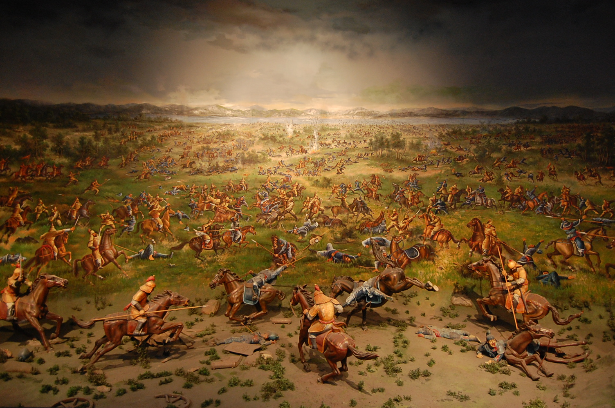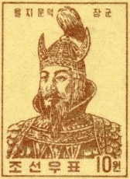
Figure 1:
(Left) Display depicting the Battle of Salsu at the War Memorial of Korea in Seoul, South Korea
(Right) Stamp displaying the likeness of Gorguryeo General Eulji Mundeok
The Korean War was not the first time that dams were attacked in the course of a war, although the practice was rather novel. During Operation Chastise in the Second World War, the British Royal Airforce attacked German dams, becoming known as the “Dambusters”. While some proponents claim that the raid and the subsequent German repair efforts significantly weakened the Nazi war machine in advance of D-Day, Marshal of the Royal Air Force Sir Arthur Harris said that he has “seen nothing (…) to show that the effort was worthwhile except as a spectacular operation”. This lends credence to the assessment that the raid was little more than a PR campaign, albeit one that came with a significant human cost to both sides. The catastrophic flooding caused by Operation Chastise killed approximately 1600 civilians and prisoners of war, including Polish, Russian, and Ukrainian slave laborers kept captive by the Nazis. In addition to this, of the 133 ‘Dambusters’ involved with the mission, 53 died – a fatality rate of nearly 40%. Operation Chastise illustrates the role that attacks upon dams can play in warfare, including in an offensive capacity. Regardless of the efficacy, however, the operation also illustrates that attacks upon dams will almost always result in significant collateral damage to civilians and civilian infrastructure. This lesson, unfortunately, would not yet be able to spur appropriate international law prohibiting these attacks.
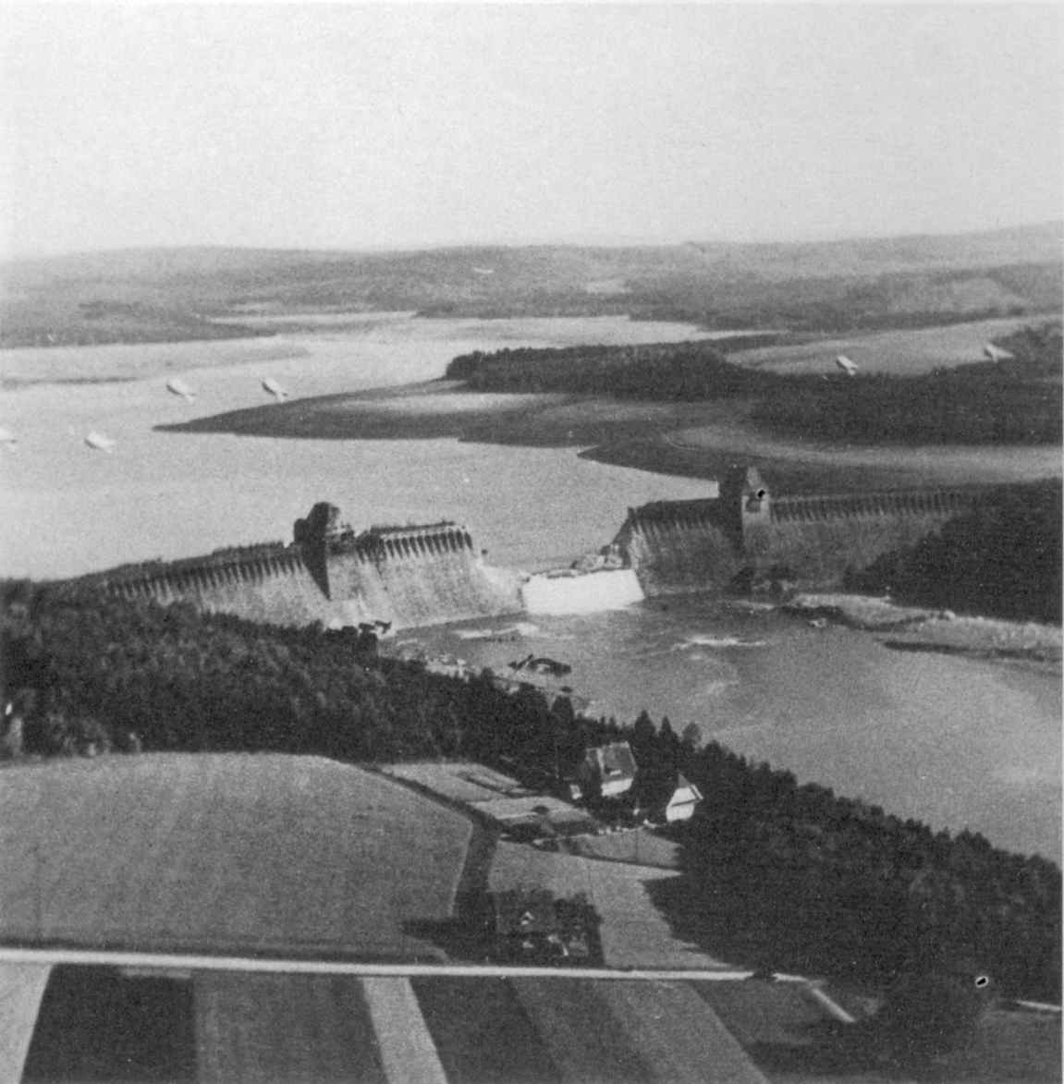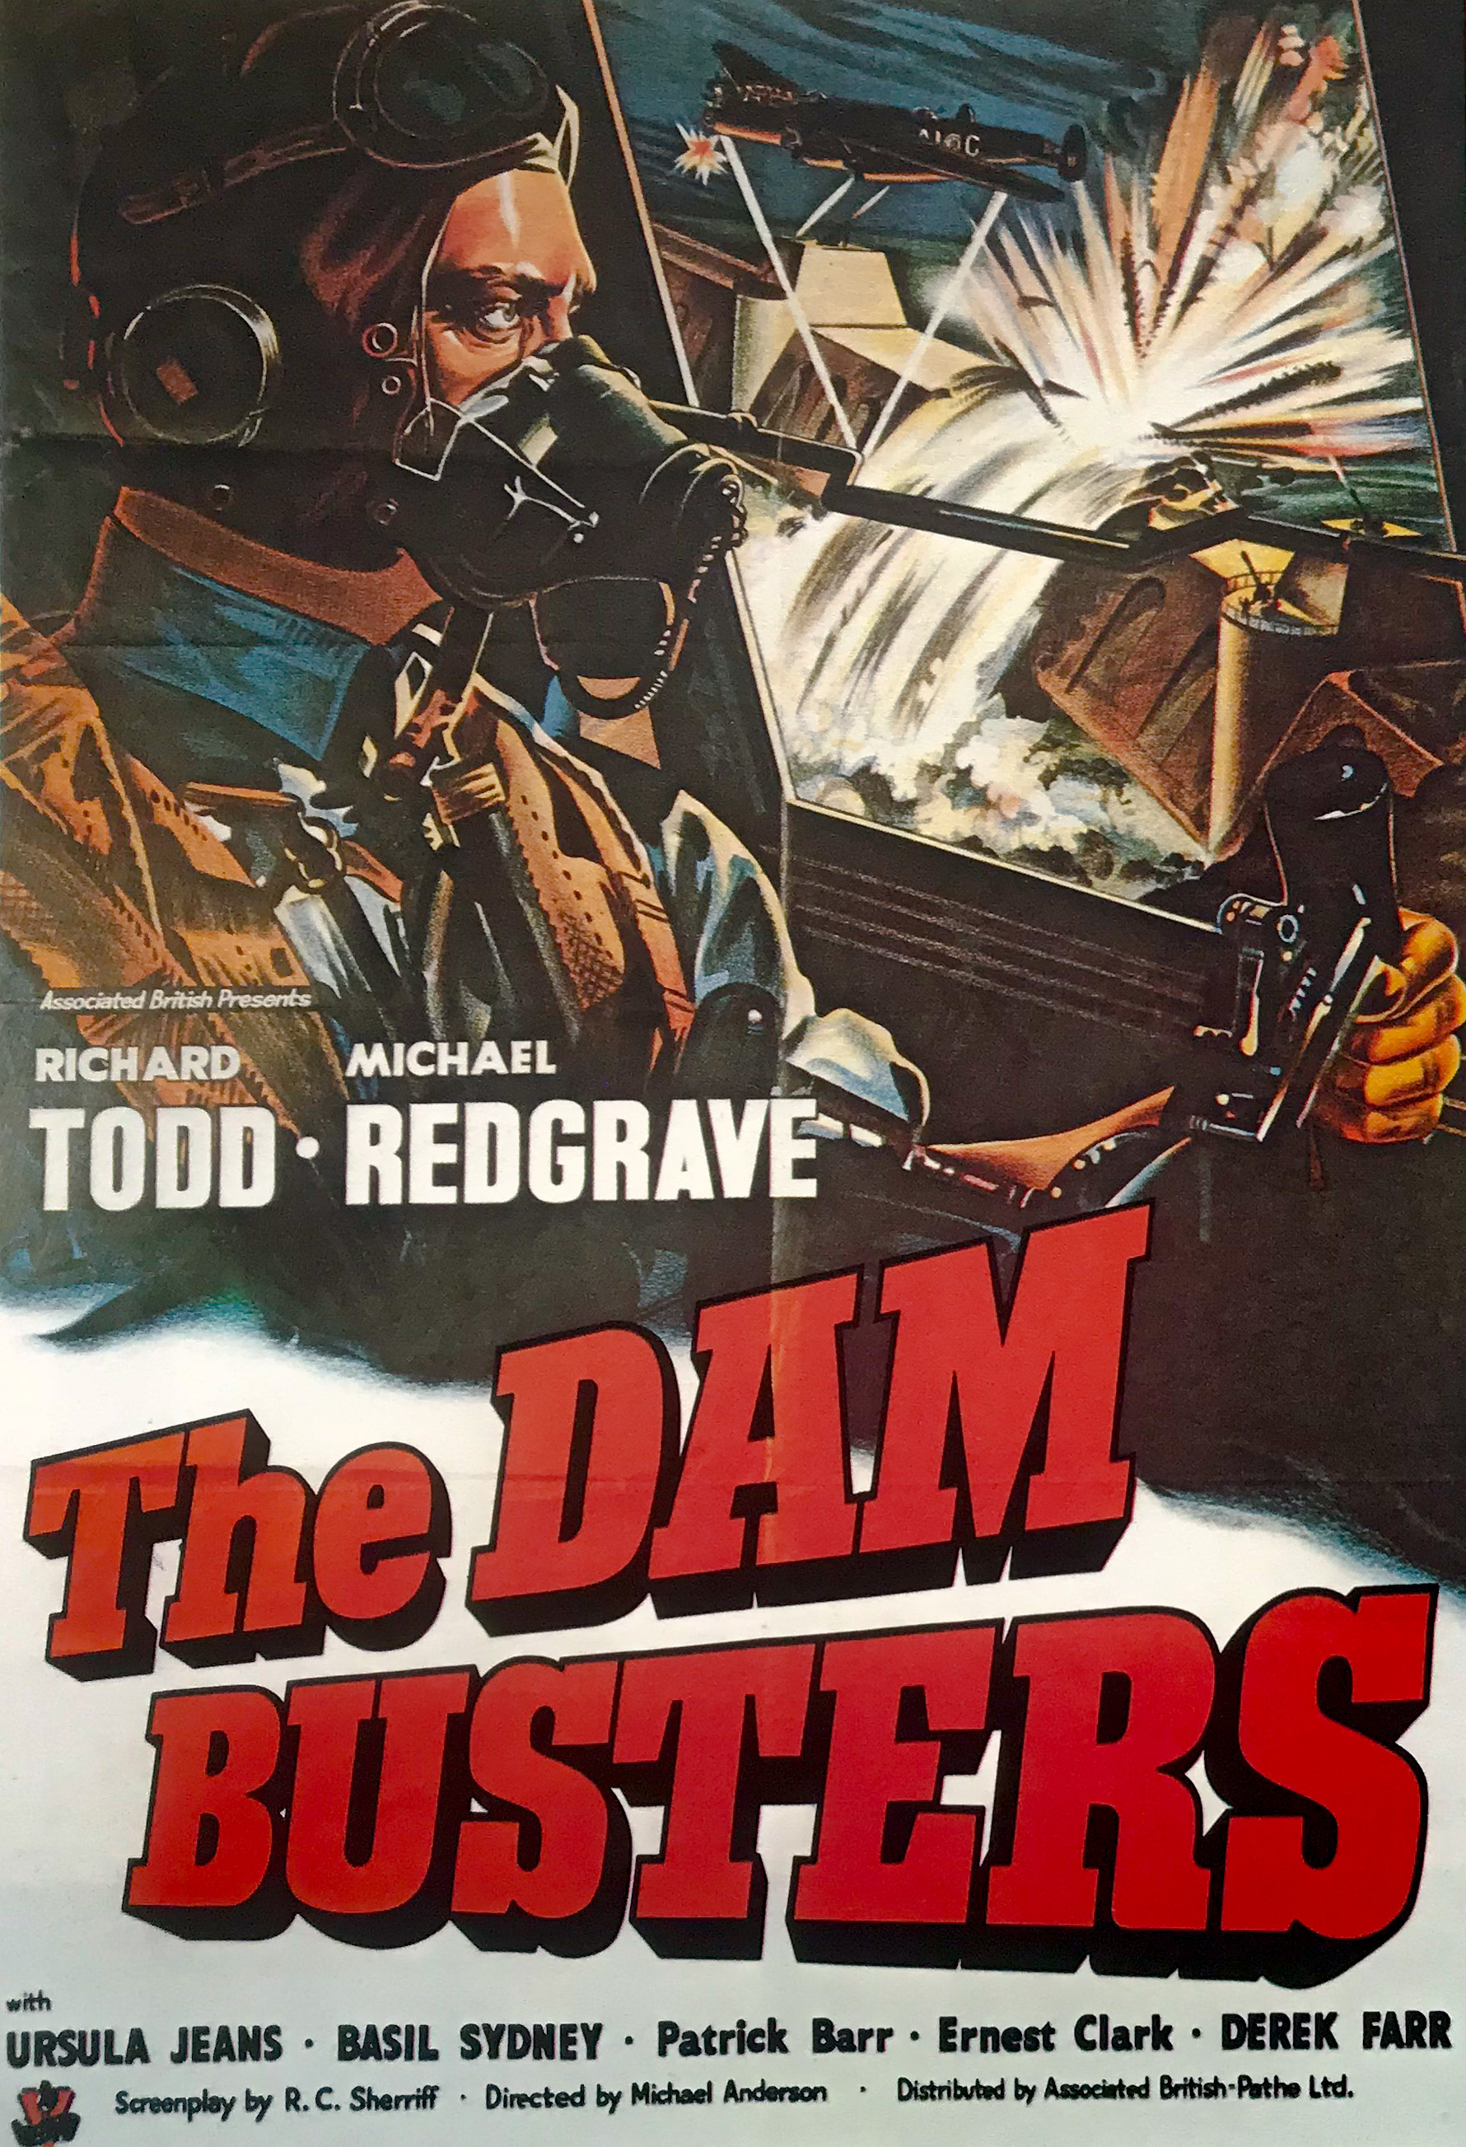
Figure 2:
(Left) Photograph from Operation Chastise of the breached Möhne Dam taken by Flying Officer Jerry Fray of No. 542 Squadron from his Spitfire PR IX, six Barrage balloons are above the dam
(Right) Poster for the 1955 British film “The Dam Busters” which received widespread acclaim and grossed more than any other British film that year. Its depiction of the low flying of the RAF’s 617 squadron provided the inspiration for the trench run on the Death Star in Star Wars: A New Hope
By the start of the Korean War, the 1949 Geneva Conventions had been completed, and there was a new global standard for conduct in war – in many ways established as a reaction to the atrocities of the Second World War. Although this included certain rights for civilians, it did not specifically address aerial bombardment in any way. It did, however, establish a prohibition on the destruction of property unless this is “rendered absolutely necessary by military operations”, stating:
Article 53 – Prohibited destruction
Any destruction by the Occupying Power of real or personal property belonging individually or collectively to private persons, or to the State, or to other public authorities, or to social or cooperative organizations, is prohibited, except where such destruction is rendered absolutely necessary by military operations.
This prohibition, however, is targeted specifically at occupying powers. As a result, while a strong case could be made to support Reginald Thompson’s quip during the United Nations (UN) counteroffensive that “few people can have suffered so terrible a liberation”, it is not clear whether the Geneva Accords of 1949 would have applied to this “liberation” - or only applied to any occupation of Korea after defeat of the Communist foe. The vast majority (90%+) of North Korea proper, however, was in fact occupied by the UN forces from October to December 1950. In his investigation into the UN occupation of the Democratic People’s Republic of Korea, Callum MacDonald concludes that “DPRK claims of over 170,000 massacred” during the occupation purges do “not seem unreasonable” and that American troops themselves were responsible for various war crimes including rape, murder, and mistreatment of both civilians and POWs.
With regards to the bombing campaign against dams specifically, however, it is evident that the UN forces made a significant effort to take attacks against critical infrastructure off of the table until and unless UN forces were pushed back behind the 38th parallel. Other than this, the aerial bombardment campaign, despite Soviet accusations of “barbarous and indiscriminate bombing of peaceful towns and civilians” and criticism of the campaign in British, Indian, and other Asian newspapers, cannot be said to have been a war crime under the 1949 Geneva Accords. In retrospect, however, it is evident that the UN aerial bombardment campaign included many attacks which would now be considered war crimes, particularly with respect to the air campaign’s attacks on critical water infrastructure.

WAR with CHINA?
Shortly after the Inchon Landing in September 1950, the Far East Air Force (FEAF) began raids on North Korean power plants, initiated “without clear guidance from Washington”. These raids on hydroelectric power plants, which also provided civilian electricity, provoked “growing international unease” as to the nature of the American-led UN bombing campaign. On 7 October 1950, the United Nations voted by a margin of 47 to 5 to approve Resolution 376(V) calling for the unification of Korea and authorizing the United Nations forces to cross north of the 38th Parallel. On that same day, Assistant Secretary of State for Far Eastern Affairs Dean Rusk formally requested that hydroelectric power plants be preserved as targets as “possible bargaining chips with the Chinese Communists”. This is primarily due to the fact that many of these power plants, including the largest Suiho power plant, provided power to Manchuria in Chinese territory as well as to Korea. This contributed to the perception that an attack on a hydroelectric power plant would cross a ‘red line’ that would drag China into the conflict, an event that was thought at the time could escalate this purportedly ‘limited engagement’ into another world war.
The concern that a so-called ‘limited engagement’ could spiral into World War III if China became involved may seem silly in retrospect, especially given the hindsight certainty that Stalin would not bring the USSR into the conflict if China joined the war. This fact, however, was not self-evident in early October of 1950. The possibility of a broader world war pitting the United States against the Soviet Union is frightening enough without the knowledge that for a few days it was a real possibility. On 8 October 1950, only a few days after the United Nations forces crossed the 38th parallel, two US Air Force pilots in an F-80 accidentally entered Soviet territory. The pilots, intending only to bomb targets in North Korea, flew off course and spotted American manufactured P-39s with red stars painted upon them. Although the pilot was confused by this, not having seen any P-39s in Korea before, he proceeded to bomb the airfield in what became a wake-up call to the Soviets as to the danger of US air power. International media reported on the incident with headlines like “Moscow Says U.S. Jets Strafed Russian Airfield”, and Stalin seemingly reacted when he cut off all aid to North Korea just two weeks later on 22 October 1950. Additionally, Stalin’s refusal to provide air support to Chinese forces was seen as a betrayal by Mao, and contributed to the fraying of Sino-Soviet relations. While Stalin’s measured response helped to ease some fears of an impending global conflict, this incident heightened awareness of the difficulty that Far East Air Force faced when attempting to confine activities to the Korean Peninsula.
As the operation across the 38th parallel commenced in earnest there was less direct focus upon the hydroelectric plants. Regardless, there was still much unease in the United Nations about bombing these facilities due to “the possibility of Chinese intervention to protect their power supply” especially at the Suiho hydroelectric plant which straddles the Chinese and North Korean border. This international attitude pressuring FEAF to swear off operations that would “interfere with plant operation or power distribution” was accentuated by the “skillful Communist propaganda” announcing the establishment of a “Volunteer Corps for the Protection of the Suiho Hydroelectric Zone”. The French delegation to the United Nations even drafted a resolution guaranteeing the protection of the hydroelectric installations, to which the Joint Chiefs of Staff (JCS) did not object. The JCS did communicate a proposal from the State Department requesting MacArthur to swear off operations against hydroelectric facilities, but MacArthur refused to limit his options unilaterally and the JCS did not push MacArthur for a statement again. MacArthur’s refusal to publicly swear off the bombing of hydroelectric facilities all but guaranteed that the possibility would be considered again at a later stage in the war.
On 5 November 1950, General MacArthur escalated the air campaign when he ordered General Stratemeyer to launch a widespread bombing effort meant to cripple enemy capabilities in northern Korea. This campaign was to be launched in the midst of growing apprehension over the possibility that China would enter the war. At the same time that the American delegation to the United Nations was putting together a special report on Chinese intervention and the British Government was holding cabinet meetings to decide its policies towards China, MacArthur was about to undertake a massive operation spitting distance from the Chinese border. This, of course, sparked considerable worry that the campaign could force China’s hand and ensure its involvement in the war.
While President Truman was “well aware of the danger of a serious border violation”, he accepted the judgment of his theater commander and gave approval to MacArthur’s proposed operation. The Joint Chiefs of Staff thus sent MacArthur a message telling him he was “authorized to go ahead” with his planned bombings so long as he recognized that this “does not authorize the bombing of any dams or power plants on the Yalu River”. The JCS further emphasized MacArthur’s limitations by telling him that “extreme care” must be taken to “avoid violation [of] Manchurian territory and airspace”. General MacArthur responded confidently that his operation was “so plainly defensive that it is hard to conceive that it would (…) provoke a general war” and in any respect that it was necessitated by a “buildup of enemy strength” along the border. He further restated his commitment to the “cardinal obligation” of the inviolability of Manchuria and Siberia and claimed that he never had any intention to destroy the hydroelectric facilities in the first place. Despite MacArthur’s strong conviction as to his innocence in escalations with the Chinese, not everyone was convinced.
On 7 November 1950, General Marshall sent a “very personal and informal” dispatch to General MacArthur expressing his support along with the support of the President, as well as the State and Defense departments. Marshall warned MacArthur to be wary of the “world disaster” that could result from his missteps and asked, seemingly rhetorically:
Incidentally, for my personal information, do you feel that the hydroelectric and reservoir situation is probably the dominant consideration in this apparently last-minute move by the Chinese Communists incited by the Soviets to protect their interests in Vladivostok, Dairen, and Port Arthur?
At the end of a message that had mostly been filled with kind words for General MacArthur, General Marshall asks whether General MacArthur’s threats of water infrastructure could have sparked the military buildup in these locations. General Marshall asks this question as casually as possible, playing it off as if he just is curious for his own edification, but in spite of this façade the memo still conveys General Marshall’s skepticism at General MacArthur’s arguments.
General MacArthur’s response is quite revealing due to both its scope and substance. First, MacArthur did not seem to perceive anything unusual about the last paragraph, and expressed his appreciations for such a “cordial and understanding message”. Second, General MacArthur’s response was not limited to a discussion of the enemy’s thinking about the water infrastructure, but instead included sweeping generalizations about the nature of the enemy. While MacArthur response to Marshall that the hydroelectric facilities were “clearly of insufficient consequence to become provocative of a major war” is a reasonable argument, he decides instead to dedicate the majority of his response to the Chinese “character and culture” and its “lust for the expansion of power”. This elaborate and rather racist explanation did little to address whether the potential bombing of hydroelectric facilities was at fault for the buildup of military assets along the border. General Marshall did not seem convinced by MacArthur’s Sinophobic diatribe, responding rather curtly:
[Thanks for this] comprehensive analysis of the causes and effect of the present situation. I think you misunderstood my query re hydroelectric installations (…) I was referring only to the sudden developments of the past week. Don’t bother to acknowledge this.
By “sudden developments of the past week”, Marshall was alluding to the Soviet aerial intervention on 1 November 1950 when MiG-15s set up effective defenses of Suiho Dam and other critical infrastructure in North Korea. Although it was not known at the time, the Soviets had provided battle-hardened World War II veteran pilots along with their MiG-15 planes. In the first confrontation between Soviet and American planes on 1 November, the Soviets shot down two American Mustangs without losing a single MiG. Marshall’s message implies that he still holds General MacArthur at least partially responsible for the escalation of the conflict in the past week, which he does not see as stemming from these broader ‘explanations’ promoted by MacArthur.
Notwithstanding General Marshall’s skepticism, neither he nor the JCS nor the President nor any other department so much as requested that General MacArthur wait to escalate the air campaign until he was sure that the Chinese had intervened. This is regardless of the fact that, as General Stratemeyer acknowledged, the bombing of targets on the Yalu River “cannot be done” without hitting Manchuria. Although MacArthur still left open the possibility, which he would take up later in the war, to engage in attacks on the hydroelectric plants, it was evident to him by early November that he should not attack these targets at this time. MacArthur stated on 9 November 1950 that:
I believe that with my air power, now unrestricted so far as Korea is concerned except as to hydroelectric installations, I can deny reinforcements coming across the Yalu in sufficient strength to prevent the destruction of those forces now arrayed against me in North Korea.
United Nations (UN) claims of engaging in a just and restrained war thus rested partially upon this refusal to target the hydroelectric plants, although this was done less out of humanitarian concerns than out of a wariness of ensuring China would join the conflict. While it is clear here that MacArthur bears significant responsibility for this bombing campaign, he should not be unfairly scapegoated. At every level those who could have overruled MacArthur decided instead to give him free rein to pursue his military objectives, regardless of potential political consequences.
The case that MacArthur is uniquely responsible for the attacks on the hydroelectric facilities is undermined by the Joint Chiefs of Staff’s query shortly after the Chinese had entered the war as to the “feasibility and desirability of destroying the dams and plants” if the Chinese were to make it south of the 38th parallel. MacArthur asserted that his medium bombers could do the job, but that the decision to conduct such operations should be based upon “political rather than military considerations”. This would seem to indicate that MacArthur now grasped the seriousness of attacking these hydroelectric facilities and was passing the buck on the decision of whether to undertake them. Despite MacArthur’s confidence that the operation could be achieved by the medium bombers, this was not a universal sentiment. While the Navy “generally favored the attacks” in a report released in January 1951, the Army “feared the action would appear to be part of a US ‘scorched earth’ policy”, and the Air Force was “not sure” whether it even had the “capabilities to harm the large dams”, requesting to target the power complexes in Manchuria instead of the dams themselves. These varied reactions meant that there was no quick resolution to the decision of whether or not to target these hydroelectric facilities. A few months later, in March 1951, the Joint Chiefs of Staff concluded that bombing the hydroelectric plants would “not contribute materially to the Korean tactical situation” and that attempts to predict the impact of such bombings in the UN were “problematical”. The bombing of hydroelectric plants, still not ruled out completely, was pushed off again out of a wariness of potential political blowback.

FIGHT for the HWACHEON DAM
The United Nations forces were not the only ones considering the use of hydroelectric facilities as tools of war. At midnight on 8 April 1951, North Korean and Chinese forces released excess water from the Hwacheon Dam’s spillway, disabling five floating United Nations Command bridges downstream. This use of the Hwacheon Dam in warfare is a rare example of the use of water infrastructure in war, but it was not close to the same severity as the eventual destruction of Korean irrigation systems by the Far East Air Force. The event does indicate that both sides viewed water infrastructure to be ‘fair game’ for military purposes, however, this should not have any bearing upon the key distinction between exploiting water infrastructure against primarily military as opposed to civilian targets.
In response to enemy flooding of the Han River with water from the Hwacheon Dam, the United States 7th Cavalry Regiment was to take the Hwacheon Dam. This was meant to be carried out immediately so that the dam could be taken before enough water could accumulate in the reservoir, given that with enough water the North Korean and Chinese forces could flood the entire Bukhan River Valley. Encountering unexpectedly strong resistance, the 7th Cavalry Regiment was unsuccessful and the task fell to the Far East Air Force. FEAF sent B-29 Superfortresses to try to destroy the floodgates, but the B-29s were unsuccessful. The next attempt to destroy the Hwacheon Dam involved sending Skyraiders to bomb the dam with 2000-pound bombs and 11.5-inch Tiny Tim rockets, to no avail. Despite aerial torpedoes not having been used since World War II and only one pilot having experience in their usage, it was decided that the Navy would fly a mission attempting to utilize aerial torpedoes to disable the Hwacheon Dam. On 1 May 1951, Commander Dick Merrick led eight Skyraiders off the deck of the carrier Princeton and set course for the Hwacheon Dam with each plane carrying a Mark XIII aerial torpedo. Six of the eight aerial torpedoes struck on or near the floodgates, blowing one of the floodgates apart, breaching the dam with holes on both sides. This attack successfully disabled the Hwacheon Dam and blacked out electricity over a wide surrounding area. The destruction of the Hwacheon Dam helped to advance the aims of the United Nations forces but did so at the cost of the flooding of and the cutting of electricity to the surrounding area.
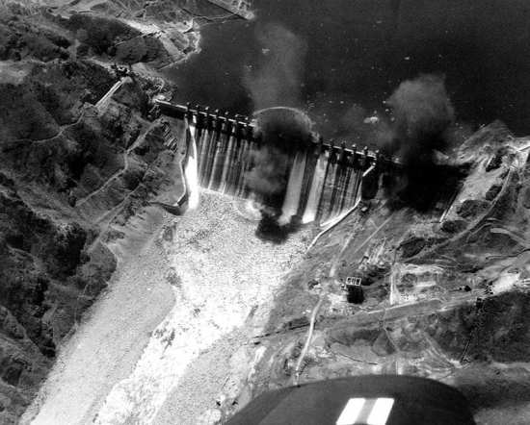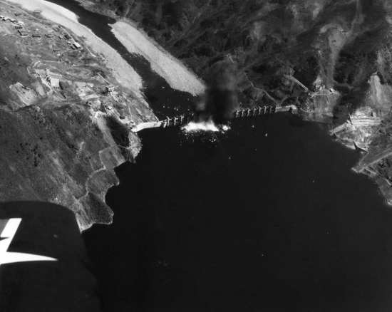
Figure 3:
(Left) The Hwacheon Dam in South Korea as pictured from what was probably CAG Merrick’s F4U Corsair, during the torpedo raid on May 1, 1951. National Archives photo
(Right) A strike photograph showing the successful torpedo attack by AD-4 Skyraiders against the Hwacheon Dam in South Korea, May 1, 1951. National Museum of Naval Aviation photo

CARPET BOMBING of KOREA
After the battle over the Hwacheon Dam, the Joint Chiefs of Staff’s prohibition of dam bombing held for over a year, until the Battle of Suiho Dam began in June 1952. During this period, however, attacks by the Far East Air Force did not slow, and in fact the UN bombing campaign caused significant damage to North Korea throughout 1951. In response to this extensive bombing campaign, the Commission of the Women’s International Democratic Federation (WIDF) sent a fact-finding mission with representatives from China, the Netherlands, and both East and West Germany to investigate claims of war atrocities in Korea. The report prepared by this group was wrongfully disregarded as fabricated Soviet propaganda for decades due to its criticism of American conduct during the war, and several of its authors suffered persecution in their home countries due to perceived Soviet sympathies. The report details the extent of the destruction that had been wrecked upon North Korea by the time of its publishing in May 1951:
In the course of the journey from Sinuiju to Pyongyang the Commission observed that the towns and villages through which they passed were almost completely destroyed (…) The ruined villages were too numerous to be listed (…) The destruction [of Pyongyang] is now virtually 100 per cent (sic). But in spite of this, bombing still continues. (…) The members, in the whole course of their journey, did not see one town that had not been destroyed, and there were very few undamaged villages.
In retrospect, the vast majority of horrific claims in the report have held up to scrutiny. In fact, testimony by Major General Emmett O’Donnell Jr., Commander of the Far Eastern Air Force Bomber Command, to the US Senate on 25 June 1951 confirms the extent of destruction in North Korea as laid out in the WIDF report:
Senator Russell: (…) As I understand it, you intended to give them notice you had better get out of the war or we will burn your cities?
Gen. O’Donnell: I thought that would take care of the humane aspects of the problem (…) Tell them to either stop the aggression and get back over the 38th parallel or (…) there is not going to be anything left up in North Korea to return to.
Senator Stennis: (…) Now as a matter of fact, Northern Korea has been virtually destroyed, hasn’t it? Those cities have been virtually destroyed.
Gen. O’Donnell: Oh, yes (…) I would say that the entire, almost the entire Korean Peninsula is just a terrible mess. Everything is destroyed. There is nothing left standing worthy of the name (…) There were no more targets in Korea.
Both the WIDF report and the Congressional testimony indicate that throughout 1951 FEAF bombed North Korea so extensively that it nearly completely destroyed all of its cities, towns, and villages, leaving virtually nothing left. This obviously resulted in a humanitarian crisis of epic proportions, with extensive civilian casualties and an unknown but massive number forced to flee their homes as refugees. It is important to remember that the specific restraint placed by the JCS upon attacks on hydroelectric facilities during this period did not preclude the widespread destruction of civilian homes and infrastructure.

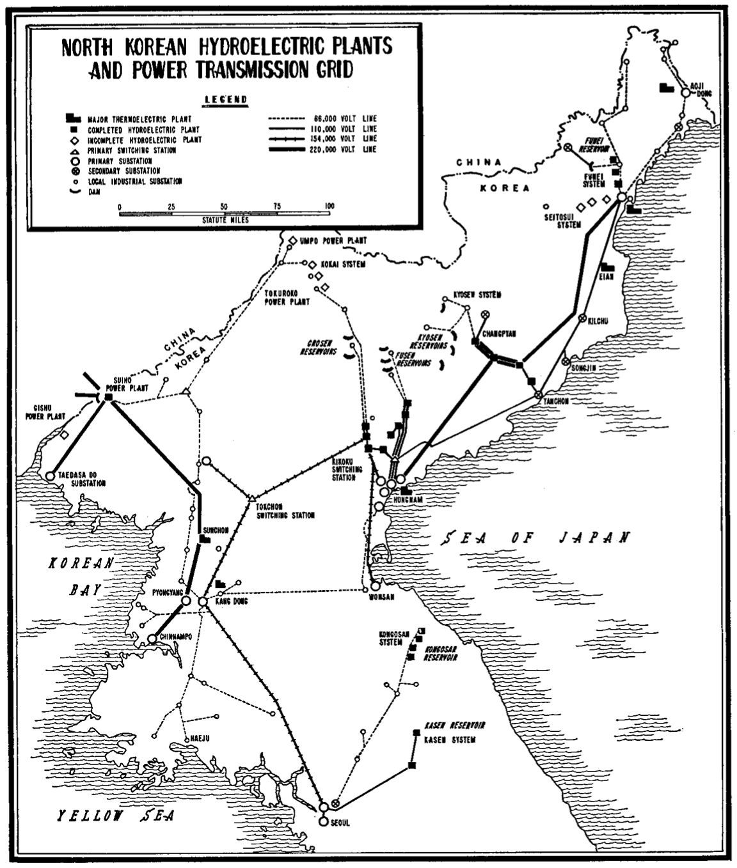
START of CEASEFIRE NEGOTIATIONS
The Korean War settled into a stalemate following the UN May-June 1951 counteroffensive which saw the UN forces retake much of the territory which they had lost in the Chinese spring offensive earlier that year. The frozen ground conflict combined with the sheer extent of the destruction in Korea left few targets for future bombing raids. Negotiation of an armistice began officially on 10 July of 1951 at Kaesong, in contemporary North Korea. Notwithstanding initial expectations that the demarcation line be at the 38th parallel, or status quo ante bellum, the Chinese and Korean delegations agreed within weeks to divide the peninsula at the Kansas Line, or the line of actual control. It is thus evident that by the summer of 1951 the Chinese and Koreans were already willing to cede significant territory even when just looking at the status quo ante bellum, much less at the initial goal of a unified socialist Korea. Despite this breakthrough, negotiations stalled on the issue of Prisoners of War (POWs), as President Truman demanded that POWs could only be repatriated voluntarily. According to President Truman, “[F]orced repatriation (…) would be repugnant to the fundamental moral and humanitarian principles which underlie our actions in Korea”, and thus it could not be conceded to achieve a ceasefire. President Truman’s position ran counter to both the Geneva Accords and the precedent of previous wars, including World War II. Truman held firm in his convictions purportedly out of humanitarian concerns but more likely due to the potentially massive moral and propaganda victory which could be achieved by taking in a significant number of Chinese and Korean POWs who rejected Communism. As a result of Truman’s stubbornness, and the continued refusal of the Chinese and Koreans to be embarrassed in this way, an armistice would not be signed for another two years.
Over the course of those next two years, UN forces became increasingly frustrated that they could not bring about the unconditional surrender of the enemy. Out of a misguided belief that further destruction could bring about a surrender, FEAF continued to escalate the air war. It would be quite surprising if the enemy’s resolve could be broken through further collective punishment when they had already witnessed the near complete destruction of North Korea, but only rarely in war does one consider the perspective of their enemy. Brigadier General Jacob Smart, FEAF deputy for operations, developed the strategy of “air pressure” as a new and better way to use “destructive power as a political tool” which could bring about surrender. A staff study with recommendations as to the targets of an escalated air war was completed on 12 April 1952 and recommended making the conflict “as costly as possible” by striking “hydroelectric plants (when they were cleared for attack by the JCS), locomotives and vehicles, stored supplies, and (…) buildings”. The placement of hydroelectric plants as the first potential target in this list is striking as these plants had not yet been cleared as targets by the JCS. This obviously does not go unrecognized, as is evident from the quoted parenthetical statement, but it is clear that FEAF viewed the hydroelectric plants as obvious targets for further escalation regardless. FEAF’s desire to strike these hydroelectric plants, long held in check by the JCS, was to be fulfilled in 1952.
Even though the hydroelectric plants were agreed to be the first targets for an escalated air campaign, General Ridgway rebuffed requests from Fifth Air Force and FEAF to destroy them in March. This was due to Ridgway’s belief that “destroying targets whose primary use was for the civilian economy (…) would not hasten Communist agreement to UN armistice terms” and thus attacks on hydroelectric plants would be sanctioned “only if negotiations were hopelessly deadlocked or were broken off”. Ridgway was stubborn in his insistence that as long as armistice talks continued at Panmunjom, the use of additional force was “fundamentally wrong”, although this problem was resolved with General Mark Clark’s replacement of General Ridgway at United Nations Commander in Korea on 28 April 1952. By this point, the JCS had jumped on the bandwagon and was also subtly encouraging General Ridgway to engage in attacks on the hydroelectric complexes, with a May 1952 message pointing out that the most recent directives only prohibited attacks on the Suiho Dam on the Yalu River. On 6 June 1952, General Wayland explained to General Clark the significance of the North Korean hydroelectric power complexes and emphasized that all of the plants other than Suiho were now considered valid targets. This interpretation, repeated by both the JCS and General Wayland, was based upon a “very strict reading” of a 10 July 1951 compilation of existing JCS directives that prohibited attacks specifically “against hydroelectric installations on the Yalu River” but with no mention of attacks upon other plants or dams not on the Yalu. The JCS had made it so that an attack on the hydroelectric plants was not just technically permissible, it was even tacitly encouraged.
Figure 4:
Map depicting the hydroelectric plants in Korea and the transmission grids for electricity
ATTACK on the HYDROELECTIC DAMS
With an attack on the hydroelectric plants now in motion, the question became merely a matter of which of the complexes would be attacked when. It was decided that the hydroelectric complexes at Fusen, Choshin, and Kyosen would be attacked initially, and General Wayland requested that two sets of plans be drawn up: one including just these three sites and one with Suiho Dam (today known as 수풍댐 or the Sup’ung Dam) added as well despite the existing explicit prohibition upon striking this target. This plan left the smaller Funei and Kongosan hydroelectric complexes to be targeted another day. After 11 June 1952 when Wayland sent Clark the aforementioned plans without an attack on the Suiho, USAF Chief of Staff General Hoyt Vandenberg set about maneuvering behind the scenes to convince the Joint Chiefs of Staff to remove all remaining restrictions upon attacks on hydroelectric installations, including on Suiho. On 17 June 1952, General Clark ordered an attack upon the hydroelectric plants excepting Suiho. Before this could be executed the generating plant at Suiho was added as a target at the recommendation of the JCS and with the express consent of President Truman. With the remaining limitations on attacks on the hydroelectric facilities now gone, the scene was set for the destruction of North Korea’s hydroelectric capacity.
The Suiho Dam was a lucrative target, but it would not be easy to destroy. As the fourth largest dam in the world at the time it was thought that the destruction of the dam itself would be “beyond the capabilities of FEAF”, and so transformers, penstocks, and power distribution facilities were targeted instead. Starting on 23 June 1952, Navy and Air Force planes carried out three days of intensive bombings of hydroelectric plants in a feat of inter-service cooperation which included more than 1400 sorties. The attack targeted 17 generators at the hydroelectricity complexes at Suiho, Chosin, Fusen, and Kyosen, resulting in a two-week total blackout in North Korea along with a loss of nearly a fourth of Manchuria’s electricity due to its reliance upon Suiho. Crane claims that more than 90% of North Korean power potential was destroyed, with the impact being apparent to UN POWs who “never got to see the end of any of the propaganda films they were exposed to that summer ‘because in no instance did the electric power hold out for the full showing’”. While it was difficult to fully destroy such a diverse set of targets, the mission was otherwise a success. By taking out much of North Korea’s hydroelectric capacity, the UN forces had struck a dual blow against both the Korean people and Manchurian industrial capacity.
While the attacks upon hydroelectric facilities went forward with the approval of Truman, the Joint Chiefs of Staff, and General Clark, these decision-makers failed to adequately consult with US allies. The French and British criticized the attack to Secretary Acheson, with the French complaining about the domestic backlash from the attack and the British upset that they had not been notified in advance. US Secretary of Defense Robert Lovett tried to mislead the press by stating that the JCS had given special permission for the raids on “purely military” grounds, but the newspapers were not fooled and speculated that the attack had resulted in “darkness and industrial paralysis” across Manchuria and North Korea. Even with repeated denials that “there was no relationship between these attacks and the armistice talks”, it was evident to most observers that the actual purpose of the campaign against the hydroelectric plants was to coerce of the Communists into accepting Truman’s position on the POW issue. The destruction of the hydroelectric plants and the subsequent loss of electricity across North Korea and much of Manchuria was a form of collective punishment carried out for the sake of achieving political concessions.

EX-POST-FACTO WAR CRIMES
It is important at this time to take a brief moment to assess the viewpoint of the United States military on these attacks, given their uniquely important role in the affairs of the Korean War. According to Futrell’s official account of the air war, attacks upon such “vital” targets as the hydroelectric plants “were especially pleasing” to both Air Force and Navy commanders and pilots. This indicates that despite both commanders and pilots being aware of the damage which would be wrought in destroying these hydroelectric plants, both groups proceeded enthusiastically, without consideration as to the potential effects upon civilians. This lack of concern extended to the international media as well, which predominately reported on the strategic dimension of the attacks with little to no regard for the possible effects on civilian water supply even given that electricity from the hydroelectric plants was needed to power the water turbines. While it is horrifying that these humanitarian issues were completely ignored, one explanation may stem from the fact that these were not considered war crimes at the time. Since the Geneva Conventions of 1949 had only a limited scope, attacks upon hydroelectric facilities were not technically in violation of international law. This would soon change, however, at least partially spurned by the atrocities committed in the Korean War.
While international law had not yet developed to the point whereby the bombing of hydroelectric dams was explicitly a war crime, it was evident that the United States considered it as such when the perpetrators were its enemies rather than itself. The case of German High Commissioner Arthur Seyss-Inquart is illustrative of this fact, as Seyss-Inquart was condemned to death at the Nuremberg Trials for crimes during his reign in the Netherlands including the opening of dykes during the Allied advance. Western media reports on the destruction of the dikes were extremely critical, viewing it as illustrative of the Nazi’s total disregard for human life. The CBC's Matthew Halton pointed out that the opening the seawall did not serve any military purpose, but instead that the Germans have done it "for no reason but bloody-mindedness". These strong reactions are indicative of the existing taboo amongst European powers against attacks upon water infrastructure, although as the Dam Busters raid shows, this taboo was not extended by the Allies to their conduct towards their enemies.
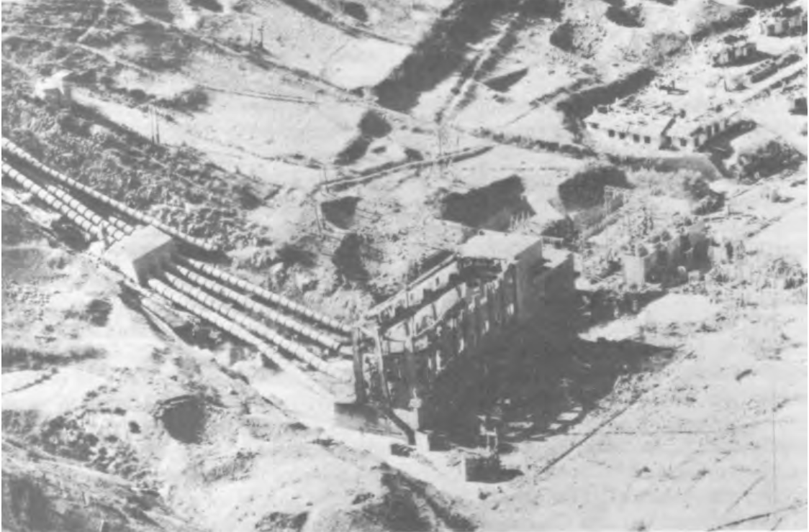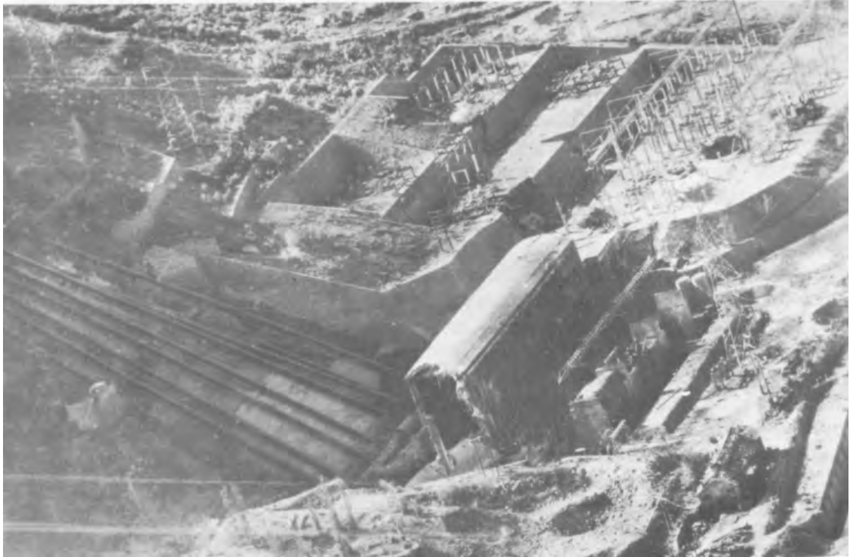Figure 4:
(left) Hits on Kyosen No.4 destroyed the generator house (foreground) and damaged the transformer yard
(right) At Kyosen No.1 UN bombing rendered the entire plant unserviceable
The rapidly increasing destructive power of war helped to inspire movements to create international standards of just war. This primarily occurred through the various Geneva Conventions, although other international treaties have helped to shape standards of international law during conflict. In 1977, the Protocol Additional to the Geneva Conventions, relating to the Protection of Victims of International Armed Conflict demarcated in Article 56: Protection of works and installations containing dangerous forces that “works or installations containing dangerous forces, namely dams, dykes and nuclear electrical generating stations, shall not be made object of attack” and that the only exceptions are to be if the installation is used “in regular, significant and direct support of military operations and if such attack [upon the installation] is the only feasible way to terminate such support”. Despite the claim that the hydroelectric plants were selected as purely military targets, the record shows that the driving force behind their targeting was collective punishment meant to coerce an armistice on UN terms. It is thus evident that the 1977 Protocol Additional to the Geneva Conventions would have been violated in the 1952 attacks on Korean hydroelectric dams since the hydroelectric facilities did not have a significant military use nor was their destruction the only way available to respond to a potential military use. This should not be surprising, given that the Korean War integrally shaped the development of international norms and laws around attacks upon water infrastructure in war. The military responded to this growing movement against indiscriminate brutality in war by escalating the air war in the face of these activists. This violent response to popular protest backfired and served only to strengthen these movements, whose activism would eventually result in the 1977 Protocol Additional to the Geneva Conventions.

ATTACK on the IRRIGATION DAMS
The final escalation of the air campaign was the attack upon the massive Korean irrigation dams, the destruction of which was meant to result in massive flooding to inundate the rice crop. The FEAF Formal Target Committee began to study attacks upon the irrigation system in March 1953 with the goal of flooding and destroying the 422,000 acres of rice relying upon this irrigation system. When the possibility was breached on 7 April 1953, several members of FEAF’s Formal Target Committee questioned whether such a drastic escalation was appropriate and General Weyland himself, in spite of his enthusiasm for the air campaign thus far, was “skeptical of the feasibility and desirability of destroying the North Korean rice-irrigation system”. Regardless, Weyland’s planners convinced him to authorize attacks upon three dams near important railways which could be targeted as part of an interdiction program, although the planners considered this rationale a “mode of deception” to obfuscate the true objective of “destroying the rice crop”.
General Weyland was not ignorant as to the machinations around him, however, and in fact vetoed a proposal by Smart to warn civilians below the dams of their imminent destruction as a part of a psychological warfare campaign. This veto likely worsened the casualties from the attack but it was seen as necessary so that General Weyland had plausible deniability as to the nature of the attacks. Both Weyland and Clark believed that the attacks had to be justified publicly as interdiction raids to minimize political backlash. While this rationale was presented to the public for the attacks, those involved in the attacks were under no illusions as to their true purpose.
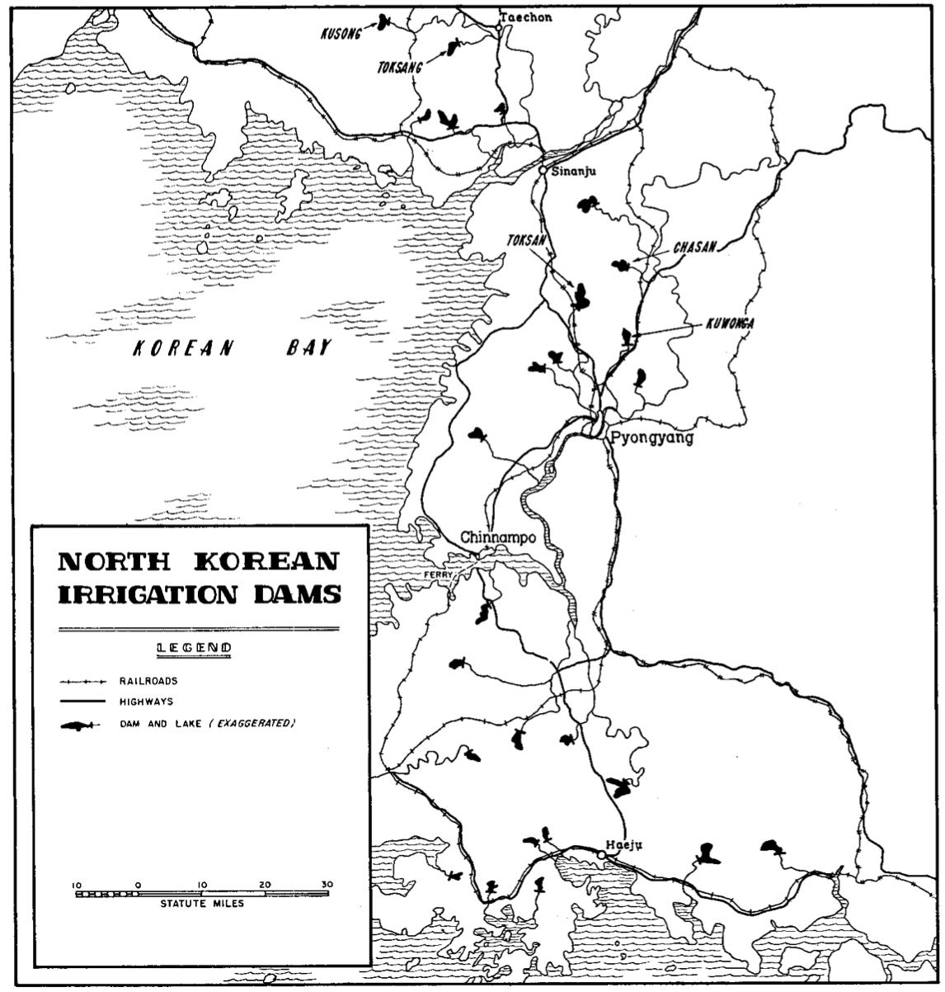
Figure 5:
Map of North Korean Irrigation Dams
The view of these attacks as a form of collective punishment meant to starve the Koreans into submission is not a common one, although it is strongly supported in the historical record. The official history from the Joint Chiefs of Staff describes the decision to attack irrigation dams and “cut off the food supply for enemy soldiers and civilians alike” as a “sensitive” one. General Clark was even more clear when he advised the JCS that in case of a prolong recess in the peace talks that he:
(…) planned to breach twenty dams to (…) destroy an estimated one-quarter million tons of rice, “thereby curtailing the enemy’s ability to live off the land and aggravating a reported Chinese rice shortage and logistic problem”.
Clark was careful in official FEAF reports about these attacks, only mentioning rail and road bridges affected while including nothing about the rice crop.
These omissions were repeated in the mainstream media and in UN communiqués as well. Mentions of the dam bombings in the New York Times were limited to a few lines from official UN reports, with a 23 May 1953 report on the bombing of Kuwonga Dam repeating the official FEAF line that the dam was targeted because it was near “key road and rail bridges”. This is despite the fact that in the 1954 edition of the US Air Force Quarterly Review it is clearly stated that Kuwonga Dam was targeted because of the “fertile agricultural lands irrigated by the waters from its reservoir”. General Clark was aware of how the attacks would look at the time and thus was surprised that there was little reporting on it, although his lack of mention of the targeting of rice crops likely played a role in the press’s disinterest. Additionally, “in accordance with Far East Command and JCS desires”, the dam attacks were purposefully not highlighted in official UN communiqués, which instead focused on the missions of the F-86s. It is evident that the planners of these attacks were aware of the effects they would have upon both the rice crop specifically and Korean civilians in general, and in fact were counting on this in the hopes that collective punishment would coerce their Communist adversaries to sign the armistice on UN terms.
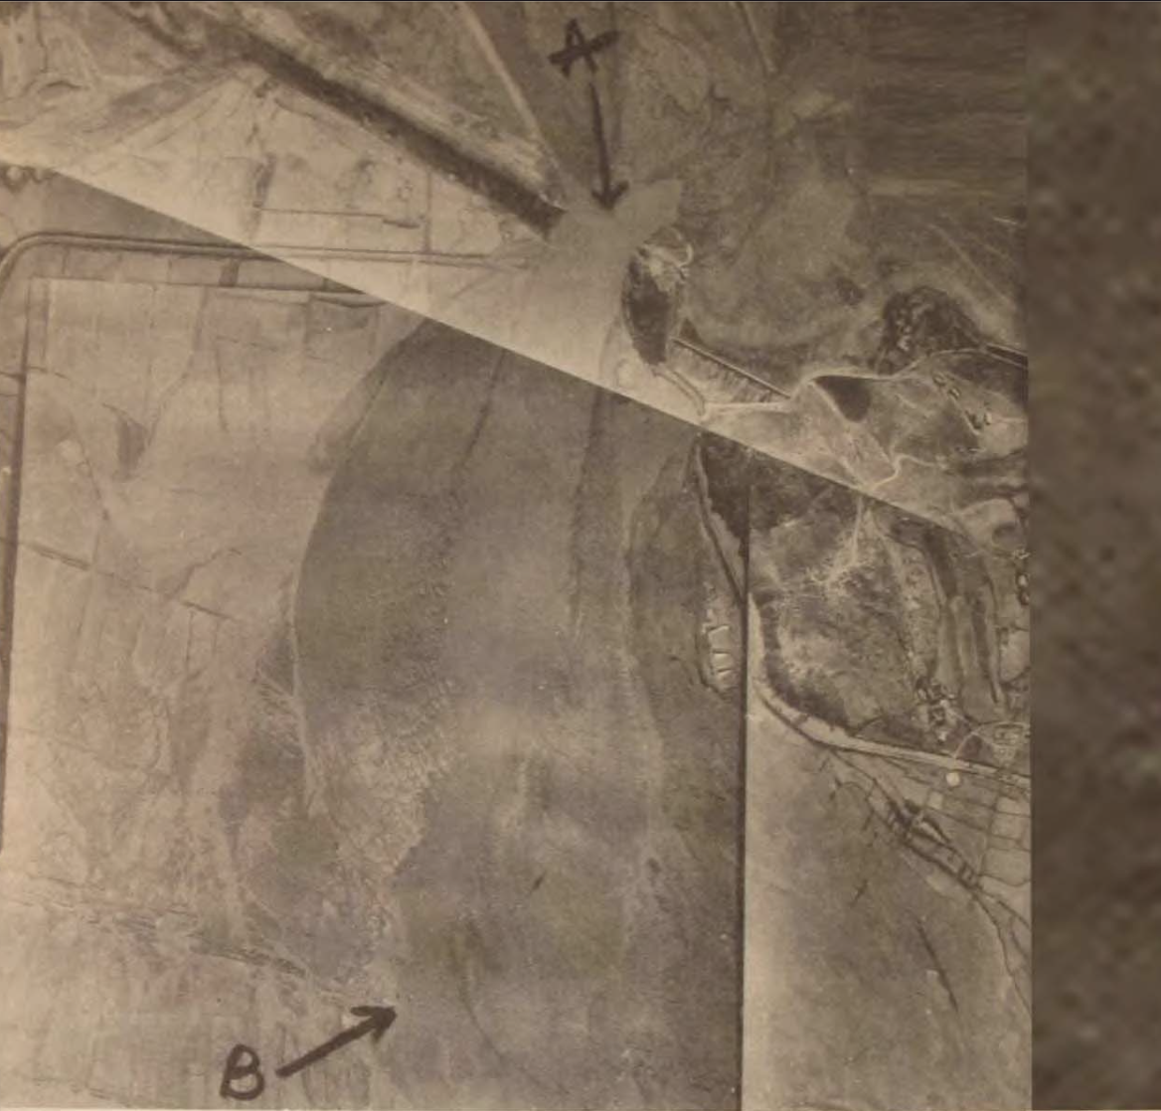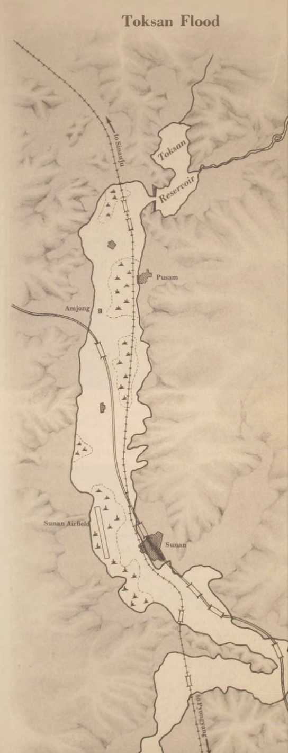
Figure 6:
(left) Aerial composite photograph shows the extent of the damage from the 13 May 1953 attack on the massive Toksan Dam. “A” marks the breach in the dam, and “B” shows the inundated Communist supply route. Although the press release that accompanied this picture misleadingly reported that the dam held “electric-power producing water”, it accurately stated that the “rushing waters washed out rail and road bridges and destroyed over 6,000 feet of the road bed” of the enemy railway, along with an antiaircraft gun position and a small airfield nearby.
(RG 342 NA II)
(right) A map of the Toksan Flood following the destruction of the Toksan Dam shows the geographic extent of the flooding and the infrastructure destroyed by it. The small tufts on the map represent rice paddies.
This final escalation to attack the enemy’s crops was a completely unnecessary form of collective punishment which did not achieve any meaningful concession, much less the signing of the armistice. On 13 May 1953, the approximately 2500 foot long Toksan Dam was bombed by the Fifth Air Force at the order of General Weyland and “at last light the dam seemed to have withstood the 1,000-pound bombs directed against it”. Unfortunately for the North Koreans, the dam would not hold and sometime overnight the impounded waters leaked out leaving an empty reservoir the next morning. With the breach of the Toksan Dam, the resulting floodwaters destroyed or damaged more than six miles of railway lines, five railway bridges, two miles of a major highway, and at least five square miles of ricefields. The attacks were carried out during mid-May, one of the most vulnerable times for a new rice crop. This illustrates that despite claiming that the purpose of the irrigation dam attacks was rail interdiction, the timing of the attacks reveals that the true target was the rice crop.
Shortly after the successful bombing of the Toksan Dam, two other dams were bombed: Chasan Dam and Kuwonga Dam. General Clark did not “ask permission of Washington” for these subsequent attacks, although the “Joint Chiefs of Staff raised no objection”. The attack upon the Chasan Dam was a success, and the impounded water flooded an extensive territory. The Chasan Flood destroyed “field after field of young rice” in addition to destroying rail, roads, and bridges. The attack upon the Chasan Dam thus again reveals itself to be no mere rail interdiction but instead to be a purposeful targeting of the young North Korean rice crop. The floods following the bombings of the Toksan Dan and Chasan Dam were so extensive that they both “sent water into the streets of Pyongyang”. Although it was never carried out, plans were made by the FEAF Formal Targeting Committee to distribute leaflets blaming the Chinese for the attacks upon the irrigation system. FEAF’s attempt to shift the responsibility for these attacks onto China indicates that they recognized the attacks were likely war crimes and that this could cause political blowback.
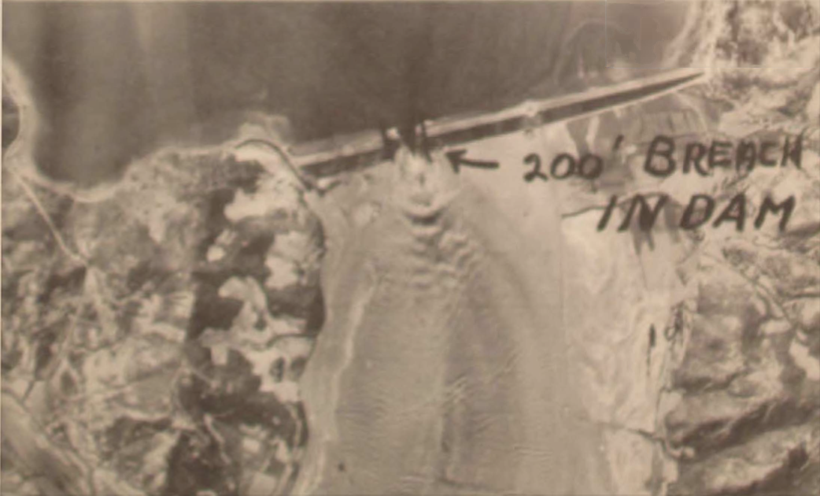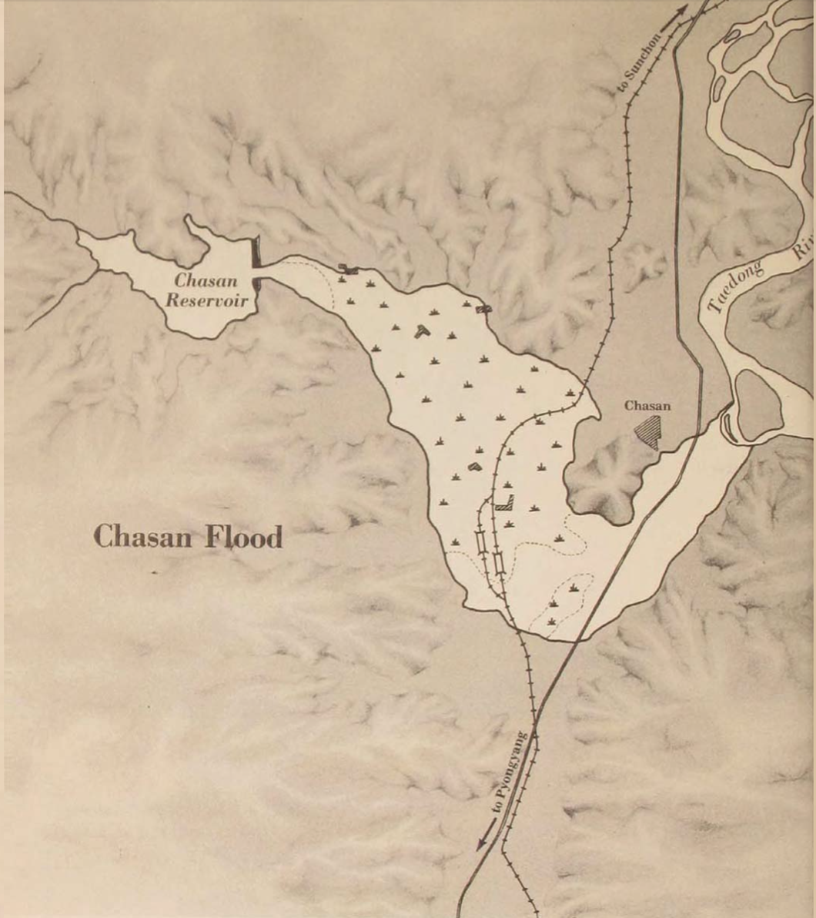Figure 7:
(left) Aerial photograph of the ~2400 foot long Chasan Dam after UN bombing left a 200 foot breach in it
(right) A map of the Chasan Flood following the destruction of the Chasan Dam shows the geographic extent of the flooding and the infrastructure destroyed by it. The small tufts on the map represent rice paddies.
By the time that Kuwonga Dam was bombed, the North Koreans had established adequate countermeasures to prevent a third flood disaster. With the simple countermeasure of lowering the water level in the reservoir behind the dam, the attacks upon the Kuwonga Dam were made impotent. Without the pressure of the water behind the dam, the cracks made by bombings would not breach the dam, and without the water in the reservoir an extensive flood could not occur. This reduced the amount of water available for irrigation, but that was a small price to pay to avoid another flood. Attempts were made to subsequently attack the Kusong Dam and Toksang Dam to create another flood, but by that point the North Koreans knew to lower the water level in advance and because of this by 20 June 1953 the attacks against both of these targets had been suspended. Luckily for the North Koreans, by halting these two later attacks they were able to preserve the rice fields which they irrigated, protecting part of the food supply and staving off a potential famine.
ATTACK on FOOD: An EVIDENT WAR CRIME
The final phase of the air campaign involved destruction on a mass scale, to such an extent that an argument can be made that some of the attacks were war crimes even at the time. While little international law predates the 1949 Geneva Convention, one of the existing international legal codes was the 1919 Report of the Commission on Responsibility which collected evidence of outrages from the First World War and recommended violations of the laws and norms of war which should be deserving of criminal prosecution. One of the norms noted to be subject to criminal prosecution was the “deliberate starvation of civilians”. While it should be obvious that the purposeful starvation of innocent civilians ought to be treated as a war crime by anyone who places any inherent value upon human life, this was not explicitly codified until the 1977 Protocol Additional to the Geneva Conventions. Article 54: Protection of objects indispensable to the survival of the civilian population which states that “starvation of civilians as a method of warfare is prohibited” and that it is similarly prohibited to destroy “irrigation works”. The attacks on the irrigation dams would certainly be treated as war crimes today, but even at the time were a clear violation of the principles set forth in the 1919 Report of the Commission on Responsibility.
While it is unclear whether the 1919 Report of the Commission on Responsibility could be legally applicable to the Korean War, it is evident by the way adversaries were treated in the 1953 Korean War Atrocities trial that the use of water and foodstuff in war was considered a war crime by the Americans. During this trial, one of the acts listed explicitly as “atrocious” to “every civilized conscious” was the “deliberate withholding of food and water”. In fact, at this trial US soldiers testified that they had been refused drinking water while UN prisoners of war, an accusation that was considered by the hearing to be a war crime. The attacks upon the North Korean irrigation dams fit this description of a deliberate withholding of food and water as the attacks actively destroyed rice crops while also reducing the water available for irrigation and other consumption. This final phase of the air campaign acted as a form of collective punishment, attempting to coerce a surrender on UN terms.

The END of the WAR
The attacks upon the irrigation dams were justified as necessary in order to pressure the North Korean populace into demanding an armistice. Professor Robert Pape argues in his book Bombing to Win that it was only the threat of nuclear weapons which was enough to convince the Communists to sign the armistice, an understanding supported by President Eisenhower and Secretary of State John Foster Dulles. In contrast, the Air Force position was that the air campaign broadly, and the attacks upon the irrigation dams in particular, were responsible for achieving the armistice. This position was similarly held by Dean Rusk, Truman’s Deputy Secretary of State for Far Eastern Affairs, who was skeptical that nuclear weapons played any role. According to the classified official Air Force history of the conflict, “American air power executed the dominant role” especially through the destruction of two irrigation dams which “portended the devastation of the most important segment of the North Korean agricultural economy”. Both of these understandings of the impetus behind the armistice have been challenged by more recent scholarship.
Other than the POW issue, it was hard to see what extra concessions such a brutal bombing campaign could win. Barton Bernstein notes that “the escalated air and sea war did not soften the Communists at the negotiating table. In the short run these attacks probably improved morale and united the people against their common foe – America.” This indicates that the dam attacks probably did not contribute to the armistice, especially given that after the initial irrigation dam attacks the Communists “simply lowered the water level in the reservoirs, thus preventing floods”. Pape concludes that the attacks on the irrigation dams “mattered (…) not because it threatened starvation, but because it raised the credibility of the threat to resort to nuclear warfare”. Since Pape’s Bombing to Win was published in 1999, however, it has become evident that in retrospect “the nuclear threat could not have caused the crucial March 30 Communist concessions about the voluntary POW repatriation policy that paved the way for an armistice” as it was revealed that these nuclear threats took place subsequent to the POW concession. The attacks upon the irrigation dams began in May 1953, also after this concession on the POW issue. While the nuclear threat and destruction of the irrigation dams have been the predominant theories advanced to explain the end of the war, current scholarship understands that neither were likely to have played a significant role in bringing about the armistice.
Current scholarship accepts that the key impetus behind the signing of the armistice in 1953 was the death of Stalin, which created the political opportunity to bring about an end to the conflict. At Stalin’s funeral, the Soviet Union expressed its desires to see hostilities ended. By May 1953, with no end yet to hostilities, it decided to withdraw Soviet pilots from the conflict entirely. Despite willingness by the Chinese and North Koreans in March 1953 to concede the POW issue so as to be able to sign an armistice, one was not signed until late July 1953 after months of continued UN bombing campaigns. Korean War scholar Bruce Cumings supports the view that Stalin’s death proved decisive, arguing that a ceasefire could have been achieved in March and that the “bombing of the dams came after that”. Elizabeth Stanley also supports this view, noting that the “Soviet shift with Stalin’s death in March 1953 was exogenous to the war yet critical for precipitating the crucial communist concession on voluntary repatriation of prisoners of war (POWs)”. This assessment, along with corroborating evidence from Chinese and North Korean sources, illustrates that the bombing of the irrigation dams in May 1953 was unnecessary as a ceasefire could have reasonably been brokered before then. In spite of this, the air campaign was escalated to unprecedented heights in the final months of the conflict.

MODERN DAY IMPLICATIONS
The taboo against attacks upon water infrastructure remains strong, but it is threatened today in unprecedented ways due to transboundary water disputes between riparians. With climate change continuing to worsen drought conditions, many states have decided that control over water systems is a national security issue. The securitization of water is the approach taken by Egypt, the traditional hegemon of the Nile River Basin, with respect to Ethiopia’s building of the Grand Ethiopian Renaissance Dam. The Grand Ethiopian Renaissance Dam challenges Egyptian hegemony over the Nile by giving Ethiopia control over the flow of the Blue Nile downstream to Sudan and then Egypt. This is viewed as Egypt as a national security risk, and has created a conundrum whereby the primary recourse left to Egypt to resolve this national security issue would be to take advantage of its military edge over Ethiopia and destroy the Grand Ethiopian Renaissance Dam. This is not implausible given Egypt’s recent building of a military base near the Ethiopian border, but the taboo against water warfare will hopefully prevent military escalation over this issue. Egypt worries, however, that failure to respond forcefully to the Grand Ethiopian Renaissance Dam could set a precedent for other upstream Nile riparians to build dams that affect the flow of Nile waters to Egypt without fear of retaliation. The situation is particularly risky due to Egypt’s superior military capabilities, which ensure that Egypt could, if necessary, destroy any dam on the Nile River with little fear of sparking a war that it could not easily win. The risk that a state could unilaterally destroy a water project which they view as threatening to their interests is growing, and will continue to grow due to climate change induced droughts. As was seen during the Korean War, sometimes it is only relevant whether the military has the capacity to destroy a dam, not whether this is advisable or legal.

CONCLUSIONS
The Korean War is often overlooked as the “forgotten war”, but it was incredibly impactful both in Korea and abroad. The extensive UN bombing campaigns reduced much of North Korea to rubble, and the popular outrage over this destruction helped to shape future international laws of warfare. The extensive global network of United States overseas bases also has its roots in the Korean War, resulting from the massive expansion of the military budget under President Truman. The bombing of dams in the Korean War is rarely referenced, and usually only in service of an argument as to the efficacy of the aerial campaign in ultimately bringing about the armistice agreement. For that reason, I think it is imperative to set the record straight as to both the middling strategic value and massive collateral impact of these attacks. This paper has attempted to do this through an assessment of the contribution of these attacks to the war effort as well as their impact upon civilian lives. The Korean War set the stage for America’s global 20th century anti-communist crusade, providing a template of intractable conflict that would later plague the United States in its ‘forever wars’ in Vietnam, Iraq, and Afghanistan. This is ironic because as of 2021, when the remaining American troops leave Afghanistan, North Korea will be the only one of these states against which America still dedicates significant overseas troops as a combatant. If the UN bombing campaign in the Korean War taught any lesson, it is that continued collective punishment of the adversary will not coerce them into submission, and in fact often will harden their resolve. It is for this reason that the ongoing sanctioning and diplomatic isolation of North Korea remains unwise. Attempts should be made instead to foster better inter-Korean relations with the goal, albeit not the expectation, of mutual denuclearization of the Korean Peninsula.

Works Cited
Air University Quarterly Review. VII. No.1 ed. Vol. VII. Spring. Air University, 1954. https://www.airuniversity.af.edu/Portals/10/ASPJ/journals/1954_Vol07_No1-4/1954_Vol7_No1.pdf.
Appleman, Roy E. Disaster in Korea: the Chinese Confront MacArthur. College Station: Texas A & M Univ. Pr, 2009.
Boose, Donald W. “Fighting While Talking: The Korean War Truce Talks.” OAH Magazine of History. Organization of American Historians, 2000. https://web.archive.org/web/20070712210732/http:/www.oah.org/pubs/magazine/korea/boose.html. Archived from the original on 12 July 2007
Clodfelter, Mark. The Limits of Air Power: the American Bombing of North Vietnam. Lincoln: University of Nebraska Press, 1989.
Crane, Conrad C. American Airpower Strategy in Korea, 1950-1953. Lawrence, Kan.: Univ. Press of Kansas, 2000.
Cumings, Bruce, and Barton J. Bernstein. “The Struggle over the Korean Armistice: Prisoners of Repatriation.” Essay. In Child of Conflict: the Korean-American Relationship, 1943-1953. Seattle: University of Washington Press, 1983.
Cumings, Bruce. Office Hours, May 27, 2021.
———. Office Hours, May 24, 2021.
———. The Korean War: A History. New York, USA: Random House Publishing Group, 2011.
Dorr, Robert F. “Skyraiders Torpedo the Hwachon Dam.” Defense Media Network, August 14, 2012. https://www.defensemedianetwork.com/stories/skyraiders-torpedo-the-hwachon-dam/.
Futrell, Robert F. The United States Air Force in Korea 1950-1953. Washington: Office of Air Force History, USAF, 1996.
“Geneva Convention (IV) on Civilians, 1949.” Treaties, States parties, and Commentaries . International Committee of the Red Cross. Accessed June 10, 2021. https://ihl-databases.icrc.org/ihl/INTRO/380.
Grech-Madin, Charlotte. “Water and Warfare: The Evolution and Operation of the Water Taboo.” International Security45, no. 4 (2021): 84–125. https://doi.org/10.1162/isec_a_00404.
Halton, Matthew. “1945: Germans Destroy Dutch Seawall.” Broadcast. CBC War Recordings. Zuider Zee, Netherlands: CBC, April 19, 1945.
Ibrahim, Shady. “Egypt May Be Looking for a Military Solution to Ethiopia Dam Dispute.” Middle East Eye, June 30, 2021. https://www.middleeasteye.net/opinion/egypt-ethiopia-military-solution-gerd-dispute.
Jackson, Robert. Air War over Korea. London: I. Allan, 1975.
“Just How Much of a Strategic Success Was the Dambuster Raid?” Sky HISTORY TV channel. Accessed June 10, 2021. https://www.history.co.uk/article/just-how-much-of-a-strategic-success-was-the-dambuster-raid.
KIM, Jinwung, Grace H. KIM, and Spencer C. TUCKER. “How Did the Weaker Actor Defeat the Stronger Actor? Koguryŏ’s War with Sui (612−614) Revisited.” Sungkyun Journal of East Asian Studies 18, no. 2 (2018): 225–44. https://doi.org/10.21866/esjeas.2018.18.2.005.
Lee, Ki-Baik. A New History of Korea. Cambridge, MA: Harvard University Press, 1984.
MacDonald, Callum. “‘So Terrible a Liberation’—The UN Occupation of North Korea.” Bulletin of Concerned Asian Scholars 23, no. 2 (1991): 3–19. https://doi.org/10.1080/14672715.1991.10413146.
Mount, Graeme S. The Diplomacy of War: The Case of Korea. Montréal: Black Rose, 2004.
“NAVY FLIERS BLAST DAM AT ARMY'S BID; RAISING THE TURKISH FLAG IN KOREA.” The New York Times - Breaking News, World News & Multimedia. Accessed June 10, 2021. https://nyti.ms/3ukHq7Q.
Neufeld, Jacob, and George M. Watson. Coalition Air Warfare in the Korean War 1950-1953. Books Express Pub., 2011.
NICHOL, JOHN. RETURN OF THE DAMBUSTERS: The Exploits of World War II's Most Daring Flyers After the Flood. WOODSTOCK: OVERLOOK, 2017.
O'Neill, M. “Soviet Involvement in the Korean War: A New View from the Soviet-Era Archives.” OAH Magazine of History 14, no. 3 (2000): 20–24. https://doi.org/10.1093/maghis/14.3.20.
Pape, Robert A. Bombing To Win: Air Power and Coercian in War. Ithaca & London: Cornell University Press, 1996.
“Practice Relating to Rule 53. Starvation as a Method of Warfare.” IHL Database: Customary IHL. International Committee of the Red Cross. Accessed June 10, 2021. https://ihl-databases.icrc.org/customary-ihl/eng/docs/v2_rul_rule53.
“Protocol Additional to the Geneva Conventions of 12 August 1949, and Relating to the Protection of Victims of International Armed Conflicts (Protocol 1) Adopted on 8 June 1977 by the Diplomatic Conference on the Reaffirmation and Development of International Humanitarian Law Applicable in Armed Conflicts.” OHCHR. United Nations Human Rights: Office of the High Commissioner. Accessed June 10, 2021. https://www.ohchr.org/EN/ProfessionalInterest/Pages/ProtocolI.aspx.
Quanbeck, Alton H. “MY BRIEF WAR WITH RUSSIA.” The Washington Post. WP Company, March 4, 1990. https://www.washingtonpost.com/archive/opinions/1990/03/04/my-brief-war-with-russia/0fe9d000-9796-4c6c-9df4-77a956bf5e96/.
Rakesh Krishnan Simha, special to RBTH. “Korean War: How the MiG-15 Put an End to American Mastery over the Skies.” Russia Beyond, April 27, 2017. https://www.rbth.com/blogs/continental_drift/2017/04/27/korean-war-how-mig-15-put-end-american-mastery-over-skies-751633.
“Resolution 376 (V), Adopted by the United Nations General Assembly, October 7, 1950.” Office of the Historian. U.S. Department of State. Accessed June 10, 2021. https://history.state.gov/historicaldocuments/frus1950v07/d640.
“Round Table – ‘Protection of Water During and After Armed Conflicts.’” Geneva Water Hub, May 3, 2017. https://www.genevawaterhub.org/round-table-protection-water-during-and-after-armed-conflicts.
Schnabel, James F., and Robert J. Watson. The Joint Chiefs of Staff and National Policy, 1950-1951: The Korean War, Part One. Washington, DC: Office of Joint History, Office of the Chairman of the Joint Chiefs of Staff, 1998.
Schnabel, James F., Robert J. Watson, and Joint Chiefs of Staff. “The Joint Chiefs of Staff and National Policy 1951-1953, Volume III, The Korean War: Part Two.” DTIC. Accessed June 10, 2021. https://apps.dtic.mil/sti/citations/ADA350172.
Stanley, Elizabeth A. “Ending the Korean War: The Role of Domestic Coalition Shifts in Overcoming Obstacles to Peace.” International Security 34, no. 1 (2009): 42–82. https://doi.org/10.1162/isec.2009.34.1.42.
Steadfast and Courageous: FEAF Bomber Command and the Air War in Korea, 1950-1953. Washington: Air Force History and Museums Program, 2000.
Stone, I. F. The Hidden History of the Korean War. New York: Monthly Review Press, 1971.
Thompson, Reginald W. Cry Korea, 1974.
Thompson, Wayne, and Bernard C. Nalty. Within Limits: the U.S. Air Force and the Korean War. Honolulu, HI: University Press of the Pacific, 2005.
The U.S. Navy's "Dambusters" at Hwachon Dam. Accessed June 10, 2021. https://www.history.navy.mil/content/history/museums/nnam/education/articles/history-up-close/the-u-s--navy_s-dambusters-at-hwachon-dam.html.
“United Nations.” The New York Times. The New York Times, May 23, 1953. https://www.nytimes.com/1953/05/23/archives/united-nations.html?searchResultPosition=4.
W., Boose Jr. Donald. Over the Beach: US Army Amphibious Operations in the Korean War. Fort Leavenworth, KS: Combat Studies Institute Press, 2008.

Cumings, Bruce. The Korean War: A History. New York, USA: Random House Publishing Group, 2011. p.xv
Lee, Ki-Baik. A New History of Korea. Cambridge, MA: Harvard University Press, 1984. p. 47. ISBN 067461576X.
KIM, Jinwung, Grace H. KIM, and Spencer C. TUCKER. “How Did the Weaker Actor Defeat the Stronger Actor? Koguryŏ’s War with Sui (612−614) Revisited.” Sungkyun Journal of East Asian Studies 18, no. 2 (2018): 225–44. https://doi.org/10.21866/esjeas.2018.18.2.005.
Appleman, Roy E. Disaster in Korea: the Chinese Confront MacArthur. College Station: Texas A & M Univ. Pr, 2009. p.354
KIM, Jinwung, Spencer C. TUCKER, and Grace H. KIM. "How did the Weaker Actor Defeat the Stronger Actor? Koguryŏ's War with Sui (612–614) Revisited."
Ibid.
Ibid.
“Protocol Additional to the Geneva Conventions of 12 August 1949, and Relating to the Protection of Victims of International Armed Conflicts (Protocol 1) Adopted on 8 June 1977 by the Diplomatic Conference on the Reaffirmation and Development of International Humanitarian Law Applicable in Armed Conflicts.” OHCHR. United Nations Human Rights: Office of the High Commissioner. Accessed June 10, 2021. https://www.ohchr.org/EN/ProfessionalInterest/Pages/ProtocolI.aspx.
“Just How Much of a Strategic Success Was the Dambuster Raid?” Sky HISTORY TV channel. Accessed June 10, 2021. https://www.history.co.uk/article/just-how-much-of-a-strategic-success-was-the-dambuster-raid.
NICHOL, JOHN. RETURN OF THE DAMBUSTERS: The Exploits of World War II's Most Daring Flyers After the Flood. WOODSTOCK: OVERLOOK, 2017.
“Just How Much of a Strategic Success Was the Dambuster Raid?” Sky HISTORY TV channel.
Ibid.
“Geneva Convention (IV) on Civilians, 1949.” Treaties, States parties, and Commentaries . International Committee of the Red Cross. Accessed June 10, 2021. https://ihl-databases.icrc.org/ihl/INTRO/380.
Thompson, Reginald W. Cry Korea, 1974. p.94
MacDonald, Callum. “‘So Terrible a Liberation’—The UN Occupation of North Korea.” Bulletin of Concerned Asian Scholars 23, no. 2 (1991): 3–19. https://doi.org/10.1080/14672715.1991.10413146. p.1
MacDonald, Callum. “‘So Terrible a Liberation’—The UN Occupation of North Korea.” p.19
Crane, Conrad C. American Airpower Strategy in Korea, 1950-1953. Lawrence, Kan.: Univ. Press of Kansas, 2000. p.43
Crane, Conrad C. American Airpower Strategy in Korea, 1950-1953, p.45
Ibid.
“Resolution 376 (V), Adopted by the United Nations General Assembly, October 7, 1950.” Office of the Historian. U.S. Department of State. Accessed June 10, 2021. https://history.state.gov/historicaldocuments/frus1950v07/d640.
Crane, p.45
Quanbeck, Alton H. “MY BRIEF WAR WITH RUSSIA.” The Washington Post. WP Company, March 4, 1990. https://www.washingtonpost.com/archive/opinions/1990/03/04/my-brief-war-with-russia/0fe9d000-9796-4c6c-9df4-77a956bf5e96/.
Quanbeck, Alton H. “MY BRIEF WAR WITH RUSSIA.”
Ibid.
Ibid.
O'Neill, M. “Soviet Involvement in the Korean War: A New View from the Soviet-Era Archives.” OAH Magazine of History 14, no. 3 (2000): 20–24. https://doi.org/10.1093/maghis/14.3.20.
Crane, Conrad C. American Airpower Strategy in Korea, 1950-1953, p.45
Ibid, p.45-46
Ibid, p.64
Crane, Conrad C. American Airpower Strategy in Korea, 1950-1953 p.45
Schnabel, James F., and Robert J. Watson. The Joint Chiefs of Staff and National Policy, 1950-1951: The Korean War, Part One. Washington, DC: Office of Joint History, Office of the Chairman of the Joint Chiefs of Staff, 1998. p.125
Schnabel, James F., and Robert J. Watson. The Joint Chiefs of Staff and National Policy, 1950-1951: The Korean War, Part One. p.125
Ibid. p.127
Ibid.
Ibid.
(U) Msg, ClNCFE C 68465 to DA for JCS, 7 Nov 50, CM IN 8731 (DTG 071125Z). In another message the following day, GEN MacArthur reported the sighting of a convoy of 500-750 vehicles heading south from the Yalu valley toward Chongju. “This could represent the major combat strength of a Chinese Corps of two divisions,” he said. (U) Msg, CINCUNC C 68493 to DA for JCS, 8 Nov 50.
Schnabel, James F., and Robert J. Watson. The Joint Chiefs of Staff and National Policy, 1950-1951: The Korean War, Part One. p.128
Ibid.
(TS) Msg, SecDef to CINCLJNC, DEF 95961, 7 Nov SO, CJCS Message book, CINCFE Outgoing (Jun 50-Jul51).
Schnabel, James F., and Robert J. Watson. The Joint Chiefs of Staff and National Policy, 1950-1951: The Korean War, Part One. p.128
(U) Msg, CINCFE C 68506 to DA for SecDef, 8 Nov 50, CM IN 9061.
(U) Msg, SecDef to CINCUNC, DEF 96047, 8 Nov 50. Portions of this exchange of messages are printed in Whitney, MacArthur, pp. 409-411, and MacArthur, Reminiscences, pp. 367, 370.
Crane, Conrad C. American Airpower Strategy in Korea, 1950-1953 p.49
Rakesh Krishnan Simha, special to RBTH. “Korean War: How the MiG-15 Put an End to American Mastery over the Skies.” Russia Beyond, April 27, 2017. https://www.rbth.com/blogs/continental_drift/2017/04/27/korean-war-how-mig-15-put-end-american-mastery-over-skies-751633.
Rakesh Krishnan Simha, special to RBTH. “Korean War: How the MiG-15 Put an End to American Mastery over the Skies.”
Futrell, Robert F. The United States Air Force in Korea 1950-1953. Washington: Office of Air Force History, USAF, 1996. p.222
Crane, Conrad C. American Airpower Strategy in Korea, 1950-1953, p.40
Ibid, p.64
Ibid.
Ibid.
Ibid.
U.S. Army Corps of Engineers. 1953. “Applications of Hydrology in Military Planning and Operations and Subject Classification Index for Military Hydrology Data.” Military Hydrology R&D Branch, Engineering Division, Corps of Engineers, Department of the Army, Washington, D.C.
W., Boose Jr. Donald. Over the Beach: US Army Amphibious Operations in the Korean War. Fort Leavenworth, KS: Combat Studies Institute Press, 2008. pp. 271–275. ISBN 0-9801236-7-4.
Dorr, Robert F. “Skyraiders Torpedo the Hwachon Dam.” Defense Media Network, August 14, 2012. https://www.defensemedianetwork.com/stories/skyraiders-torpedo-the-hwachon-dam/.
Dorr, Robert F. “Skyraiders Torpedo the Hwachon Dam.”
“NAVY FLIERS BLAST DAM AT ARMY'S BID; RAISING THE TURKISH FLAG IN KOREA.” The New York Times - Breaking News, World News & Multimedia. Accessed June 10, 2021. https://nyti.ms/3ukHq7Q.
The U.S. Navy's "Dambusters" at Hwachon Dam. Accessed June 10, 2021. https://www.history.navy.mil/content/history/museums/nnam/education/articles/history-up-close/the-u-s--navy_s-dambusters-at-hwachon-dam.html.
Dorr, Robert F. “Skyraiders Torpedo the Hwachon Dam.”
Ibid.
Kim, Taewoo. "Frustrated Peace: Investigatory Activities by the Commission of the Women’s International Democratic Federation (WIDF) in North Korea during the Korean War." Sungkyun Journal of East Asian Studies20, no. 1 (2020): 83-112. muse.jhu.edu/article/756100.
Kim, Taewoo. "Frustrated Peace: Investigatory Activities by the Commission of the Women’s International Democratic Federation (WIDF) in North Korea during the Korean War."
Ibid.
Stone, I. F. The Hidden History of the Korean War. New York: Monthly Review Press, 1971. p. 312.
Mount, Graeme S. The Diplomacy of War: The Case of Korea. Montréal: Black Rose, 2004. p.122–123. ISBN 978-1551642390.
Boose, Donald W. “Fighting While Talking: The Korean War Truce Talks.” OAH Magazine of History. Organization of American Historians, 2000. https://web.archive.org/web/20070712210732/http:/www.oah.org/pubs/magazine/korea/boose.html. (Archived from the original on 12 July 2007)
Truman statement, May 7, 1952, Truman Papers, 1952, p.321-322
Boose, Donald W. “Fighting While Talking: The Korean War Truce Talks.” OAH Magazine of History. Organization of American Historians, 2000.
Crane, Conrad C. American Airpower Strategy in Korea, 1950-1953, p.115
Ibid, p.116
Crane, Conrad C. American Airpower Strategy in Korea, 1950-1953, p.118
Jackson, Robert. Air War over Korea. London: I. Allan, 1975. p.141
Crane, Conrad C. American Airpower Strategy in Korea, 1950-1953, p.118
Futrell, Robert F. The United States Air Force in Korea 1950-1953. p.485
Crane, Conrad C. American Airpower Strategy in Korea, 1950-1953, p.119
Futrell, Robert F. The United States Air Force in Korea 1950-1953. Washington: Office of Air Force History, USAF, 1996. p.484
Futrell, Robert F. The United States Air Force in Korea 1950-1953. p.485
Ibid.
Neufeld, Jacob, and George M. Watson. Coalition Air Warfare in the Korean War 1950-1953. Books Express Pub., 2011. p.161
Futrell, Robert F. The United States Air Force in Korea 1950-1953. p.485
Crane, Conrad C. American Airpower Strategy in Korea, 1950-1953, p.119
Schnabel, James F., Robert J. Watson, and Joint Chiefs of Staff. “The Joint Chiefs of Staff and National Policy 1951-1953, Volume III, The Korean War: Part Two.” DTIC. Accessed June 10, 2021. https://apps.dtic.mil/sti/citations/ADA350172. p.147
Thompson, Wayne, and Bernard C. Nalty. Within Limits: the U.S. Air Force and the Korean War. Honolulu, HI: University Press of the Pacific, 2005. p.51
Crane, Conrad C. American Airpower Strategy in Korea, 1950-1953, p.119
Schnabel, James F., Robert J. Watson, and Joint Chiefs of Staff. “The Joint Chiefs of Staff and National Policy 1951-1953, Volume III, The Korean War: Part Two.” p.147
Crane, Conrad C. American Airpower Strategy in Korea, 1950-1953, p.120
Crane, Conrad C. American Airpower Strategy in Korea, 1950-1953, p.122
Futrell, Robert F. The United States Air Force in Korea 1950-1953. p.488
Grech-Madin, Charlotte. “Water and Warfare: The Evolution and Operation of the Water Taboo.” International Security 45, no. 4 (2021): 84–125. https://doi.org/10.1162/isec_a_00404.
“Geneva Convention (IV) on Civilians, 1949.” International Committee of the Red Cross.
Grech-Madin, Charlotte. “Water and Warfare: The Evolution and Operation of the Water Taboo.”
Halton, Matthew. “1945: Germans Destroy Dutch Seawall.” Broadcast. CBC War Recordings. Zuider Zee, Netherlands: CBC, April 19, 1945.
Futrell, Robert F. The United States Air Force in Korea 1950-1953. p.486
“Round Table – ‘Protection of Water During and After Armed Conflicts.’” Geneva Water Hub, May 3, 2017. https://www.genevawaterhub.org/round-table-protection-water-during-and-after-armed-conflicts.
Grech-Madin, Charlotte. “Water and Warfare: The Evolution and Operation of the Water Taboo.”
Steadfast and Courageous: FEAF Bomber Command and the Air War in Korea, 1950-1953. Washington: Air Force History and Museums Program, 2000. p.170
Futrell, Robert F. The United States Air Force in Korea 1950-1953, p.667
Crane, Conrad C. American Airpower Strategy in Korea, 1950-1953, p.160
Ibid. p.163
Futrell, Robert F. The United States Air Force in Korea 1950-1953
Schnabel, James F., Robert J. Watson, and Joint Chiefs of Staff. “The Joint Chiefs of Staff and National Policy 1951-1953, Volume III, The Korean War: Part Two.” p.217
Crane, Conrad C. American Airpower Strategy in Korea, 1950-1953, p.160
Grech-Madin, Charlotte. “Water and Warfare: The Evolution and Operation of the Water Taboo.”
“United Nations.” The New York Times. The New York Times, May 23, 1953. https://www.nytimes.com/1953/05/23/archives/united-nations.html?searchResultPosition=4.
Air University Quarterly Review. VII. No.1 ed. Vol. VII. Spring. Air University, 1954. https://www.airuniversity.af.edu/Portals/10/ASPJ/journals/1954_Vol07_No1-4/1954_Vol7_No1.pdf. p.53
Crane, Conrad C. American Airpower Strategy in Korea, 1950-1953, p.162
Ibid.
Crane, Conrad C. American Airpower Strategy in Korea, 1950-1953, p.161
Air University Quarterly Review. VII. No.1 ed. Vol. VII. Spring. Air University, 1954. p.47
Futrell, Robert F. The United States Air Force in Korea 1950-1953 p.668
Ibid, p.669
Schnabel, James F., Robert J. Watson, and Joint Chiefs of Staff. “The Joint Chiefs of Staff and National Policy 1951-1953, Volume III, The Korean War: Part Two.” p.217
Crane, Conrad C. American Airpower Strategy in Korea, 1950-1953, p.160
Ibid.
Schnabel, James F., Robert J. Watson, and Joint Chiefs of Staff. “The Joint Chiefs of Staff and National Policy 1951-1953, Volume III, The Korean War: Part Two.” p.217
Futrell, Robert F. The United States Air Force in Korea 1950-1953, p.669
Conrad C. Crane, “Searching for Lucrative Targets in North Korea: The Shift from Interdiction to Air Pressure,” in Jacob Neufeld and George M. Watson Jr., eds., Coalition Air Warfare in the Korean War, 1950–1953 (Washington, D.C.: GPO, 2005) p. 172.
Grech-Madin, Charlotte. “Water and Warfare: The Evolution and Operation of the Water Taboo.”
Air University Quarterly Review. VII. No.1 ed. Vol. VII. Spring. Air University, 1954. p.49
Ibid. p.52
Futrell, Robert F. The United States Air Force in Korea 1950-1953, p.669
Thompson, Wayne, and Bernard C. Nalty. Within Limits: the U.S. Air Force and the Korean War. p.55
Air University Quarterly Review. VII. No.1 ed. Vol. VII. Spring. Air University, 1954. p.54
“Practice Relating to Rule 53. Starvation as a Method of Warfare.” IHL Database: Customary IHL. International Committee of the Red Cross. Accessed June 10, 2021. https://ihl-databases.icrc.org/customary-ihl/eng/docs/v2_rul_rule53.
Ibid.
“Round Table – ‘Protection of Water During and After Armed Conflicts.’” Geneva Water Hub. p.16
Senate Committee on Government Operations, Hearing on S. Res. 40, Korean War Atrocities, before the Subcommittee on Korean War Atrocities of the Permanent Subcommittee on Investigations, 83d Cong., 1st sess., pt. 1, December 2, 1953 (statement of Gen. Matthew B. Ridgway, Chief of Staff, United States Army), p.5, https://www.loc.gov/rr/frd/Military_Law/pdf/KW-atrocities-part1.pdf.
Ibid., parts 1, 2, and 3, https://www.loc.gov/item/2011525374/. On deprivation, see the testimony of Corporal Lloyd Kreider, pt. 1, p. 52; Sergeant Wendell Treffery, pt. 2, p. 89; Mr. Charles E. Kinard, pt. 2, pp. 100–101, 103; Mr. Roy P. Manring, pt. 2, pp. 129–130; and Colonel Robert Abbott, pt. 3, pp. 183–186.
Pape, Robert A. Bombing To Win: Air Power and Coercian in War. Ithaca & London: Cornell University Press, 1996. p.140
Clodfelter, Mark. The Limits of Air Power: the American Bombing of North Vietnam. Lincoln: University of Nebraska Press, 1989. p.24.
Robert F. Futrell, United States Air Force Operations in the Korean Conflict, 1 July 1952-27 July 1953, USAF Historical Study no.127 (Maxwell Air Force Base, Ala.: USAF Historical Division, Research Studies Institute, Air University, 1956), pp. 93, 126, Air University Library M-U 27218 no.127.
Cumings, Bruce, and Barton J. Bernstein. “The Struggle over the Korean Armistice: Prisoners of Repatriation.” Essay. In Child of Conflict: the Korean-American Relationship, 1943-1953. Seattle: University of Washington Press, 1983. p. 295
Schnabel, James F., Robert J. Watson, and Joint Chiefs of Staff. “The Joint Chiefs of Staff and National Policy 1951-1953, Volume III, The Korean War: Part Two.” p.217
Pape, Robert A. Bombing To Win: Air Power and Coercian in War. p.141
Stanley, Elizabeth A. “Ending the Korean War: The Role of Domestic Coalition Shifts in Overcoming Obstacles to Peace.” International Security 34, no. 1 (2009): 42–82. https://doi.org/10.1162/isec.2009.34.1.42. p.78
Pape, Robert A. Bombing To Win: Air Power and Coercian in War. p.172
Futrell, Robert F. The United States Air Force in Korea 1950-1953. p.666
Email with Cumings, Bruce. Office Hours, May 24, 2021.
Stanley, Elizabeth A. “Ending the Korean War: The Role of Domestic Coalition Shifts in Overcoming Obstacles to Peace.” p.60
Email with Cumings, Bruce. Office Hours. May 27, 2021.
Ibrahim, Shady. “Egypt May Be Looking for a Military Solution to Ethiopia Dam Dispute.” Middle East Eye, June 30, 2021. https://www.middleeasteye.net/opinion/egypt-ethiopia-military-solution-gerd-dispute.

