Thought for Food:
A Community Level Exploration of Nutritional Health Literacy Among Children from Majority Low Income Neighborhoods in Chicago
By
Rachel Abrams

Submitted in partial fulfillment of the requirements for the degree of
BACHELOR OF ARTS IN PUBLIC POLICY
at THE UNIVERSITY OF CHICAGO

Preceptor: Samantha Steinmetz
Second Reader: Dr. Marcia Tan
April 24th, 2020

ABSTRACT
Obesity is an epidemic in this country with childhood obesity rates continuing to increase over the past several decades. Research has demonstrated that many groups living in or near poverty are the most vulnerable to becoming obese and, in turn, other diet related health outcomes. This paper aims to explore one particular relationship, that of nutritional health literacy and food choice as it relates to and is influenced by elements of a given community among children from majority low income neighborhoods. Prior research has shown the threats of the obesogenic environment many children live in, where environmental, cultural, and social factors can make the risk of obesity extremely high. Recent research into the relationships between obesity and health literacy and poverty and health literacy among children and adolescents have demonstrated negative correlations with regard to both, pointing towards the influence of nutritional health literacy specifically, or what individuals know about healthy eating and food choices, as a critical aspect of the relationship between poverty and juvenile obesity and weight related health issues.

Through survey data, ethnographic research, and population data, this research explored the differences in health literacy and food choice among children from neighborhoods with high levels of poverty, but diverse sets of resources and cultures. Through this data, I isolated several community level influences on nutritional health literacy and food choice. In addition, I found that in order to improve both health literacy and food choice issues of access, education and exposure must be addressed, which would likely result in vastly different programs and policies throughout communities, even within communities with similar economic make up.

AKNOWLEDGMENTS
Thank you to the many people who helped this project come to fruition.
Firstly, thank you to Chad Broughton for his guidance in helping shape the beginning stages of this project through both his field research seminar and through independent meetings and discussions as the project began to take form, your feedback during these early versions of the project were incredibly helpful. Furthermore, thank you to Sorcha Brophy, Jim Leitzel, and the entire Public Policy department for their excellent courses, guidance, and support throughout this process. The skills I learned in these courses influenced every aspect of this project and helped shaped my interest in this topic and the approach of my study.

Thank you to my preceptor Samantha Steinmetz for the time, energy, and support she brought to our thesis seminar. Your feedback and guidance was critical to the writing of this paper thank you for helping us all to successfully complete this seemingly monumental task. Thank you to the fellow students in my seminar for your comments and thoughtful feedback through out the writing process.

Thank you to Eric Werge and the Y Community Schools Program for allowing me access to your students for my research and being so generous with your time and invested in my success. Thank you to all the parents who allowed their children to be a part of my study and to all the children who filled out my survey and helped me create such a robust data set.

Thank you to Marcia Tan. You were not only my second reader for this paper but a true mentor and collaborator. Your guidance and feedback in developing the surveys and moving past difficult setbacks was greatly appreciated. Your thoughtful edits and questions about my paper have helped shape it into its best possible form. Thank you for always being so willing to read through sections, talk through potential challenges, and help me to be successful in this endeavor.

Finally, thank you to my family and friend for being so supportive through my entire college career and especially through the past year as I tackled the sometimes overwhelming goal of completing this thesis. Thank you for connecting me with potential sites to conduct my research, reading over versions of this paper, discussing my findings with me, and sharing in my enthusiasm for this project. You all had the confidence that I would complete this project even when I was less than certain. Thank you for everything, especially to my parents and my older sister, who having been through this process herself offered priceless advice and guidance, I love you all very much.

TABLE OF CONTENTS
INTRODUCTION……………………………………………………………………6
BACKGROUND………………………………………………………………….......8
LITERATURE REVIEW……………………………………………………………10
Overview of The Issue…………………………………………………......10
Prior Research……………………………………………………………...12
Theoretical Framing for Further Research…………………………………15
METHODOLOGY……………………………………………………………………17
Overview of the Project……………………………………………………17
The Survey…………………………………………………………………17
Subject Pool and Administration…………………………………………..17
Further Data Collection and Research……………………………………..19
Merits of Methods…………………………………………………………..19
Potential Challenges and Limitations……………………………………....20
RESEARCH FINDINGS AND ANALYSIS………………………………………....21
Overview of Communities and Demographics…………………………..…..21
Individual Findings for Schools 1 Through 7.……………………………….24
Overall Observations………………………………………………………...35
Discussion and Further Analysis…………………………………………….36
Moving Toward Policy Recommendations……………………………….....38
Potential Objections and Issues with Findings……………………………....39
Further Research……………………………………………………………..41
POLICY RECOMMENDATIONS…………………………………………………...42
Recommendation 1………………………………………………………….43
Recommendation 2………………………………………………………….45
Recommendation 3………………………………………………………….47
CONCLUSION………………………………………………………………………..48
BIBLIOGRAPHY……………………………………………………………………..52
APPENDIX………...…………………………………………………………………..54

Introduction
Over the past 30 years the number of people with obesity in the United States has increased dramatically (Wiley, 2013). According to data from the National Health and Nutrition Examination Survey (NHANES), in 2014, one in three adults and one in six children and adolescents were considered to be obese. Levels of obesity are so high among children and adolescents that the Center for Disease Control has categorized juvenile obesity as an epidemic (Wiley, 2013). Childhood obesity has many causes. Increased consumption of sugary drinks and processed food in the United States is partially responsible for the rise of overweight and obese children in the past 30 years (Chen et al, 2016). Coupled with increased screen time and decreased time spent playing outdoors, the rise in consumerism, and unbalanced school lunch programs, childhood obesity has become a crisis in the United States (Schanzenbach, 2009; Wiley, 2013). While these influences affect children across all socio-economic levels, many studies have shown a disproportionate impact among those living in or near poverty, with the odds of a child from many demographics of low-income or low-education households being obese being 3.4-4.3 times higher than a child of the same racial or ethnic background from a higher socioeconomic status background (Singh, 2010).
While a lot of the focus in attempting to understand the correlation between obesity and poverty explores the role of food options within the community and schools including the influences of food deserts, school lunch programs and the like, recent research has noted that the influences of these areas may not be as direct or causative as is often assumed (Shanzenbacg, 2009; Paykin, 2019). One area that has begun to receive more attention for its potential influence in the correlation between income and obesity is health literacy (Chari et al, 2014).
Recent research including several studies in both the United States and Japan, have demonstrated a strong connection between health literacy and obesity (Chari et al, 2014). Health literacy is defined as the knowledge individuals have about their health and the role they themselves play in maintaining good health (CDC.gov). One recent study revealed that parents with poor health literacy are significantly more likely to have children who are in the overweight to obese range (i.e., BMI >25). This same study also revealed that adolescents and teens with body mass indexes in these ranges tend to have lower health literacy themselves, demonstrating the importance of imparting health literacy information early for long term success and health (Nakamura et al, 2018). There is also a strong connection between levels of health literacy and income level. This correlation likely has many causative influences including access to care, education level, and the biases of the healthcare field (Rikard et al, 2016). Given the current research in both the area of health literacy and nutrition and dietary health in lower socioeconomic status individuals and communities, diet related health literacy specifically is likely to play a large role in the observed correlation between obesity and health literacy. In this paper I will refer to this form of knowledge, i.e. how much individuals know about proper diet and eating habits as nutritional health literacy.
With this project I studied the ways in which community dynamics, resources, and environment in predominantly lower socioeconomic communities influence the relationship between nutritional health literacy and food choices. I explored these phenomena specifically through survey data collected from children and adolescents from seven schools on the south and west sides of Chicago, including schools in neighborhoods such as Gage Park, Ashburn, and Roseland, on these topics. By delving deeper into the differences in nutritional health literacy and how this knowledge as well as community influences impact food choices among these children and adolescents, I was able to better understand gaps in nutritional health literacy that exist through the lens of the unique community level influences that exist in each neighborhood despite fairly uniform socio economic make ups. I also explored how variance in nutritional health literacy and community level factors influences food choices and, in turn, dietary health.
With data collected from surveys distributed in after school programs within seven public schools located in the south and west sides of Chicago, I created a robust and diverse data set to help better understand nutritional health literacy and its influence on food choice for children from low income backgrounds. With this data and a better understanding of these communities, I was able to explore potential effective and targeted strategies for helping to enhance nutritional health literacy and improve food choices within communities of varying needs and resources but similar socioeconomic status. In addition, this initial research project allowed me to pinpoint areas for further research to enhance our understanding of the issues at play within low income communities with regard to diet and nutrition.
Background
Income level and rates of obesity have been found to have a negative correlation (Fan et al, 2016). Many studies have highlighted how the disparities in food access lead to poorer eating habits and more health issues among those living at or below the poverty line (Fan et al, 2016; Gittelsohn et al, 2016). There is also evidence showing that children from less affluent neighborhoods and backgrounds are more likely to be obese or overweight than their peers from higher income backgrounds because of their dependence on school lunch and breakfast programs, their inability to access healthy food and meals, or a lack of safe outdoor play spaces in their communities (Maidenberg, 2016; Shanzenbach, 2009; Pointak and Schulman, 2016). While there are merits to these points, and income level is a definitive social determinant of health, the explanation of how income level affects dietary health is much more complicated than it is often portrayed.
Many demographics of children of living in or near the poverty line are considerably more likely to be obese and overweight than their middle and upper-class peers of similar ethnic and cultural backgrounds (Gittelsohn, 2017; Maidenberg, 2016). Chicago provides an excellent case study for this inequality, as the city’s neighborhoods are extremely isolated in terms of socio-economic level, race, and ethnicity. For example, one predominantly black, majority low socio-economic status neighborhood located in the South Side reported 54 percent of its children to have body mass indexes (BMIs) in the obese range (i.e., >30) while a largely white, majority upper- and middle-class neighborhood on the North Side had a reported rate of obesity of only 11 percent (Margellos-Anast et al, 2008). In comparison, the national rate of obesity among children ages 6 to 11 of 18.4 percent (Margellos-Anast et al, 2008). Among white children from higher income backgrounds in Chicago, the obesity rate is nearly half that of the national average, while black children from low-income backgrounds have an obesity rate that is three times the national average, with a nearly 5-fold difference across the neighborhoods.
The causes of higher rates of obesity and diet related health issues such as diabetes, high blood pressure, and nutritional deficiencies among many groups living near or below the poverty line cannot be isolated into a single impact point (Gittelsohn et al, 2016; Wiley, 2013; Pointak and Schulman, 2016). As one author explained, “the causes of obesity are multifactorial…yet, most interventions and policies tested to date have focused on single solutions” (Gittelsohn et al, 2016). There are no simple solutions to addressing the disparity in diet related health issues across socioeconomic groups and communities of different levels of prosperity. However, there are several areas, specifically related to community environment, that, when combined, appear to have a significant impact on obesity and diet related health (Singh et al, 2010).

Literature Review
- Overview of the Issue
The Role of Food Access in the Relationship Between Poverty and Obesity
One area that has a significant impact on health and nutrition in communities that are classified as “low income” is the lack of access to raw ingredients (Gittelsohn et al, 2016). The phenomenon in which grocery stores and fresh food are not accessible within a community is known as living in a “food desert” (Allcott et al, 2018). Often in a situation where a community is a food desert, it is because large supermarket chains do not want to enter those neighborhoods because they seem “dangerous” or not profitable, or the local government has no interest in pushing one of these chains to open in the community (Allcot et al, 2018; Pointak and Schulman, 2016).
Even when a supermarket is built in a community, if public transportation and accessibility are not properly addressed, the supermarket will not prove to be useful for those who do not have a car and live too far to walk (Allcot et al, 2018). Without access to the raw ingredients to create well rounded healthy meals, it is a challenge for individuals living in these communities with limited access to consistently provide balance, nutritionally dense meals and snacks for themselves and their families (Gittelsohn et al, 2016). Instead, they will have to use what is accessible, which in some neighborhoods and communities means relying primarily on fast food or provisions found in corner stores for meals and groceries (Gittelsohn et al, 2016). The lack of access not only impact eating habits in the present, but also reinforces those choices as the only option for the future and reinforces the preferences and cravings for those highly processed generally unhealthy food items.
The Influence of the “Obesogenic Environment”
While childhood obesity is an epidemic in the U.S., the connection is not as direct to eating habits and activity levels as one might assume (Singh, 2010; Wiley, 2013). In fact, one study found that “Childhood BMI is about 77% heritable; meaning, about 77% of variation in childhood BMI is explained by genetic factors” (Wiley, 2013). While some children’s high BMIs can be attributed to poor diet and lack of activity, especially in low income communities which may provide fewer safe outdoor spaces to play and less healthy food options, there is a genetic factor at play for many children (Maidenberg, 2010; Wiley, 2013).
In many ways, this frames the issue differently than how the literature tends to orient itself. The common narrative is children’s eating habits directly affect their body mass index and where they fall on the growth curves (Singh, 2010). However, it has been found that “for younger children, there was no statistically significant association between weight and daily calorie consumption…[and] obese and overweight children reported consuming fewer calories per day than their healthy weight peers” (Wiley, 2013).
However, while childhood obesity may not be entirely correlated with caloric intake or food choices, that does not mean that the issue should be ignored or that a laissez faire attitude should be adopted when addressing childhood obesity. As Lindsay Wiley writes in the Duke Forum for Law and Social Change, “scientists refer to our current environment as ‘obesigenic,’ meaning, in simple terms, that ‘if you go with the flow, you’ll get fat’” (Wiley, 2013). While genetics are a factor in childhood obesity, the environment for many children is such that regardless of genetics, diet related health issues will eventually present themselves (Singh, 2010; Maidenberg, 2016). The author goes on to explain the following:
Parents play an important role, but parental choice about the foods and beverages available to their children in the home and consumed by them outside of the home can be constrained by socioeconomic factors and convenience. And parents have very little control over their children’s exposure to unhealthy school environments” (Wiley, 2013).
If the major social and environmental influences on obesity are not addressed in childhood it is likely that a given child will either remain or become obese in adulthood, regardless of genetics.
- Prior Research
Influence of Improved Access
Although there is a genetic factor at play within the childhood obesity epidemic, the resources and information that are accessible within a given community also play a major role in knowledge and choices around food and eating habits. This is critical to better understanding the influence of wealth on nutritional health literacy and outcomes. One study on the effects of food access and education in low income areas found that even when provided with exposure, education, and access, adult caregivers did not tend to change their shopping habits (Gittelsohn et al, 2016). Meaning, despite more access, strong habits are difficult to overcome, and caregivers will continue to feed themselves and their children in less than ideal ways, which are more familiar to them. As caregivers tend to provide most of the food for the children in their care, these choices not only influence the children’s current health, but also may reinforce habits that will potentially lead to less healthy futures and perpetuate diet related health issues that may already be present.
In contrast, the same study found a positive correlation between exposure to this program and healthier choices among children (Gittelsohn et al, 2016). When interventions are introduced at an early age, the cycles and habits have the potential to be broken. Because children are so malleable and easily influenced, they provide an excellent subject group for various interventions and may hold the key to improving diet and therefore diet related health in these communities (Maidenberg, 2016). This phenomenon relates directly to the phenomenon of the obesogenic environment, in that if individuals develop poor habits as children or lack information about healthy eating, they will likely maintain these ideas and habits as adults, and the cycle of poor health and obesity will continue, but if information and access can be provided early on there is potential to alter eating habits and improve future dietary health within these communities (Singh, 2010; Wiley, 2013).
School Lunches
The issue of childhood obesity is multifaceted without a single direct cause. Even more so, while school lunches are often identified as a major cause of obesity, one study on the impact of school lunches found that “school lunches can explain only a small part of the overall obesity rate, and are not a strong candidate for describing the cause of the large and rapid increase in the obesity rate over the last three decades” (Schanzenbach, 2009). Children from lower income backgrounds are far more likely to be a part of school lunch programs than their wealthier counterparts. Therefore, if school lunches were the most important influence in the obesity epidemic, this phenomenon would help to explain the correlation between obesity and poverty. However, Shanzenbach reiterates the notion that childhood obesity does not have a single cause that can be easily isolated, making it more difficult to understand the disparities in weight related issues across socioeconomic groups.
Health Literacy, Obesity, and Income Level
Many recent studies have found strong correlations between health literacy and obesity in both children and adults (Chari et al, 2014; Nakamura et al, 2018). The Center for Disease Control (CDC) defines health literacy as "the degree to which individuals have the capacity to obtain, process, and understand basic health information and services needed to make appropriate health decisions" (CDC.gov). This spans far beyond knowledge of healthy eating, from understanding how to sign up for insurance plans, to recognizing symptoms of serious conditions, to attending yearly wellness checkups (Rikard, 2016). All of these areas of knowledge are necessary for living a healthy life; however, the findings that health literacy is correlated with obesity in a variety of age demographics and settings points to the impact of low nutritional health literacy, specifically. Health literacy has also been found to be a strong determinant of health inequalities across groups, with many studies finding a positive connection between health literacy and income as well as overall level of health (Rikard et al, 2016). From this research a connection between obesity and poverty begins to come into focus through the channel of health literacy.
A recent study found that low health literacy corresponded with higher rates of obesity for both adults and adolescents (Nakamura et al, 2018). Knowing more about healthy living should logically lead to healthier lifestyles, but the gravity of this study is much greater, revealing that the children of parents with low health literacy scores were also more likely to be overweight (Nakamura et al, 2018). The parental influence on children’s weight points to the important element of the cyclical nature of the obesity epidemic and the realities of the obesogenic environment many children grow up in. Therefore, it is critical to address health literacy early on to mitigate the potential snowball effect in later years.
Health literacy broadly covers knowledge about healthy habits and behavior regarding the entire body and healthcare system. The various tools for gauging health literacy focus on several areas, including understanding risk factors, proper care and indicators for various conditions, preventative care, and accessing health resources (CDC.gov). While gaps in knowledge in any of these areas could lead to higher levels of obesity, the most direct correlation between obesity and health literacy can likely be found in the area of nutritional health literacy, or how much individuals know about healthy eating and the effect of nutrition on overall health.
While it may seem likely that knowing more about healthy eating habits and the effects of food choice on overall health would have a causal association with the rate of obesity and weight related diseases, the association between nutritional health literacy and obesity has been less explored than that of obesity and overall health literacy. Even more so, the ways in which income level affects this nutritional health literacy, the channels by which this information is or is not disseminated given income-based inequalities, and the ways in which the influences of community and nutritional health literacy affect food choice have received even less attention (Rikard et al, 2016).
Theoretical Framing for Further Research
With an understanding of this association, as well as the phenomenon of the “obesogenic” environment, it is possible to begin to build a theory on the reason for the differences in the diet related health of individuals of different socio-economic levels. If the various environments and resources a person has access to shape food knowledge, and that knowledge and access together enable individuals to make better food choices, and resources are often correlated with wealth levels of a community, then individuals raised in lower income communities with fewer resources are at an automatic disadvantage with regard to dietary health. Therefore, a logical link exists within the noted phenomena of the high rates of obesity in many areas of lower socio-economic means (White et al, 2013). While not a “cure all” for the obesity epidemic, a better understanding of the association between nutritional health literacy and food choice among individuals from less affluent communities could help lead to more effective interventions for mitigating the effects of income level on health and helping to create a healthier future.
Given what we know about effectiveness of education and exposure on children’s choices, the lack of nutritional health literacy among overweight and obese teenagers, and that while obesity in childhood is often connected to genetics, if left unaddressed it inevitably leads to unhealthy habits in adulthood that are harder to change, it is critical to study the potential gaps in nutritional health literacy with in a young population. By understanding the ways in which community environment and socioeconomic level influence nutritional health literacy, more effective multi-level interventions and policies can be implemented. These policies and initiatives can help provide better education, as well as more exposure and access to healthy models of eating, which in the long term will help create a healthier population.
In public health and epidemiology, the theory in which health is affected by environmental factors in this cyclical manner is known as the social ecological model (Krieger, 2001). In this model, the social determinants are tiered from natural environment to the individual level in the way they impact health issues (Gregson, 2001). Nutritional health literacy is influenced by so many environmental factors, and in turn influences health outcomes in a myriad of ways. The social ecological model provides an excellent map for exploring the relationship between community influences, health literacy, and food choice in children from majority low income backgrounds. This multi-pronged perspective also helps to focus the exploration of the potential interventions that could be the most effective for raising nutritional health literacy, changing food choices, and in turn, improving diet related health outcomes in majority low income neighborhoods.
Methods
Overview of the Project
The research I conducted focused on survey data collected from children, from 2nd through 8th grade, on the south and west sides of the city regarding nutritional health literacy and food choices. That data was analyzed alongside ethnographic research, mapping of food choices, census data from the subjects’ neighborhoods, and data from the City of Chicago to produce a more complete picture of the influences of nutritional health literacy within the study population. The data I collected through the surveys elucidate and compare the gaps and deficits in nutritional health literacy and abilities to make healthy food choices across neighborhoods; the supplemental fieldwork and paper research brings potential causes of these inequalities in each specific neighborhood into focus, as well as areas for effective intervention.
The Survey
The survey questions focused primarily on gauging the children’s knowledge of healthy eating and the choices they make when given autonomy over their eating habits. The questions for the elementary and middle school students varied in complexity but assesed the same issues. Questions included identifying healthy versus unhealthy foods and what food choices children make when given autonomy over what they eat. Sample prompts included:
- “How many times a week do the students eat fast food?”
- “How often do you buy food for yourself and what do you buy?”
- Name five vegetables.
The surveys had eight (elementary) and thirteen (middle school) questions and were designed to take no more than seven minutes to complete. The full surveys can be found in the appendix of this paper. Students were asked to provide their school name, age, grade, and the neighborhood in which they lived. School names were used for organizing purposes but were redacted in the final analysis to protect the privacy of both students and the institutions. The schools and neighborhoods were used to categorize students and allow further exploration of the communities, grounding the survey results in ethnographic field research and data provided by the City of Chicago.
Subject Pool and Administration:
Subjects were recruited through after school programs run inside Chicago Public Schools through a network of community centers. Precautions were taken to ensure the safety of all subjects including redaction of school names. Parental consent, as well as a student assent form, were required for participation, and all subjects, their parents, and the programs and schools were given a clear overview of the project prior to allowing access. The study was approved by the University of Chicago’s Institutional Review Board.
Due to logistical complexities, the surveys were administered by the programs themselves with my guidance. For independent administration, the program directors were provided with strict guidelines. Administrators were instructed to remind students that they should answer each question to the best of their ability, there were no “right answers,” and that the survey was not an exam. They were also instructed to remind students to answer independently and not to say answers aloud. Students’ filled out the surveys independently, but for students who needed assistance with reading or writing, instructors were permitted to read the survey aloud or take dictation but provide no guidance or commentary.
I received nearly 200 responses to the survey. After discarding surveys that were missing answers, were completely illegible, and those that were seemingly filled out without comprehension (such as circling every answer when respondents were asked to circle one), I was left with 119 completed surveys. A total of 73 surveys were completed by elementary school aged students, and 46 were completed by middle school aged students.
Further Data Collection and Research
Each school from which subjects came was also explored in more in-depth. Data was obtained on food options in each community students came from. I utilized census data to estimate the number of households with income below $60,000 a year (the closest approximation to the Chicago average household income of $57,000 a year), and number of children living in poverty within each school’s boundaries. Data for the percent of students on free lunch programs (implying living within 185% of the poverty line), and the percent of students who were bilingual in any language in each school was also collected. This data was obtained from mapping software and census data from the website Social Explorer, and through the City of Chicago’s online data bank.
Merits of Methods
Collecting survey data allowed for highly specific information to be ascertained quickly from a large and diverse group of people. These methods allowed me to collect a large number of data points to better understand levels of nutritional health literacy among students from different communities with high levels of poverty. This process was also more streamlined than attempting to do individual interviews with child subjects, which would require more time, ethics reviews, and would likely not have provided the same quantity of subjects. Streamlining the questions for a survey also allowed for more objective manipulation of the data than parsing through interview notes. While these are all benefits of collecting survey data, these methods have limitations as well.
Potential Challenges and Limitations
Allowing the students to complete their own surveys independently, there was potential for the data to be less accurate due to the risk of younger children’s misunderstanding of a question, lack of reading comprehension, or difficulties writing. In addition, outside of asking them what neighborhood they are from and the school level data I was able to access from the city, the study had no way of accurately gauging the income level or wealth of individual subjects; claims about the association between income level and nutritional health literacy were extrapolated from previously collected data on the socio-economic status of these neighborhoods and schools. Therefore, the claims of this study lack the validity I would have had if I had feasibly been able to collect data on net and gross income and other financial and personal details for each subject’s family, such as family/household size.
Some of these limitations were circumvented with various precautions, and some were impossible to mitigate. The surveys were written to be clear and concise at the level of a seven-year-old, to avoid some of the issues related to independently completing them. As stated above, the surveys could also be read aloud, and students were encouraged to try their best and reminded repeatedly that there were no correct answers. While the lack of income data does potentially limit the legitimacy of the claims made by this paper, this data would have been difficult to collect from both a logistical and ethical standpoint and was out of the scope of the study. Instead, every effort was made to support each conclusion and association with fieldwork and data from the City of Chicago on the socioeconomic status of each neighborhood and school. In compiling this data, I highlighted that I have not found definitive evidence of a trend, but rather am attempting to provide general insights and patterns that lead to substantiated conclusions about the association between nutritional health literacy, poverty, and food choice.
Research Findings and Analysis
Overview of Communities and Demographics
In this study, I collected data from seven public schools representing thirteen neighborhoods on the south and west sides of Chicago, including Englewood, Roseland, Ashburn, Gage Park. The areas these students reside in are predominantly low-income communities. The number of households with incomes below $60,000 , range from 20 to 90 percent within the census tracts served by these seven schools (Figure 4,5,7, and 10). The average household income in Chicago is $57,000, so this $60,000 threshold was a solid estimate for contextualizing the comparative wealth of these neighborhoods given the data available.
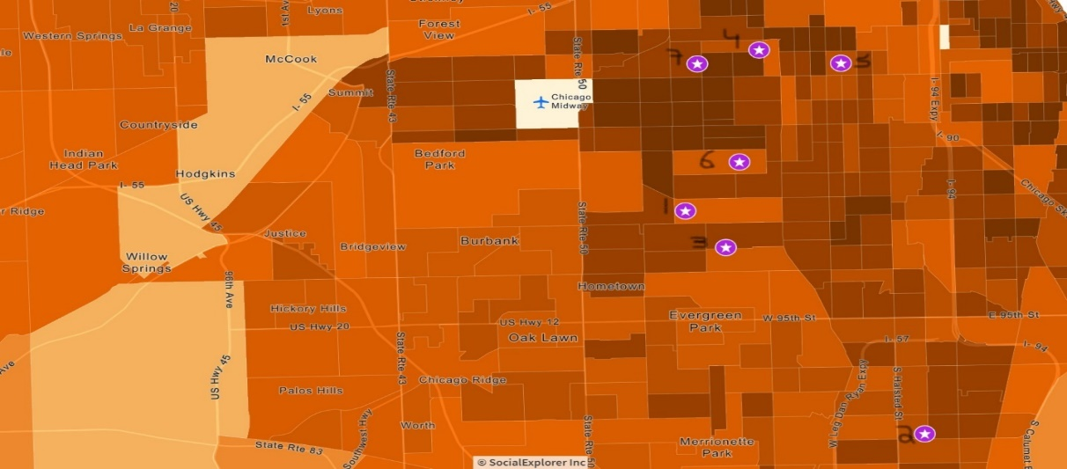
Figure 1: A map of the location of all the schools that participated in the study
All seven schools predominantly serve children from low-income backgrounds. Income level was evaluated based on the number of students who benefit from the free school lunch programs in their schools. Children whose family household income falls within 185% of the federal poverty line are enrolled in free school meals, meaning they are provided with breakfast and lunch at school every day free of charge (City of Chicago data). The schools’ range between having 81% and 97%of their students enrolled in the program. A full overview of the schools’ demographics can be found in Figure 2. The mapping of the neighborhoods was done based on census tracts, and each school’s jurisdiction are outlined on each map. While parents can choose to send their children to any public school within the city, they were assumed to live inside the area designated for their school, unless otherwise specified by the student.

Group | Zip | COMMAREA | Fast food consumption (1=almost never, 5=every day) | % Dinner prepared by parent or guardian | % "sources" identified correctly | Buy own food (1=almost never, 5=everyday) | % Healthy food identified (%) | % Unhealthy food Identified | Average vegetables named | Average consumption sweets (1=almost never, 5=everyday)
1 | 60652 | ASHBURN | . | . | . | . | 78 | 67 | 4.7 | 3.625
2 | 60628 | ROSELAND | 3 | 60% | 25% | 2.2 | 74.5 | 58.5 | 4.83 | 3.35
3 | 60652 | ASHBURN | 3.4 | 20% | 44% | 2.9 |  | X |  | .
4 | 60632 | GAGE PARK | 2.5 | 25% | 75% | 2.5 | 41 | 53 | 3.6 | 3.85
5 | 60609 | NEW CITY | 3 | 88% | 67% | 3 | 66.4 | 50.45 | 4.5 | 4.625
6 | 60629 | CHICAGO LAWN | 2.42 | 73% | 45% | 2.412 | 60 | 53.2 | 3.5 | 2.58
7 | 60632 | GAGE PARK | 1.875 | 88% | 88% | 1.75 | 77 | 65.45 | 4.2 | 3

Group | No. Respondents elementary | No. Respondents Middle | % Report as healthy | Total Students | % Bilingual | %  School Lunch Eligible
1 | 16 | 0 | 62.5 | 446 | 2.2% | 81.2%
2 | 17 | 5 | 77 | 703 | 13.8% | 93.0%
3 | . | 10 | 40 | 482 | 23.9% | 93.2%
4 | 8 | 4 | 75 | 339 | 20.4% | 81.1%
5 | 15 | 7 | 59 | 543 | 0.9% | 97.4%
6 | 12 | 12 | 58 | 1,291 | 37.4% | 94.2%
7 | 5 | 8 | 69 | 363 | 54.6% | 92.6%

Figure 2: Selected survey data findings with Chicago City Data for each school, blue=middle school survey question yellow= elementary

Food access in each of these areas ranges from moderate with a few food and grocery options in the area, to qualifying as a food desert, meaning there is no full access grocery store within one mile of the area. This limits food options and access mainly to mini mart provisions, fast food and locally owned restaurant, which, according to their menus on sites like GrubHub and Ubereats, sell mainly burgers, fried chicken, and other less health conscious fair.
Individual School Findings and Analysis
School 1
The first school I received data from is located in Ashburn in the West side of Chicago (Figure 1). It is an integrated arts school, meaning fine and performing arts are integrated into the general curriculum, as well as many opportunities to study the arts. This school is both one of the smallest in the group with only 446 students and has the second lowest number of students enrolled in the free meals program, 81.2% (Figure 2). This school likely admits students from a relatively more mixed socio-economic status community. This is also evident in the community map, which shows the area students come from as including census tracts where only between 20 and 30% of children live in poverty and only 5 to 15% of household incomes are below $60,000 per year (Figures 3 and 4).
Only elementary school students were surveyed in this school. Their health literacy appears to be high, with the average student identifying 78% of the healthy foods and 67% of the unhealthy foods from a list of 18 items. These were the highest percentages across all six schools where elementary school students were surveyed. They also named an average of 4.7 vegetables when asked to name five. However, despite these seemingly high levels of nutritional health literacy, the students, when asked to rank how often they eat candy and treats from 1 being only on birthdays and holidays to 5 being every day, averaged a 3.6, meaning they are on average eating sweets and treats at least once if not multiple times a week. According to Google maps, the closest grocery store is a mile and a half away from the school and takes more than thirty minutes to get to by public transportation. While it is closer for students who live at the southern end of the school’s boundaries, for many students it is likely more than one and a half miles, with no grocery store less than a mile from the homes of many students who are assigned to attend this school.
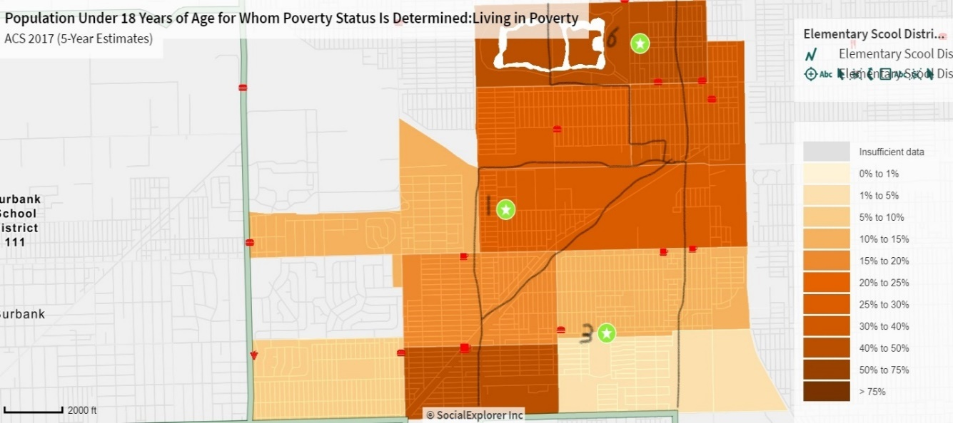
Figure 3: Population under 18 living in poverty by census tract, Schools 1,3,and 6
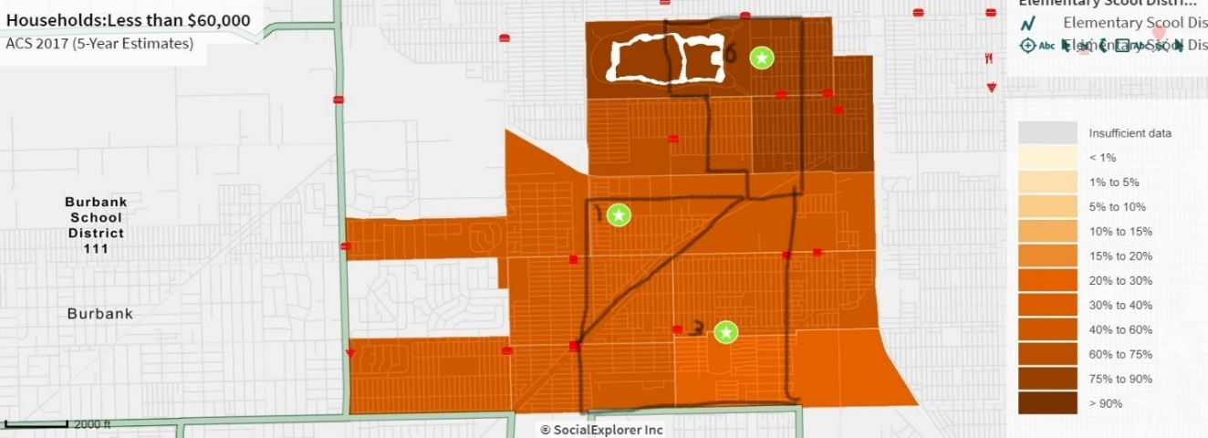
Figure 4: Household with total income less than $60,000 per year by census tract
While the students from this school appear to know a fair amount about food and healthy eating given their age, there seems to be some inconsistency between knowledge and action, as many students appear to continually eat sweets and treats regularly. However, it is unknown whether they are purchasing these items for themselves or simply have access to them at home. Also, students from School 1 cited food like pizza, Popeye’s Fried Chicken, and nachos as their favorite foods that they eat often. Therefore, while the students seem to understand what is healthy, they do not appear to be following those practices. There are many areas that could likely influence those practices. One possibility is the lack of grocery stores in the surrounding area, as even though higher income and better education may improve health literacy, if there is a lack of food available it will be more difficult to put those actions into practice.
School 2
School 2 is located in Roseland in the south side near the edge of Chicago proper. The area is quite isolated with very few grocery stores and restaurants even beyond the school’s student population area. The school has 703 students in kindergarten through eighth grade, with 93% of them enrolled in free school lunches (Figure 2). The area School 2 resides in has some of the highest levels of childhood poverty, with 50 to 75% of its children living below the poverty line across all its census tracts, and the census tracts served by the school ranging from having 40 to 90% of the households living on total incomes of less than $60,000 per year (Figures 5 and 6).
Sixty percent of middle school respondents from this school reported that a parent or guardian prepares or provides them with dinner every night, and they reported, on average, eating fast food once a week. However, when asked how often they buy themselves food the average answer was only once every few weeks. When asked to provide sources of protein, carbohydrates, healthy fat, and trans/saturated fat, respondents provided on average 25% correct identities, with nine or more identities being considered a full answer (if they only wrote down seven for example but they were all correct, they received a 7/9; the threshold of nine was derived based on both the question on the survey along with average responses). The students defined eating healthy in several ways, both in the affirmative, “To have a healthy diet you have to have at least two fruits or veggies in your diet a day and drink 16 0z of water,” and in the negative “it means to not eat that much pop and candy.” However, while they may conceptually understand what it means to eat healthy, these students may still be lacking some of the tools that are critical for implementing healthy eating and better decisions surrounding food.
Most of the elementary school respondents reported eating sweets at least once a week, despite being able to identify 60% of the unhealthy foods on the list and 75% of the healthy foods. Many issues in this school are like those of School 1 in that both schools reside in food deserts, but School 2 is in a decidedly lower income area, which may contribute to why students purchase their own food less frequently. However, many of these children are served dinner each night by their parents or guardians, and the students also reported a low frequency of buying their own food, pointing to parents playing a large role in their children’s food knowledge and choices in the communities served by this school. Pointing to a potential deficit in community or familial constraints that result inability to fully practice or model healthier eating behaviors

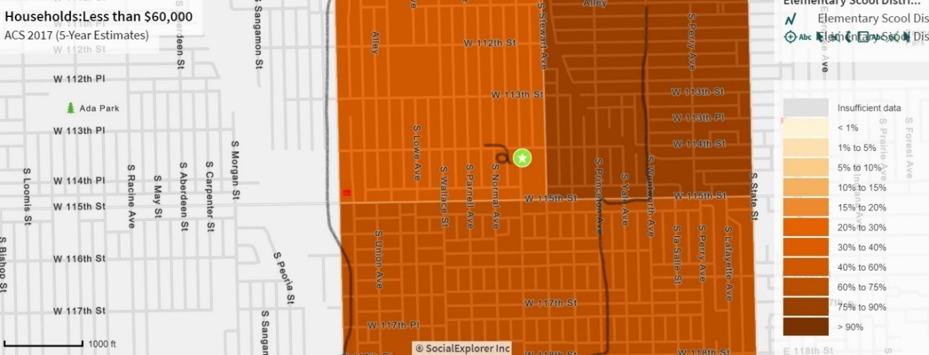

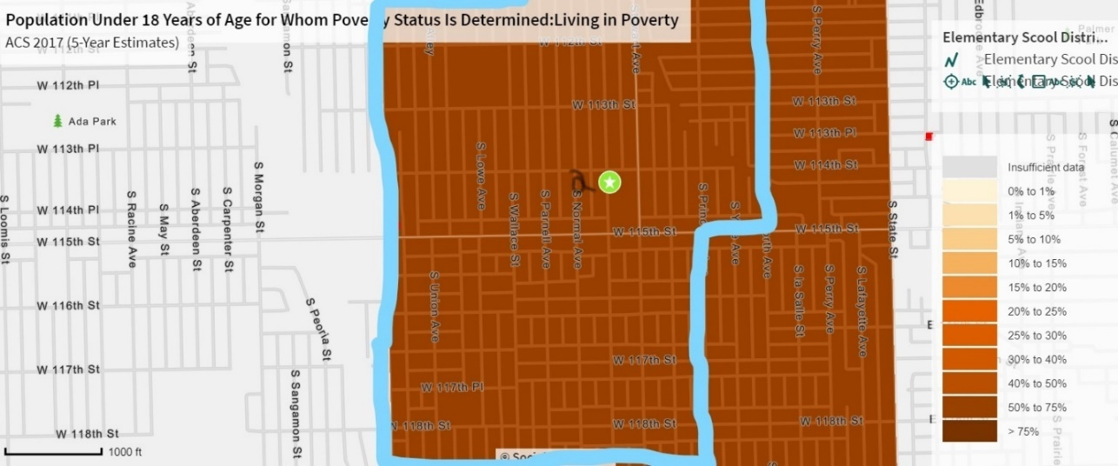
Figure 5: Total Households with income under $60,000 per year by census tract, School 2

Figure 6: Population under 18 living in poverty by census tract, School 2
School 3
The third school is located in the Ashburn neighborhood of the South side and can be found in Figure 3. The school area serves a population that mainly live in areas where between 30 and 60%of households live on a total income of under $60,000 per year, and more than 93% of students live within 185% of the poverty line (Figures 2 and 3). However, the area of this school is less impoverished than some of the other neighborhoods studied as, according to the most recent census data available on the Social Explorer website the majority of the census tracts served by this school have less than 15%o f their child residents living in poverty. There is an Aldi grocery store, a more affordable chain grocer, one mile southwest of the school. Because of its location, it is well over a mile away from many of the areas served by this school; however, it is still the closest option for this school’s jurisdiction. 70% of the respondents from this school, all of whom were in middle school, reported that they choose what they eat for dinner each night. The average respondent also reported buying food for themselves about once a week, citing that they buy fast food, chips, and candy. These students also reported eating fast food about once a week on average and averaged about 44% correct identities for sources of macronutrients. Notably this school had the lowest yield of students who believed they were healthy with only 40%responding yes.
The results from this school indicate that there may be characteristics of some of the neighborhoods served by this school that require children to begin taking care of themselves at a younger age, despite them not fully knowing how. This issue manifest itself in terms of food choices in two ways. The first being similar to School 2 in that these children are not buying their own food very often. It could be that they are choosing what to eat from what is at home, which is a combination of access and the choices made by their parents, or that the financial situation is such that there simply is not ample food at home or money for them to purchase snacks and meals for themselves. The second is a lack of information or education about healthy food choices. These students know they are not healthy but continue to purchase unhealthy foods. Their lack of ability to identify good sources of macronutrients implies that health education about what it means to be healthy and how to maintain good health through diet seem to be lacking.
School 4
The students from School 4 come from Gage Park on the southwest side of the city. Between 60 and 75%of the household incomes in the area the school serves are below $60,000 a year; however, only 81%of students live within 185% of the poverty line and serves areas where between 20 and 40% of the under 18 population live in poverty ( Figures 2, 7, and 8). This school also has a mixed ethnic makeup with about 20% of students being bilingual. While the average number of macronutrient sources identified was around 75%among middle school respondents, the elementary school respondents had the poorest demonstration of knowledge; students were able to identify only 3.6 vegetables on average, and 53% and 40% of healthy and unhealthy options, respectively. The average consumption of fast food for middle schoolers was between every few weeks and once a week, but the average frequency of sweet consumption among the elementary respondents was a 3.85 on a scale of 1 being almost never to 5 being every day. This implied that most of these students eat sweets, cookies, and cakes regularly. The middle school students from this school only periodically purchased their own food and about half had dinner prepared for them by a sibling. While Gage Park itself is not in a food desert, some of the areas served by this school are, which likely affects what the children know and eat due to access (Figure 9).

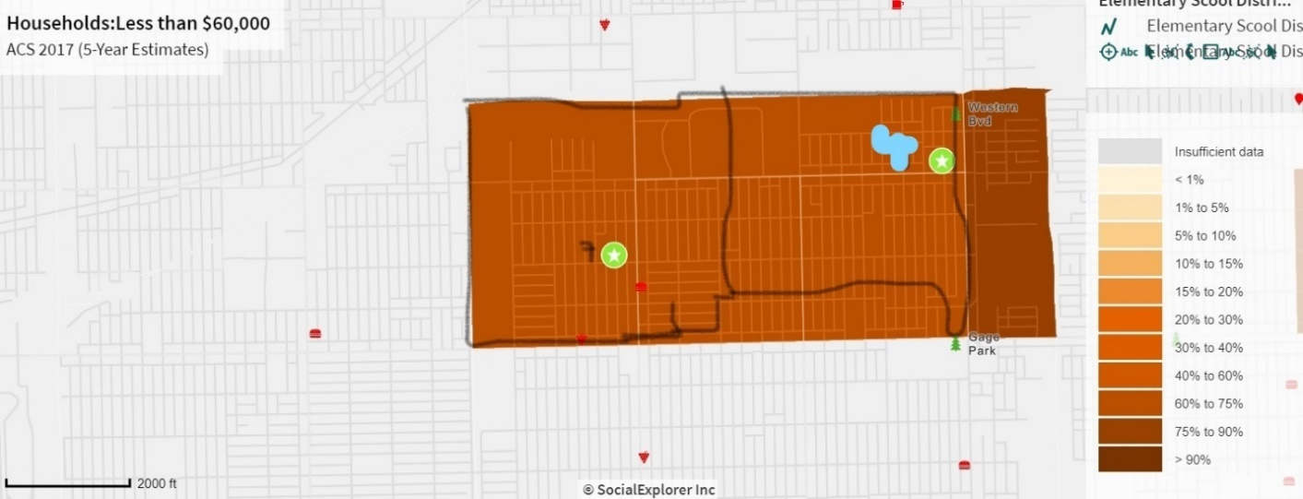

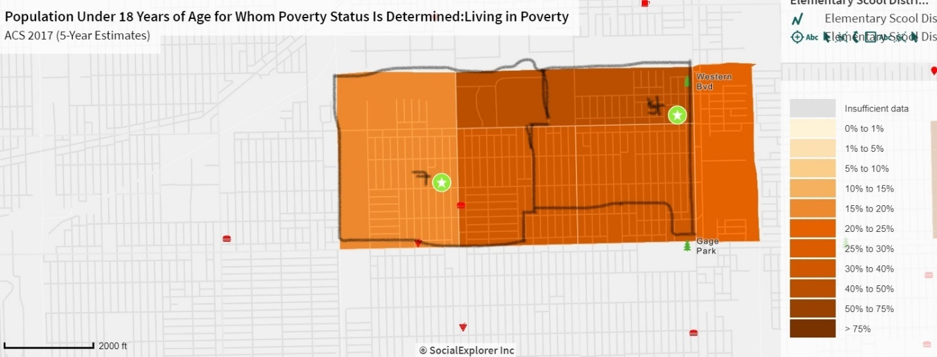
Figure 7: Percentage of households with income below $60,000 a year by census tract, Schools 4 and 7

Figure 8: Population under 18 living in poverty by census tract, Schools 4 and 7
School 5
School 5 is located in the south side and serves children from the Back of the Yards and New City neighborhoods. This school had the highest rate of students in the free lunch program with more than 97% of students living within 185% of the poverty line. The neighborhoods served by this school also have some of the highest rates of children living in poverty, with more than 75% of individuals under the age of 18 living in poverty (Figure 10). All but one middle school student reported a parent or guardian preparing dinner for them each night, and about two-thirds of their macronutrient identities were correctly identified on average. Middle school respondents reported both eating fast food and buying their own food once a week on average. Elementary school respondents fared similarly, successfully identifying about 66% and 50% of the healthy and unhealthy options, respectively, and naming 4.5 vegetables on average. However, the children from this school had the highest sweets consumption on average, at 4.625, meaning most elementary school respondents are consuming sweets nearly every day. The area served by this school has very low food access (Figure 9), which is likely reflected in what the children eat and what their parents provide for them. Especially given the level of poverty in this area, it is likely that even if there were healthier options available many families still would be unable to afford them. This school is the most apparent example thus far of how a lack of resources can lead to a lack of practice of healthy habits even when the building blocks of nutritional health literacy are present.
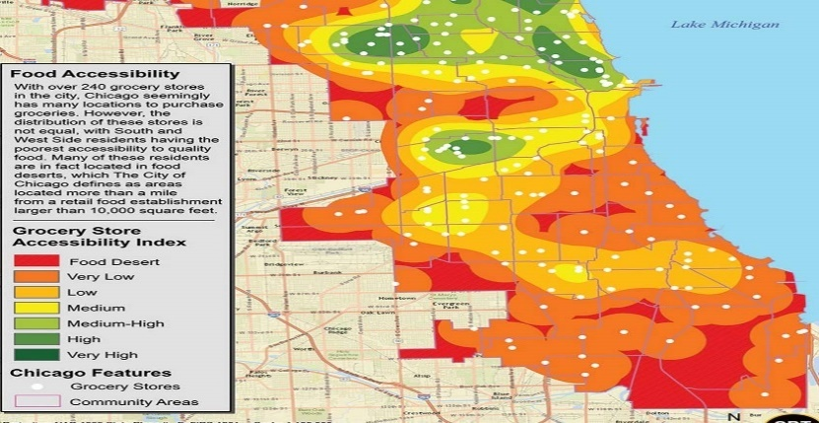
Figure 9 Chicago Food Desert Map Courtesy of urbanfarm.org

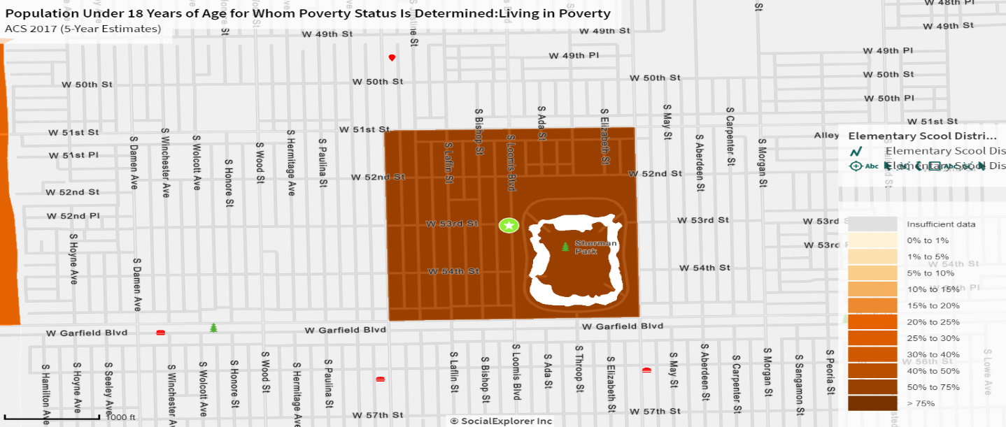Figure 10: percent of individuals under 18 living at or below the poverty line, School 5

School 6
School 6 serves children from the Marquette Park, Chicago Lawn, and Englewood neighborhoods. School 6 has a sizable population of bilingual students with more than 40%of its students being bilingual (Figure 2). In addition, 94% of students are enrolled in the school lunch program, and between 60 and 90% of households have combined incomes below $60,000 a year across the census tracts served by this school (Figures 2 and 3). Overall, the middle school respondents from this school had the best understanding of what it means to eat healthy, sighting that one must limit junk food, eat lots of fruits and vegetables, and stay in shape. However, they fared poorly in their nutritional literacy, identifying only 45% correct macronutrient sources. In addition, elementary schoolers were only able to identify an average of 3.5 out of 5 vegetables on average being identified by elementary school students. These results were interesting when juxtaposed with the results that middle school respondents on average reported eating fast food or purchasing their own food only once every couple weeks, and the elementary students reported the lowest sweets consumption of any school. When asked if they believed they ate healthfully though, only 60% said yes. Taken together, this evidence could imply that while on the theoretical level the students understand what it means to “be healthy,” they either do not have the access to healthy foods, or the proper guidance about how to eat a proper diet, or some combination of the two.
School 7
School 7, like School 4, is also located in Gage Park. However, the School 7 has 11% more students living within 185% of the poverty line with 92% of their students participating in the free lunch program. More than 50% of students in this school are bilingual (Figure 2). Notably the area served by this school is the only one in which there is a full-service grocery store accessible within one mile of any point within the school’s jurisdiction. Three of the stores specialize in Mexican and Latin American products, and there is an Aldi supermarket half a mile north of the school. Respondents from this school reported the lowest average fast food consumption and independent food purchasing (1.875 and 1.75 respectively), and had the highest rates of correct macronutrient source, healthy, and unhealthy food identities, at 88%, 77%, and 65.45% respectively. In addition, the food the middle school respondents report purchasing were mainly grocery items like bread, yogurt, vegetables and meat. These results indicate that they are likely purchasing family groceries and are choosing healthy choices either by instruction or potentially by their own choice. The results from this school point to potential intervention that, in certain communities, could help overcome the limitations on health brought about by low socioeconomic status. As mentioned above, this school area has the best access to fresh food, with multiple supermarkets within the area the school serves and “medium” food access in the surrounding area (Figure 9). In addition, there is a potential cultural aspect to consider. In both School 6 and School 7, there are large bilingual populations, made up primarily of individuals of Mexican and Latin American descent. Latin American food, while not all traditionally healthy, does focus on fresh products, ample vegetables, and nutrient dense staples like rice and beans. The culture of home cooking is also strong, potentially leading to less fast food consumption.
Overall Observations
Nearly every child asked to describe their favorite food that they eat often gave an “unhealthy food” as their answer. The most popular answer to this question was pizza by a wide margin, with chicken and tacos as two other popular answers. This is not surprising, as these are popular foods among most children. When asked to name five vegetables most children who took the survey were able to name at least three, although many classified potatoes as a vegetable or listed fruit in place of vegetables.
When asked to identify healthy foods or foods that should be eaten often and unhealthy foods or foods that should only be consumed infrequently from a list nearly every student identified apples, carrots, oranges, broccoli as healthy foods and ice cream and cheeseburgers, as unhealthy foods. Many children circled orange juice and apple juice as healthy despite their high sugar content. This is unsurprising given that the fruit in their names would imply that they are healthy alternatives to soda and could lead children to assume that fruit juices (and even juice drinks like Sunny-D) are healthy. There was one student, however, who, unprompted, made a note that only 100 percent orange juice and apple juice are healthy, while juice drinks are not. Similarly, many children identified Caesar salad as a healthy “always” food despite the caloric dressing and high fat content. While I would not expect the children taking this survey, who range in age from 6 to 13, to identify high and low calorie foods, the consistency with which they identified Caesar salad as a healthy food implies that health benefits were likely assumed because of the word salad or the presence of lettuce in the dish, without any concept that a salad could potentially be an unhealthy food.
Discussion and Further Analysis
The students in the study group were nearly uniformly from areas that were majority low-income, with high levels of poverty and low levels of food access. However, their results with regard to food choice and nutritional health literacy varied greatly across the schools. This allowed me to see the multitude of ways in which socioeconomic status can affect nutritional health literacy in various communities even when income level is a constant. The major areas of influence into children’s nutritional health literacy and food choice that I identified from this research were as follows: 1. Lack of guidance regarding food choices, 2. Lack of exposure or excitement regarding healthy foods 3. Poor access to healthy food and grocery stores. These issues can be put into three main problem areas: access, education, and exposure. In order to create effective change regarding health literacy and food choices, all three areas must be addressed in every community regardless of income level.
Access
Many neighborhoods across the south and west sides of Chicago are considered food deserts; there is no full-service grocery store within one mile of any given point within the community. Therefore, if there is no access to fresh food, it would be impossible for both parents and children to make better food choices even if they did have sufficient knowledge about health and food choices. In addition, if children are not even provided with a choice between healthy and unhealthy options when buying or choosing their own food, they will be unable to make better choices or develop healthier habits. While access to healthy food and supermarkets is necessary for closing the gaps with regard to dietary health and food choice, without the proper information about and tools for eating healthfully, both adults and children will not make better choices even when faced with ample opportunities and access.
Education
While adding grocery stores to a community removes its “food desert” status, it does not solve the food-related issues that are associated with the presence of a food desert within a community. If individuals do not have a good grasp of what they should be purchasing, how to budget for healthy groceries, or, in lower socioeconomic status communities, how to properly utilize the Supplemental Nutrition Assistance Program (SNAP), then increased access is unlikely to translate to more health-conscious choices and better health outcomes. Access to information and education are just as important as access to the food itself for improving nutritional health literacy, food choices, and health outcomes among both children and adults. If parents and guardians have a better grasp of the component of a healthy diet and the importance of healthy eating habits, they will be able to better model those behaviors for the children in their care, and be able to provide them with healthier, well-balanced meals. When children learn more about healthy eating and the importance of a balanced diet, they can lead their families into creating healthier meals together and make more informed choices when purchasing their own snacks and meals.
Exposure
Even with knowledge and access, if individuals, especially children do not have exposure and an understanding of all the healthy food options available, then they will continue to make poor food choices regardless of their understanding of healthful eating. Nearly every student in the study cited unhealthy foods as their favorites, and those who bought food for themselves were on the whole buying typical junk food like chips, soda and fast food. This result is unsurprising and is what is to be expected for most children regardless of background. When given a choice between carrot sticks and candy, there are very few children who would choose the carrot sticks independently, regardless of their level of nutritional health literacy. However, when nutritional health literacy is lower the ability to distinguish the “sometimes” foods from the “always” foods will likely be more challenging and the child may be less inclined or capable of seeing their favorite food as a treat. In addition, if levels of food access in an area are low, or a child is relying on school meals for much of their sustenance (which while conforming to health guidelines are still often kid friendly offerings like pizza or chicken nuggets) there are fewer opportunities to develop a taste for and an interest in new healthier foods and meals, especially as a child accustomed to eating a certain way. It takes a fair amount of effort and an openness to trying new foods for anyone to adjust their taste buds to the point where they crave healthy foods and are willing to give up regular consumption of chips, fast food, and candy. In addition, if there was never any exposure to healthy alternatives that are also tasty (i.e., fruits, hummus, whole wheat crackers, or Greek yogurt) or satisfying recipes that are both easy to make and lower in added fat, red meat, and salt, then it is even more difficult to make those healthier choices. This is likely why there were many students who appeared to have a good grasp of what it means to be healthy but continue to make poor food choices and not consider themselves to have a healthy diet.
Moving Toward Policy Recommendations
Through this survey I have identified three major areas for intervention; Access, Education, and Exposure. However, any intervention that addresses one of these areas while still leaving community deficits in the others will be unlikely to change nutritional health literacy or food choices in the short term or have an impact on long term health outcomes. Therefore, the communities that receive intervention need to be assessed carefully to determine which forms of policy change and intervention are necessary to ensure that all the gaps in access, education, and exposure are addressed properly and fully. In addition, because these policy recommendations deal mainly with outcomes in low-income communities, we must be conscious of the socioeconomic limitations and the potential social realities that may be present. These could include low levels of education among parents, single parent households, and ethnic and cultural backgrounds different from our own. These dynamics must be taken into account in order to ensure that the recommended policies will be both implementable and effective without appearing to be patronizing, insensitive, or overly controlling.
Potential Objections and Issues with the Findings
The data I am using and basing my claims from is a collection of information from multiple sources. I have collected my own data, utilized data from the City of Chicago, used data from mapping software, and done observational fieldwork. I have put all of this information together in order to create an understanding of the food culture and nutrition within these communities as well as the possible areas for intervention and improvement. However, because the data I collected myself is based on individuals and the data I was able to access from other sources is more general and not associated with those specific subjects, I am, on some level, extrapolating. The discrepancies in the types of data I have, may appear to some readers to weaken my argument, as the combination of general and specific data makes causative claims more difficult. Therefore, my main goal in this project is to better understand general trends within communities and neighborhoods, rather than to attempt make broad declarations or definitive statements and claims.
I am utilizing the data from the students to provide a snapshot of how children in a variety of neighborhoods think about food, what they know about healthy eating, and how the characteristics of their schools and neighborhoods affect the general trends that I have observed. Rather than extrapolating quantitative claims from disparate data sets, I am using this broad data to better understand the results I found in the individual responses to my surveys and create a more robust picture of these neighborhoods in an effort to better understand the discrepancies in food knowledge and choices across various schools, neighborhoods, and communities.
Given that I know there are gaps in my data that inhibit me from further exploring certain areas, I have included in addition to policy recommendations, recommendations for further research and studies. This project has helped support the claim that the correlation between poverty and nutritional health is more complex than simply lack of grocery stores or ample access to fast food. This research has demonstrated that nutritional health literacy plays a clear role in food choices, but that there are nuances and variance in both nutritional health literacy and its effect on food choice across neighborhoods and communities that, in terms of socioeconomic status, appear to be fairly similar. This area of the connection between health literacy and food choice and its association with income and community resources is an important element to better understand the correlation between obesity and poverty. It is my hope that my research has shed light on the necessity for further research and exploration of this topic as well as provide a starting point for some effective interventions.

Future Research
There are many projects that, while unfeasible for me to pursue given my limited resources and time, could help to enhance my data and further explore the association between income and nutritional health literacy and its effects on food choice and diet among children. Across the country there are schools and districts that have introduced healthy eating curricula, school gardens, and healthier lunch options. Many of these programs have been spearheaded in communities with high levels of poverty and socioeconomic inequality.
One study I propose for exploring the impact of improved nutritional health literacy on diet is to compare schools with and without these programs in like communities. This study would look at the food choices and preferences of both students and their families who were and were not exposed to the program. Ideally, we would find a program like the one described above in three schools with varying socioeconomic makeup and compare those results to students from schools and communities that were similar but did not have these healthy eating programs. A study like this would be able to accomplish several things. Firstly, it would be able to demonstrate the impact of education and education-based policies on improving nutritional health literacy, and in turn how improved nutritional health literacy impacts food choices. This type of comparative study would also help to better understand what other elements beyond education impact food choice for children and families within different kinds of communities and income brackets. This information would help to better tailor curriculum based policy recommendations to the communities in which they will be implemented, and better understand the way income level influences both synthesis and implementation of nutritional health literacy information.
Policy Recommendations
With this study I have identified three main areas in need of intervention in order to see long lasting positive results in nutritional health literacy and food choices among children from low income backgrounds in the city of Chicago. This three-pronged approach of education, exposure, and access will be critical in the development of successful policies surrounding improving nutritional health literacy and food choices. While the deficits in one area may be larger than in the other two in any given school or neighborhood, it is critical to ensure that all three areas are fully addressed in order to have the possibility of creating positive results.
Due to the variety of elements at play and the necessity of tailoring interventions on an individual level, the policies I recommend are built to be flexible and malleable to suit the needs of the schools and communities in which they are implemented. The neighborhoods and students I focused on within this study come from predominantly low-income backgrounds. Due to these socioeconomic and environmental characteristics, I wanted to focus my recommendations on economically sensible suggestions, that utilize resources that may already be available, or do not result in high costs to the schools, students, or parents. In this vain, I also aimed to be weary of potential cultural differences and risk of apparent paternalism in my proposals
My policy recommendations are based on the findings of my survey in conjunction with several systematic reviews of prior programs to increase nutritional education and health in school age children around the globe (Yip et al, 2016; Escaron et al, 2014; Wang and Stewart, 2012). Cumulatively I looked at over 30 different programs, ranging from breakfast clubs, to lecture series, to peer to peer education. I took the challenges and successes of these studies and programs into account in my own proposals, while also framing my recommendations with respect to the specific characteristics of the communities and neighborhoods I have been looking at. What failed in rural China may be incredibly successful in urban Chicago, while a program teacher in London found easy to implement may be a challenge in the bureaucracy of the Chicago Public School system. Ultimately for nutrition and health education policy to be successful, it must be feasible, address the core issues of education, exposure, and access, and most importantly be narrowly tailored to the community in which it is being implemented.

Recommendation 1: Supermarket Based Education and Exposure
Recently there has been a huge push in Chicago to have grocery stores open up in lower socio-economic status neighborhoods (Paykin, 2019). While grocery stores alone will not solve food deserts or the issues that food insecurity brings about, they do address the core issue of access, and with the proper programs being rolled out in conjunction with their opening, can help provide more food education and exposure. Therefore, my first recommendation is to develop grocery store-based education and exposure opportunities through a partnership with the department of health and or community organizations.
I propose the creation of partnerships with both local and larger grocery chains whereby recipe cards for healthy meals and free samples of those recipes can be handed out in the stores, infographics can be placed around the stores with information about the health benefits of those foods, and coupons or rebates for healthy foods are made available. In order for a program like this to succeed a partnership between a funding body like the board of health or mayor’s office, and a lay leading body like a hospital, community center, or school, is necessary. The government can provide ample resources, but community involvement is critical for the success of this program.
The exposure to this information, as well as a demystification of healthy cooking and foods will help provide caregivers with a better base level of information to successfully model healthy eating for their children. The program would also provide them with access to healthier food options making healthier eating more feasible. In addition to supermarkets, these initiatives could also be partnered with the Chicago City Markets program. This is a program through the City of Chicago which opens farmer’s markets each spring and summer in dozens of neighborhoods, including several that have a majority low socio-economic status population, such as Bronzville and Englewood (greencitymarket.org).
A systematic review entitled “Supermarket and Grocery Store–Based Interventions to Promote Healthful Food Choices and Eating Practices”, found that point of purchase interventions combined with promotion and advertising, like those recommended above consistently demonstrated positive change in food purchasing habits (Escaron et al, 2014). The studies were conducted across the United States and various socio-economic levels, demonstrating that this approach translates broadly as an effective strategy. The review also emphasized that the addition of access to healthy food is critical for these other supermarket based programs to take hold, making this recommendation a next step in places like Englewood and Woodlawn where large grocery stores have recently been built, (Escaron et al, 2014; Paykin, 2019).
Regardless of who is implementing these programs, I believe the key to their success is immediate action. If the curriculum plan, implementation strategy, and funding have already been developed and made accessible by the department of health or mayor’s office, then it is straightforward for the local government, or these other entities and individuals to reach out to the grocery store or chain as soon as they announce they will be building a store within the community. This way of building on access with exposure and education is critical to consistent long-term success and implementation of nutrition education and nutritional health literacy programs; it also allows grocery stores to be a part of the solution to the phenomenon of food deserts.

Recommendation 2: Integrated Interdisciplinary School Based Nutrition Curriculum
My second recommendation is to incorporate food and nutritional education and resources into classroom education in an interdisciplinary way, specifically in elementary schools. Children learn by modeling and experience, so if nutrition and food education can be disseminated in less conventional spaces than a health class, and the information is incorporated into the daily routine, it is more likely to stick with them and become consistent behavior. Incorporating healthy eating into math and reading lessons is a low-cost way to introduce these concepts. Using healthy recipes to teach fractions, practicing spelling with the names of fruits and vegetables, or creating math word problems around the themes of diet and exercise are simple ways to normalize healthy eating and introduce concepts around nutritional health literacy in a “digestible” way.
Several studies on health education found that conventional health classes were less successful in turning information into positive action among school age children, or even helping them to process said information (Wang and Stewart, 2012). Much more success was found when health education was more broadly integrated into the school day through peer lead sessions, or all school water drinking and healthy eating competitions (Yip et al, 2015). The recommendation for integrated curriculum takes this observation a step further, incorporating and normalizing the language and information around healthy eating and food choices as part of everyday life and all school activities.
Incorporating healthier options into school provided snacks and meals would also help introduce children to a variety of foods from an early age and demystify healthy foods. Children’s taste buds are highly malleable, and they can learn to enjoy the taste of nearly anything with enough exposure (Cosmi et al, 2017). Introducing sliced fruits, vegetables with hummus, or rice cakes with peanut butter or sunflower seed butter into the snack and meal rotation will allow the students to try new foods in a safe environment and find the healthy foods they enjoy eating. In turn they will begin to request these foods from their parents and seek these foods out when they are purchasing their own snacks and meals. Although this proposal may appear costly, there may be opportunities for potential partnerships with companies like Sabra or Chobani, or local supermarkets. Children are critical for the success of any company as their desires and requests often dictate what their parents purchase, or what they themselves buy, making these partnerships mutually beneficial. Of course, these partnerships would need to be developed in with local government or the school board but have the potential to be both effective and profitable.
Parent involvement was, in many studies, found to be critical to the adoption of healthier eating habits among children (Wang and Stewart, 2012). A short newsletter sent home once a month or once every two weeks outlining the major areas of nutrition and health the students have been focusing on in school, with tips for incorporating healthy habits at home would be an excellent first step for increasing parent involvement and knowledge (Wang and Stewart, 2012). Teachers could also send home weekend “homework” where the students receive extra credit or a prize if their parents sign off that they did 30 minutes of exercise, drank a certain amount of water, or made a healthy recipe that they were sent home with. These incentive-based activities done at home will ultimately involve the parents and create a partnership between the parents and children in living a healthier lifestyle. When involving parents though, it is important to be mindful of specific community characteristics, such as time constraints of working long hours, financial constraints, or language barriers. The information sent home to parents may look different in any given school or neighborhood, but the key is to provide as much information as is helpful and encourage as much participation as is feasible.

Recommendation 3: Comprehensive, Community Specific Health Class Nutrition Units
My third recommendation is a comprehensive nutrition unit within middle school health curriculum, specifically tailored to students in lower socio-economic communities. Beginning in adolescence individual food choices and knowledge begin to have a larger effect on overall health than do the choices and knowledge of parent and guardians (Nakamura et al, 2018). The greater degree of freedom and bodily autonomy that is a result of getting older, also results in more say in what goes into one’s own body, and whether these teenagers will make the active choice to try and live a healthy balanced lifestyle. Middle school is therefore a time when education and guidance around eating and nutrition are critical to helping children gain the skills and tools necessary to transition to a healthy and balanced adulthood. However, simply preaching the virtues of a balanced diet and exercise in a one size fits all vacuum will not work. The immaturity and antiestablishment nature of many adolescents may make them less than responsive to lectures on what they should or should not be eating, especially if the information being given feels irrelevant or impractical in their social and societal context. Instead a baseline curriculum must be developed by the board of education in conjunction with the department of health, that while providing all of the necessary information also allow for adjustment to ensure the information and skills are taught to the needs of the community, in turn making it more likely the students will retain the information and be more willing put these skills into practice.
As my data shows, simply knowing what is and isn’t healthy does not always lead to better food choices. Most of the respondents in my study had at most a basic understanding of healthy eating: fruits and vegetables are healthy and fast food is unhealthy. But when it came to identifying foods that contain various nutrients, or whether less obvious items are healthy or unhealthy, these students often did not have a strong grasp overall. If their health education included teaching them how to read nutrition labels, what a healthy day of eating looked like, or what the effects of various foods and macronutrients are on their body, they would be better equipped to make healthier decisions about food. In addition, the education would also need to be tailored to these students, meaning there would need to be lessons on how to find healthy options within the food options available, how to shop for food in a cost and health conscious way, or how to make healthy nourishing meals from what can be found in the local stores. Ideally, the board of education and department of health would work together to develop a curriculum that could be easily adapted based on the needs of a given school or community and work within the confines of whatever resources are available.
Conclusion
Childhood obesity in this country is an epidemic, which is glaringly seen in the City of Chicago (Margellos-Anast et al, 2008). While weight in childhood is partially a result of genetics (Wiley, 2013),the noticeably high rates of childhood and adult obesity, especially among certain groups of lower socioeconomic status individuals, points to the effects of environmental as well as cultural influences on obesity, food choices, and nutritional health literacy, in various neighborhoods and communities in relation to creating this obesogenic environment (Maidenberg, 2016).
While childhood obesity may have a significant genetic component, the transition to adult obesity is not (Wiley, 2013). And therefore it is critical that we isolate the deficits and lacking resources that children might face that secure obesity as a lifelong disease rather than a prepubescent phase.
This study aimed to better understand the association between nutritional health literacy and food choice in seven schools serving primarily communities of lower economic status, and to better understand the influences on these two areas within lower income communities. Middle and elementary school aged children were surveyed with questions relating to nutritional health literacy, such as asking them to name vegetables or identify macronutrients. The students were also asked questions relating to their eating and food consumption habits with the survey asking them how often they eat fast food, what their favorite foods were, and who regularly makes them dinner. The schools served neighborhoods that were both food deserts and ones that were not (Figure 9). Some served schools with a high number of bilingual students while some had higher rates of students in special education (Figure 2). This led to varied results and illuminating insights despite the economic makeup of the neighborhoods served being relatively consistent.
Poverty is not in and of itself the reason for individuals making poor food choices and lacking nutritional health literacy. Rather, many of the effects of living in or near poverty alongside the cultural and environmental influences in many communities with high levels of poverty, tend to result in low levels of the resources, information, and positive modeling necessary to obtain a solid nutrition education and implement those skills and education into positive and healthy food in choices.
In line with prior research, results from this study revealed that the children who attended schools that serve neighborhoods with more grocery stores tended to eat fast food and sweets less, and knew more about healthy eating overall. However, this study also shed light on the role of parental or adult supervision and cultural divisions on levels of nutritional health literacy.
Most importantly, the results of this survey, coupled with the prior research and findings, reaffirmed that the association between nutritional health literacy and food choices, and more broadly obesity in communities with high levels of poverty, cannot be boiled down to a single cause and effect, or even a direct route of influence. Just because a child comes from a low income background does not mean that their nutritional health literacy is low, and in lower socio-economic neighborhoods, a higher level of nutritional health literacy will likely not ensure healthier eating habits and food choices.
There is a symbiotic relationship between access and education in the world of nutrition and improving eating habits. Specifically, in many communities serving low income individuals, many of these resources and the key players in implementation may be limited, making holistic and multifaceted interventions necessary in order to see long term changes in diets and eating habits. It is my hope that this study has illuminated some of these deficits that are present in various neighborhoods and, in turn, shed light on potential initiatives to not only improve nutritional health literacy but help put that knowledge into practice.
This study has only begun to explore these associations and the impact of community level influences on nutritional health literacy and food choice in neighborhoods serving primarily lower income individuals. Further research into the correlation between weight and nutritional health literacy, effectiveness of various nutrition education programs in low income schools at increasing nutritional health literacy and improving eating choices, and a comprehensive study of the differences in nutritional health literacy and income level are necessary to further expand the body of knowledge on this topic and isolate the most effective policies and initiatives for improving nutritional health literacy and food choice. However, this study has brought to light the necessity of programs and policies that are tailored to the specific communities in which they are implemented. The effects of poverty do not manifest identically in every community; therefore, policies surrounding mitigating these effects on nutritional health literacy should not be identical either.
I have provided three areas for intervention: the community through grocery store education and point of purchase intervention programs, elementary schools through interdisciplinary nutrition education curricula that support parent involvement, and middle schools through nutrition units in health classes that focus not only on the facts, but also how to create healthy habits within the students’ specific communities. The goal of these recommendations is to be straight forward, affordable, and easily tailored to a variety of communities. They also focused on the concepts of ensuring education, access, and exposure, that appeared as a continual theme in my research and findings on topics relating to the relationship between poverty and obesity. With this paper, I hope to have illuminated one potential area of influence within this relationship, prompted thought toward additional research, and brought to light some concepts for first steps to improving diet related outcomes within majority low income communities.

Bibliography
“CDC Health Literacy - Defining Health Literacy - Health Literacy Training.” Centers for Disease Control and Prevention, Centers for Disease Control and Prevention, www.cdc.gov/healthliteracy/training/page572.html.
Chari, Roopa; Warsh, Joel; Ketterer, Tara; Hossain, Jobayer; Sharif, Iman; “Association between health literacy and child and adolescent obesity” Patient Education and Counseling, Vol 94(1), Jan, 2014 pp. 61-66. Publisher: Elsevier Science
“Chicago City Markets.” City of Chicago :: Chicago City Markets, www.chicago.gov/city/en/depts/dca/supp_info/farmers_market.html.
Cosmi, Valentina De, et al. “Early Taste Experiences and Later Food Choices.” Nutrients, vol. 9, no. 2, 2017, p. 107., doi:10.3390/nu9020107.
Escaron, Anne L., et al. “Supermarket and Grocery Store–Based Interventions to Promote Healthful Food Choices and Eating Practices: A Systematic Review.” Preventing Chronic Disease, vol. 10, 11 Apr. 2013, doi:10.5888/pcd10.120156.
Fan, Jessie X., et al. “Tract- and County-Level Income Inequality and Individual Risk of Obesity in the United States.” Social Science Research, vol. 55, 2016, pp. 75–82., doi:10.1016/j.ssresearch.2015.09.008
Figures 3,6, 8,10: Population Under 18 Years of Age for Whom Poverty Status is Determined: Living in Poverty [Map]. In SocialExplorer.com. ACS 2017 (5-Year Estimates) Retrieved April 23, 2020, from https://www.socialexplorer.com/c4cf8c30d4/edit
Figures 4,5,7: Households: Less Than $60,000 [Map]. In SocialExplorer.com. ACS 2017 (5-Year Estimates) Retrieved April 23, 2020, from https://www.socialexplorer.com/c4cf8c30d4/edit
“Food Insecurity: Urban Farm.” UrbanFarmU, 14 Mar. 2019, www.urbanfarm.org/2019/03/15/food-insecurity/.
Holmberg, Christopher; Berg, Christina; Dahlgren, Jovanna; Lissner, Lauren; Chaplin, John Eric. “Health literacy in a complex digital media landscape: Pediatric obesity patients’ experiences with online weight, food, and health information” Health Informatics Journal , Dec2019, Vol. 25 Issue 4, p1343-1357, 15p; DOI: 10.1177/146045821875969
Gittelsohn, Joel, et al. “The Impact of a Multi-Level Multi-Component Childhood Obesity Prevention Intervention on Healthy Food Availability, Sales, and Purchasing in a Low-Income Urban Area.” International Journal of Environmental Research and Public Health, vol. 14, no. 11, Oct. 2017, p. 1371., doi:10.3390/ijerph14111371.
Maidenberg, Michelle P. “Childhood, Adolescent, and Teenage Obesity: Recommendations for Community Initiatives in Central Harlem.” Health & Social Work, vol. 41, no. 2, July 2016, pp. 85–91., doi:10.1093/hsw/hlw012.
Nakamura, Daisuke; Ogawa, Masato; Nakamura, Teruhiko; Izawa, Kazuhiro P. “Impact of Parents’ Comprehensive Health Literacy on BMI in Children: A Multicenter Cross-Sectional Study in Japan” Journal of School Health , Dec2018, Vol. 88 Issue 12, p910-916, 7p, 1 Diagram, 3 Charts; DOI: 10.1111/josh.12700
Paykin, Susan. “Chicago Food: More Supermarkets Do Not Mean Healthy Food for All.” Chicago Policy Review, 15 Apr. 2019, chicagopolicyreview.org/2019/04/17/chicago-food-more-supermarkets-do-not-mean-healthy-food-for-all/.
Piontak, Joy Rayanne, and Michael D. Schulman. “School Context Matters: The Impacts of Concentrated Poverty and Racial Segregation on Childhood Obesity.” Journal of School Health, vol. 86, no. 12, Aug. 2016, pp. 864–872., doi:10.1111/josh.12458.
Rikard, R. V., Thompson, M. S., McKinney, J., & Beauchamp, A. (2016). Examining health literacy disparityes in the United States: a third look at the National Assessment of Adult Literacy (NAAL). BMC public health, 16(1), 975. doi:10.1186/s12889-016-3621-9
Schanzenbach, Diane Whitmore. “Do School Lunches Contribute to Childhood Obesity?” Journal of Human Resources, vol. 44, no. 3, 2009, pp. 684–709., doi:10.1353/jhr.2009.0021.
“School Data .” Chicago Public Schools, 2019, cps.edu/SchoolData/Pages/SchoolData.aspx?fbclid=IwAR0oFIa4SS3t25SQKvII0gY-LURu5FIa9n5NoB8Fn9POgs5egXHwW84R_F4.
Singh, Gopal K., et al. “Rising Social Inequalities in US Childhood Obesity, 2003–2007.” Annals of Epidemiology, vol. 20, no. 1, 2010, pp. 40–52., doi:10.1016/j.annepidem.2009.09.008.
Wang, Dongxu, and Donald Stewart. “The Implementation and Effectiveness of School-Based Nutrition Promotion Programmes Using a Health-Promoting Schools Approach: a Systematic Review.” Public Health Nutrition, vol. 16, no. 6, 31 July 2012, pp. 1082–1100., doi:10.1017/s1368980012003497.
White, Richard O.; Thompson, Jessica R.; Rothman, Russell L.; Scott, Amanda M. McDougald; Heerman, William J.; Sommer, Evan C.; Barkin, Shari L.; “A health literate approach to the prevention of childhood overweight and obesity” Patient Education and Counseling, Vol 93(3), Dec, 2013 pp. 612-618. Publisher: Elsevier Science
Wiley, Lindsay F. “‘NO BODY LEFT BEHIND’: RE-ORIENTING SCHOOL-BASED CHILDHOOD OBESITY INTERVENTIONS .” DUKE FORUM FOR LAW & SOCIAL CHANGE , vol. 5, no. 97, 2013, pp. 97–128.
Yip, Calvin, et al. “Peer-Led Nutrition Education Programs for School-Aged Youth: a Systematic Review of the Literature.” Health Education Research, vol. 31, no. 1, Feb. 2016, pp. 82–97., doi:10.1093/her/cyv063.

Appendices
Appendix 1: Elementary School Survey
What is your favorite food that you eat often?

Can you name five vegetables? (spelling doesn’t matter!)

Circle all the healthy foods that are always good for us to eat:
Chicken nuggets, Ice cream, Cheeseburgers, Apples, Carrots, Orange Juice, Birthday cake, Chocolate cake, Apple Juice, Oranges, Broccoli, grilled chicken, fruit snacks, peanut butter, Frozen yogurt, Chinese food, Ceaser salad, garden salad
Circle all the less healthy foods that are only good to eat as treats sometimes:
Chicken nuggets, Ice cream, Cheeseburgers, Apples, Carrots, Orange Juice, Birthday cake, Chocolate cake, Apple Juice, Oranges, Broccoli, grilled chicken, fruit snacks, peanut butter, Frozen yogurt, Chinese food, Ceaser salad, garden salad, veggie straws
How often do you get eat candy, cake, cookies, or other sweets (circle 1)?
Everyday a couple times a week once a week once a month only on holidays and birthdays never

Do you usually eat school lunch or packed lunch?
School Packed
Do you think you eat healthy?
Yes No
Age:
Grade:
School:
Gender:
What neighborhood do you live in?

Appendix 2: Middle School Survey
Who chooses what you eat for dinner most nights (circle 1)?
Me A parent or guardian a sibling other
How often do you eat fast food like McDonald’s or KFC(circle 1)?
Everyday (5) a couple times a week (4) once a week (3) every couple of weeks (2) almost never (1)
Try to name 3 foods that are a good healthy source of the following
Proteins:

Carbohydrates:

Heathy fats:

Trans or saturated fats:
How often do you buy food for yourself?
Everyday (5) a couple times a week (4) once a week (3) every couple of weeks (2) almost never or never (1)
If you do, what do you buy usually?

What does it mean to eat healthy? Do you think you eat a healthy diet?
Yes No
Age:
Grade:
School:
What neighborhood do you live in?

