I. Introduction
A. Background
As a disease, human cancer is a disease rife with stark heterogeneity. This variation exists at multiple levels. Rates of cancer incidence vary significantly across geographic regions and populations (Sun, Warrington, and Rubin 2012; Liu et al. 2012; Hung et al. 2016). The biological and genetic mechanisms for development vary widely between cancer sites in the body (Lee et al. 2018; Dagogo-Jack 2018). Finally, research on cancer subtypes have established that the greatest variation may exist within each organ (Zhang 2017; Yeo and Guan 2017). While this heterogeneity limits the potential for disease control through treatment and prevention, the variability within this disease highlights opportunities to better understand cancer’s development at each level. To answer this call, public health researchers are beginning to mix classical methods, such as epidemiology and biostatistics, with rigorous policy analysis and economic modelling techniques to identify possible causes of cancer variation at the population level. The opportunities to investigate cancer outcomes, however, remain heterogenous as well. While all health centers are required to submit cancer case data to state level registries, only a few select states have made this de-identified data available. Still, the plethora of outcomes data at the case and county level provide econometricians and statisticians an opportunity to support the evolution of public health research by linking large-scale data sources. The potential for innovation in this pursuit of knowledge continues to grow and be reinforced by new biological discoveries and contemporary policy implementation.
The intersection of biological and social determinants of cancer becomes more complicated by environmental epidemiology and public policy. In a recent campaign speech, President Trump declared that the noise from wind turbines may cause cancer. This statement resulted in tremendous outcry from political opponents and wind energy advocates, but was greeted warmly by Trump’s proponents. But from a scientific standpoint, however, this question does not lack merit. Outside of the United States, recent researching using large-scale population data has evaluated the effect of wind turbine noise on a variety of communicable and non-communicable health outcomes (Poulsen Aslak Harbo et al., n.d., n.d.; Poulsen et al. 2018a, 2018b, 2018c, 2018d). The results have been mixed, further driving continued exploration at the suggestion of variability for human receptivity to wind turbine noise. Concurrently, recent basic scientific studies have identified noise as a potential mechanism driving certain subtypes of breast and colorectal cancer (Hegewald et al. 2017; Roswall et al. 2017). But, this research has not led to any consensus on the role of noise, let alone from wind turbines, on the development of cancer due to the limited understanding of biological noise in general (Eling, Morgan, and Marioni 2019). However, as biological and basic science research establishes potential mechanisms for cancer growth, economic and epidemiological studies can attempt to support or reject findings through a convergence of population level analyses.
B. Significance
Largely due to confounding political factors and a lack of comprehensive data on wind turbine development, no previous research has directly investigated the effect of long-term exposure to wind turbines on cancer incidence. However, multi-level model analyses have been shown to mitigate bias against possible inference by parsing out inherent county and state level characteristics. This framework can be utilized to remove endogenous factors related to cancer and wind turbine development. A hierarchical analysis linking SEER data on cancer incidence with a newly released wind turbine database creates an opportunity for econometric research to further inform public health policy in the highly partisan energy sector.
C. Objective
This study aims to identify any association between wind turbine exposure and cancer incidence. By conducting a series of multi-level regression models, the analytical results will highlight if the effect of exposure, if any exists, occurs between counties, within counties overtime, or between cancer types. This study has two hypotheses, the first being that increased exposure to wind turbine increases cancer incidence and the second being that the quasi-intervention effect of wind turbine development increases cancer incidence.
II. Methodology
A. Data Description
Age-adjusted cancer incidence data was obtained from two sources: 1) the Center for Disease Control (CDC) State Cancer Profiles Wonder Portal (CDC 2016) and the Surveillance Epidemiology End Results (SEER) Program, Registry 9 (SEER 2018). The CDC cancer dataset contained a five-year average incidence for every county in the United States. The SEER dataset contained annual incidence for select counties in nine states. Wind turbine count and characteristic data was accessed from the U.S. Wind Turbine Database created by the U.S. Geological Survey Program (Diffendorfer 2015). Five-year average county-level and state-level demographic data was obtained from the CDC State Cancer Profiles Wonder Portal. State election results were obtained from the Federal Elections Commission 2016 report (FEC 2016).
Using the RStudio statistical environment, all cancer incidence and wind turbine data were merged by county-code and year (RStudio 2015). Because the wind turbine data contained new, not current wind turbine, the R-package “Zoo” was needed to impute, then sum wind turbine count data to obtain each year’s current exposure (Achim 2005). A “wind turbine square mile” variable was created by dividing current wind turbines at each time point by the county’s size in square miles. The wind turbine dataset also included a set of height and electrical capacity indicators. After taking the weighted average for each type of wind turbine, a “burden” variable was created by taking the log of total wind turbines, plus the product of capacity and height indicators, then dividing by the population density. This “log burden” variable serves as an indicator of wind turbine burden (noise) on the population. This indicator increases with larger populations exposed to higher quantities of more powerful, burdensome wind turbines in smaller geographic areas. Finally, to create the effect of wind turbine development as a quasi-experiment, dummy variables were created to indicate the following: whether the county had a wind turbine at the current time point, whether the current time point was past a set of “wind turbine development years” (1984, 1998, 1999, 2011, 2012 for each respective study), and lastly a set of dummy variables using the product of the respective year and wind turbine dummy variables.
B. Analytical Models
In all, four hierarchical models were constructed: one cross-sectional study nesting counties within states; one three-level longitudinal model nesting repeated measures within counties, within states; another longitudinal model nesting repeated measures within counties; and a final cross clustered model nesting repeated measures within counties and cancer sites. Independent variables included county and state level indicators associated with cancer incidence, as well as wind turbine count and capacity measures. To estimate the effect of wind turbine development at the county-level, a Difference-in-Difference (DID) analysis was used as the primary variable of interest in all longitudinal models. All statistical analyses were calculated using the software package HLM (Raudenbush 2011). Before any analysis was conducted with wind turbine variables, a basic model was constructed using only county and state level indicators potentially influencing cancer incidence. The purpose of this initial computation was to test for subsequent model deviance. Each study’s primary model group-centered the wind turbine variables of interest to remove potential bias from overestimating effects between counties and states. An uncentered model was constructed as a specification test. Descriptive statistics were reported for each study. Robust standard errors were used to establish significance of the estimates.
1. Study 1: Cross-sectional, 2-level model (counties nested within states)
The first study used cross-sectional, five-year average age-adjusted cancer incidence data as the outcome variable. 2,740 counties were nested within 45 states (Table 1). The county’s wind turbines per square mile and wind turbines status (yes/no) were the variables of interest. For the intercept, each county’s proportion of uneducated, insured, unemployed, and poverty population were included as level-1 controls, as were each state’s proportion of smokers, obese, and 2016 republican voters as level-2 controls. An omnibus hypothesis test contrasted the difference between counties without a wind turbine and the effect of wind turbines per square mile on cancer incidence. A deviance test calculated the significance of the added variance of the final model against the original model without any wind turbine data. All level-1 and level-2 components vary in order to estimate both the fixed and random effects of wind turbine exposure.
2. Study 2 – Longitudinal, 3-level model (repeated measures, nested within counties, nested within states)
The next study introduced repeated measures of longitudinal cancer incidence data at the county level. 8,107 years of data were nested in 195 counties, from the nine states in the SEER 9 Cancer Registry (Table 7). In addition to the standard county and state level controls, the “log wind turbine burden” variable was added to the model along with wind turbine status and wind turbines per square mile. Additionally, given the longitudinal nature of this test, a “Difference-in-Difference” approach was utilized to estimate any effect before and after wind turbine development, between counties which did and did not introduce wind turbines to their county. From the USGS data, most wind turbines were developed in 1984 and 2012, which serve as a quasi-treatment year for this interrupted time series model. Among dummy variables, only the DID estimators were allowed to vary randomly (Table 8). Hypothesis and deviance tests were administered for each DID coefficient’s effect.
3. Study 3 – Longitudinal, 2-level model (repeated measures nested within counties)
It Is important to note, that in the SEER9 Registry some states include all their counties, while others only include select regions. When linking the USGS wind turbine data with the SEER9 cancer data, there was a clear discrepancy between counties providing cancer data and counties implementing the most wind turbines. For example, in California, most wind turbines were developed in rural areas such as Kern County, but these rural counties supplied no data to the SEER9 registry. This missing data is problematic from a power and missing data perspective. So, in the third study, only three states were included in the model: Iowa, Utah, and New Mexico. Each of these states mandate all counties to report incidence data to the SEER9 registry. However, what is gained in potential confidence and precision of the model is traded for an inability to add a third, state-level to the analysis. So, this study included 6,609 time points, nested within 157 counties (Table 11). Standard county-level control and wind turbine data were included in the analysis, as well as the two DID covariates for 1999 and 2011 (Table 12). All coefficients varied randomly, except the wind turbine status and year dummy variables. Hypothesis and deviance tests were calculated and reported.
4. Study 4 – Longitudinal Cross-Clustered Model (repeated measures nested within counties and cancer sites)
A major benefit of the hierarchical model is its precise capacity for parsing out variation in effects between different levels. The recent scientific evidence on biological noise, however limited, promotes further investigation into the variability of its effect on cancer outcomes. While most of these analyses have focused solely on geographic variability, given the heterogeneity in human cancer, the final study warrants greater attention to cancer site and diagnostic variability. Using SEER9 registry, age-adjusted county level data was obtained for 60 types of cancer. These repeated measures were nested into their respective organ (cancer site). This cross-cluster analysis led to a design of 34,560 repeated measures, nested within 98 counties and nine cancer sites (Table 16). Only the state of Iowa was included in this model, as any additional state exponentially increased the computing power required for even the most basic statistical computation. County-level control and wind turbine data were consistent with previous models. To further decrease the computing power required, only years 1987-2007 were included in the model, allowing for a single year, 1999, to act as the DID dummy variable (Table 17). Only primary variables of interest at the column (cancer site) level were allowed to vary. Only fixed and random effects were reported for this study. No hypothesis or deviance tests were conducted for this analysis. Column-level dummy variables were used to estimate the variable effect of the DID coefficient for specific cancer sites.
III. Results
A. Study 1: Cross-sectional, 2-level model (counties nested within states)
The results of the first study find that a county with a wind turbine is likely to have a higher incidence of cancer than counties without wind turbines, but this effect is only marginally significant (FE = 4.28, p = .062). However, a one-unit change in wind turbines per square mile was associated with a stark decline in cancer incidence (FE = -26.78). But this effect too is only marginally significant (p = .092). The results of the Wald Test did show that when considered simultaneously, the contrasting effect of both wind turbine status and wind turbines per square mile were significant (Table 5, p = .04). Regarding the random effects of wind turbine indicators, there is little evidence to suggest that each state experiences differential effects from exposure (Table 3). Further, the results of the Deviance Test suggest that no gain in explained variance in cancer incidence is achieved from adding in wind turbine indicators (Table 5, p = .22).
B. Study 2 – Longitudinal, 3-level model (repeated measures, nested within counties, nested within states)
The addition of a yearly covariate negated any significant effect of wind turbine indicators from the previous models (Table 8). However, the primary coefficients of interest are the two DID dummy variables for 1984 and 2012. The 1984 DID reported a negative effect, implying that counties which introduced wind turbine after 1984 had a lower cancer incidence than if those same counties would not have introduced wind turbines (FE = -30.1, p = .019). However, the 2012 DID coefficient returned no significant effect. But while these two quasi-experiments differ in their fixed effects, supporting the interpretation of this model, however, is the insignificant variation in the random effect of the DID coefficients (Table 9). Unexplained variability in the effect of the coefficient would be a potential threat to a DID model’s validity (Figure 7). As mentioned, the results of the coefficient indicate a significant decline in cancer incidence. But, that decline does not appear to have differential effects when controlling for insurance rates or specific to counties failing to implement wind turbines at all. Contrary to the first study, the deviance test results suggest that the addition of the wind turbine indicators and DID dummy variables add significant explanation to the variance in cancer incidence for these representative counties in the SEER9 registry.
C. Study 3 – Longitudinal, 2-level model (repeated measures nested within counties)
Similar to the first longitudinal model, the yearly covariate accounts for most of the significant growth in cancer incidence. However, while marginal in significance, the “log burden” variable reports a positive effect (FE = 3.1, p = .06). More so, this effect does not appear to vary between counties, suggesting that the effect of more frequent exposure to more powerful wind turbine (in smaller geographic or heavily dense areas) becomes a potential risk factor for cancer incidence.
Another similarity to the previous model was the contrasting effects of the two DID coefficients (FE_99 = -12.4, p = .039; FE_11 = 13.8, p = .034; Figure 11). But, in this model, both appear to be significantly different than zero in their effect of counties implementing wind turbines after the quasi-intervention date (Table 13). Neither DID coefficient shows any considerable variation in their effect, supporting the validity of the analytical approach (Table 14; Figures 9, 10). While the first hypothesis test showed that each DID coefficient was significantly different than zero, a second test attempted estimate if the combined effect of wind turbine development, pre-and-post both quasi-intervention years, were significant from zero. It appears that when looking at each intervention point as a single treatment, the significant effect disappears completely (DID = 1.37, p > .5). This interrupted time series model, again, adds considerable explained variance above the model without wind turbine data (Table 15).
D. Study 4 – Longitudinal Cross-Clustered Model (repeated measures nested within counties and cancer sites)
Contrary to previous longitudinal models, the “year” covariate had no effect on cancer incidence (Table 18). Nor did any wind turbine indicator show a significant effect. And while the DID estimator showed no effect for most cancer sites, breast cancer increased from the intervention (FE = 20.1, p = .002; Table 19). And while no effect was present for digestive or other cancer sites, there did appear to be considerable variation between the quasi-experimental effect across sites and counties (RE = 3.1, p <.001; Table 19). Finally, while other cancer types had no variation in their response to the DID’s effect, breast cancer continued to express variable receptivity to the DID estimator (RE = 6.4, p = .25; Table 20). This result highlights the necessity of further stratifying by breast cancer subtype to confirm and establish any potential mechanism of wind turbine exposure on rising breast cancer incidence.
IV. Discussion
The cross-sectional study offers a nice starting point for discussing the “effect” of wind turbines on cancer incidence. The marginally significant, contrasting effects of wind turbine status and wind turbines per square mile struggle to support the primary hypothesis. Instead, it seems that there may be some underlying factor that separates states with and without wind turbines, be it geographic isolation or economic development as respective hindering or protective factors. A visual representation of the results supports the statistical tests. Figure 1 shows the slightest decline in cancer incidence as wind turbines per square mile increases and that the effect is consistent across states with various obesity rates. And while Figure 2 shows that the wind turbines per square mile coefficient varies, the standard errors are quite large and limit any inference of random effects. The absence of a pattern between the effect of more wind turbines and obesity rates further supports the limited fixed and random effect of wind turbine exposure between counties within states, where the effect of wind turbine status is even less prominent (Figures 3, 4).
While the potential validity threats to the DID approach have been discussed, the diverging effects of the pre-and-post 2000 DID coefficients warrants further discussion. Is there a disjoint in the trend between counties developing and not developing wind turbines occurring between 1998 and 2011? Could there be unobserved variables correlated with both cancer incidence and whether or not a county could have implemented a wind turbine development program earlier than 2011? These possible confounders should not be discredited. However, given what is known about cancer development, a disease of progression and age, another possibility exists for the discrepancy in the quasi-experimental interpretation. Perhaps immediate analysis post-intervention fails to consider the speed of any possible biological mechanism? Or, perhaps the development of wind turbines early before 2000 spurred an economic boom, attracted the immigration of healthier people, or stunted competing development projects such as high-quality comprehensive cancer centers. All of which would increase the magnitude of the quasi-intervention. Had the studies only included a single intervention point, the results of these two longitudinal analyses would have been drastically different. But, given the obvious time points when wind turbines were developed, both DID models needed to include a dual-interrupted time series. Perhaps if more was known about the potential mechanistic effect of noise on the development or growth of cancer, a more robust time-series model could be implemented. But at this point, no evidence exists to support picking and choosing lagged effects for wind turbine exposure.
The most interesting result of these sequential tests was, undoubtedly the variable effect of wind turbine “quasi-intervention” between cancer sites. But, this should not come as a surprise to scientists studying cancer heterogeneity, be it from a population health disparities perspective, or a biological, basic science point of view. No, any new information supporting heterogeneous development, progression, or causes of cancer only solidify the well-established consensus: human cancer is highly variable. This analysis does not confirm that wind turbine noise is a potential risk factor for breast cancer. There are far too many assumptions required to stand behind the claim that breast cancer is associated with wind turbine noise. And, who is to say that these results indicate causation or risks? Perhaps, these women may have already been developing breast cancer, but wind turbine exposure exasperated the progression? Or, what is most likely, that the model fails to go far enough in stratifying by cancer site. A more robust approach would stratify by breast cancer subtype, stage, and region. Perhaps this variability at the cancer site level has more to do with heterogeneity than tilting at wind turbines.
V. Limitations
This analysis attempted to mitigate any threats to validity, interpretation, and inference by constructing uncentered and grand-centered models as specification tests. Also, necessary assumptions for linear regressions were tested when appropriate for studies 1-3 (Figures 5, 6, ,8, 12, 13). While there does appear to be some heterogeneity in the residuals for each model, there does not appear to be any confounding or predictable pattern at higher levels of the model.
This current report is not without limitations. While the data was comprehensive and nearly representative of the United States, one note must be made about the lack of variation in wind turbine development once a county develops the energy infrastructure. It appears that once a county creates their first round of wind turbine projects, it is unlikely that county will significantly change their quantity or capacity of wind turbines in the future. Low variation does not provide ample opportunity to identify covariance with an outcome of interest.
By nature of a DID approach, there existed significant collinearity among indicator and dummy variables for years and wind turbines respectively. This collinearity does not fit well with the HLM statistical package which uses maximum-likelihood to calculate empirical Bayes estimates. To mitigate any potential error in the statistical software, potential perfectly colinear variables were forced to have no random variation. This practice, while necessary to estimate primary variables of interest, limits one of the strengths of a hierarchical model, the ability to estimate effects between and within different levels.
Finally, a note regarding the interpretation of the cross-clustered model. This analysis proved problematic for two reasons: 1) immense computing power required to iterate maximum likelihood estimation over 35,000 data points and 2) the multi-collinearity of wind turbine indicators computing poorly with extremely heterogenous cancer incidence rates. These issues prevented any attempt to recreate results or conduct specification tests, conduct hypothesis and deviance tests, print graphical representations of the data, and allow for comprehensive variability of the random effects. These findings should be met with heighted hesitancy and skepticism.
VI. Conclusion
The motivation for using multiple tests in this analysis was to converge estimates from each study to make a stronger case for any potential claim of inference. Limitations aside, the consistent findings from each study support the following conclusions. One, that exposure to a single wind turbine or hundreds of wind turbines per square mile has the same effect on cancer incidence, none. Two, that while early “adherence” to the quasi-intervention of wind turbine programs served as a protective factor against cancer, those gains were eliminated after “late adherence” for wind turbines developed after 2000. And finally, in each of the linear hierarchical models, there were signals of differential effects in the DID estimators. But, what at first seemed like a threat to the DID approach’s validity, was in fact partially induced by the variability in the effect on different reactions from different cancer sites and subtypes. Again, evidence of the wide variability of cancer between humans, and within. Cancer is not a single disease, and should not be treated as such, be it medicine, behaviors, or environmental exposures.
These findings in no way end the debate over wind turbine exposures’ association with cancer risk. Nor does it serve as the beginning of the end of political and scientific barriers to the pursuit of controversial investigation. But perhaps this study can, through the utilization of innovative methods and data sources, motivate the end to an era of segmented or siloed research which prevents the translation of new discoveries in cancer heterogeneity into sound public health policies.
These findings remain limited by the dearth of biological evidence suggesting any causal effect from wind turbine noise on cancer incidence. Without concrete, consensus support from the fields of basic science and epidemiology, health policy analysis lacks any ability to confront assumptions needed for confident quasi-experimentation. The causes of cancer heterogeneity will remain a critical public health concern until political platforms no longer hold greater legitimacy than scientific investigation and public health priorities.

References:
Achim Zeileis and Gabor Grothendieck (2005). zoo: S3 Infrastructure for Regular and Irregular Time Series. Journal of Statistical Software, 14(6), 1-27.doi:10.18637/jss.v014.i06
Centers for Disease Control and Prevention. (2019). State Cancer Profiles. Retrieved from https://statecancerprofiles.cancer.gov/demographics/index.php.
Dagogo-Jack, Ibiayi, and Alice T. Shaw. 2018. “Tumour Heterogeneity and Resistance to Cancer Therapies.” Nature Reviews Clinical Oncology 15 (2): 81–94. https://doi.org/10.1038/nrclinonc.2017.166.
Diffendorfer, Jay E., Louisa A. Kramer, Zach H. Ancona, and Christopher P. Garrity. 2015. “Onshore Industrial Wind Turbine Locations for the United States up to March 2014.” Scientific Data 2 (1): 150060. https://doi.org/10.1038/sdata.2015.60.
“Election Results for the U.S. President, the U.S. Senate and the U.S. House of Representatives” 2016. Washington, D.C. :Federal Election Commission, n.d. https://transition.fec.gov/pubrec/fe2016/federalelections2016.pdf
Eling, Nils, Michael D. Morgan, and John C. Marioni. 2019. “Challenges in Measuring and Understanding Biological Noise.” Nature Reviews Genetics, May, 1. https://doi.org/10.1038/s41576-019-0130-6.
Giovino GA, Mirza SA, Samet JM, et al. Tobacco use in 3 billion individuals from 16 countries: an analysis of nationally representative cross-sectional household surveys. Lancet. 2012; 380(9842):668-79.
Hansen, Johnni. 2017. “Environmental Noise and Breast Cancer Risk?” Scandinavian Journal of Work, Environment & Health 43 (6): 505–8. https://doi.org/10.5271/sjweh.3681.
Hegewald, Janice, Melanie Schubert, Mandy Wagner, Patrik Dröge, Ursel Prote, Enno Swart, Ulrich Möhler, Hajo Zeeb, and Andreas Seidler. 2017. “Breast Cancer and Exposure to Aircraft, Road, and Railway-Noise: A Case–Control Study Based on Health Insurance Records.” Scandinavian Journal of Work, Environment & Health 43 (6): 509–18. https://doi.org/10.5271/sjweh.3665.
Hung, Mei-Chuan, Donatus U. Ekwueme, Sun Hee Rim, and Arica White. 2016. “Racial/Ethnicity Disparities in Invasive Breast Cancer among Younger and Older Women: An Analysis Using Multiple Measures of Population Health.” Cancer Epidemiology 45 (December): 112–18. https://doi.org/10.1016/j.canep.2016.10.013.
Lee, Won-Chul, Lixia Diao, Jing Wang, Jianhua Zhang, Emily B. Roarty, Susan Varghese, Chi-Wan Chow, et al. 2018. “Multiregion Gene Expression Profiling Reveals Heterogeneity in Molecular Subtypes and Immunotherapy Response Signatures in Lung Cancer.” Modern Pathology 31 (6): 947. https://doi.org/10.1038/s41379-018-0029-3.
Liu, Lihua, Juanjuan Zhang, Anna H. Wu, Malcolm C. Pike, and Dennis Deapen. 2012. “Invasive Breast Cancer Incidence Trends by Detailed Race/Ethnicity and Age.” International Journal of Cancer. Journal International Du Cancer 130 (2): 395–404. https://doi.org/10.1002/ijc.26004.
Poulsen, Aslak Harbo, Ole Raaschou-Nielsen, Alfredo Peña, Andrea N. Hahmann, Rikke Baastrup Nordsborg, Matthias Ketzel, Jørgen Brandt, and Mette Sørensen. 2018a. “Short-Term Nighttime Wind Turbine Noise and Cardiovascular Events: A Nationwide Case-Crossover Study from Denmark.” Environment International 114 (May): 160–66. https://doi.org/10.1016/j.envint.2018.02.030.
———. 2018b. “Long-Term Exposure to Wind Turbine Noise at Night and Risk for Diabetes: A Nationwide Cohort Study.” Environmental Research 165 (August): 40–45. https://doi.org/10.1016/j.envres.2018.03.040.
———. 2018c. “Pregnancy Exposure to Wind Turbine Noise and Adverse Birth Outcomes: A Nationwide Cohort Study.” Environmental Research 167 (November): 770–75. https://doi.org/10.1016/j.envres.2018.09.011.
———. 2018d. “Long-Term Exposure to Wind Turbine Noise and Redemption of Antihypertensive Medication: A Nationwide Cohort Study.” Environment International 121 (December): 207–15. https://doi.org/10.1016/j.envint.2018.08.054.
Poulsen Aslak Harbo, Raaschou-Nielsen Ole, Peña Alfredo, Hahmann Andrea N., Nordsborg Rikke Baastrup, Ketzel Matthias, Brandt Jørgen, and Sørensen Mette. n.d. “Impact of Long-Term Exposure to Wind Turbine Noise on Redemption of Sleep Medication and Antidepressants: A Nationwide Cohort Study.” Environmental Health Perspectives 127 (3): 037005. https://doi.org/10.1289/EHP3909.
———. n.d. “Long-Term Exposure to Wind Turbine Noise and Risk for Myocardial Infarction and Stroke: A Nationwide Cohort Study.” Environmental Health Perspectives 127 (3): 037004. https://doi.org/10.1289/EHP3340.
Roswall, Nina, Ole Raaschou-Nielsen, Matthias Ketzel, Kim Overvad, Jytte Halkjær, and Mette Sørensen. 2017. “Modeled Traffic Noise at the Residence and Colorectal Cancer Incidence: A Cohort Study.” Cancer Causes & Control 28 (7): 745–53. https://doi.org/10.1007/s10552-017-0904-0.
RStudio Team (2015). RStudio: Integrated Development for R. RStudio, Inc., Boston, MA URL http://www.rstudio.com/.
Sun, Tao, Nicole M Warrington, and Joshua B Rubin. 2012. “Why Does Jack, and Not Jill, Break His Crown? Sex Disparity in Brain Tumors.” Biology of Sex Differences 3 (January): 3. https://doi.org/10.1186/2042-6410-3-3.
Surveillance, Epidemiology, and End Results (SEER) Program (www.seer.cancer.gov) SEER*Stat Database: Incidence - SEER 9 Regs Research Data, Nov 2018 Sub (1975-2016) Linked To County Attributes - Total U.S., 1969-2017 Counties, National Cancer Institute, DCCPS, Surveillance Research Program, released April 2019, based on the November 2018 submission.
Yeo, Syn Kok, and Jun-Lin Guan. 2017. “Breast Cancer: Multiple Subtypes within a Tumor?” Trends in Cancer 3 (11): 753–60. https://doi.org/10.1016/j.trecan.2017.09.001.
Zhang, Y., L. Zhang, R. Li, D. W. Chang, Y. Ye, J. D. Minna, J. A. Roth, B. Han, and X. Wu. 2017. “Genetic Variations in Cancer-Related Significantly Mutated Genes and Lung Cancer Susceptibility.” Annals of Oncology 28 (7): 1625–30. https://doi.org/10.1093/annonc/mdx161.

Study 1 – Cross-sectional, 2-level model (counties nested within states)

Table 1:

Level-1 Model
ADJ_INC_{ti} = π_{0i} + π_{1i}*(WM_YN_{ti}) + π_{2i}*(NOTEDUCA_{ti}) + π_{3i}*(INSURED__{ti}) + π_{4i}*(POVERTY__{ti}) + π_{5i}*(UNEMPLOY_{ti}) + π_{6i}*(WM_SQMI_{ti}) + e_{ti}

Level-2 Model
π_{0i} = β₀₀ + β₀₁*(OBESITY_{i}) + β₀₂*(SMOKING_{i}) + β₀₃*(TRUMP_P_{i}) + r_{0i}
π_{1i} = β₁₀ + r_{1i}
π_{2i} = β₂₀ + r_{2i}
π_{3i} = β₃₀ + r_{3i}
π_{4i} = β₄₀ + r_{4i}
π_{5i} = β₅₀ + r_{5i}
π_{6i} = β₆₀ + r_{6i}

Table 2:
LEVEL-1 | DESCRIPTIVE | STATISTICS
VARIABLE | N | MEAN | SD | MINIMUM | MAXIMUM
ADJ_INC | 2740 | 440.1 | 57.7 | 153.9 | 1195.2
LAND_SQM | 2740 | 1121.2 | 3798.3 | 22.8 | 145504.8
DENSITY_ | 2740 | 246.8 | 1796.9 | 0.0 | 69468.4
WM_MEAN | 2740 | 5.2 | 75.8 | 0.0 | 3378.3
WM_YN | 2740 | 0.1 | 0.2 | 0.0 | 1.0
NOTEDUCA | 2740 | 14.7 | 6.5 | 2.0 | 51.5
MED_INCO | 2740 | 58703.5 | 14600.0 | 22500.0 | 147164.0
INSURED_ | 2740 | 86.5 | 6.2 | 59.3 | 97.5
POVERTY_ | 2740 | 16.9 | 6.6 | 3.7 | 53.9
UNEMPLOY | 2740 | 7.4 | 3.2 | 0.0 | 29.9
NOMOVE_P | 2740 | 93.3 | 2.9 | 55.9 | 98.9
WM_SQMI | 2740 | 0.0 | 0.0 | 0.0 | 0.5
WM_DENS | 2740 | 799.3 | 16183.0 | 0.0 | 525613.9
LEVEL-2 | DESCRIPTIVE | STATISTICS
VARIABLE | N | MEAN | SD | MINIMUM | MAXIMUM
OBESITY | 45 | 30.9 | 3.9 | 22.6 | 38.1
SMOKING | 45 | 17.4 | 3.7 | 8.9 | 26.0
TRUMP_P | 45 | 49.1 | 10.6 | 30.0 | 68.5
TRUMP | 45 | 0.6 | 0.5 | 0.0 | 1.0

Table 3:
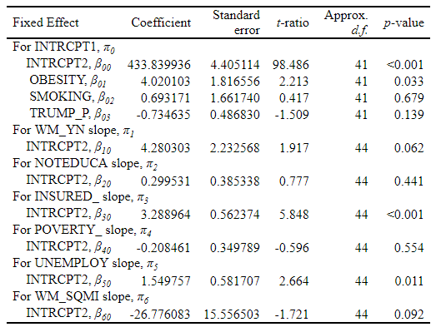

Table 4:
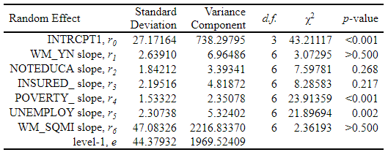

Table 5: Hypothesis and Deviance Test

Wald Test to determine if the difference in cancer incidence between counties with and without windmills, and the effect of a change in windmills per square mile are significant.

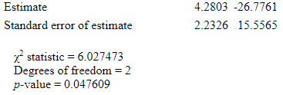

Deviance Test to determine if adding windmill data to the model explains significant variation compared to the original model without windmill indicators.

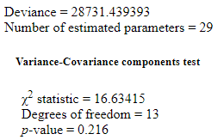

Study 2 – Longitudinal, 3-level model (repeated measures, nested within counties, nested within states)
Table 6:

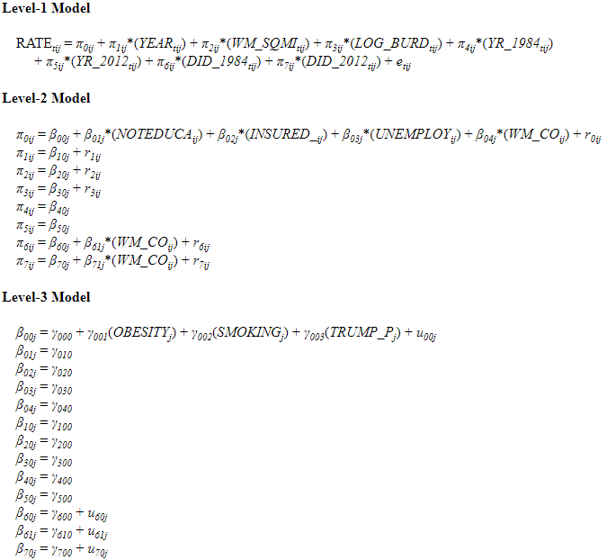

Table 7:
LEVEL-1 | DESCRIPTIVE | STATISTICS
VARIABLE | N | MEAN | SD | MINIMUM | MAXIMUM
YEAR | 8107 | 1995.7 | 12.2 | 1975.0 | 2019.0
RATE | 8107 | 428.1 | 79.1 | 49.6 | 894.5
CURENT | 8107 | 6.8 | 30.8 | 0.0 | 317.0
WM_SQMI | 8107 | 0.0 | 0.1 | 0.0 | 0.6
WM_DENS | 8107 | 2200.2 | 29654.5 | 0.0 | 637603.2
CAP | 8107 | 145.8 | 488.6 | 0.0 | 3557.1
HEIGHT | 8107 | 7.1 | 22.0 | 0.0 | 100.0
ROT_DIA | 8107 | 7.5 | 23.8 | 0.0 | 136.0
LAND_SQM | 8107 | 1465.8 | 1668.8 | 46.9 | 7820.0
DENSITY_ | 8107 | 304.7 | 1317.1 | 0.3 | 17179.2
LOG_BURD | 8107 | 0.5 | 1.5 | 0.0 | 7.5
YR_1984 | 8107 | 0.8 | 0.4 | 0.0 | 1.0
YR_2012 | 8107 | 0.1 | 0.3 | 0.0 | 1.0
WM_YN | 8107 | 0.1 | 0.3 | 0.0 | 1.0
DID_1984 | 8107 | 0.1 | 0.3 | 0.0 | 1.0
DID_2012 | 8107 | 0.1 | 0.2 | 0.0 | 1.0
LEVEL-2 | DESCRIPTIVE | STATISTICS
VARIABLE | N | MEAN | SD | MINIMUM | MAXIMUM
NOTEDUCA | 195 | 10.2 | 4.7 | 2.1 | 30.7
MED_INCO | 195 | 65827.4 | 15504.5 | 32551.0 | 130079.0
INSURED_ | 195 | 91.2 | 4.0 | 77.9 | 96.5
POVERTY_ | 195 | 13.6 | 5.5 | 4.1 | 38.1
UNEMPLOY | 195 | 5.7 | 2.6 | 0.3 | 16.3
NOMOVE_P | 195 | 93.6 | 2.2 | 83.5 | 97.5
WM_CO | 195 | 0.4 | 0.5 | 0.0 | 1.0
LAND_SQM | 195 | 1471.4 | 1672.9 | 46.9 | 7820.0
DENSITY_ | 195 | 307.0 | 1315.6 | 0.3 | 17179.2
LEVEL-3 | DESCRIPTIVE | STATISTICS
VARIABLE | N | MEAN | SD | MINIMUM | MAXIMUM
OBESITY | 9 | 28.6 | 4.1 | 23.8 | 36.4
SMOKING | 9 | 14.5 | 3.5 | 8.9 | 19.3
TRUMP_P | 9 | 41.6 | 7.8 | 30.0 | 51.2
TRUMP | 9 | 0.6 | 0.5 | 0.0 | 1.0
WM_STATE | 9 | 0.8 | 0.4 | 0.0 | 1.0

Table 8:

Fixed Effect | Coefficient | Standard  error | t-ratio | Approx.  d.f. | p-value
For INTRCPT1, π₀
For INTRCPT2, β₀₀
INTRCPT3, γ₀₀₀ | 438.038820 | 14.720770 | 29.757 | 5 | <0.001
OBESITY, γ₀₀₁ | 11.828502 | 5.358665 | 2.207 | 5 | 0.078
SMOKING, γ₀₀₂ | -9.753812 | 4.693189 | -2.078 | 5 | 0.092
TRUMP_P, γ₀₀₃ | 1.028243 | 2.710937 | 0.379 | 5 | 0.720
For NOTEDUCA, β₀₁
INTRCPT3, γ₀₁₀ | 1.028936 | 0.610405 | 1.686 | 143 | 0.094
For INSURED_, β₀₂
INTRCPT3, γ₀₂₀ | 4.693615 | 1.067643 | 4.396 | 143 | <0.001
For UNEMPLOY, β₀₃
INTRCPT3, γ₀₃₀ | 2.047917 | 0.876205 | 2.337 | 143 | 0.021
For WM_CO, β₀₄
INTRCPT3, γ₀₄₀ | -0.405328 | 3.573330 | -0.113 | 143 | 0.910
For YEAR slope, π₁
For INTRCPT2, β₁₀
INTRCPT3, γ₁₀₀ | 1.808546 | 0.131900 | 13.712 | 143 | <0.001
For WM_SQMI slope, π₂
For INTRCPT2, β₂₀
INTRCPT3, γ₂₀₀ | -31.762389 | 29.513190 | -1.076 | 143 | 0.284
For LOG_BURD slope, π₃
For INTRCPT2, β₃₀
INTRCPT3, γ₃₀₀ | 1.838460 | 1.614026 | 1.139 | 143 | 0.257
For YR_1984 slope, π₄
For INTRCPT2, β₄₀
INTRCPT3, γ₄₀₀ | 38.063960 | 2.405358 | 15.825 | 6890 | <0.001
For YR_2012 slope, π₅
For INTRCPT2, β₅₀
INTRCPT3, γ₅₀₀ | -41.627015 | 3.134720 | -13.279 | 6890 | <0.001
For DID_1984 slope, π₆
For INTRCPT2, β₆₀
INTRCPT3, γ₆₀₀ | -30.149100 | 10.331708 | -2.918 | 8 | 0.019
For WM_CO, β₆₁
INTRCPT3, γ₆₁₀ | 6.085855 | 19.507999 | 0.312 | 8 | 0.763
For DID_2012 slope, π₇
For INTRCPT2, β₇₀
INTRCPT3, γ₇₀₀ | 6.430548 | 11.164822 | 0.576 | 8 | 0.580
For WM_CO, β₇₁
INTRCPT3, γ₇₁₀ | -1.174758 | 20.640588 | -0.057 | 8 | 0.956

Table 9:

Random Effect | Standard  Deviation | Variance  Component | d.f. | χ² | p-value
INTRCPT1,r₀ | 21.03381 | 442.42110 | 5 | 112.17142 | <0.001
YEAR slope,r₁ | 1.14048 | 1.30071 | 9 | 21.56726 | 0.010
WM_SQMI slope,r₂ | 60.54239 | 3665.38133 | 9 | 11.20246 | 0.261
LOG_BURD slope,r₃ | 5.76402 | 33.22388 | 9 | 7.51082 | >.500
DID_1984 slope,r₆ | 22.44412 | 503.73832 | 8 | 7.17345 | >.500
DID_2012 slope,r₇ | 12.59935 | 158.74364 | 8 | 8.22557 | 0.412
level-1, e | 57.05623 | 3255.41312

Table 10: Hypothesis and Deviance Test

Wald Test to determine if overall effect of both DID model coefficients causes a change in cancer incidence before and after developing windmills in 2012.

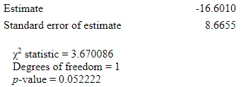

Deviance Test to determine if adding windmill data and DID estimators to the model explains significant variation compared to the original model without windmill indicators.

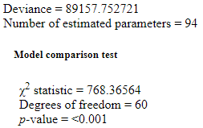

Study 3 – Longitudinal, 2-level model (repeated measures nested within counties)
Table 11:
LEVEL-1 | DESCRIPTIVE | STATISTICS
VARIABLE | N | MEAN | SD | MINIMUM | MAXIMUM
YEAR | 6609 | 1995.6 | 12.2 | 1975.0 | 2019.0
RATE | 6609 | 418.2 | 81.4 | 49.6 | 894.5
CURENT | 6609 | 6.9 | 30.0 | 0.0 | 317.0
WM_SQMI | 6609 | 0.0 | 0.1 | 0.0 | 0.6
WM_DENS | 6609 | 203.0 | 1162.5 | 0.0 | 21725.7
CAP | 6609 | 148.0 | 483.6 | 0.0 | 3557.1
HEIGHT | 6609 | 7.5 | 22.5 | 0.0 | 100.0
ROT_DIA | 6609 | 7.6 | 23.6 | 0.0 | 136.0
LAND_SQM | 6609 | 1599.2 | 1791.0 | 109.2 | 7820.0
DENSITY_ | 6609 | 62.1 | 160.7 | 0.3 | 1387.1
LOG_BURD | 6609 | 0.5 | 1.6 | 0.0 | 7.5
YR_1999 | 6609 | 0.4 | 0.5 | 0.0 | 1.0
YR_2011 | 6609 | 0.2 | 0.4 | 0.0 | 1.0
WM_YN | 6609 | 0.1 | 0.3 | 0.0 | 1.0
DID_1999 | 6609 | 0.1 | 0.3 | 0.0 | 1.0
DID_2011 | 6609 | 0.1 | 0.3 | 0.0 | 1.0
LEVEL-2 | DESCRIPTIVE | STATISTICS
VARIABLE | N | MEAN | SD | MINIMUM | MAXIMUM
NOTEDUCA | 157 | 10.4 | 5.0 | 2.1 | 30.7
MED_INCO | 157 | 62154.5 | 12303.5 | 32551.0 | 127500.0
INSURED_ | 157 | 91.2 | 4.0 | 78.3 | 96.5
POVERTY_ | 157 | 13.9 | 5.7 | 4.1 | 38.1
UNEMPLOY | 157 | 5.2 | 2.6 | 0.3 | 16.3
NOMOVE_P | 157 | 93.7 | 2.2 | 83.5 | 97.5
WM_CO | 157 | 0.5 | 0.5 | 0.0 | 1.0
LAND_SQM | 157 | 1604.6 | 1799.7 | 109.2 | 7820.0
DENSITY_ | 157 | 62.2 | 161.4 | 0.3 | 1387.1

Table 12:

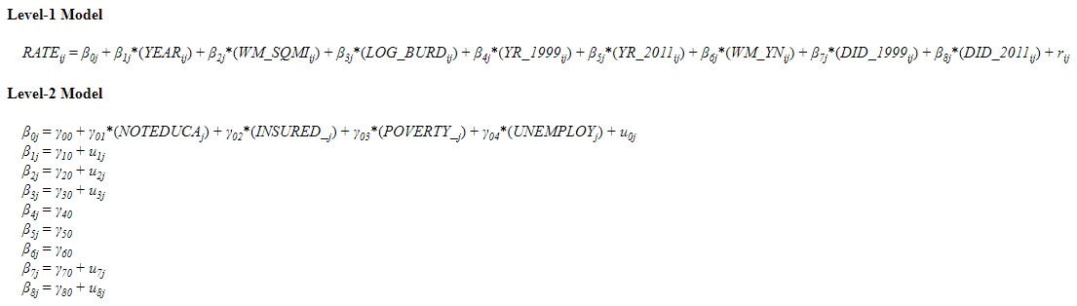

Table 13:

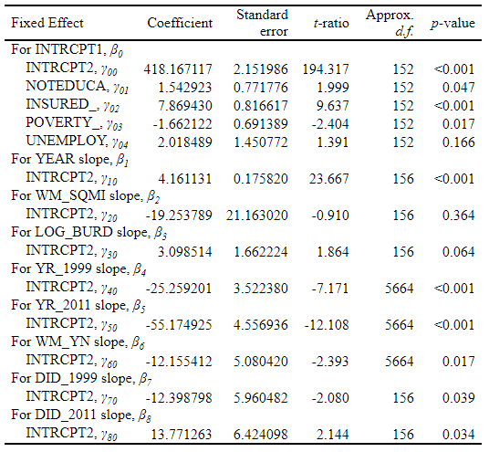

Table 14:
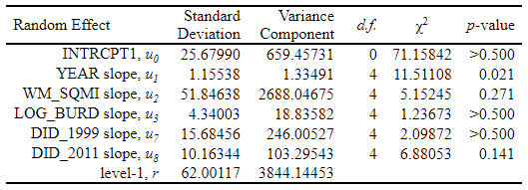

Table 15: Hypothesis and Deviance Test

Wald Test to determine if overall effect of both DID model coefficients causes a change in cancer incidence before and after developing windmills in 2011.
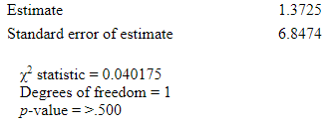

Deviance Test to determine if adding windmill data and DID estimators to the model explains significant variation compared to the original model without windmill indicators.
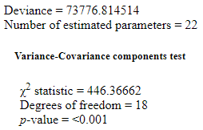

Study 4 – C-Clustered Model (repeated measures nested within counties / cancer sites)
Table 16:
LEVEL-1 | DESCRIPTIVE | STATISTICS
VARIABLE | N | MEAN | SD | MINIMUM | MAXIMUM
YEAR | 34560 | 1997.2 | 6.1 | 1987.0 | 2007.0
ADJ_RATE | 34560 | 22.3 | 26.8 | 0.2 | 219.7
CURENT | 34560 | 2.9 | 20.0 | 0.0 | 259.0
WM_SQMI | 34560 | 0.0 | 0.0 | 0.0 | 0.5
WM_DENS | 34560 | 100.3 | 698.7 | 0.0 | 9116.8
CAP | 34560 | 56.6 | 230.9 | 0.0 | 2500.0
HEIGHT | 34560 | 4.1 | 15.2 | 0.0 | 80.0
ROT_DIA | 34560 | 3.6 | 13.4 | 0.0 | 96.0
LOG_BURD | 34560 | 0.3 | 1.1 | 0.0 | 6.4
LAND_SQM | 34560 | 577.8 | 123.9 | 380.6 | 972.7
DENSITY_ | 34560 | 74.8 | 122.6 | 9.5 | 750.5
WM_YN | 34560 | 0.1 | 0.3 | 0.0 | 1.0
YR_1998 | 34560 | 0.5 | 0.5 | 0.0 | 1.0
DID_1998 | 34560 | 0.1 | 0.3 | 0.0 | 1.0
ROW | LEVEL | DESCRIPTIVE | STATISTICS
VARIABLE | N | MEAN | SD | MINIMUM | MAXIMUM
NOTEDUCA | 98 | 8.9 | 3.1 | 3.7 | 21.8
MED_INCO | 98 | 65113.3 | 7793.7 | 50083.0 | 99151.0
INSURED_ | 98 | 93.7 | 1.5 | 88.6 | 96.1
POVERTY_ | 98 | 11.8 | 3.3 | 5.7 | 22.3
UNEMPLOY | 98 | 4.3 | 1.4 | 1.8 | 8.4
NOMOVE_P | 98 | 93.9 | 2.0 | 83.5 | 97.1
WM_CO | 98 | 0.6 | 0.5 | 0.0 | 1.0
LAND_SQM | 98 | 564.1 | 118.7 | 380.6 | 972.7
DENSITY_ | 98 | 53.5 | 90.9 | 9.5 | 750.5
COLUMN | LEVEL | DESCRIPTIVE | STATISTICS
VARIABLE | N | MEAN | SD | MINIMUM | MAXIMUM
DIAG_NOR | 9 | 41.9 | 26.1 | 3.0 | 86.7
ORAL | 9 | 0.1 | 0.3 | 0.0 | 1.0
DIGESTIV | 9 | 0.1 | 0.3 | 0.0 | 1.0
RESPRITO | 9 | 0.1 | 0.3 | 0.0 | 1.0
SKIN | 9 | 0.1 | 0.3 | 0.0 | 1.0
BREAST | 9 | 0.1 | 0.3 | 0.0 | 1.0
FGS | 9 | 0.0 | 0.0 | 0.0 | 0.0
MGS | 9 | 0.1 | 0.3 | 0.0 | 1.0
US | 9 | 0.0 | 0.0 | 0.0 | 0.0
BRAIN | 9 | 0.1 | 0.3 | 0.0 | 1.0
ENDOCRIN | 9 | 0.1 | 0.3 | 0.0 | 1.0
LYMPHOMA | 9 | 0.0 | 0.0 | 0.0 | 0.0
LEUKEMIA | 9 | 0.1 | 0.3 | 0.0 | 1.0

Table 17:

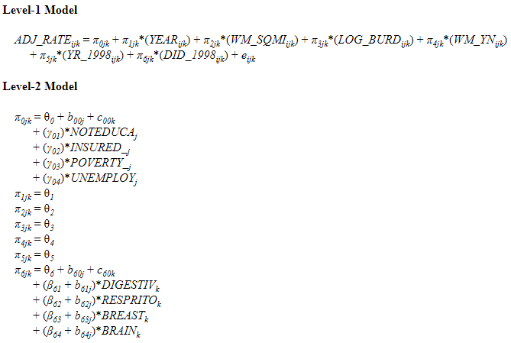

Table 18:

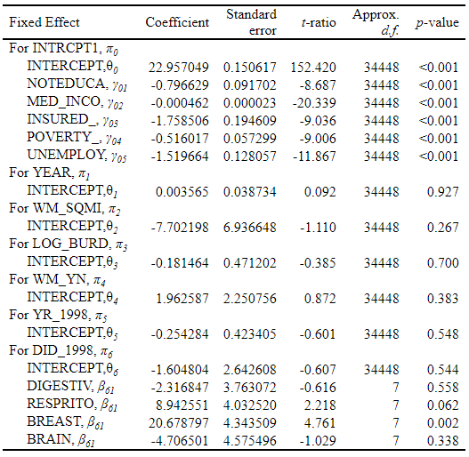

Table 19:
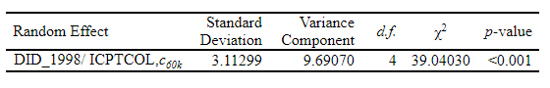

Table 20:

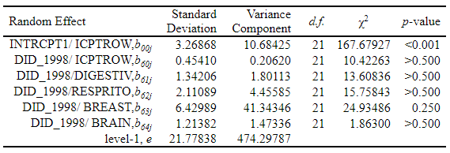

Study 1 – Cross-Sectional, 2-level model (counties nested within states)
Figure 1:
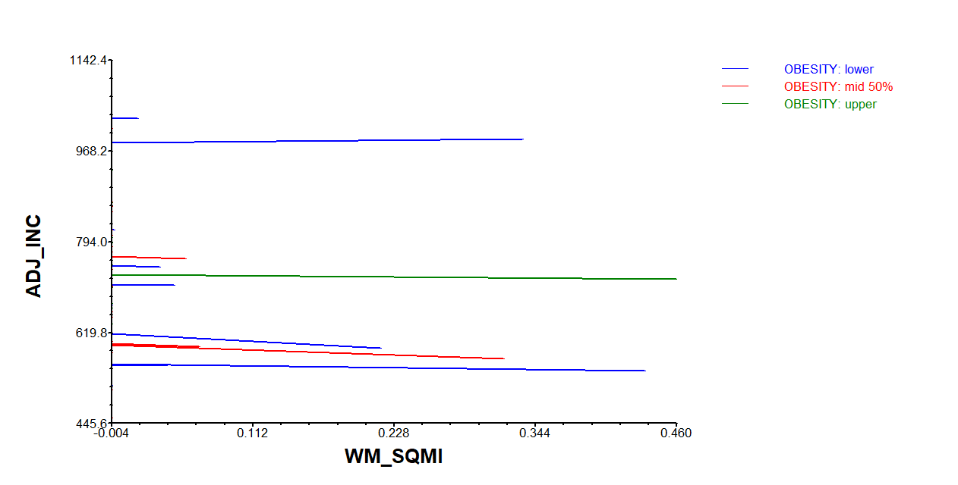

Figure 2:
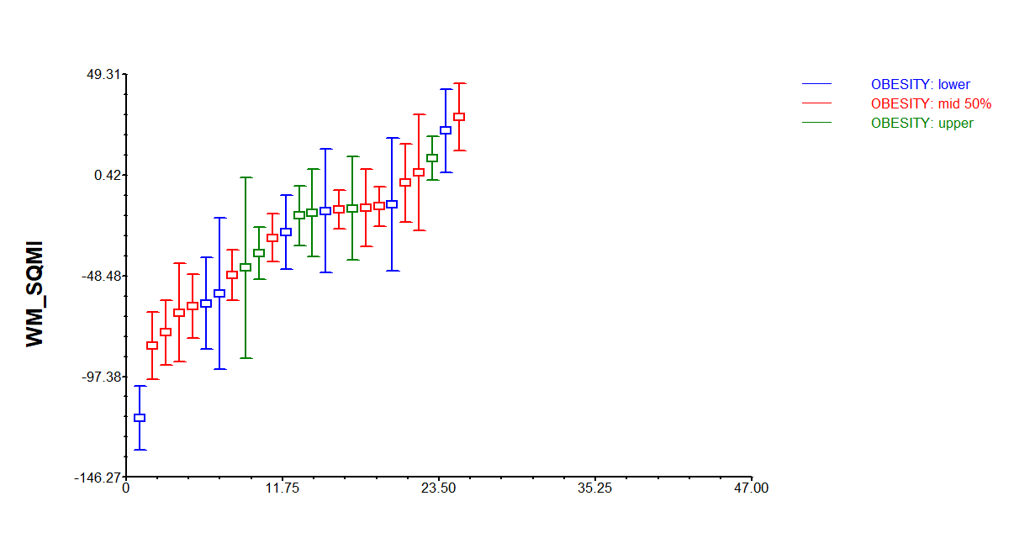

Figure 3:
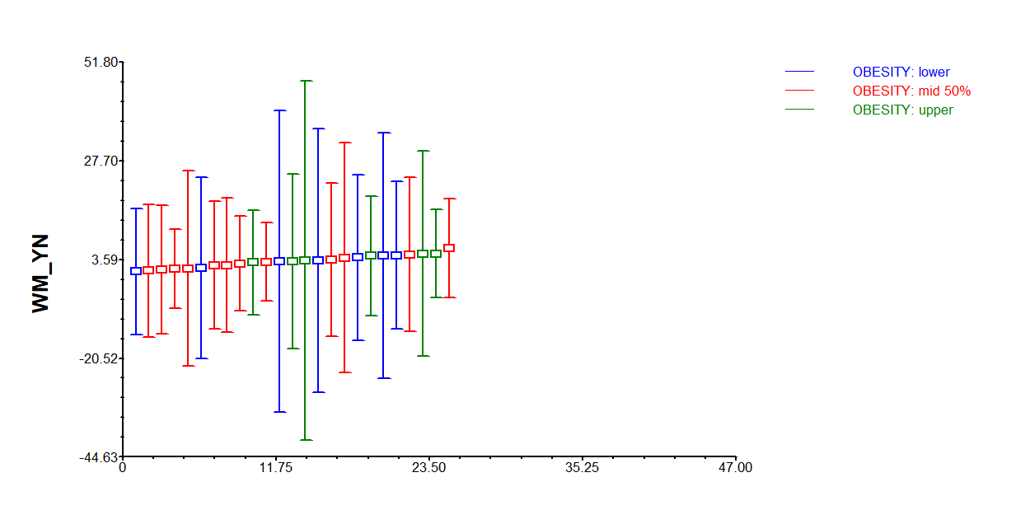

Figure 4:
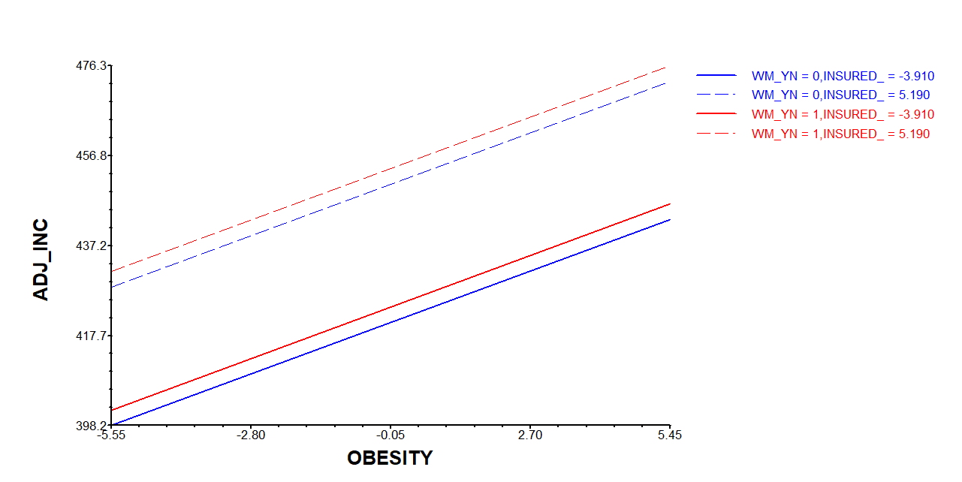

Figure 5:
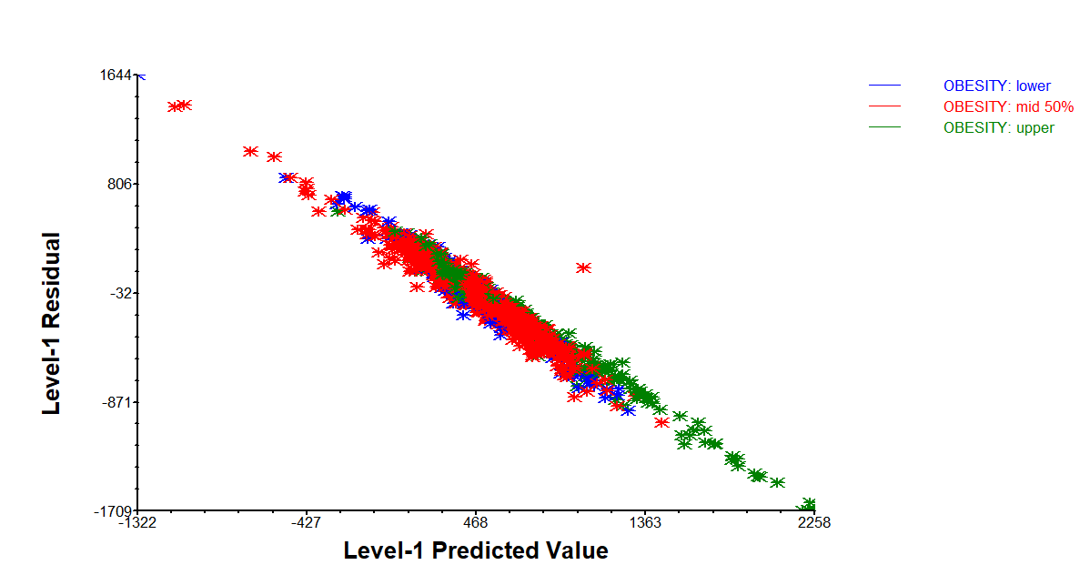

Figure 6:
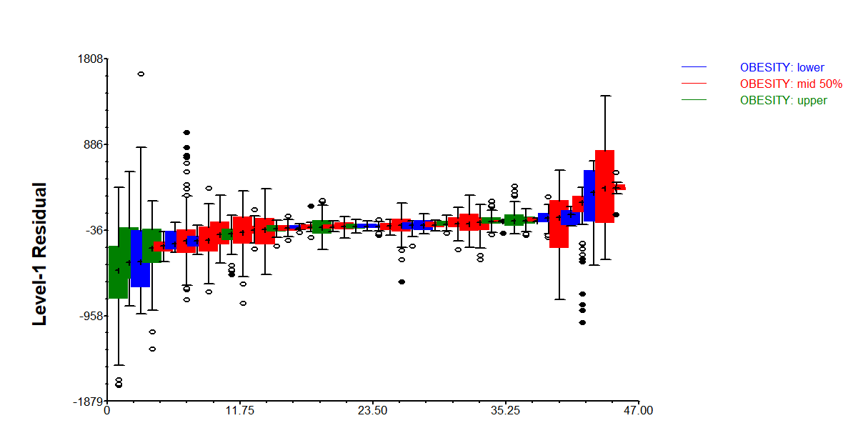

Study 2 – Longitudinal, 3-level model (repeated measures, nested within counties, nested within states)
Figure 7:

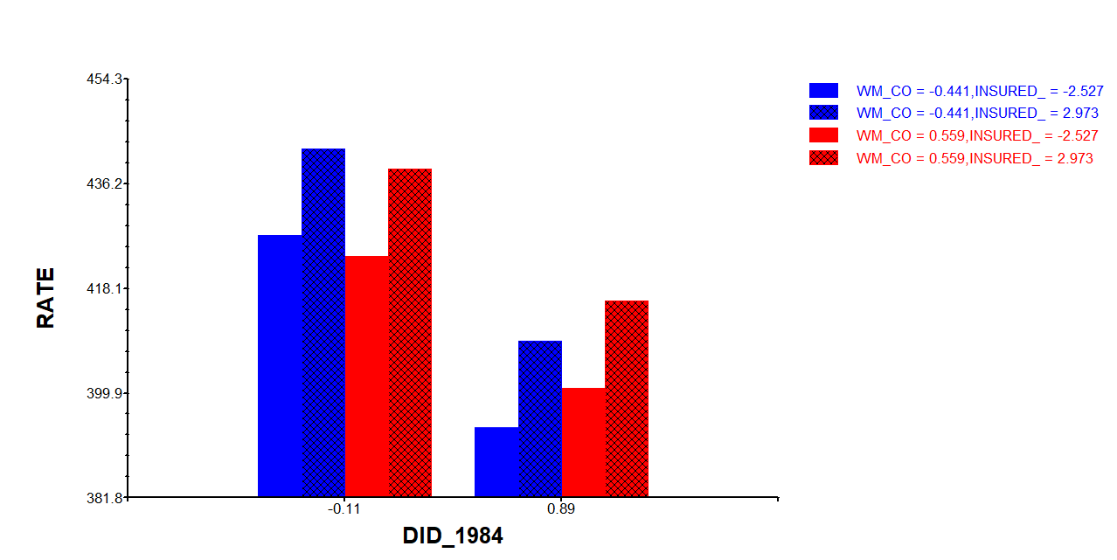

Figure 8:
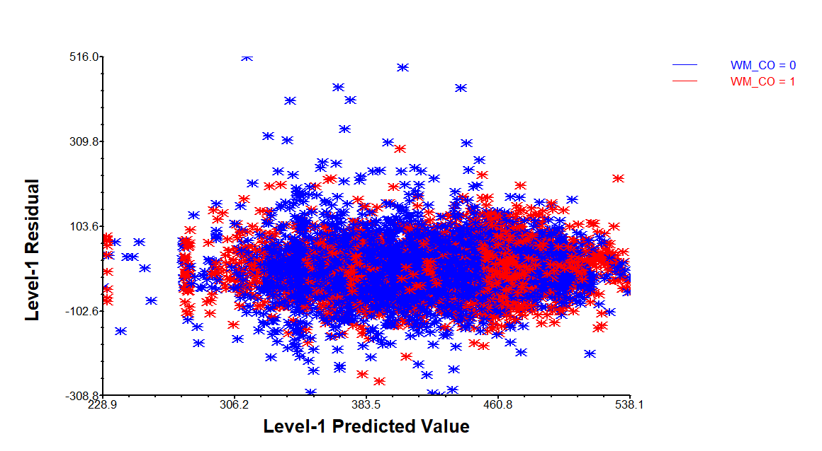

Study 3 – Longitudinal, 2-level model (repeated measures nested within counties)
Figure 9:
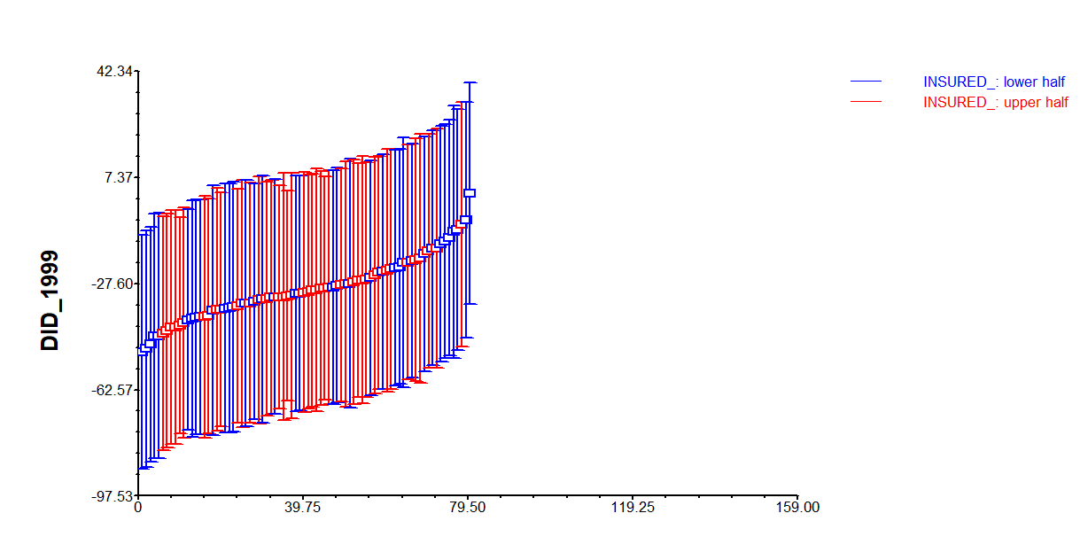

Figure 10:
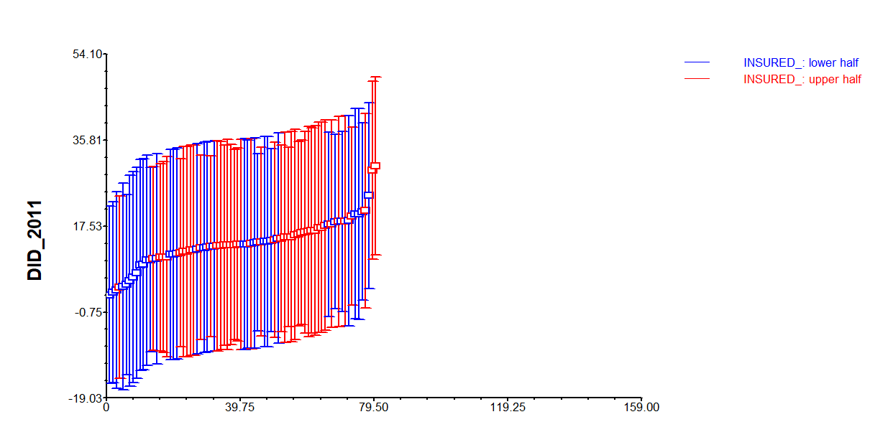

Figure 11:
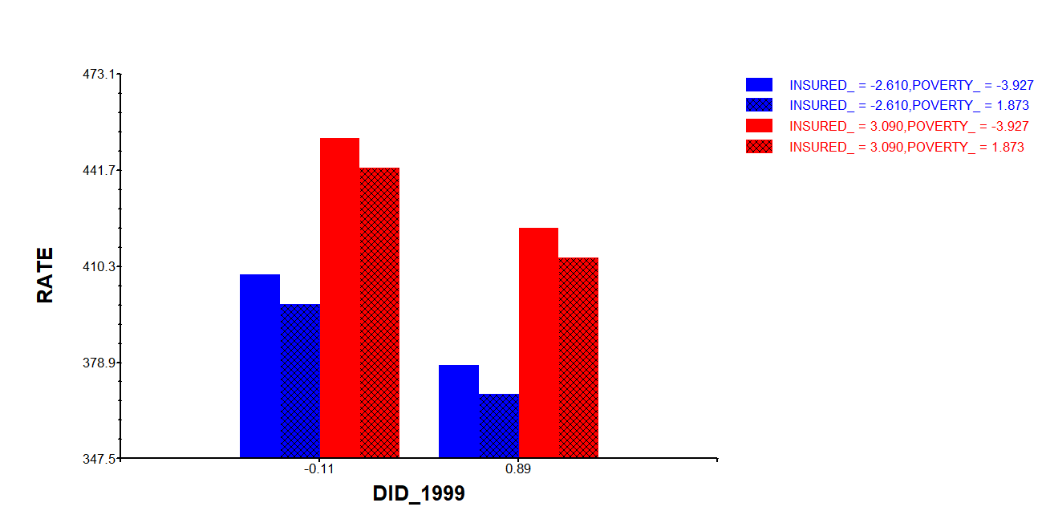

Figure 12:
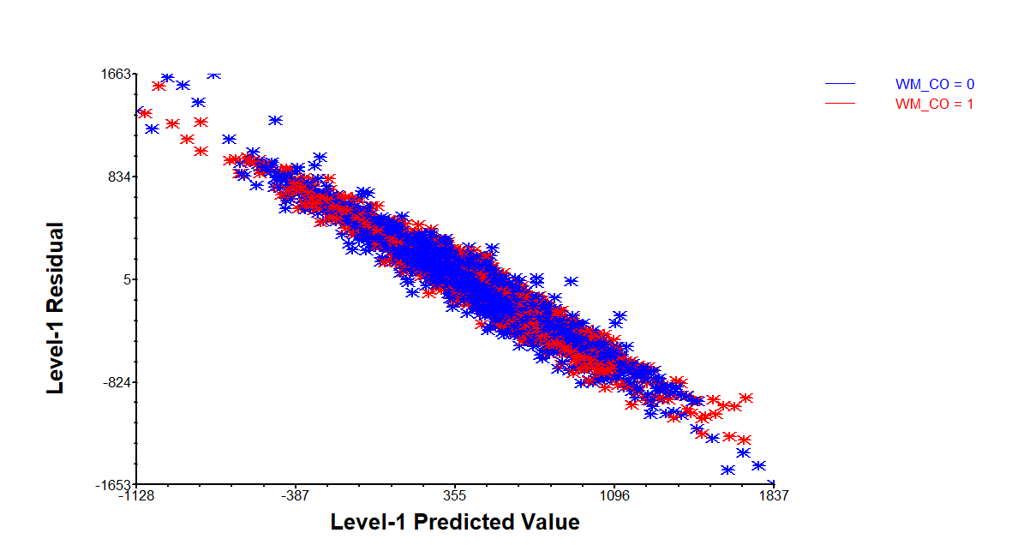

Figure 13:
