Supplement

Brick et al. (2024). Current research practices on pro-environmental behavior: A survey of environmental psychologists. doi.org/10.1016/j.jenvp.2024.102375

S1.1 Favorite papers; S1.2 Recruitment sources and text; S1.3 Open response codes;
S1.4 Additional figures; S1.5 Additional analysis output

S1.1 Table S1

Favorite Papers from Environmental Psychology (See Raw Data for 95 Papers Mentioned Once)

DOI | Title | Authors | N
10.1016/j.jenvp.2021.101559 | The case for impact-focused environmental psychology | Nielsen, K. S., Cologna, V., Lange, F., Brick, C., & Stern, P. C. | 4
10.1037/a0023566 | The dragons of inaction: Psychological barriers that limit climate change mitigation and adaptation | Gifford, R. | 4
10.1177/0956797617719950 | Dynamic norms promote sustainable behavior, even if it is counternormative | Sparkman, G., & Walton, G. M. | 4
10.1016/j.gloenvcha.2013.05.014 | A comprehensive model of the psychology of environmental behaviour—A meta-analysis | Klöckner, C. A. | 3
10.1016/j.jenvp.2014.01.002 | An integrated framework for encouraging pro-environmental behaviour: The role of values, situational factors and goals | Steg, L., Bolderdijk, J. W., Keizer, K., & Perlaviciute, G. | 3
10.1111/j.1467-9280.2007.01917.x | The constructive, destructive, and reconstructive power of social norms | Schultz, P. W., Nolan, J. M., Cialdini, R. B., Goldstein, N. J., & Griskevicius, V. | 2
10.1016/j.jenvp.2020.101474 | Towards cross-cultural environmental psychology: A state-of-the-art review and recommendations | Tam, K. P., & Milfont, T. L. | 2
10.1073/pnas.1001509107 | Public perceptions of energy consumption and savings | Attari, S. Z., DeKay, M. L., Davidson, C. I., & Bruine de Bruin, W. | 2
10.1038/s41558-018-0371-y | Meta-analyses of factors motivating climate change adaptation behaviour | van Valkengoed, A. M., & Steg, L. | 2
10.1037/amp0000624 | How psychology can help limit climate change. | Nielsen, K. S., Clayton, S., Stern, P. C., Dietz, T., Capstick, S., & Whitmarsh, L. | 2
10.1038/s41893-022-00888-7 | The motivation–impact gap in pro-environmental clothing consumption | Nielsen, K. S., Brick, C., Hofmann, W., Joanes, T., Lange, F., & Gwozdz, W. | 2
10.2139/ssrn.4046264 | The i-Frame and the s-Frame: How focusing on individual-level solutions has led behavioral public policy astray | Chater, N., & Loewenstein, G. | 2
10.1038/s41893-019-0263-9 | Meta-analysis of pro-environmental behaviour spillover | Maki, A., Carrico, A. R., Raimi, K. T., Truelove, H. B., Araujo, B., & Yeung, K. L. | 2

S1.2. Recruitment

Sources

Conservation psychology CO listserv
ENVPSY listserv
Florian Kaiser listserv
Slack ECR group
APA Div34 facebook, listserv
SPSP Sustainability Forum
IAAP Division 4
IPU Germany; Austria; Switzerland
PsicAmb
Norway Environmental Psychology Network
Environmental Psychology Census
International Society for Justice Research
Facebook
Twitter/X
[Authors' laboratory listservs]

Recruitment Text (Listserv and Email)

Dear colleagues and students,

Would you please consider participating in our short community-led survey of researchers from many countries?

We are interested in the current practices, topics of interest and methods used to study pro-environmental behaviors. We hope to cover a wide range of domains, whether recycling, energy consumption, biodiversity conservation, civic engagement and others.

Participation is anonymous and will take less than 10 minutes. You can direct us to make a contribution to the Center for Open Science, Society for the Improvement of Psychological Science, or the Sustainability Pre-conference of the Society for Personality and Social Psychology. We will divide the contribution according to everyone’s choices. I would mention the four-digit amount but I think it will trigger some spam filters.

This survey can be completed on a mobile device, but survey formatting will be best on a computer. Thank you for your time and expertise.

[ Qualtrics link removed ]

[ Author names and affiliations removed ]

If you have any questions, please contact Cameron Brick, University of Amsterdam, c.brick@uva.nl

S1.3. Open Response Codes

Table S2

Frequency of Thematic Codes by Open Response Question

Question | Response option |  | Code | Freq.
Which of the following best characterises you and your work? | Neither of the above (please specify) |  | Trained in psychology (1) | 6
Which of the following best characterises you and your work? | Neither of the above (please specify) |  | Not trained in psychology (2) | 4
Which of the following best characterises you and your work? | Neither of the above (please specify) |  | Neither | 0
What field were you trained in? Please leave blank if you do not have scientific training |  |  | Humanities (Law) | 1
 |  |  | Social and behavioral sciences (e.g., Economics, Psychology, Political sciences) | 31
 |  |  | Natural sciences (e.g., Chemistry, Biology, Environmental science) | 6
 |  |  | Professions and applied sciences (e.g., Agriculture, Pedagogy, Applied ecology) | 8
 |  |  | NA | 2
When conducting empirical studies on pro-environmental behaviour, people can have different research objectives. | Other (please specify) |  | Understanding the causes of pro-environmental behaviours (3a_1) | 1
 |  |  | Understanding interventions to change pro-environmental behaviours (3a_2) | 6
 |  |  | Testing or advancing theories (3a_3) | 2
 |  |  | Developing, validating, or improving methods (3a_4) | 8
 |  |  | Replicating previous research (3a_5) | 0
 |  |  | Other (please specify) (3a_6) | 7
 |  |  | NA | 4
Thinking about the last empirical study with pro- environmental behaviour that you worked on or published, which theory/theories have you used? If you did not use a theory, leave this blank¹. |  |  | Campbell Paradigm | 9
 |  |  | Comprehensive Action Determination Model | 7
 |  |  | Construal-Level Theory of Psychological Distance | 7
 |  |  | Goal Framing Theory | 5
 |  |  | Norm Activation Model | 14
 |  |  | Protection Motivation Theory | 5
 |  |  | Self Determination Theory | 7
 |  |  | Self-Efficacy Theory | 5
 |  |  | Social Identity Theory | 16
 |  |  | Social Norms Theory | 6
 |  |  | Theory of Planned Behavior/Theory of Reasoned Action/etc. | 33
 |  |  | Value Belief Norm Theory | 24
 |  |  | Not a theory (e.g., awe; radical flank effect) | 82
 | Other (please specify) |  | (e.g., Normative Influence Theory) | 88
Please specify your main goal for the given theory below. | Other (please specify) |  | Testing one or multiple predictions of the theory (1) | 0
Please specify your main goal for the given theory below. |  |  | Inspiration for intervention design (2) | 2
Please specify your main goal for the given theory below. |  |  | Post-hoc interpretation or integration of findings (3) | 0
Please specify your main goal for the given theory below. |  |  | Modifying and/or advancing the theory to better predict behaviour (4) | 0
 |  |  | Validating the theory in new contexts (5) | 2
 |  |  | Other (specify on next page) (6) | 3
Does this theory help to address the climate crisis or other environmental problems? Please explain.² |  |  | Yes | 104
 |  |  | No | 9
 |  |  | Somewhat/Unclear | 52
 |  |  | NA | 60
Please consider the last empirical study with pro-environmental behaviour that you worked on or published. Which method did you primarily use? | Other (please specify) |  | Mixed methods | 10
What was the main study design? | Other (please specify) |  | Experimental (1) | 7
What was the main study design? | Other (please specify) |  | Cross-sectional (survey, correlation) (2) | 4
What was the main study design? | Other (please specify) |  | Longitudinal (3) | 3
What was the main study design? |  |  | Field study (e.g., exploratory ethnography) | 2
What was the main study design? |  |  | Qualitative | 3
What was the main study design? |  |  | Thematic analysis | 3
What was the main study design? |  |  | Mixed methods | 5
What was the main study design? |  |  | Quasi-experimental | 2
What was the main study design? |  |  | Interpretivist | 1
How did you select the effect size for the power analysis? | Other (please specify) |  | Meta analysis (1) | 0
How did you select the effect size for the power analysis? | Other (please specify) |  | Previous studies/Similar sizes of related effects or relationships (2, 3) | 4
How did you select the effect size for the power analysis? |  |  | General advice, e.g., Cohen's d = 0.2, 0.4, 0.6 guidelines (4) | 1
How did you select the effect size for the power analysis? |  |  | Smallest effect size of interest | 2
How did you select the effect size for the power analysis? |  |  | Unclear | 2
Considering the last empirical study you published measuring pro-environmental behaviour, which behaviour(s) did you study? (Multiple answers possible) | Other (please specify) |  | Consumer | 27
 | Other (please specify) |  | Citizen | 16
 | Other (please specify) |  | Other | 6
 |  |  | Combination | 10
 |  |  | None/not behavior | 4
How did you measure the following behaviour(s)?³ |  |  | Self-report | 45
How did you measure the following behaviour(s)?³ |  |  | Observed/traces (donation, sending letters) | 10
How did you measure the following behaviour(s)?³ |  |  | Choice tasks | 9
How did you measure the following behaviour(s)?³ |  |  | Not specified | 8
How did you measure the following behaviour(s)?³ |  |  | None/not behavior | 3
Considering the last study you worked on with pro-environmental behaviour(s), how strongly did the following factors influence the choice of behaviour? | Other (please specify) |  | Personal interest (4) | 1
 | Other (please specify) |  | Environmental impact(s) of behaviours (5) | 1
 |  |  | Available funding (6) | 2
 |  |  | Measurement ease (7)
 |  |  | Continuing previous research on this behaviour (8) | 3
 |  |  | Research norm of the target journal (9)
 |  |  | Other | 11
 |  |  | None/not behavior | 4
Have you collaborated with any of these groups outside of academia? (choose all that apply) | Other (please specify) |  | Practitioners in government (1) | 3
 | Other (please specify) |  | Practitioners in nonprofit sector (2) | 1
 |  |  | Practitioners in companies or industry (3) | 1
 |  |  | Public utilities (4) | 2
 |  |  | Other | 3
 |  |  | Community members | 3
Note. Frequent codes from the open response questions were included in the main Results section, for example when they matched pre-existing response options. Here, the codes followed by a number in parentheses are answer options given in the survey, and those not followed by a number were added by the coders.
¹ Participants could indicate up to three theories.
² Counts are based on open answers that were coded as theories in the previous step.
³ "How did you measure the following behaviour(s)?" could be filled in separately for 16 types of behaviors.

S1.4. Additional Figures

Figure S1
Pro-Environmental Behavior Measurement Sorted by Behavior Type Frequency
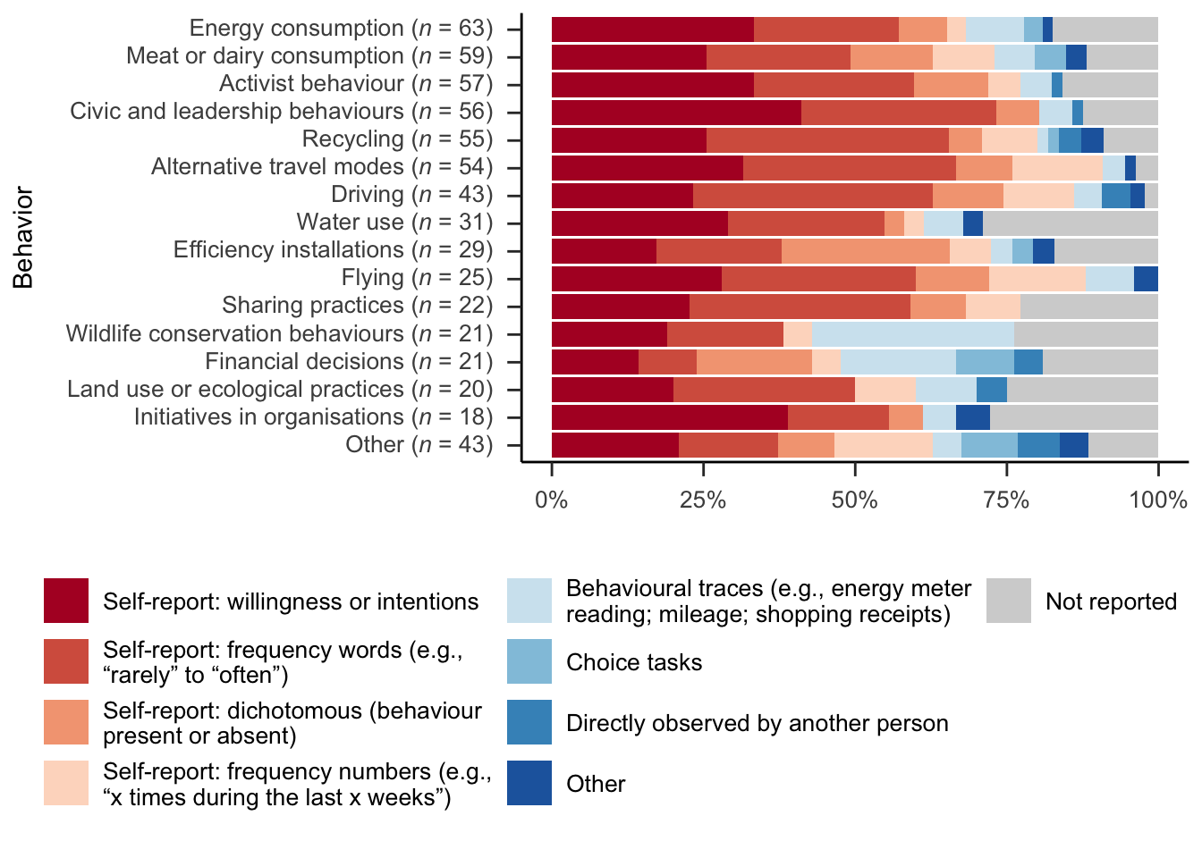Note. This is a different sorting of the same data shown in Figure 4.

Figure S2

Motives for Population Selection
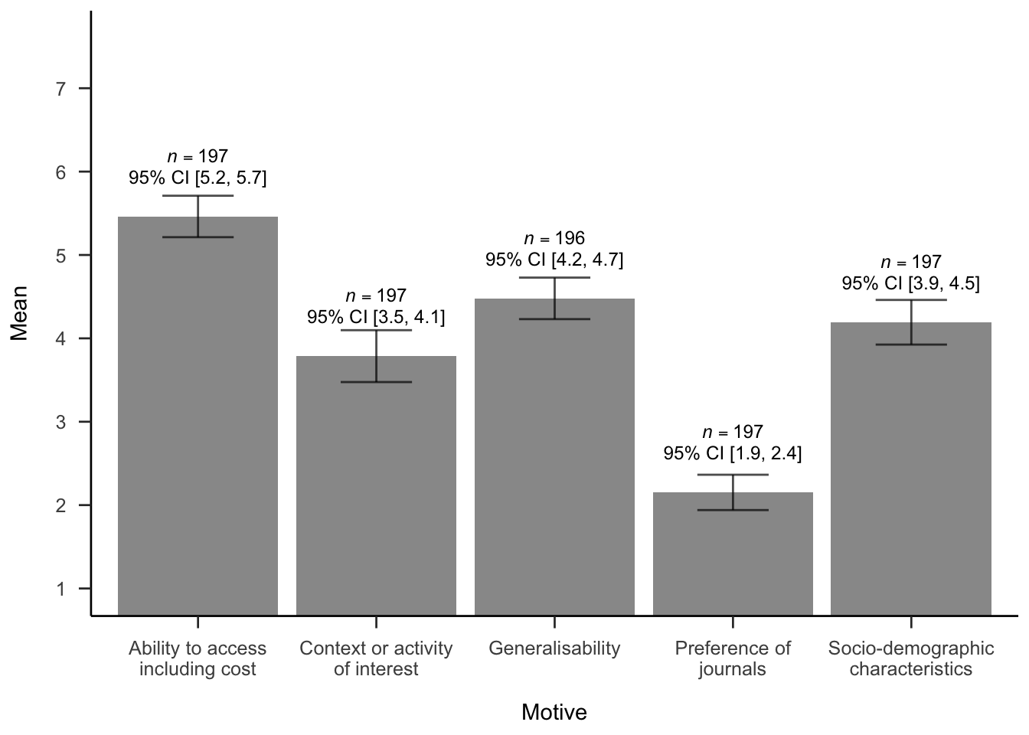
Note. This is a visualization of the data in Table 1.

S1.5. Additional Analysis Output (RMarkdown)

https://osf.io/yns62

This HTML file provides additional analysis output such as Ms (SDs) for figures.

