The University of Chicago

Voting and Bar Associations: An Analysis of Cook County Judicial Bar Ratings and their Relationship with Judicial Elections
Are bar association ratings useful for understanding how well judicial candidates perform?

By: Milan Rivas

Public Policy Studies
April 2020

Abstract

Despite traditional media’s focus on higher, more visible races, the average community member is far more likely to have their life directly impacted by a judge that any other election official. This paper focuses on the relationship between major bar association ratings and the primary election vote share received by candidates for judicial office in Cook County, to see whether Cook County has an effective way of discerning quality in potential candidates. The literature indicates that ratings should be at least somewhat predictive of vote share, if primarily through indirect mechanisms, such as party slating. This paper primarily relies on a linear regression, with clustered standard errors to investigate the possibility of a statistical relationship. Statistically significant evidence is found that there is a positive relationship between general bar association approval and the vote share experienced by a given candidate. Additionally, there is evidence that this relationship is stronger in larger races, further evidence of an indirect relationship between ratings and how voters choose candidates. This paper primarily offers policy recommendations that will allow for bar associations to spend longer researching a candidate prior to offering a rating, as this should increase the amount of meaningful information voters and other parties can expect to receive from these ratings, but also recognizes the need for these ratings to also reach a broader audience if they are to be a meaningful source of voter information.

Acknowledgement

I would first like to thank Injustice Watch and my many coworkers there who not only directly helped me with what eventually became the data for this thesis, but also taught me practically everything I know about the strange world that is Cook County judicial elections. I owe a special thanks to Rick Tulsky, for doling out practical wisdom on the subject, as well as connecting me with what would prove to be valuable industry contacts. Thanks as well to my fellow interns, who unwittingly provided me with the just the data I needed.

I would also like to thank Daniel Moskowitz, who provided crucial expertise and guidance regarding how to analyze the data with which I showed up at his office hours. Without his input, many more hours would have been spent failing about in the dark.

Finally, I must express deep gratitude to my parents, for providing me with endless support, and for always being ready to pretend they found the subject of this thesis irresistibly engaging.

Thank You,

Milan Rivas
Table of Contents
Abstract 2
Acknowledgement 3
Introduction & Background 5
Literature Review 10
Judicial Elections: 10
The Generation of Bar Association Ratings: 14
The Intersection of Politics and Judicial Elections in Cook County: 17
How Voters Use Information in Judicial Elections 23
Methods 26
Data Collection: 26
Statistical Analysis: 28
Limitations of the Model: 30
Results 32
Basic Descriptive Statistics: 32
Models: 34
Conclusions: 39
Policy Recommendations: 41
Areas for Further Research: 43
Appendix: 45
References: 50

Introduction & Background

This paper will focus on the relationship between bar association ratings and the outcomes of judicial elections in Cook County. This topic has remained minimally explored to this point, in large part due to the small-scale nature of judicial elections, with a large amount of participation in judicial elections simply being the result of voters drawn to the polls by larger, more attractive races. As Goldstein asserted about judicial elections as far back as the 1970’s, “the number of races and candidates involved discourage most citizens from devoting the time and energy needed to make an intensive study of the ability and orientation of the candidates,” so it may be that there is a high degree of randomness, or noise in the results of judicial elections. An extremely low voter engagement rate would prevent bar association ratings from being causally linked to election outcomes, and potentially prevent these ratings from being able to meaningfully predict the eventual winners and losers of races. Therefore, an exploration of the role played by bar associations must remain open to the possibility that there exists very little relationship between the quality of candidates and their election performance.
When viewed state-by-state, judicial elections appear in many diverse forms, to the extent that some states never see judicial candidates on the ballot, while others have the majority of their bench filled by popular vote. These different systems also place differing amounts of emphasis on factors such as campaign fundraising, political party affiliation, and minority representation. As the scope of this thesis’ study is Cook County, in the state of Illinois, it is important to understand not only the formal structures as outlined by Illinois law, but also how these structures interact with the unique politics of the Chicagoland area to produce the current Cook County judicial landscape. By understanding this landscape, the reader may then have a better idea of the potential for impact by bar associations, most notably through their ratings of judicial candidates.
When it comes to filling vacant benches, Cook County generally relies on elections. The focus of this thesis will be county-wide and subcircuit (an intra-county division) judgeships, both of which are elected positions, and for which elections occur every two years. However, especially in subcircuit elections, the voting population is very small, and thus there exists the opportunity for great variation from one subcircuit result to the next. While candidates running for a subcircuit position may be able to experience success in running against the establishment party (usually the Democratic Party in Cook County), this phenomenon becomes rarer when looking at county-wide races. These circuit court elections require much more resources to win, which typically gives greater advantage to those candidates who have received the official endorsements of the Democratic Party, who can lend support and infrastructure to the judicial candidate’s campaigns, typically through a formal process known as slating. To underscore the historical importance of slating for candidates, prior to 1984 only six judicial candidates not slated ended up winning a circuit election. However, there is also strong evidence that in recent years, the absolute power slating once possessed has begun to decrease. The ratings a candidate has received may play a role in helping them secure a party ‘slating’, but these ratings are far from the driving factor in whether or not this occurs. An important note is that this slating only occurs for offices at the circuit level and higher, not for subcircuits. As a result, party endorsement plays a large complicating factor that will have to be accounted for, but a comparison between subcircuit and country wide elections could prove useful in teasing out the nature of this relationship.
Because of the strength of other factors like political party endorsement, a theory proposed to the author of this paper by an expert in judicial elections is that bar association ratings do not play a role in determining elections. This paper withholds judgement on that particular theory, but even if true, such a premise would not be cause to abandon investigation. While determining the exact nature of the relationship between rating and results may be difficult, and this paper makes no claims to any causal relationship between the two, at the very least the low bar of whether bar association ratings actually predict the success of candidates for office may be assessed. The general view that this paper will take is that while bar association ratings are not as discerning as is theoretically possible (due to a combination of pressures, both internal and external to each bar association as an organization), they should still have a degree of predictive power, especially when used collaboratively to determine an underlying fitness for office.
In order to accomplish the above analysis, there will largely be a two-pronged approach taken in this paper: firstly, a look at the quantitative link between election results and bar association ratings from 2010 to present will be conducted. The elections covered in this analysis will only be for Cook County and its subcircuits, and but as several hundred judges are elected or up for a retention election every other year, many data points exist. These data points will consist of the ratings for each judicial candidate from the three main bar associations in Cook County: the Illinois State Bar Association (ISBA), the Chicago Bar Association (CBA), and the Chicago Council of Lawyers (CCL), and one identity bar association, the Cook County Bar Association (CCBA). For each of these sets of ratings, a result has been recorded: a win or loss, and the accompanying vote share received by that candidate. This data was compiled by multiple individuals, through scraping data from voter information sheets either obtained online or directly from bar associations. The vote share and results data were collected directly by the researcher and is publicly available at the website of the Cook County Clerk.
The second aspect prong of investigation will be a complementary search of existing literature on judicial elections. This second prong serves not only as a qualitative look at the scene in Cook County, but is also key for the statistical interpretation of the data that has been collected for the first prong of investigation. The knowledge of the underlying factors motivating voter behavior and bar association ratings will be necessary for developing priors that motivate the correct statistical conclusions and will mitigate chances of measuring confounding variables. Specifically, there is a concern that party support (particularly for Democratic candidates) may be such a powerful force that other measures of success and competence may simply be the result of the same, already measured backing of the establishment. There is also useful, if limited previous quantitative research into Cook County judicial elections, which may help frame the eventual results of this paper’s own results.
As outlined above, the scope of this paper is very focused, as necessitated by the unique nature of judicial elections from state-to-state. This unfortunately means that although this paper may be useful as another piece of context surrounding judicial elections and what drives their results, its findings will most likely not be directly applicable to elections outside of Illinois. Indeed, even for judicial elections in Illinois, but outside of Cook County, the political climate may be sufficiently different from Cook County as to rob the analysis of the powers and players done in this paper of any insight they may have. However, much as the analysis done here will be limited to largely Cook County, the relevance of this paper is largely due to the fact that the majority of existing literature has a somewhat limited applicability to the specific relationship between Cook County bar groups and judicial elections, particularly in a more modern context.

Literature Review

Judicial Elections and the Generation of Ratings, Politics and Elections in Cook County, and How Voters Use Information in Judicial Elections.

Judicial Elections:

As referenced in the introduction, there doesn’t exist a universal judicial selection system from state-to-state. While the federal judicial system is standardized because its stems from one organizing power (the US government), local judicial selection structures vary extensively across state lines, and often these systems are constructed specifically to bring about greater amounts of some desired quantity (for example democratization in one state, or accountability in another). These judicial systems tend to operate through “five different means: partisan election, nonpartisan election, Missouri Plan, gubernatorial appointment, and legislative selection.” However, each state’s specific application of the general principle is different, resulting in “a myriad of possible mechanisms [that] exist for selecting judges in the American states,” many of which do not actually involve elections by civilians for judges. Perhaps this variety is to be expected, because even though there exists a wealth of discussion on the topic, there is almost no “hard data about just what kinds of differences do in fact result from the adoption of alternative systems.”

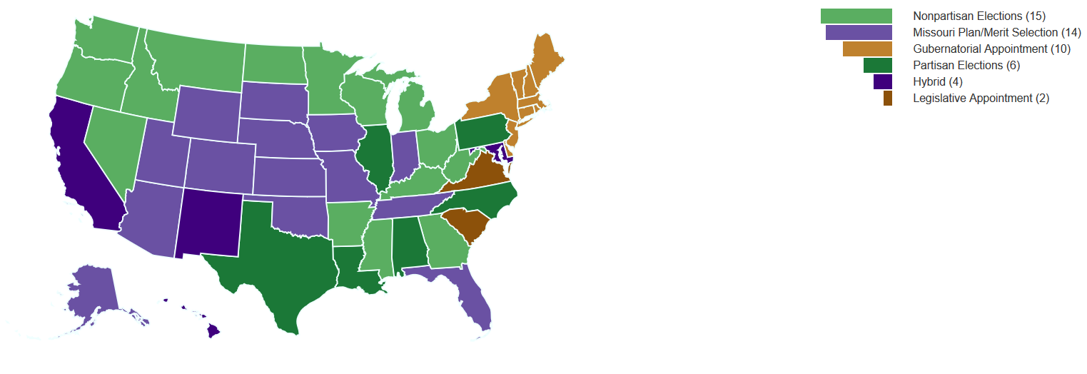
Figure A: Election systems (for State Supreme Courts), these are usually similar, if not the same as the lower courts within each state.
The system that is used in Cook County, one of judicial election with explicit party labels, traditionally has both benefits and drawbacks associated with its implementation. While it may seem obvious that the motivation for a simple election is the democratization of the judiciary, legal experts quibble with this point, asserting “Democracy requires an informed choice, and with the large number of candidates in some areas, [this] is impossible for even the best-intentioned voter.” In an urban area as dense as Cook County, informational constraints are certainly a factor for voters, and play an important role in how bar association ratings are (or aren’t) used. For perhaps this reason, superficial factors have been known to play a large role in judicial elections, with candidates waiting for hours in the freezing cold to have their name put at the top of the ballot, or even going so far as to change their name to sound more ethnically Irish, as this has been proven to provide a statistical bump in vote percentage received.
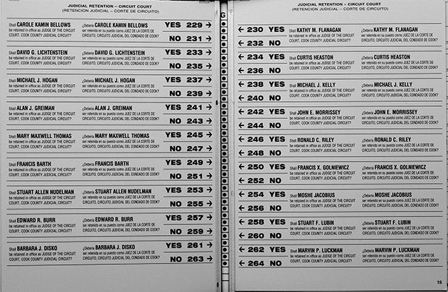
Figure B: An example of the high level of demand placed on voters who wish to be informed in judicial elections, this is just one page of many in a sample ballot from Cook County.

However, despite these criticisms of judicial elections in general, most of the existing literature points to partisan judicial elections as having real advantages over elections wherein every candidate must run unaffiliated with a party. The party of a candidate offers an important signal to voters on the likely position the candidate holds on a variety of issues, and this information is available free of charge on the ballot. In contrast, elections that lack explicit party labels make candidates more dependent on things like campaigning and advertising. This is turn, makes candidates more beholden to private interests, and compromises their general claim to judicial impartiality. On the whole however, there exists little evidence that the type of judicial selection systematically changes the quality of the candidates that are eventually placed on the bench. However, Cook County still represents a unique location for the study of judicial election, because of its singular political landscape, which has largely grown around the framework of Illinois judicial election systems.
In general, although analyses of judicial elections systems have been conducted, they fall into one of two categories that make them sub-optimal for analysis of the particular situation of Cook County: One, they perform an in-depth analysis, but aggregate data from multiple states and thus election systems. This then prevents specific conclusions from being drawn and makes any casual claim much harder to prove. This trend has been noted by previous authors on the subject, with others seeking to understand what influences voters, commenting that “our knowledge of voter’s behavior in judicial elections is based chiefly on inferences from aggregate voting data” which leads to conclusions which must therefore be “tentative and limited”.
The alternative situation, into which most other literature falls, is perhaps obvious and to be anticipated, but no less of an obstacle. This situation is that the focus of the judicial election system, though narrow and refined in certain academic literature, is simply not of Cook County (or a system similar enough to warrant extensive comparison). For perhaps the reasons listed above, this is unfortunately common, as “Two thirds of the states and the District of Columbia select some or all of their judges under the merit system,” which obviously translates poorly to conclusions about judicial voting trends, as judges appointed by local officials are affected by different pressures than those present in popular elections. Even when studies are on systems of judicial election, there can exist obstacles to generalizability. Laurence Baum, the author who noted a lack of insight into voter decision-making above, sought to remedy the lack of specific system data with an in-depth analysis of the 1984 Ohio Supreme Court race. Illuminating as his paper was to the psychology of the average voter in a highly publicized races, even Baum admits traditional cues that voters rely on in normal judicial elections “lose some of their importance, and information that voters usually lack… could be expected to play a larger role”, which indicates that it is highly likely the conclusions from his data would not translate to Cook County. This is simply one example of a situation that is exceedingly probable in a national system as diverse as that of the United States judicial election environment: most studies conducted simply do not translate in their specific conclusions. However, the literature on how voters operate in judicial elections is especially useful to this paper’s focus, and will thus be discussed at length later.
Even if there is a lack of specific translation to Cook County politics, there does exist a rich literature on judicial elections that provides at least a general idea of what forces play an important role in predicting and possibly determining who successfully runs for judge. These forces are the subject of interest in the following section.

The Generation of Bar Association Ratings:
Due to the local nature of the bar associations studied in this paper, there does not exist a robust academic field of work on the ratings they generate. As a result, most of what is known about what bar associations produce, and how they do so, comes from the associations themselves. Fortunately, these organizations bill the ratings they provide as a public service, and so provide a degree of transparency regarding their rating-generation process. Each rating involves the collection of “detailed information supplied by candidates, a background check by trained lawyers/investigators, and interviews of each candidate” and as such, represents a non-trivial time investment on the part of the bar association. In the current system, judicial candidates are required to declare their candidacy by late November, and early voting starts the first week of March. This leaves about four months for bar associations to research hundreds of candidates every election cycle, because in addition to judges seeking first time appointment, bar associations put out recommendations as to whether every judge running for retention should be kept on the bench.
One attempt to ameliorate these burdens, both for candidates who must sit for interviews, and for the bar associations conducting research, has been the formation of the Alliance of Bar Associations. The “Alliance” not only compiles the ratings of 11 bar associations, they streamline the process of collecting information as well. Any candidate who is evaluated by one Alliance member should be receive an evaluation from every member, as information is submitted to a standardized questionnaire, and only one interview is conducted. This lowers the cost for candidates to receive their evaluations, and allows for affinity bar associations (representing minority groups) a chance to evaluate candidates who might otherwise not seek their evaluation.
As seen in the consolidation above, the dominant thread throughout these policy choices by bar associations is that they seem to be driven by the time constraints placed upon them. The first and most understandable is this: any candidate who does not submit materials for evaluation to a bar association, and respond to the interview questions provided, is automatically found “Not Recommended”. This has the effect of naturally sorting the candidates, at least from the perspective of the bar associations. Candidates that know they will not receive favorable ratings will not see an incentive to submit materials and sit for interviews, and thus will receive negative ratings without work being required by either the candidate or the bar associations.
However, there are complications to this sorting. Every bar association has a standing policy that any candidate with less than 10 years (for some it is 12 years) is automatically found “Not Recommended” for any judicial office. For these candidates, there also exists no incentive to submit materials or submit interview information. The result of this is that for most voters, receiving a “Not Recommended” could mean many different things about the qualifications of a candidate, from an actual lack of qualification, general inexperience, or from a lack of desire to submit information to bar associations. Some bar associations do provide a discrimination between those candidates who did not submit materials and those who have been investigated and found not ready for office, but because this is not standardized, this information may lose impact for voters. This creates an incredibly opaque system that is hard to engage with, for the average voter. For a visual demonstration of the differences between associations, simply see the below figure.
ISBA | CCL | CBA | CCBA
Not Qualified (unspecified)  (29%) | Not Recommended (no evaluation)  (14%) | Not Recommended (unspecified)  (32%) | Not Recommended (23%)
 | Not Qualified for Office  (19%) |  | Not Qualified (3%)
Qualified (65%) | Qualified (58%) | Qualified (55%) | Recommended (69%)
Highly Qualified  (6%) | Well Qualified (8%) | Highly Qualified  (13%) | Highly Recommended  (5%)
 | Highly Qualified (.4%)
Figure C: A small preview of the collected data, this table gives a sense of the multiple meanings even the same term can have when used by different bar associations to rate a candidate. The percentages in each box refer to the percentage of ratings by a given association that fit that category.

The Intersection of Politics and Judicial Elections in Cook County:

Though it may be obvious to a reader even passingly familiar with US politics, it bears repeating: Chicago is a city strongly dominated by the Democratic Party. Cook County, comprised as it is by the city of Chicago and its many suburbs, it similarly dominated, and in fact is the seat from which all Democratic power in the state is directed. A direct companion to this Democratic strength in the Chicago area is the legacy of Democratic structure, and to a certain degree, Democratic corruption. As is to be expected, there exists very little formal literature on the recent (and possibly current) corruption that affects Chicago’s Democratic Party, and as such, traditional news outlets are the only source of information on more recent developments, of which there are many, which illuminate the way in which business has been conducted. The infamous machine of the Democratic Party has been able to control Chicago (and thus Cook County) politics for the better part of a century, and the Cook County Democratic Party remains a crucial instrument for wielding this control. All of this is likely review for an informed reader, but especially regarding corruption in Cook County, this historical legacy, which is just beginning to change, plays an important role in determining the fate of judicial candidates.
The strength and support of the Democratic Party for individual candidates has usually been formally announced through a process known as slating. Being slated has traditionally been an important predictor of success for candidates in primaries and general elections, both anecdotally in Cook County, and demonstrably in other judicial primary systems. In subcircuits, local democratic officials are allowed to endorse candidates, and this support carries weight, but generally lacks the instructional heft of a full Democratic endorsement. In subcircuits that are safely Republican, this informal process plays a similarly important role, and obeys a similar process. Only one candidate per race may be slated and being slated comes as not only as a sign of the Democratic establishment’s moral support, but also with their infrastructure. Each slated candidate (after paying in $40,000) gets a commitment from the party that Cook County Democratic Party resources will employ “everything from mailers to foot soldiers who help ensure voters turn out to support slated candidates,” according to election experts. Rather than a factor that dampens the effects that bar association ratings have on judicial primaries, it is possible that the process of slating may in fact amplify them, if “strong legal qualifications play a major role in winning” a slated endorsement, which should be the way the system works, according to Democratic Party officials. This is the first possible mechanism through which there could be a theoretical causal relationship between bar association ratings and eventual voter behavior, albeit an indirect one.
The history of the Democratic Party in Cook County, however, places strong doubt that such an interpretation can be adopted universally, as illegitimate dealings and power brokerage have been documented to affect the judicial process, particularly through the slating mechanism. Specifically, the recently-indicted Alderman Edward Burke was known to play an outsized role in creating a system of “political donation-driven candidate slating,” as opposed to one built on merit. As his removal from influence has only been within the last judicial election cycle, and Burke was first elected to office in 1969, all of the data that is collected (spanning 2012 through 2018) will be of candidates that theoretically had to receive Burke’s approval. Indeed, 2020 has been characterized as the first year in many cycles where “The party might actually slate judicial candidates… based on their qualifications, not their connections.” However, all of this reporting has been done from an anecdotal perspective, with no data collected on how this alleged corruption influenced elections on aggregate, It remains to be seen if there is still room for other factors to play an important role in helping Cook County voters decide for whom to cast their ballot. Indeed, all the data collected for analysis in this paper will have been during the tenure of Alderman Burke, and thus may be subject to forces that, ideally, would no longer be present the judicial election process moving forward.

An important by-product of the Democratic dominance of Cook County is that the analysis conducted in this paper is fundamentally concerned with partisan primaries. Because of the overwhelmingly democratic population and organization in Cook County, it has been said that “Republicans don’t win elections here; Democrats just occasionally lose them” and as a result, the fiercest competition most judicial candidates face is in their own party’s primary. This rule is broken in a few subcircuits located in Chicago suburbs, where either Republicans either reliably experience success, or even more rarely, where there exist competitive general elections. The figure to the left shows which subcircuits fail to overlap with Chicago city limits (those that are unshaded), and these are the subcircuits that typically have experienced greater Republic success. However, a full 70% of judicial general elections elsewhere go uncontested in Cook County, and even more are uncompetitive.
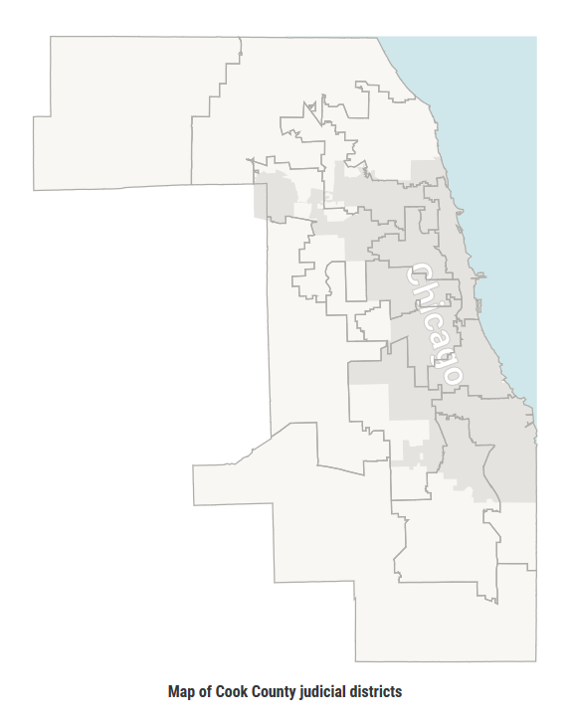
Figure D: A map of the subcircuits in Cook County, with the darker shaded regions representing the area covered by the City of Chicago, and indicative of greater Democratic Party strength.
The creation of subcircuits is a relatively new enterprise, designed to increase minority representation on the bench and the essential compromise that allowed the creation of such divisions was that it was believed that it would also create several subcircuits that allowed Republican judicial candidates to experience success in Cook County. However, this belief has not been entirely validated with time, and the increased Democratic strength in Cook County has meant that even some of those subcircuit intended to be Republican strongholds have flipped, and now fewer than 5% of the total vacancies experience competitive general elections.
As mentioned previously, the creation of subcircuits, where races are significantly smaller than even county-wide races, has had important impacts on the role of parties in judicial elections. Specifically, the importance of slating by party officials seems to have declined with time. Evidence to the possible magnitude of this impact can be found in the effect of slating before and after the creation of judicial subcircuits. The early 80’s saw only six total defeats for candidates endorsed by the Democratic Party, whereas by the 2018 election (more than 20 years after the creation of judicial subcircuits, slated candidates experienced a success rate of barely over 50%.
In the years following the creation of judicial subcircuits, there has been relatively little focused effort undertaken to quantify the relationship between various political factors and judicial elections in Cook County and the greater Chicagoland area. The two notable exceptions are the work of Albert J. Klumpp, and that of Hirano and Snyder. Klumpp’s analysis of Cook County judicial elections has been varied, from performing an analysis of factors that influence voters in general elections, to quantifying the results of the little-discussed judicial retention elections, to even taking a more general look at judicial primary elections. In a synthesis of the first, he found that in general elections, “meaningful choice is virtually non-existent” [Klumpp 2007] because of the aforementioned lack of competitiveness between the two parties in Cook County. While this is hard to contest, it does underscore the importance of understanding judicial primaries through a quantitative lens, which Klumpp has also attempted. Klumpp’s focus in previous study was a holistic look at what factors seemed to best predict success in elections, including factors like fundraising and endorsement from organizations like the Chicago Tribune,. This paper aims to continue this process, if only in the limited scope of the voter’s interaction with diverse array bar association ratings.
By contrast, Hirano and Snyder were focused on the importance of primaries, especially in placed dominated by one party (like Cook County), as they served as the primary mechanism for choosing “high quality” candidates. They studied Illinois judicial elections and bar associations in order to see how the qualifications of candidates changed with the level of competitiveness in general elections, but like this paper, their measure of qualification was a broad aggregation of bar association ratings. Fundamentally, Hirano and Snyder were concerned with a different metric for judicial evaluation, but their study helped fill in the gap left by Klumpp in the literature, though neither source is in enough direct conversation with each other to agree or disagree.

How Voters Use Information in Judicial Elections
Bar association ratings, if they do play a role in informing judges, could theoretically do so by one of two causal mechanisms. The first is indirectly: As has been mentioned, party slating plays a key role in securing primary victories for candidates in Cook County, and the Democratic Party has expressed an explicit desire to appoint well qualified and rated candidates. The second however, is more direct, and perhaps more intuitive: especially in low-information campaigns like those most often run in subcircuits, voters may have few salient cues. By moving from the unit of study from the general election to the primary, all candidates being compared are of the same party. This means that for voters the informational cue that is often the easiest cue of a candidate’s general position is removed: that of party label. In fact, in judicial voting as it is done in Cook County, voters are without both party affiliation and incumbency, the two cues DuBois finds most important for low-information voters. This is where factors like those studied by Klumpp and others (aka having a female, Irish name) play a bigger role, but this vacuum could also indicate room for bar associations to provide meaningful information to voters, which they use to inform their voting choice.
A key assumption upon which such a causal interpretation would rest is that voters are informed. Only if voters are actively seeking information about judicial candidates are likely to find informational cues beyond the very basic ones that appear on the ballot (again name, apparent gender). Fortunately, there does exist significant evidence that those who do cast ballots are informed, if only relative to the general population.
As discussed above, a voter’s use of information depends not only on the voter themselves, but also the information provided. Specifically, in elections between candidates of multiple parties, more subtle sources of voter information (like judicial ratings) are widely believed to play a less important role, because the voters have more salient information (mostly party identification) on which to base their decision. This, combined with the fact that general elections field a low number of candidates, with many democrats running unopposed, whereas primary races typically yielded a much higher number, makes primaries ideal for the analysis this paper was interested in conducting.

Methods

Data Collection:

In order to perform the regressions and build the models that makeup the analysis contained in this paper, and to come to meaningful conclusions about the interplay between ratings and judicial races, a dataset that did not yet exist needed to be created. Originally, the beginnings of this dataset found themselves in the work being conducted by Injustice Watch, a Chicago-area nonprofit. The basic data of judicial candidates and the ratings they received from four area bar associations (the Chicago Bar Association, the Cook County Bar Association, the Chicago Council of Lawyers, and the Illinois State Bar Association), along with identifying elements for the race in which they ran, were all assembled by Injustice Watch interns in the summer of 2019. These were primarily collected from two sources: an organization known as the Alliance of Bar Associations compiles and prepares ratings from most bar associations in Cook County, so they served as the primary resource. They do not, however, track ratings from the Chicago Bar Association, an organization deemed important enough to warrant a separate data search and collection. Ratings were collected from the CBA, CCL, and ISBA because they represent the three Chicago bar associations not explicitly tied to an identity group and were thus expected to display a greater degree of impartiality in their ratings. The CCL in particular should be the most rigorous evaluator, as it bills itself as “Chicago’s public interest bar association,” (explain why they are trustworthy) and has a mission explicitly tied to voter education, rather than serving any particular member base. The CCBA was recorded primarily as a reference point to see if ratings from bar association directly linked to identity groups did in fact systematically differ from the more nominally independent organizations (the CCBA is a group of African American lawyers in Cook County, but these identity group associations represent various ethnicities, nationalities, and sexual orientations).
Because multiple vacancies may open in any given election year, even within the same subcircuits, the common method of tagging each election by the last name of the person on the bench was adopted. Due to the desires of the original data collectors, judicial retention elections were included in the dataset, and so the specification of ‘Type of Election’ was necessary. Finally, many of the unmentioned variables for which information was collected were either to serve the purposes of Injustice Watch, or were only relevant for retention elections, but not useful to the analysis of this paper.
Figure E: An example entry in the primary dataset. The Vacancy categorization is under “Addtl Notes”
There were two outputs of interest for any given candidate: whether or not they won, and of their vote share, both on the level of the party primary. This was advantageous for analysis for multiple reasons. As referenced in the literature review, with the exception of a few suburban subcircuits, judicial general elections are wholly uncompetitive. This means that effect sizes of something like bar ratings would be anticipated as very small, making them harder to detect.
All of the data that was collected was made publicly available, either by Cook County or by local non-profits, and often with the explicit purpose of educating voters, so to adapt it for the purposes of further education seems in keeping with that spirit. Additionally, none of the data compiled about individual candidate goes beyond the level of their name in terms of aiding their identification, which is entirely reasonable for a cohort of individuals who, at one time or another, all have sought public office.

Statistical Analysis:
Once the data was collected, a meaningful way of interpreting the data was necessary. For this, a least-squares linear regression was employed. With the categorical nature of the predictors being used, there are few effective points of comparison on which to fit the data. While the predictor of “Percentage Approval” was nominally a percentage, it actually took the form of all the other predictors, namely that of a categorical variable. Because of this lack of fidelity in determining small movements in the data, the parsimonious approach seemed to be that of a simple linear model, with a few important tweaks to better fit the dataset being employed.
The first of those tweaks was the use of a clustered model, which performs what is largely a standard regression but produces robust standard errors. The idea of this is that although the $β$ coefficient is performing a least-squared regression for each individual candidate, the unit of analysis is actually higher, at the race level. This is because each candidate exerts a powerful influence on the expected vote share of the others, simply by being in the same race. Clustered regression necessarily sacrifices some statistical power for the sake of integrity, because the particular race a candidate is in, and especially the number of their opponents in that race, is massively influential on the voter share any judicial candidate is expected to receive. For example, candidates who run in a two-person race can generally expect to receive at least 25% of the vote, simply by being on the ballot. Races with four or more candidates are not uncommon in Cook County, and in these races, candidates often win with below 40% of the vote (a simply plurality is required to win in Illinois), so choosing to make the unit of analysis the race is the more responsible statistical choice. The end result of this is however, that the effective number of observations in the sample is decreased, and there is less confidence in the final model produced.
With this is mind, the most basic regression will take the following form:
$$Vote Share {Percentage}_{\begin{aligned}Competitive Election \\ \end{aligned}}=$$
$${α+ β}_{1}*\left(Percentage Approval\right) {+ β}_{2}*\left(Percentage Highest Rating\right)$$
$${+ β}_{3}*\left(Number of Candidates in Race\right)+Error$$
Several steps were necessary to arrive at this regression. As has been mentioned, each bar association has different rating systems. For each of these systems, a binary variable was developed that classified the rating as either a 1 or a 0. This binary indicator was then aggregated across agencies, to find the “Percentage Approval” or the percentage of the bar associations that found any given candidate qualified for office. The same was done to find the “Percentage Highest” variable, except the binary variable was only a 1 when the rating received by a candidate was the highest that could possibly be given out by a particular bar association.
The aggregation of the bar association ratings into a single metric makes these variables a reasonable choice to answer the central question of this thesis: What is the relationship between bar association ratings and judicial election outcomes? In particular this regression is a general measure of how much explanatory power bar association ratings have in regard to vote share. In order to better place into context the fitness of “Percentage Approval” as a predictor, multiple auxiliary regressions were also run, in order to test for multicollinearity. The results of these regressions will be explored in the results section.
The only additional regressions that have their foundations directly in the literature follow the same form as our primary regression, but work with more sorted data. As has been mentioned throughout the paper, there are real differences in the way elections take place when comparing subcircuit races to those that occur on the county level. To that end, it was fitting to explore whether the effect of judicial ratings appears to differ across the level of the race. These regressions thus looked precisely like the basic regression from above, but with two different datasets: one with only subcircuit races, and one with all the county-wide races.
To perform these analyses, the statistical package R was used. R is open source and free to the public, which should aid any attempt at replication. For more information on the specific packages within R that were used, see the additional documentation in the appendix.

Limitations of the Model:

The most basic limitation of the model is one that is fairly common to statistical models: that of sample size. While the number of candidates represented in in the original dataset is in the thousands, numerous limitations drastically reduced the number of effective observations. The first is that of the quality of data. Many candidates did not have available recommendations for all bar associations, or didn’t have vote share information. This prevented them from being a part of the regression. The second is by the nature of the models themselves, which are clustered regressions. This means that the real number of observations is actually the number of unique races that were run, not the number of candidates. With an average number of 2.56 candidates per race, this step effectively halved the data. When completed, these cleaning and organizing methods produced a total number of 186 unique clusters. These clusters included many races however, that only had a single candidate (who obviously received 100% of the vote). While these races do occur in real life, it seemed out of the scope of this model to include these races, and as expected, their removal increased the explanatory power in every model, and thus this became a permanent change, but further decreased the effective sample size to 144 unique races. This number of observations is suboptimal for detecting what the literature indicates should be a fairly small effect size.
Another obstacle is the nature of the regressors used in for these models, e.g. the bar association ratings. Because these are all categorical variables, there is limited ability for the model to detect subtle trends in the data, especially with the limited sample size. Add to this the fact that every bar association uses a different rating scale, and these variables must be further simplified in order to facilitate standardization across variables (the use of only the “Percentage Approval” and “Percentage Highest” variables). Even for the variables that were nominally a percentage, because only 4 bar associations were included in the dataset, this means that the percentages that were possible were not continuous (the only possible percentages were multiples of 25).
Finally, this model is not an attempt to predict the outcomes of judicial elections, and as such, doesn’t attempt to arrive at a precise estimate of effect sizes for various bar association ratings. This is unfortunate, as the dataset does not incorporate all the variables that play an important role in elections, for instance, money raised by a candidate, or their endorsements by local papers, making omitted variable bias within the model inevitable. The available literature indicates that this omission of variables is likely to produce a model will overestimate the effect size of bar association evaluations. Specifically, because many of these important other predictors (like for instance whether a candidate is slated), covary with association ratings because more qualified candidates are more likely to be slated, we may be in fact attributing some of the effect size of being slated to the effect of judicial evaluations on a race. However, within the limited context of establishing a general relationship and its direction, this model can still provide important insight.

Results

Basic Descriptive Statistics:

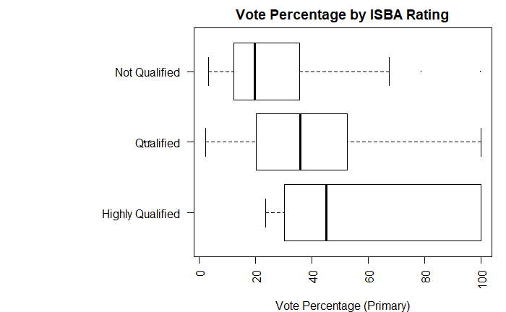
Figure F: A boxplot summarizing the vote share distributions for candidates based on their ISBA rating. All of the bar association ratings displayed a similar upward trend, with good ratings being associated with higher vote share percentages.
On the whole, the final dataset in large part followed what literature review and conversations with those familiar in the field indicated would be the trends within the data. While it is certainly a possibility that voters are faced with a very qualified field, it is also likely that bar associations err on the side of generosity in their ratings, if they are aiming to inform voters: each of the bar associations found more than 50% of candidates who ended up losing their races at minimum qualified. However, the rate at which candidates were found qualified was higher on average for primary winners than losers for every single bar association, preserving the possibility that there was a directionality to the relationship between ratings and outcomes.
One complication in interpreting these results was the diversity in how ratings were communicated across bar associations. Each rating agency has different specific labels for their endorsements, and a different number of ratings that can be given. For example, the CCL has more possible ratings than any other association, and because of this, their “Highly Qualified” classification is used much more sparingly than other “Highly Qualified,” and thus may be interpreted to mean something different to the rating agency. This diversity means that one-to-one comparison of ratings across associations are largely impossible, but rather must be the result of a degree of interpretation (for a more in-depth breakdown of how complicated interpreting ratings can get, see the “Generation of Bar Associations” section in the literature review).
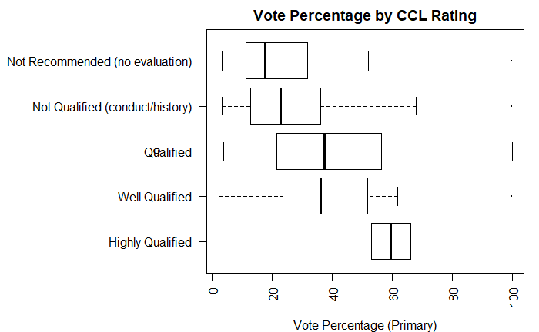
Figure G: Another boxplot, but this time with CCL ratings, which have several more categories, offering a more precise look at the relationship between ratings and vote percentage.
While the extensive breakdown of each individual association’s ratings can be found the appendix, the broad evaluation is that while there were notable differences between the bar associations, they largely conformed to what research into the Cook County judicial scene indicated.

Models:

As mentioned previously, this paper’s model followed the following form:
$$Vote Share {Percentage}_{\begin{aligned}Competitive Election \\ \end{aligned}}=$$
$${α+ β}_{1}*\left(Percentage Approval\right) {+ β}_{2}*\left(Percentage Highest Rating\right)$$
$${+ β}_{3}*\left(Number of Candidates in Race\right)+Error$$
Therefore, ${ β}_{2}$ can be thought of as the estimated effect size of increased high ratings, and ${ β}_{1}$ can be thought of as the estimated change that is brought about by an increase in general approval across the measured bar associations. ${ β}_{3}$primarily exists to provide a higher degree of accuracy for our model, as it adjusts for the very important element of the number of candidates in a given election. For our first model, the following parameters were estimated:
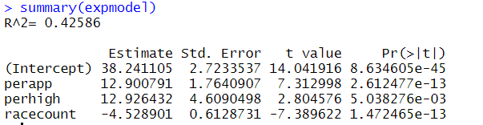
Here, ${ β}_{1}$ is being represented by “perapp” short for percentage approval. Similarly, ${ β}_{2}$ is being represented by “perhigh” or percentage of high ratings and ${ β}_{3}$ is the number of candidates in the race.
With this figure in mind, we can make the following statistical claims:
- For each percentage increase in bar associations that found a candidate qualified, we expect to see a .13-point increase in that candidate’s vote share, on average. This occurs at a statistically significant level, as evidenced by a p-value many times smaller than .05. To put this in more concrete terms: if one of the bar associations in our dataset went from not approving to approving of a candidate, that would increase their “perapp” by .25, and we would expect to see a 3.2-point bump in their vote share on average.
- For each percentage increase in bar associations that gave a candidate their highest rating possible, we expect to see a .13-point increase in that candidate’s vote share, on average. This also occurs at a statistically significant level, albeit not quite as powerfully as the ${ β}_{1}$ effect.
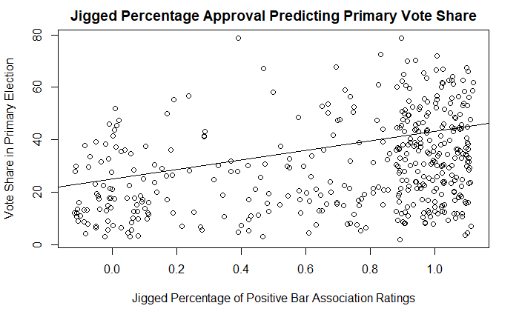
Figure H: A plot of the basic regression. The data displayed has been “jigged” or randomly spread to make the observation of trends easier, but to view the unjigged plot, see Appendix Item F.

An important model to create was one that would allow for a comparison between those races that are expected to be the lowest information and those that are more likely to receive media and be considered otherwise important. To do this, the essential division was between races at the county level or higher and those races that exist in the subcircuit level. To this end, we conducted the final regression described above, once for races at the subcircuit level, and once for the races at the countywide level. The essential comparison was between the $R^{2}$ of the two regressions, as this would indicate how much of the variance was being explained at each level by the predictors that proved informative in the general regression. The final result is as follows:
- The $R^{2}$of the model when applied to the subcircuit dataset was .42125, a very small drop from the explanatory power of the model when applied to the entire dataset.
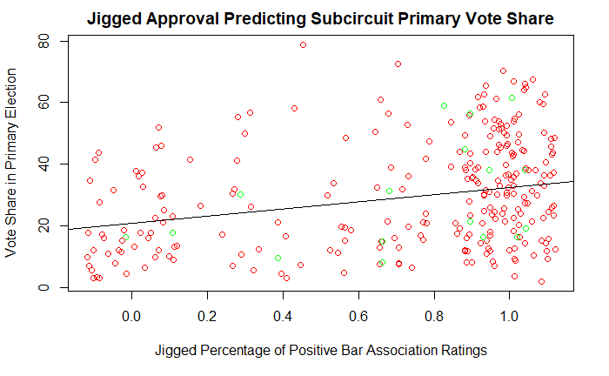
Figure I: The subcircuit dataset, with a regression line overlaid.
- The $R^{2}$of the model when applied to the countywide dataset was .48216, a decent increase from our original model, and higher by a decent margin than the subcircuit dataset.
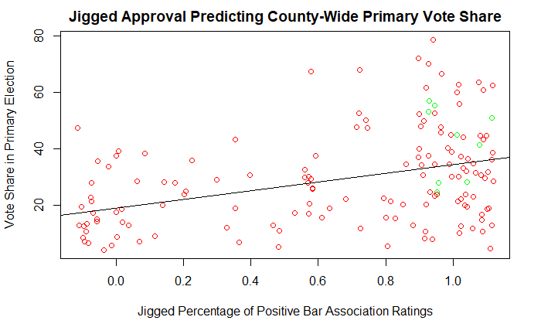
Figure J: The dataset containing countywide races, with a regression line overlaid.
What do these data indicate? The first is to note that the change in $R^{2}$, while relatively large, corresponds to a rather weak statistical claim. All that can be said is: the same basic model of aggregated bar association rating offers more explanatory power for county-wide races than it does for those at the subcircuit level. This is of note because of the systematic differences discussed in the literature review. One might expect, given the lower level of information saturation at the subcircuit level, that bar associations would play a bigger role in voter’s decision making. This is not supported by the results that we see from this comparison of fit. An alternative explanation could be that bar associations play a relatively minimal role in direct voter education, and instead are measures of quality. Thus, with the increased attention and resources placed on county-wide elections, candidates of better quality tend to be selected, and thus a greater number of highly rated candidates do well. This alternative is also somewhat intuitive and in keeping with research performed for the literature review, but requires further research to become a substantial hypothesis.

Conclusions:

Considering the many factors that were discussed as important in the literature review section of this paper but were not included in the model, it would be inappropriate to say the model presented offers any type of evidence to support a causal interpretation at this time. However, there are still statistically significant results, in both aggregated and individual bar association ratings that indicate a positive relationship between ratings and eventual vote share. This paper provides as many regressions as it does to better establish certainty in the direction of this relationship, which is also backed by previous findings by authors like Klumpp and Hirano (as discussed in the literature review).
The insight provided by the second set of regressions performed also has potentially broad implications. Again, it was found that a model of aggregated bar associations offered more explanatory power at the county level than it did at the subcircuit level. The reasoning put forth by this paper is that the increased attention and resources placed on county-wide races means that candidates of higher quality tend to be selected, and therefore candidates with higher bar association ratings are more highly correlated with high vote share percentage. This interpretation relies on several key assumptions, which remain mostly supported by the literature. Hirano established that bar association ratings can be thought of as a decent measure of quality when taken in the aggregate, and it is widely accepted that more traditionally qualified candidates are seen at higher levels of office.
It is with these premises established that we can view the results of the second set of regressions as evidence for a more indirect relationship between ratings, rather than as a direct source of voter information. This interpretation has important consequences for policy recommendations, as bar associations put out ratings with the explicit intent of educating voters, and not as a metric upon which academics can forecast candidate success. Therefore, the policy recommendations to be set forth will not only focus on the quality of the ratings themselves, but also how to better increase the direct importance ratings play as a source of information for voters.

Policy Recommendations:

While it may be optimal to have a voter base that is educated, engaged, and passionate about judicial elections, this goal seems out of reach for the near future, and would likely rely on a type of cultural shift that is harder to directly implement through policy. Finding such an option somewhat unrealistic, there are still several steps that have been implemented in other judicial systems that help promote a responsible judiciary.
The first measure is aimed to allow the bar associations to provide higher quality ratings. As a basic breakdown of the candidate ratings saw, the bar associations tend to err on the side of approval when considering a candidate, or at the very least, do not issue enough negative ratings for a simple “Qualified” to be a particularly ringing endorsement for a voter. The first policy proposal is therefore to allow the bar associations more time to conduct their ratings, in the belief that it will allow them to conduct more research and therefore be more discerning in the ratings they confer. As mentioned in the literature review section “Generation of Bar Association Ratings”, the bar associations have approximately 4 months to perform many in-depth interviews and personal investigations of hundreds of candidates.
Many of the current practices of bar associations around ratings are a direct result of the current time crunch that they experience. Because of this, most positive changes that bar associations could make would stem from one central proposal: to provide bar associations more time to do their research. This could most effectively be done making the official filing deadline for candidates earlier. Best of all, this would not affect the majority of candidates or place an undue burden, as most candidates running serious campaigns have begun organizing in earnest long before this time. Simply moving this deadline up to October 1st would increase by over 25% the time available to bar associations, and make possible many of the smaller proposals that are to follow in this paper.
Finally, on the note of public-facing element of bar associations, standardizing the ratings across bar associations can only help increase voter engagement. Even amongst experts in the field, the different standard and categories across associations can be confusing. While it may be a coordination trap amongst the various bar associations to adopt one system or another, if they are truly dedicated to facilitating an informed electorate, this seems a reasonable step to take. Although each has a historical and pedagogical reasoning to their rating system, most rating agencies fail to inform the electorate as effectually as possible because they send their information in ways that is not optimized for easy consumption. Specifically, the CCL’s model provides the most information, while still remaining fairly intuitive. By looking at just the rating assigned to a candidate, a voter can know:
- Whether a candidate submitted materials for evaluation
- If they were found qualified or not
- If they are in an elite echelon of judges in terms of qualification and temperament
In this same vein, the Alliance of Bar Associations, as discussed in the literature review, has one obvious member missing from its ranks. The Chicago Bar Association is an important player in the Chicago judicial scene, and as such, should have its ratings spread as effectively as possible. This means inclusion in the Alliance. Although there are historical reasons for this lack of inclusion, integration would mean that Cook County voters would only have to go to one source to receive all relevant bar association ratings, and that candidates would only have answer one set of questionnaires. Under the status quo, roughly double the work is required from voters and candidates as would be necessary under a more streamlined situation.
In conclusion, there appear to be two main types of improvement to be made, if bar associations wish to see the impact they have on elections increase, or if they want to at least better reflect the quality of the candidates that they rate. The first revolves around the increasing the time bar associations have to do this difficult rating process, and then asking to do more with that increased time. The second is a matter of clarifying and streamlining the refined information, so that voters never feel the need to ignore ratings because their presentation is obtuse or inaccessible.

Areas for Further Research:

As mentioned in the literature review, 2019 marks an important time in the political landscape of Cook County, with the removal of the longtime centerpiece of democratic slating, Ed Burke. It could be informative to conduct a similar study to the one in this paper with data from elections in 2020 and beyond, as 2020 is the first year for judicial elections post this political change. If the relationship between bar association ratings and electoral success appears to be more direct (as might be evidenced by a stronger statistical relationship), one interpretation might be that Ed Burke had a corruptive influence on the judicial slating process that removed the influence that ratings would normally occupy. This would be good news for the integrity of future elections, but perhaps worrying as it would only add to the current level of undue influence that is ascribed to Burke at the height of his powers.
A more direct path could also be taken to see whether the ratings produced by bar associations play a direct role in determining electoral winners. This could be done by conducting exit polls, which would require not inconsiderable resources, but would allow researchers to directly access voters. This is important, because it would allow the desired population to be more effectively targeted, meaning researchers could, minutes after voting occurs, sort out those who voted for judicial elections, and ask them whether they had been exposed to bar association ratings. This is an obvious prerequisite to ratings having a direct influence, but until now, little study has been done on voters who do not experience ballot roll-off (voters who make it all the way down the ballot to judicial elections), thus making trends from the data hard to trust, because they are muddled by results from voters who never even vote in the election of interest.

Appendix:

Model 1: Basic Regression of Vote Percentage on Percentage Approval and Percentage High Ratings
Model 2: Basic Regression in Subcircuit Dataset
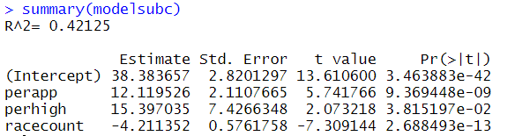
Model 3: Basic Regression in County-wide Dataset
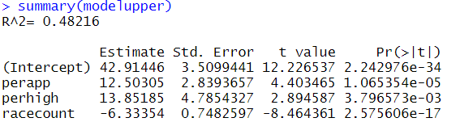

Model 4: Regression for all CCL Ratings
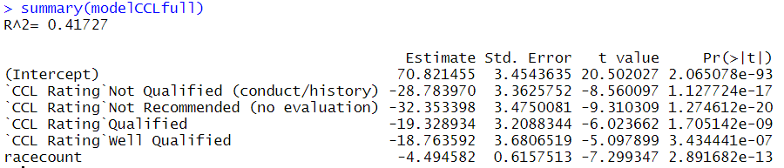
Model 5: Regression for all ISBA Ratings
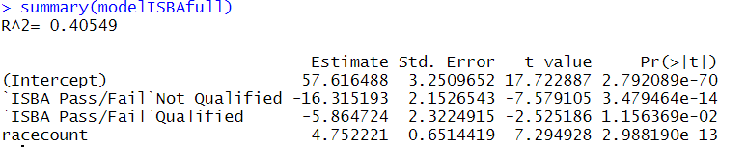
Model 6: Regression for all CBA Ratings
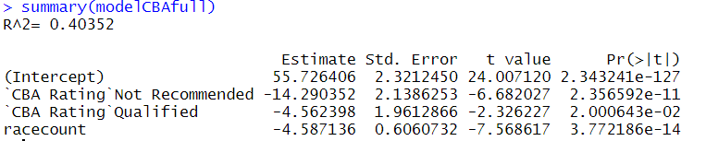
Model 7: Regression for all CCBA Ratings
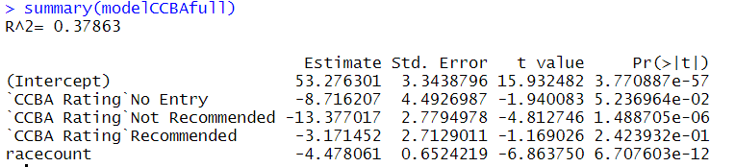
Figure J: Basic Breakdown of General Bar Association Approval
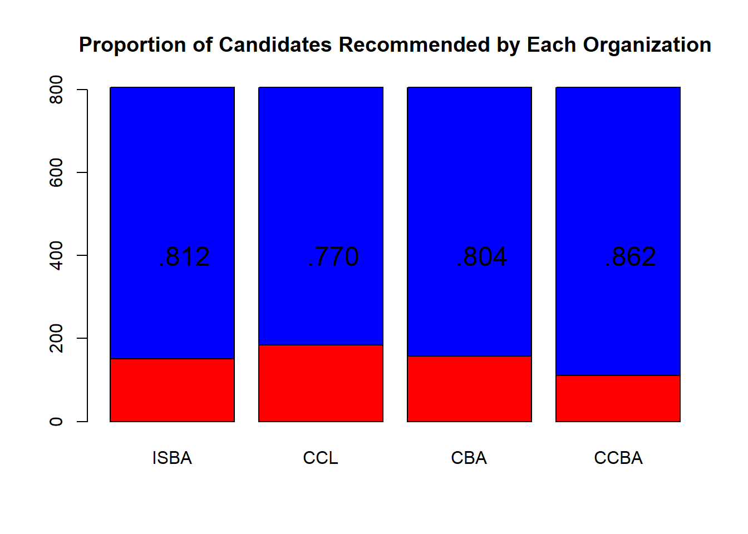
Figure K: ISBA Ratings Breakdown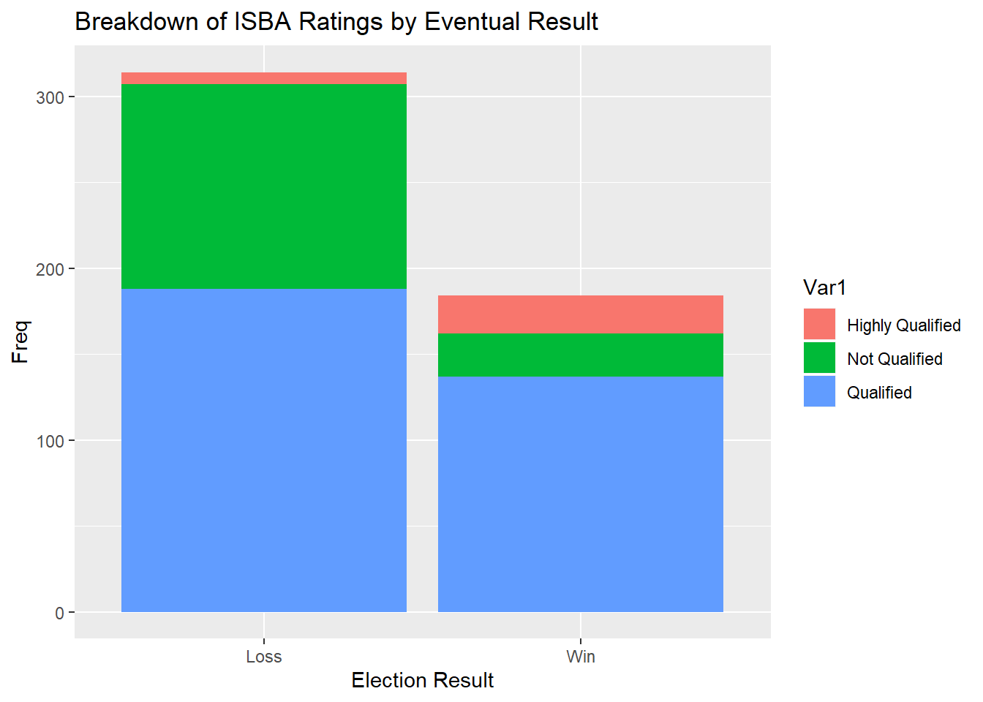
Figure L: CBA Ratings Breakdown 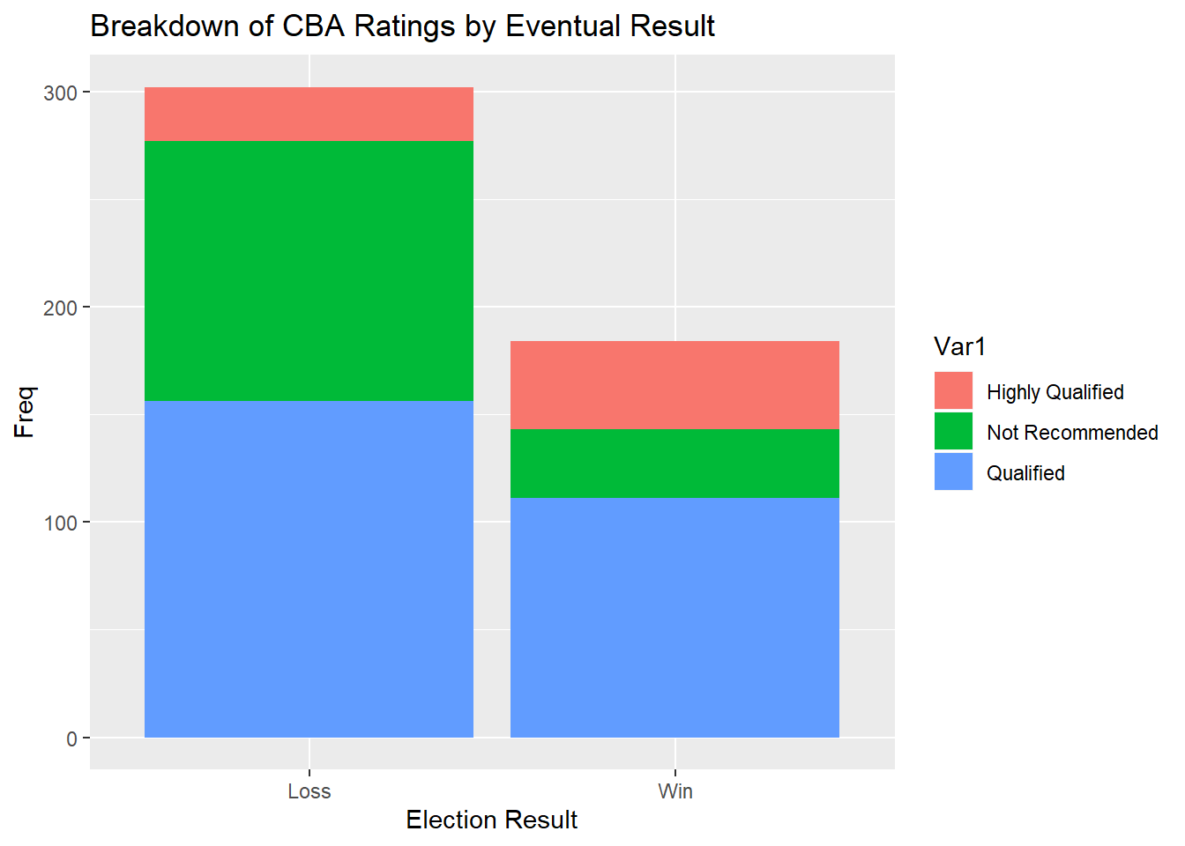
Figure M: CCL Ratings Breakdown 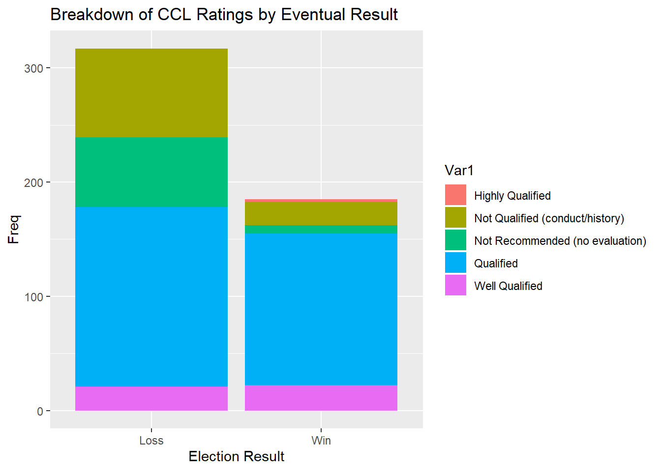

Figure N: CCBA Ratings Breakdown 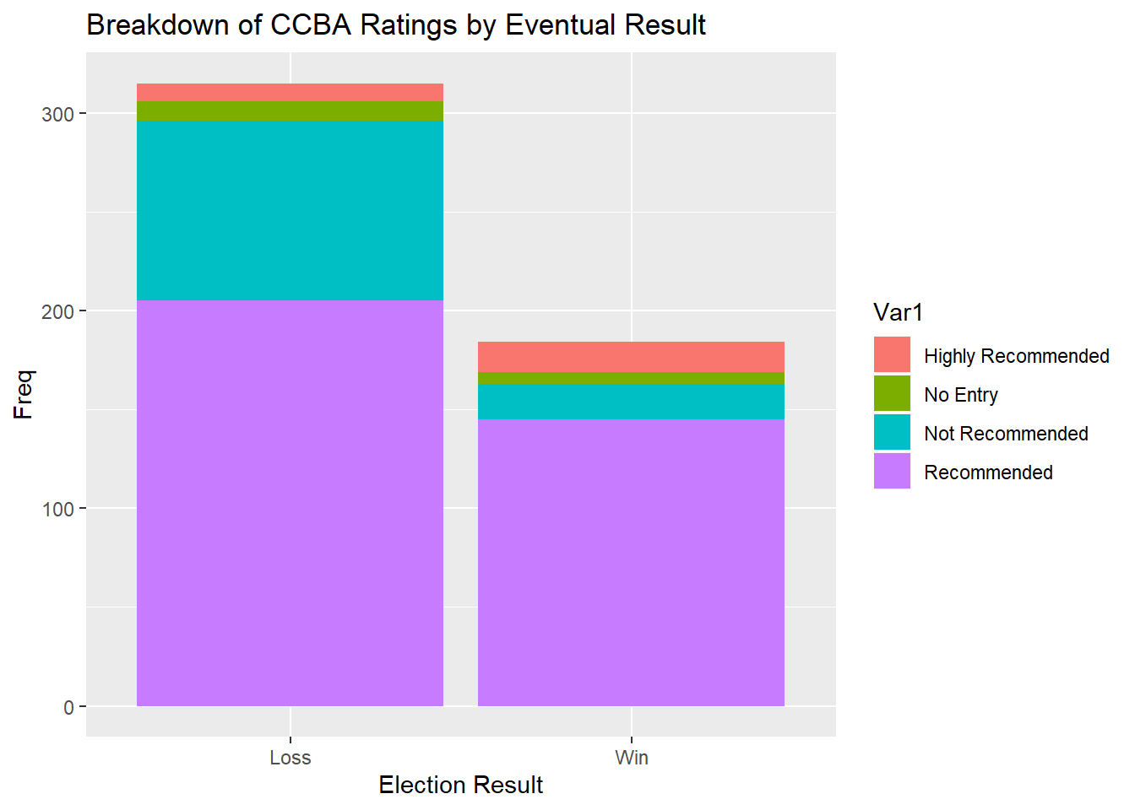

Figure O: Unjigged Data from the basic regression model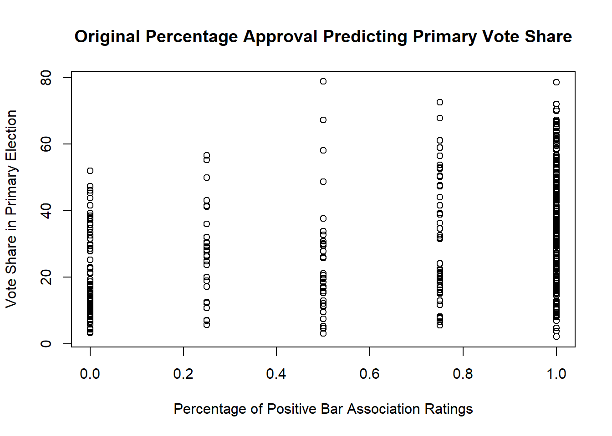

References:

“2020 Candidate Guide.” Cook County Clerk's Site, Illinois State Board of Elections, 2019,
www.cookcountyclerk.com/sites/default/files/pdfs/2020%20IL%20Candidates%20Guide_0.pdf

“Bar Association Links.” Chicago-Kent College of Law, Chicago-Kent, 26 Sept. 2017, www.kentlaw.iit.edu/career-development/career-services/students/career-strategies/bar-association-links.

“Merit Selection: The Best Way to Choose the Best Judges .” The American Judicature Society, www.judicialselection.us/uploads/documents/ms_descrip_1185462202120.pdf.

Albert J. Klumpp, Judicial Primary Elections in Cook County, Illinois: Fear the Irish Women!, 60 DePaul L. Rev. 821 (2011)

Alliance of Bar Associations. “ALLIANCE OF BAR ASSOCIATIONS FOR JUDICIAL SCREENINGNOVEMBER 6, 2018 - GENERAL ELECTION.” Www.decaloguesociety.org, www.decaloguesociety.org/assets/docs/2018-General-Election-and-Retention-003-10.15.pdf.

Baum, Lawrence. “Explaining the Vote in Judicial Elections: The 1984 Ohio Supreme Court Elections.” The Western Political Quarterly, vol. 40, no. 2, 1987, pp. 361–371. JSTOR, www.jstor.org/stable/448318.

Bradford, Cale Addison. “Judicial Slating in Marion County, Indiana: Defending Its Constitutionality While Advocating Reform.” Indiana Law Review, vol. 49, no. 2, 2016, journals.iupui.edu/index.php/inlawrev/article/view/21000/20427.

Brennan Ctr. for Justice, Judicial Selection: An Interactive Map, http://judicialselectionmap.brennancenter.org. Digital Image

Cohen, Mari, and Olivia Stovicek. “Cook County Judicial Voters Disfavored Weak Candidates.” Injustice Watch, 30 July 2019, www.injusticewatch.org/news/2018/cook-county-judicial-voters-reject-old-habits-disfavor-poorly-rated-candidates/.

Crepeau, Megan. “Candidates Seek Democratic Backing for State’s Highest Court, Cook County Judicial Races.” Chicago Tribune, 15 Aug. 2019, www.chicagotribune.com/news/criminal-justice/ct-cook-county-democrats-judge-slating-20190815-xuafc5emgzbujbjxwztwulvw74-story.html.

Dubois, Philip L. "The Significance of Voting Cues in State Supreme Court Elections." Law & Society Review, vol. 13, no. 3, Spring 1979, p. 757-780. HeinOnline, https://heinonline.org/HOL/P?h=hein.journals/lwsocrw13&i=759.

Flango, Eugene, and Craig R. Ducat. "What Difference Does Method of Judicial Selection Make." Justice System Journal, vol. 5, no. 1, Fall 1979, p. 25-44. HeinOnline, https://heinonline.org/HOL/P?h=hein.journals/jusj5&i=28.

Galvan, Manuel. “Cook County Subcircuits Elect Their First Judges.” Illinois Issues, Jan. 1993, p. 36., www.lib.niu.edu/1993/ii930136.html.

Goldstein, Joel H. “Bar Poll Ratings as the Leading Influence on a Non-Partisan Judicial
Election.” Judicature, no. 8 (1980 1979): 377–84.

Groeger, Lena V. “Disenfranchised by Bad Design.” ProPublica, 9 Mar. 2019, www.propublica.org/article/disenfranchised-by-bad-design. Digital Image.

Hoerner, Emily, and Jeanne Kuang. “Bar Groups: Mixed Messages about Judicial Hopefuls.” Injustice Watch, 31 July 2019, www.injusticewatch.org/news/2018/voter-conundrum-bar-groups-send-mixed-messages-about-some-judicial-hopefuls/.

Hoerner, Emily. “Cook County Judicial Candidate in Irish Name Switcheroo.” Injustice Watch, 30 July 2019, www.injusticewatch.org/news/2018/cook-county-judicial-candidate-pulls-an-irish-name-switcheroo/.

https://www.lib.niu.edu/1993/ii930136.html, “Cook County subcircuits elect their first judges”

Klumpp, Albert J. “The 2007 Judicial Elections: Partisanship, Campaign Spending, & Voter Turnout.” CBA Record, vol. 34, Jan. 2007.

Lovrich, Nicholas P, and Charles H Sheldon. “VOTERS IN JUDICIAL ELECTIONS: AN ATTENTIVE PUBLIC OR AN UNINFORMEDELECTORATE?” The Justice System Journal, vol. 9, no. 1, 1984, pp. 23–39., www.jstor.org/stable/20877727.

McClelland, Edward. “Why It’s so Hard for Republicans to Win in Illinois.” Chicago Mag, 29 Aug. 2018, www.chicagomag.com/city-life/August-2018/Why-Its-So-Hard-for-Republicans-to-Win-in-Illinois/.

McQueary, Kristen. “Judicial Slating without Ald. Edward Burke's Blessing? It's a Start.” Chicago Tribune, 10 June 2019, www.chicagotribune.com/columns/kristen-mcqueary/ct-perspec-mcqueary-cook-county-judge-slating-20190610-story.html.

Nicholson, Marlene Arnold, and Bradley Scott Weiss. “Funding Judicial Campaigns in
the Circuit Court of Cook County.” Judicature 70 (1987 1986): 17.

S. Strickland, R. Schauffler, R. LaFountain & K. Holt, eds. State Court Organization.
Last uploaded 30 June 2017. National Center for State Courts. www.ncsc.org/sco.

Seasly, John. “How to Become a Cook County Judge: One Key Step, Woo Dem Party.” Injustice Watch, 16 Aug. 2019.

Volcansek, Mary L. “An Exploration of the Judicial Election Process.” The Western Political Quarterly, vol. 34, no. 4, Dec. 1981, pp. 572–577.

Goldstein, Joel H. “Bar Poll Ratings as the Leading Influence on a Non-Partisan Judicial Election.” Judicature, no. 8 (1980 1979): 377–84.
S. Strickland, R. Schauffler, R. LaFountain & K. Holt, eds. State Court Organization. Last uploaded 30 June 2017. National Center for State Courts. www.ncsc.org/sco.
https://www.lib.niu.edu/1993/ii930136.html, “Cook County subcircuits elect their first judges”
Nicholson, Marlene Arnold, and Bradley Scott Weiss. “Funding Judicial Campaigns in the Circuit Court of Cook County.” Judicature 70 (1987 1986): 17.
Ibid
https://www.cookcountyclerk.com/election-results
Volcansek, Mary L. “An Exploration of the Judicial Election Process.” The Western Political Quarterly, vol. 34, no. 4, Dec. 1981, pp. 572–577.
Ibid
Flango, Eugene, and Craig R. Ducat. "What Difference Does Method of Judicial Selection Make." Justice System Journal, vol. 5, no. 1, Fall 1979, p. 25-44. HeinOnline, https://heinonline.org/HOL/P?h=hein.journals/jusj5&i=28.
Brennan Ctr. for Justice, Judicial Selection: An Interactive Map, http://judicialselectionmap.brennancenter.org. Digital Image
“Merit Selection: The Best Way to Choose the Best Judges .” The American Judicature Society, www.judicialselection.us/uploads/documents/ms_descrip_1185462202120.pdf.
Hoerner, Emily. “Cook County Judicial Candidate in Irish Name Switcheroo.” Injustice Watch, 30 July 2019, www.injusticewatch.org/news/2018/cook-county-judicial-candidate-pulls-an-irish-name-switcheroo/.
Albert J. Klumpp, Judicial Primary Elections in Cook County, Illinois: Fear the Irish Women!, 60 DePaul L. Rev. 821 (2011)
Groeger, Lena V. “Disenfranchised by Bad Design.” ProPublica, 9 Mar. 2019, www.propublica.org/article/disenfranchised-by-bad-design. Digital Image.
Flango, Eugene, and Craig R. Ducat. "What Difference Does Method of Judicial Selection Make." Justice System Journal, vol. 5, no. 1, Fall 1979, p. 25-44. HeinOnline, https://heinonline.org/HOL/P?h=hein.journals/jusj5&i=28.
Baum, Lawrence. “Explaining the Vote in Judicial Elections: The 1984 Ohio Supreme Court Elections.” The Western Political Quarterly, vol. 40, no. 2, 1987, pp. 361–371. JSTOR, www.jstor.org/stable/448318.
Merit Selection: The Best Way to Choose the Best Judges .” The American Judicature Society, www.judicialselection.us/uploads/documents/ms_descrip_1185462202120.pdf.
Baum, Lawrence. “Explaining the Vote in Judicial Elections: The 1984 Ohio Supreme Court Elections.” The Western Political Quarterly, vol. 40, no. 2, 1987, pp. 361–371. JSTOR, www.jstor.org/stable/448318.
Alliance of Bar Associations. “ALLIANCE OF BAR ASSOCIATIONS FOR JUDICIAL SCREENINGNOVEMBER 6, 2018 - GENERAL ELECTION.” Www.decaloguesociety.org, www.decaloguesociety.org/assets/docs/2018-General-Election-and-Retention-003-10.15.pdf.
“2020 Candidate Guide.” Cook County Clerk's Site, Illinois State Board of Elections, 2019, www.cookcountyclerk.com/sites/default/files/pdfs/2020%20IL%20Candidates%20Guide_0.pdf
Alliance of Bar Associations. “ALLIANCE OF BAR ASSOCIATIONS FOR JUDICIAL SCREENINGNOVEMBER 6, 2018 - GENERAL ELECTION.” Www.decaloguesociety.org, www.decaloguesociety.org/assets/docs/2018-General-Election-and-Retention-003-10.15.pdf.
A small disclaimer, the above is a generalization, as terminology can differ from association to association.
Hoerner, Emily, and Jeanne Kuang. “Bar Groups: Mixed Messages about Judicial Hopefuls.” Injustice Watch, 31 July 2019, www.injusticewatch.org/news/2018/voter-conundrum-bar-groups-send-mixed-messages-about-some-judicial-hopefuls/.
McClelland, Edward. “Why It’s so Hard for Republicans to Win in Illinois.” Chicago Mag, 29 Aug. 2018, www.chicagomag.com/city-life/August-2018/Why-Its-So-Hard-for-Republicans-to-Win-in-Illinois/.
Crepeau, Megan. “Candidates Seek Democratic Backing for State’s Highest Court, Cook County Judicial Races.” Chicago Tribune, 15 Aug. 2019, www.chicagotribune.com/news/criminal-justice/ct-cook-county-democrats-judge-slating-20190815-xuafc5emgzbujbjxwztwulvw74-story.html.
Bradford, Cale Addison. “Judicial Slating in Marion County, Indiana: Defending Its Constitutionality While Advocating Reform.” Indiana Law Review, vol. 49, no. 2, 2016, journals.iupui.edu/index.php/inlawrev/article/view/21000/20427.
Chicago appleseed report (insert citation) “electing judges in Cook County”
Seasly, John. “How to Become a Cook County Judge: One Key Step, Woo Dem Party.” Injustice Watch, 16 Aug. 2019.
Ibid
McQueary, Kristen. “Judicial Slating without Ald. Edward Burke's Blessing? It's a Start.” Chicago Tribune, 10 June 2019, www.chicagotribune.com/columns/kristen-mcqueary/ct-perspec-mcqueary-cook-county-judge-slating-20190610-story.html.
Ibid
McClelland, Edward. “Why It’s so Hard for Republicans to Win in Illinois.” Chicago Mag, 29 Aug. 2018, www.chicagomag.com/city-life/August-2018/Why-Its-So-Hard-for-Republicans-to-Win-in-Illinois/.
Klumpp, Albert J. “The 2007 Judicial Elections: Partisanship, Campaign Spending, & Voter Turnout.” CBA Record, vol. 34, Jan. 2007.
Galvan, Manuel. “Cook County Subcircuits Elect Their First Judges.” Illinois Issues, Jan. 1993, p. 36., www.lib.niu.edu/1993/ii930136.html.
Ibid
Albert J. Klumpp, Judicial Primary Elections in Cook County, Illinois: Fear the Irish Women!, 60 DePaul L. Rev. 821 (2011)
Galvan, Manuel. “Cook County Subcircuits Elect Their First Judges.” Illinois Issues, Jan. 1993, p. 36., www.lib.niu.edu/1993/ii930136.html.
Cohen, Mari, and Olivia Stovicek. “Cook County Judicial Voters Disfavored Weak Candidates.” Injustice Watch, 30 July 2019, www.injusticewatch.org/news/2018/cook-county-judicial-voters-reject-old-habits-disfavor-poorly-rated-candidates/.
Ibid
Klumpp, Albert J. “The 2007 Judicial Elections: Partisanship, Campaign Spending, & Voter Turnout.” CBA Record, vol. 34, Jan. 2007.
Hirano, Shigeo. “Primary Elections and the Quality of Elected Officials.” Quarterly Journal of Political Science, vol. 9, no. 4, 22 Feb. 2014, pp. 473–500., doi:10.1561/100.00013096.
Ibid
Dubois, Philip L. "The Significance of Voting Cues in State Supreme Court Elections." Law & Society Review, vol. 13, no. 3, Spring 1979, p. 757-780. HeinOnline, https://heinonline.org/HOL/P?h=hein.journals/lwsocrw13&i=759.
Albert J. Klumpp, Judicial Primary Elections in Cook County, Illinois: Fear the Irish Women!, 60 DePaul L. Rev. 821 (2011)
Lovrich, Nicholas P, and Charles H Sheldon. “VOTERS IN JUDICIAL ELECTIONS: AN ATTENTIVE PUBLIC OR AN UNINFORMEDELECTORATE?” The Justice System Journal, vol. 9, no. 1, 1984, pp. 23–39., www.jstor.org/stable/20877727.
Klumpp, Albert J. “The 2007 Judicial Elections: Partisanship, Campaign Spending, & Voter Turnout.” CBA Record, vol. 34, Jan. 2007.
https://chicagocouncil.org/
“Bar Association Links.” Chicago-Kent College of Law, Chicago-Kent, 26 Sept. 2017, www.kentlaw.iit.edu/career-development/career-services/students/career-strategies/bar-association-links.
Klumpp, Albert J. “The 2007 Judicial Elections: Partisanship, Campaign Spending, & Voter Turnout.” CBA Record, vol. 34, Jan. 2007.
Hirano, Shigeo. “Primary Elections and the Quality of Elected Officials.” Quarterly Journal of Political Science, vol. 9, no. 4, 22 Feb. 2014, pp. 473–500., doi:10.1561/100.00013096.
Hirano, Shigeo. “Primary Elections and the Quality of Elected Officials.” Quarterly Journal of Political Science, vol. 9, no. 4, 22 Feb. 2014, pp. 473–500., doi:10.1561/100.00013096.
An anecdotal observation, resulting from the compilation of judicial election guides, which requires careful tracking of candidates throughout the year.
Lovrich, Nicholas P, and Charles H Sheldon. “VOTERS IN JUDICIAL ELECTIONS: AN ATTENTIVE PUBLIC OR AN UNINFORMED ELECTORATE?” The Justice System Journal, vol. 9, no. 1, 1984, pp. 23–39., www.jstor.org/stable/20877727.

